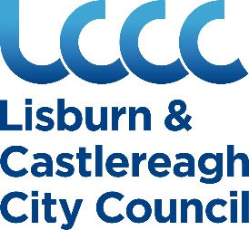

Lisburn & Castlereagh City Council
Notice of Conclusion of Audit

In accordance with the Local Government (Accounts & Audit) Regulations (Northern Ireland) 2015, notice is given that the audit of the accounts for Lisburn & Castlereagh City Council for the year ended 31st March 2020 has been concluded by the local government auditor.

Any member of the public may –

- inspect and make copies of the statement of accounts (or any part of it) prepared by the Council;
- inspect and make copies of (or any part of it) any report made to the Council by the local government auditor;
- require copies of any such statement or report (or any part thereof) to be delivered to him/her on payment of £10 for each copy.

The above documents may be inspected at

Civic Headquarters,
Lagan Valley Island,
Lisburn,
BT27 4RL

Between the hours of 9am and 5pm Monday to Friday.

The Statement of Accounts may also be downloaded from the Council’s website at www.lisburncastlereagh.gov.uk

Mr David Burns
Chief Executive

4 December 2020

