LISBURN & CASTLEREAGH CITY COUNCIL
CHILD AND ADULT SAFEGUARDING POLICY -PREVENTION AND PROTECTION IN PARTNERSHIP

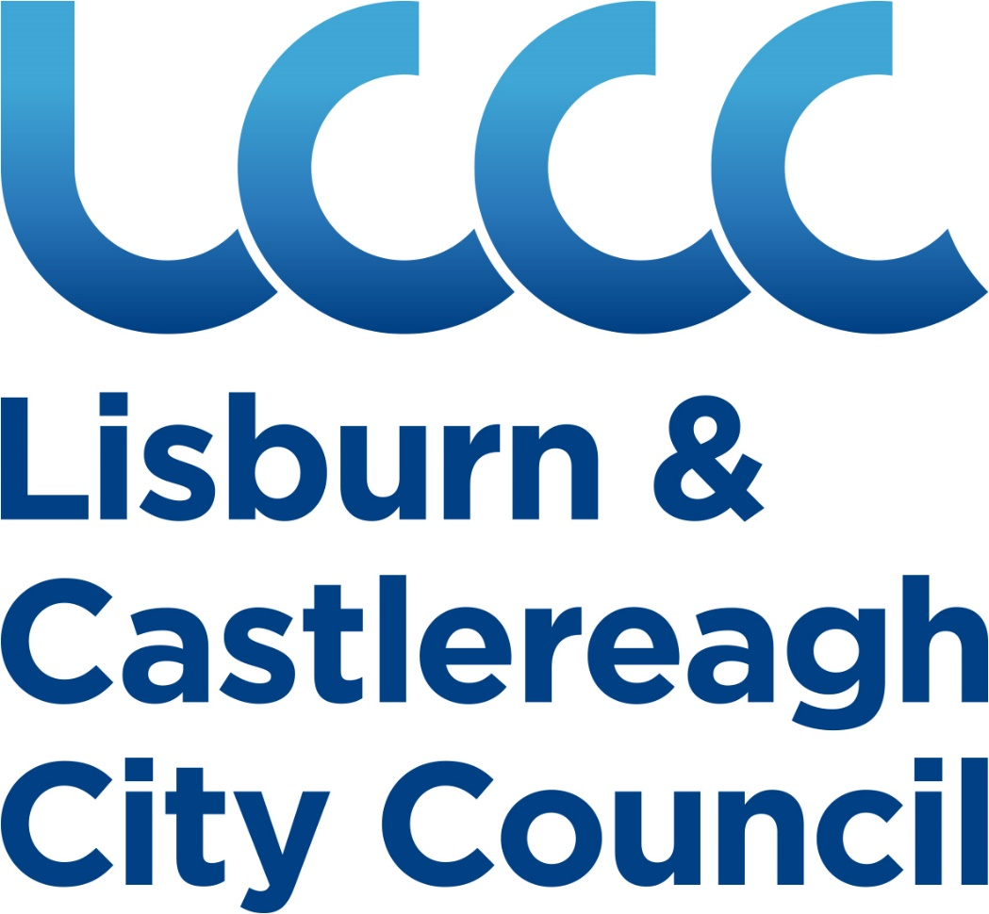

CHIEF EXECUTIVE’S FOREWARD

Everyone has a fundamental right to be safe. Whatever the cause, and wherever it occurs, harm caused to children and adults by abuse, exploitation or neglect is not acceptable. This policy emphasises that safeguarding is everyone’s business and that as a Council, Lisburn & Castlereagh City Council (LCCC) should strive to prevent harm to children and adults from abuse, exploitation or neglect.

This Policy requires us to put all individuals who may be at risk at the centre of what we do, to listen to them and to work in partnership with them and on an inter-agency basis, to create an organisation which has a zero-tolerance of harm to the most vulnerable people living in Northern Ireland.

The Policy contributes to the fulfilment of a Northern Ireland Executive Programme for Government commitment to deliver a package of measures to safeguard children and adults who are at risk of harm and to promote a culture where safeguarding is everyone’s business. It also links with LCCC Community Action Plan in that it helps to deliver on pledges to support our young people and older people who may be at risk of abuse.

The Council recognises that the Safeguarding Policy must be owned at all levels within the organisation. As Chief Executive of LCCC I have directed that this Policy be developed and I, with the Corporate Management Team, will be responsible for its approval and ensuring it is fully implemented and reviewed. A key element of the Safeguarding Policy is the nomination of a Safeguarding Manager, with the remit of Adult Safeguarding Champion, who will ensure that this council embraces best practice in this area.

The Policy and its supporting procedures have been developed by the Council’s Safeguarding Working Group (SWG) with the support of expert advice. It applies to all employees, elected members, volunteers, contractors, grant-aided organisations and those using our facilities, irrespective of their function, remit or role. I particularly commend this Policy to all employees and would ask that you take the time to familiarise yourself with the contents.

David Burns
May 2019

WHAT IS SAFEGUARDING?

1.1 Within this Policy the term ‘safeguarding’ is used in its widest sense, that is, to encompass both activity which prevents harm from occurring in the first place (Council Safeguarding Procedures) and activity which protects children and adults at risk and in need of protection, where harm has occurred or is likely to occur (Council Reporting to statutory agencies Procedures).

1.2 Preventative Safeguarding includes a range of actions and measures. Council employees may come into contact with children and adults who may be at risk of harm and so must recognise the potential for, and to prevent, harm. In practice the Council supports staff by providing safeguarding procedures:
- Recruitment and Selection
- Reporting Procedures and Incident Report Form
- Code of Behaviour for Staff and Volunteers
- Booking of LCCC facilities
- Photographic Guidance
- Role of Safeguarding Manager and Designated Officers/Appointed persons
- Safeguarding Training for staff and elected members
- Leisurewatch Procedure
- Workplace Domestic Violence Guidance
- Supervision levels
- Student Work Placements
- Contractor Guidance
- Managing Challenging Behaviour/Anti-Bullying
- Persons in Crisis/At risk of suicide
- Allegations Against Staff Procedure (Pending)

1.3 Protective Safeguarding is targeted at children and adults who are in need of protection, that is, when harm from abuse, exploitation or neglect is suspected, has occurred, or is likely to occur. The protection service is led by Health and Social Care Trusts and PSNI. In practice the Council has internal reporting protocols for concerns regarding children and adults which may lead to referrals to these statutory agencies.

1.4 Arena of Safety

The ‘arena of safety’ diagram expresses the Council’s Prevention and Protection Procedures.

Signs and Symptoms of abuse

Role of Manager DO/AP & SWG
Code of Behaviour

Lisburn & Castlereagh City Council Safeguarding Policy

Protection Policy

Reporting Procedures

Good Recruitment and Vetting

Training
Method of recording information

Dealing with Disclosures

2.0 Definitions (for the purposes of this policy)

2.1 Child
Those aged under 18 years.

  - Adult at risk of harm
An adult at risk of harm is a person aged 18 or over, whose exposure to harm through abuse, exploitation or neglect MAY be increased by their personal characteristics and/or life circumstances.

i) personal characteristics may include, but are not limited to age, disability, illness, mental or physical frailty or impairment of, or disturbance in, the functioning of the mind or brain;
ii) life circumstances may include, but are not limited to, isolation, socio-economic factors and environmental living conditions;

  - Adult in need of protection is a person aged 18 or over, whose exposure to harm through abuse, exploitation or neglect may be increased by their:
A personal characteristics AND/OR
B life circumstances

AND
C who is unable to protect their own well-being, property, assets, rights or other interests;
AND
D where the action or inaction of another person or persons is causing, or is likely to cause, him/her to be harmed.

In order to meet the definition of an ‘adult in need of protection’ either A or B must be present, in addition to both element of C and D.

In most situations HSC Trusts will make a decisions regarding the degree of risk and level of harm an adult may be facing and decide on the most appropriate action to take.

3.0 AIMS

This policy aims to:

3.1 promote zero-tolerance of harm to all children and adults who are at risk from abuse, exploitation or neglect;

3.2 improve safeguarding arrangements for children and adults who are at risk of harm from abuse, exploitation or neglect;

3.3 influence the way the organisation thinks about harm to children and adults resulting from abuse, exploitation or neglect by embedding a culture which recognises every person’s right to respect and dignity, honesty, humanity and compassion in every aspect of their life;

3.4 establish clear procedures for reporting and responding to concerns that a child or adult is, or may be, at risk of being harmed or in need of protection;

  - prevent and reduce the risk of harm to adults, while supporting their right to maintain control over their lives and make informed choices free from coercion;

  - promote a continuous learning approach to safeguarding and to support the adoption of a Trauma Informed Workforce; and

  - to incorporate safeguarding responsibilities into Service Plans where appropriate.

4.0 WHO IS THIS POLICY FOR?

4.1 The policy applies to all employees, elected members, volunteers, contractors, grant-aided organisations and those using our facilities irrespective of their function, remit or role.

4.2 There is an expectation that all employees will work in partnership as they apply this policy to their work with children and adults who may be at risk of harm or in need of protection.

5.0 UNDERPINNING PRINCIPLES/BACKGROUND

5.1 This policy has been developed in line with the following legislation and guidance and good practice guidelines, current at the time of publication.

5.2 Legislation

- The Criminal Law Act 1967
- The Children’s (NI) Order 1995
- UN Convention on the Rights of the Child 1989
- The Mental Health(NI) Order 1986
- The Safeguarding Vulnerable Groups (NI) Order 2007 (as amended by the Protection of Freedoms Act 2012 )
- The Sexual Offences Order (NI) 2008
- Section 75 NI Act 1998
- The Safeguarding Board Act (NI) 2011

5.3 Guidance Documents

- Adult Safeguarding- Prevention and Protection in Partnership – NIASP 2015
- Adult Safeguarding Operational Procedures -NIASP
- Keeping Adults Safe: A shared Responsibility – Volunteer Now 2017
- SBNI – Safeguarding Board for NI - Policy standards
- Co-operating to Safeguard Children (DHSSPS) Guidance in Northern Ireland, 2016
- Keeping Children Safe: Our Duty to Care- Volunteer Now 2016

5.4 Relationship with other Council Policies and Guidance

5.4.1 This policy operates in parallel and is supported by other Council Policies and guidance namely:

Disciplinary; Equality; Training and Development; Whistleblowing; Social Media; Health and Safety; Fraud and Corruption; Complaints procedure; Performance Review Scheme; Disposal of Records Policy; Dignity at Work Policy; Data Protection Policy; and Community Planning Policy.

6.0 FORMS OF ABUSE

6.1 ADULTS
Abuse is a single or repeated act or lack of appropriate action, occurring within a relationship where there is an expectation of trust, which causes harm or distress to another individual or violates their human or civil rights.
Abuse is the misuse of power and control that one person has over another. It can involve direct or indirect contact and can include online abuse.
The types of abuse are not exhaustive, nor listed in any order of priority.

6.1.1 Physical abuse
Physical abuse is the use of physical force or mistreatment of one person by another which may or may not result in actual physical injury. This may include hitting, pushing, rough handling, exposure to heat or cold, force feeding, improper administration of medication, denial of treatment, misuse or illegal use of restraint and deprivation of liberty. Female genital mutilation (FGM) is considered a form of physical AND sexual abuse.

6.1.2 Sexual violence and abuse
Sexual abuse is any behaviour (physical, psychological, verbal, virtual/online) perceived to be of a sexual nature which is controlling, coercive, exploitative, harmful, or unwanted that is inflicted on anyone (irrespective of age, ethnicity, religion, gender, gender identity, sexual orientation or any form of disability).
Sexual violence and abuse can take many forms and may include non-contact sexual activities, such as indecent exposure, stalking, grooming, being made to look at or be involved in the production of sexually abusive material, or being made to watch sexual activities. It may involve physical contact, including non-consensual penetrative sexual activities or non-penetrative sexual activities, such as intentional touching (also known as groping). Sexual violence can be found across all sections of society, irrelevant of gender, age, ability, religion, race, ethnicity, personal circumstances, financial background or sexual orientation.

6.1.3 Psychological / emotional abuse
Psychological / emotional abuse is behaviour that is psychologically harmful or inflicts mental distress by threat, humiliation or other verbal/non-verbal conduct. This may include threats, humiliation or ridicule, withholding security, love or support, provoking fear of violence, shouting, yelling and swearing, blaming, controlling, intimidation and coercion.

6.1.4 Financial abuse
Financial abuse is actual or attempted theft, fraud or burglary. It is the misappropriation or misuse of money, property, benefits, material goods or other asset transactions which the person did not or could not consent to, or which were invalidated by intimidation, coercion or deception. This may include exploitation, embezzlement, withholding pension or benefits or pressure exerted around wills, property or inheritance.

6.1.5 Institutional abuse
Institutional abuse is the mistreatment or neglect of an adult, by a regime or individuals, in settings within which adults who may be at risk reside or use. Institutional abuse may occur when the routines, systems and regimes result in poor standards of care, poor practice and behaviours, inflexible regimes and rigid routines which violate their dignity and human rights and place adults at risk of harm. Institutional abuse may occur within a culture that denies, restricts or curtails the privacy, dignity, choice and independence. It involves the collective failure of a service provider or an organisation to provide safe and appropriate services, and includes a failure to ensure that the necessary preventative and/or protective measures are in place.

6.1.6 Neglect
Neglect is the deliberate withholding, or failure through a lack of knowledge, understanding or awareness, to provide appropriate and adequate care and support, which is necessary for the adult to carry out daily living activities. It may include physical neglect to the extent that health or well-being is impaired, administering too much or too little medication, failure to provide access to appropriate health or social care, withholding the necessities of life, such as adequate nutrition, heating or clothing, failure to intervene in situations that are dangerous to the person concerned or to others particularly when the person lacks the capacity to assess risk.
Note that self-neglect and self-harm do not fall within the scope of this definition. Each individual set of circumstances will require a professional HSC assessment to determine the appropriate response and consider if an any underlying factors require a protection response.

6.1.7 Exploitation
Exploitation is the intentional maltreatment, manipulation or abuse of power and control over another person; to take selfish or unfair advantage of another person or situation usually but not always for personal gain from using them as a commodity. It may manifest itself in many forms including slavery, servitude, forced or compulsory labour, domestic violence and abuse, sexual violence and abuse or human trafficking.

6.1.8 Domestic abuse and sexual violence
Domestic abuse and sexual violence is threatening controlling, coercive behaviour, violence or abuse (psychological, physical, virtual, verbal, sexual, financial or emotional) inflicted on one person by anyone (irrespective of age, ethnicity, religion, gender, gender identity, sexual orientation or any form of disability) by a current or former intimate partner or family member. Domestic violence and abuse is essentially a pattern of behaviour which is characterised by the exercise of control and the misuse of power by one person over another. It is usually frequent and persistent. It can include violence by a son, daughter, mother, father, husband, wife, life partner or any other person who has a close relationship with the victim. It occurs right across society, regardless of age, gender, race, ethnic or religious group, sexual orientation, wealth, disability or geography.

6.1.9 Human trafficking/Modern Slavery
Human trafficking/modern slavery involves the acquisition and movement of people by improper means, such as force, threat or deception, for the purposes of exploiting them. It can take many forms, such as domestic servitude, forced criminality, forced labour, sexual exploitation and organ harvesting. Victims of human trafficking/modern slavery can come from all walks of life; they can be male or female; children or adults; and they may come from migrant or indigenous communities.
The response to adults at risk experiencing human trafficking/modern slavery will always be to report the incident to the Police Service.

6.1.10 Hate crime
Hate crime is any incident which constitutes a criminal offence perceived by the victim or any other person as being motivated by prejudice, discrimination or hate towards a person’s actual or perceived race, religious belief, sexual orientation, disability, political opinion or gender identity.
The response to adults at risk experiencing human trafficking/modern slavery will usually be to report the incident to the Police Service.

6.2 CHILDREN

6.2.1 Physical Abuse
Physical abuse is the deliberate physical injury to a child or the wilful or neglectful failure to prevent physical injury or suffering. This may include hitting, shaking, throwing, poisoning, burning or scalding, drowning, suffocating, confinement to a room or cot, or inappropriately giving drugs to control behaviour.

6.2.2 Emotional Abuse
Emotional abuse is the persistent emotional ill treatment of a child such as to cause severe and persistent adverse effects on the child’s emotional development. It may involve conveying to children that they are worthless or unloved, inadequate, or valued only insofar as they meet the needs of another person. It may involve causing children frequently to feel frightened or in danger, or the exploitation or corruption of children. Smothering a child’s development through over-protection can also be a form of abuse. Some level of emotional abuse is involved in all types of ill treatment of a child, though it may occur alone. Domestic violence, adult mental health problems and parental substance misuse may expose children to emotional abuse.

6.2.3 Sexual Abuse
Sexual abuse involves forcing or enticing a child to take part in sexual activities, whether or not the child is aware of what is happening including Child Sexual Exploitation. The activities may involve physical contact, including penetrative or non-penetrative acts. They may include non-contact activities, such as involving children in looking at or the production of pornographic material or watching sexual activities, or encouraging children to behave in sexually inappropriate ways.

6.2.4 Neglect
Neglect is the persistent failure to meet a child’s physical and/or psychological needs, likely to result in significant harm. It may involve a parent or carer failing to provide adequate foods, shelter and clothing, failing to protect a child from physical harm or danger, failing to ensure access to appropriate medical care or treatment, lack of stimulation or lack of supervision. It may also include neglect of, or unresponsiveness to, a child’s basic emotional needs.

6.2.5 Child Sexual Exploitation (CSE)
Child sexual exploitation is a form of sexual abuse in which a person(s) exploits, coerces and/or manipulates a child or young person into engaging in some form of sexual activity in return for something the child needs or desires and/or for the gain of the person(s) perpetrating or facilitating the abuse. (SBNI 2014, adopted from CSE Knowledge Transfer Partnership NI)

6.2.6 Female Genital Mutilation (FGM)
The World Health Organisation defines female genital mutilation (FGM) as:
“Any procedure which involves the partial or complete removal of
the external female genitalia or other injury to the female
genital organs for non-medical reasons”. Some communities refer to FGM as ‘circumcision’, ‘cutting’ or ‘sunnah’, rather than ‘FGM’.
FGM violates the rights and dignity of women and girls and is illegal regardless of the age of the female on which it is performed. FGM is usually practised on girls between infancy and 15 years old, but can also be
performed on older girls. More than 125 million girls and women alive today have been cut globally and in the UK, it is estimated that there are over 130,000 women living with FGM.

6.3 CONSENT AND CAPACITY- ADULT ABUSE ONLY

Staff, elected members and volunteers should always seek to work in the best interests of the adult and with his/her consent. They should be mindful of the need for the adult to consent to, and to be comfortable with, any proposed activity or service. Consent is a clear indication of a willingness to participate in an activity or to accept a service. For consent to be valid the adult must have capacity to make the decision AND has been appropriately informed AND consent must be freely given.
Capacity is the mental ability to make a decision and take actions. An adult will always be assumed to have capacity to make a decision unless it is suspected otherwise. It does not matter what the adult looks like, how they behave, what age they are or if they have a disability or illness. If a member of staff, elected member or volunteer has any doubts about the capacity of an adult to make a decision they should report this to the Appointed Person/ Safeguarding Manager as it may be necessary for a professional from the local HST Trust to conduct a capacity assessment.

7.0 ROLE OF THE COUNCIL’S SAFEGUARDING MANAGER

7.1 Key to the Council’s ability to safeguard and to enable its employees to provide a safe environment the Council has nominated a Safeguarding Manager. This is an important role since the expertise and experience of safeguarding is focused on one post and the manager will in turn act as a pivotal point for all safeguarding matters.

The Safeguarding Manager for Lisburn and Castlereagh City Council is:

Name Sandra Pinion and Brona Turley, Environmental Health Manager

Contact Environmental Health Service, Island Civic
Centre, Lisburn, BT 27 4RL

Email safeguarding@lisburncastlereagh.gov.uk
028 92 447406

Out of hours (children and adult) 028 95 049999 (Regional)

Gateway (children) South Eastern Trust 0300 1000 300
Belfast Trust 028 90 507000

PSNI 999 or PPU – 028 94 482633

Gateway (adult) South Eastern Trust 028 92 501227
Belfast Trust 028 95 041744

7.2 Specifically the role and responsibilities of the Safeguarding Manager will include:

7.2.1 Referral of child protection concerns

- Monitoring the implementation of the Council’s Safeguarding Policy and procedures and specifically to inform Social Services/PSNI within the appropriate Trust area of any concerns about a child or adult.

- Ensuring that any referral made by telephone is confirmed in writing for any documentation relating to concerns to be passed to Social Services or the PSNI.

- To act as custodian to ensure the safekeeping of any case material and keeping Senior Management of the Council appraised of any developments.

7.2.2 Adult Safeguarding Champion

All organisations which require staff to be vetted are required to nominate an ASC who must be at a senior position and should have the necessary training, skills and experience to carry out the role. The ASC provides strategic and operational leadership and oversight in relation to adult safeguarding for the organisation and is responsible for implementing its safeguarding policy.
The ASC is the main point of contact with HSC Trusts and the PSNI for all adult safeguarding matters

Key responsibilities of the ASC include:
- To provide information, support and advice for staff and/or volunteers on adult safeguarding within the organisation.
- To ensure that the organisation’s adult safeguarding policy is disseminated and support implementation throughout the organisation.
- To advise the organisation regarding adult safeguarding training needs.
- To provide advice to staff or volunteers who have concerns about the signs of harm and ensure a report is made to HSC Trusts where there is a safeguarding concern.
- To support staff to ensure that any actions take account of what the adult wishes to achieve – this should not prevent information about risks of serious harm being passed to the relevant HSC Trust Adult Protection Gateway Service for assessment and decision making.
- To establish contact with the HSC Trust Designated Adult Protection Officer (DAPO), PSNI and other agencies as appropriate.
- To ensure accurate and up to date records are maintained detailing all decisions made, the reasons for those decisions and any actions taken.
- To compile and analyse records of reported concerns to determine whether a number of low level concerns are accumulating to become more significant. These records must be available on request for inspection.

To meet the governance requirements set out in the NIASP Policy the ASC will compile an annual Adult Safeguarding Position Report (number of referrals to HSC Trusts, etc.)

7.2.2 Partnership with Health Trusts
- Providing a link through regular liaison with senior members of the South Eastern Health and Social Care Trust and the Belfast Health and Social Care Trust to participate in any appropriate training, new legislation and guidance etc.

- Safeguarding Manager or deputy is member of the Local Adult Safeguarding Partnership (LASP) in both Trust areas.

- Safeguarding Manager or deputy is member of the Keeping Safe Steering groups in both Trust areas.

- Safeguarding Manager or deputy is a member of the Safeguarding Board for NI in both Trust areas (SBNI).

7.2.3 Within the Council and Regionally

- Advising the Corporate Management Team of any immediate Safeguarding concerns and reporting annually on the work of the SWG.

- Chairing the Safeguarding Working Group.

- Monitoring the implementation of the Safeguarding Policy and Procedures.

- Acting as source of advice and assistance on safeguarding matters in the Council.

- Advising the Council in conjunction with the Training Officer of any safeguarding training needs.

- Communicating Safeguarding Procedures to all employees.

- Promoting the inclusion of safeguarding in regular facility management teams’ agendas.

- Safeguarding Manager or deputy is a member of the NI Network of Councils for Safeguarding.

- Overseeing the review of the Safeguarding Policy and Procedures at least every three years.

8.0 Designated Safeguarding Officers / Appointed Persons

8.1 In order to assist the Safeguarding Manager, the Council has nominated a number of Designated Officers/Appointed Persons within the service units of the Council. They sit on the Safeguarding Working Group.

8.2 Responsibilities include:
- Acting as a point of contact for safeguarding matters for their unit
- Receiving and recording concerns
- Responsible for reporting all concerns to the appropriate statutory agency for safeguarding and the Council’s Safeguarding Manager
- Making referrals to the statutory agencies in the absence of the Safeguarding manager/out of hours.
- Attend training

8.3 The names and contact details of DSOs/Appointed Persons are held on the Council’s Safeguarding intranet site.

9.0 Safeguarding Working Group

9.1 The Safeguarding Working Group is a cross-departmental group set up to oversee the practical implementation of this policy and to develop/review safeguarding procedures. It is governed by the Terms of Reference for the group.

9.2 Its role includes:
- Identifying safeguarding training needs within services
- Developing supplementary safeguarding procedures as required
- Promoting good practice within Council services
- Discussing incidents and concerns raised in services to facilitate a Council-wide response if necessary

9.0 APPENDICES

SAFEGUARDING PROCEDURES
- Role of Safeguarding Manager and Designated Officers
- Recruitment and selection

- Incident Reporting Forms and guidance

- Code of Behaviour for Staff and Volunteers

- Supervision levels for LCCC activities

- Photography Guidance

- Booking of LCCC facilities

- Safeguarding Training

- Leisurewatch Guidance

- Workplace Domestic & Sexual Violence and Abuse Guidance

- Student Work Placements

- Contractor Guidance

- Managing Challenging Behaviour/Anti-bullying

- Persons in Crisis/ at risk of suicide

