Annual Complaints Report 2025/26

Lisburn & Castlereagh City Council (LCCC) aims to provide an effective and efficient service to all its ratepayers and customers. If on occasions, the service is not as our customers would expect, the Council would like to know about it.
Compliments and complaints are captured on the Council’s Customer Care System and Complaints are dealt with through the Council’s complaints handling procedure.
Reporting on complaints and compliments is carried out monthly to the Council’s Corporate Management Team and quarterly to Council.
The following links will provide access to the dashboard reports which details the key data regarding complaints and compliments in Quarter 1 (April – June inclusive), Quarter 2 (July – September inclusive), Quarter 3 (October - December inclusive) and Quarter 4 (January – March) of 2025/26.
STAGE 1 COMPLAINTS
The total number of complaints logged through the Councils Customer Care/Waste Management System at Stage 1 between 1st April 2025 – 31st March 2026 were 985, in comparison with 806 received during 24/25.
This is an increase of 179 (22%)
Total compliments received during 25/26 were 223, a slight decrease of 26 (10.5%) from 249 for the period 24/25.

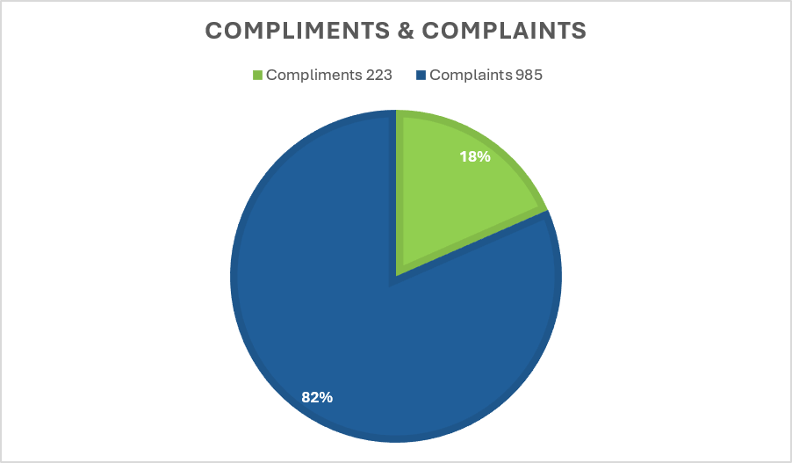

Most complaints continue to relate to Environmental Services at 64% with Leisure & Community Services at 31%.

STAGE 1 COMPLAINT OUTCOMES
Upheld | Not Upheld | Partially upheld | Resolved | Redacted outcome | Withdrawn
90  (9.14%) | 125  (12.69%) | 78  (7.92%) | 639  (64.87%) | 48  (4.87%) | 5  (<1%)

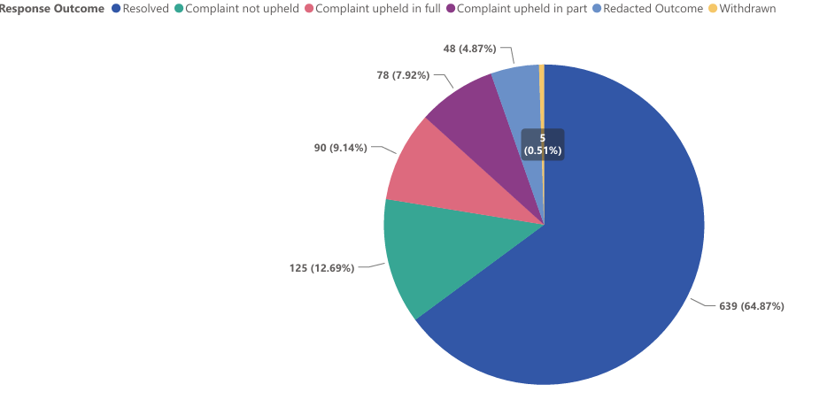
Stage 1 complaint responses issued within the expected timeframe: 903 (91.7%)
Stage 1 complaint responses issued outside the expected timeframe: 65 (6.6%)
Stage 1 complaints with the response time extended: 17 (1.7%)
Stage 1 complaint responses issued within the extended timeframe 17 (100%)

STAGE 1 LEARNINGS – UPHELD COMPLAINTS
A brief summary of key learning outcomes from complaints received are as follows:
- Litter at Hydebank after football matches - Council has contacted all teams and made it clear that continued littering may affect future bookings. Council has also advised the attendants of the importance of clearing any remaining litter.
- Waste collection calendar not available – We have been working with the calendar provider but as they have been fixing the initial incorrect information more errors have been found. A meeting has been scheduled to try and resolve the issues, but we are also considering alternative ways to provide the information if necessary.
- Moira Demesne toilets – We are assigning an operative to do nothing but clean toilets in Hillsborough, Wallace, Blaris, Moira, Bells Lane. This will increase our frequency of toilet cleaning from twice to four times per day, over the summer. We will also be arranging for a deep clean of all the toilets. Refurbishment works had been planned before the summer. This was not possible, and we are reluctant to close them off for this work while schools are off and we have an event program in place. It is planned to complete these works at the first opportunity.
- DIIB – Ice Rink conditions – Council are exploring the feasibility of having the Zamboni staff cut the ice before the pad is accessed. This might however result in a delay of approximately 30 minutes in opening the ice pad for private lessons.
- Arts Centre Studio Theatre – Heating – This matter has been brought to the attention of our Assets team and will be addressed as part of planned works being considered in the near future.
- DIIB – Customer Service – We recognise that this may highlight a wider need for further staff training. We are reviewing our current training programs to ensure all team members are equipped with the skills, knowledge, and attitude needed to provide the level of service our customers expect and deserve. Refresher training sessions will be scheduled, with a particular focus on customer service, communication, and booking procedures.
- Lambeg Playpark – A meeting has been arranged with the contactors to discuss the bins not being emptied as required. Spot checks will also be carried out over the coming weeks to ensure the bins are being emptied.
- Lambeg Playpark – A meeting has been arranged with the contactors to discuss the bins not being emptied as required. Spot checks will also be carried out over the coming weeks to ensure the bins are being emptied.
- Ongoing issue with waste collection - Collections interrupted due to roadworks and inconsiderate parking, letter drop to be carried out.
- Wallace Park opening times – The contractor has been instructed that playparks must remain open until 5.00 and if there is an issue with clearing the park at 5.00, the solution is not to close it earlier than the stated time. We will also be checking the closing times of all the other playparks across the council area to ensure that this is not happening elsewhere.
- Centre Management – Seating – We are currently in the process of planning a full upgrade to our seating infrastructure, including the introduction of a new bleacher seating system. This is scheduled for installation by August 2026 and will significantly improve comfort and accessibility for all guests. We will continue to monitor and maintain the existing seating as best we can. As part of our interim measures, we are recovering some of the more badly damaged seats to improve comfort in the short term, while longer-term upgrades are underway.
- Light trail – Admission to trampoline – We strive to ensure that the light trail is an accessible event and that all our visitors have an enjoyable experience. We have spoken to the owner of the fairground rides and he has confirmed that, given the nature of the trampoline ride there is a height and weight restriction, however this can be overridden by him. Family have been invited back to the event and an offer to meet Santa has also been given.
- Parks & Amenities - E Scooters – Wallace Park – We recognise this is an important issue and are actively taking steps to address it, which includes providing the public with information, signage and engagement with neighbourhood policing. Hopefully this will reduce the use of such vehicles in our parks going forward.
- Dundonald International Ice Bowl – Ice Rink skating time – We are currently making improvements to our systems to make our processes faster & more efficient. These will likely be implemented over the next couple of months.
- Centre Management – Lagan Valley Island – gravel path - We have asked our maintenance and health and safety teams to review this, to ensure any appropriate mitigation measures are considered and implemented to reduce the risk of similar incidents occurring in the future. In the interim, we will install signage such as “Caution – Loose Surface” at both gravel/stone areas which should give a clear indication to pedestrians or cyclists that these areas are not suitable for use.
- Parks & Amenities – litter bins - We have arranged a meeting with the contracts manager and will be explaining to them the importance of all bins being emptied on every visit. We will also make a point of visiting Duncans every fortnight or so for the next few months to ensure that they are emptying them.

STAGE 2 COMPLAINTS

22 complaints were escalated to Stage 2 (Director) during the year 25/26.

Stage 2 complaint responses issued within the expected timeframe: 21 (95.5%)

Stage 2 complaint responses issued outside the expected timeframe: 0 (0%)

Stage 2 complaints with the response time extended:1 (4.5%)

Stage 2 complaint responses issued within the extended timeframe 1 (100%)

Stage 2 complaints were escalated to the following Directorates:
- Regeneration & Growth 8 cases logged
(Planning, Hillsborough Forest, market selection process, toilet facilities)
- Environmental Services 9 cases logged
(Abandoned dog, request for a postcode, BW collections, customer service, noise, Health & Housing)
- Finance & Corporate Services 1 case logged
(Incident at show)
- Leisure & Community Wellbeing 3 cases logged
(BMX Club, community centre access, grant application)
- ODI 1 case logged
(Recruitment exercise)

STAGE 2 OUTCOMES
• Not Upheld 12
• Upheld 1
• Upheld in part 6

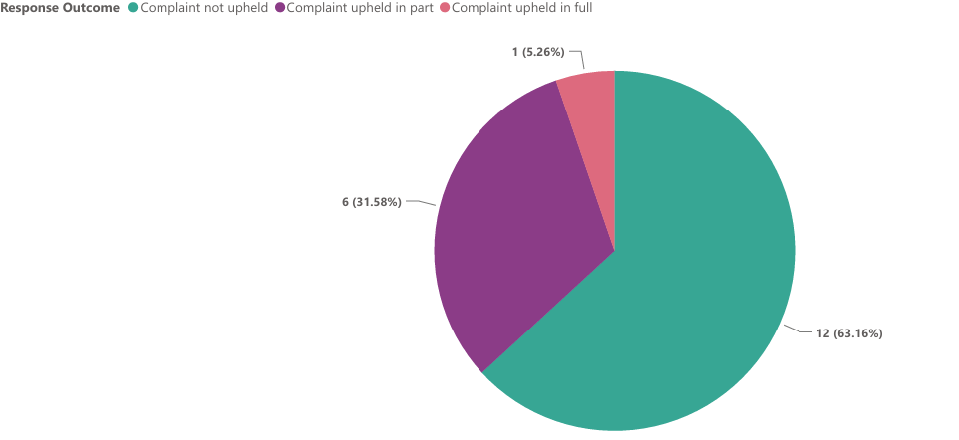

STAGE 2 LEARNINGS – UPHELD COMPLAINTS
- Environmental Services – Bulky waste not collected – We are reviewing our policy on bulky waste collections and it has been requested that in an instance where a bulky waste collection is not lifted for whatever reason, that the person placing the request is advised by the team as soon as possible to prevent this situation happening again. Furthermore, staff will be reminded of the items which are eligible/non eligible under the policy to ensure consistent messaging to enquiries.

STAGE 3 COMPLAINTS - NIPSO
THREE complaints were escalated to stage 3 (NIPSO) during the year 25/26.
- Regeneration & Growth (1) – Planning
- Environmental Services (1) – Environmental Health
- Leisure & Community Wellbeing (1) - DIIB

FOUR stage 3 complaints were closed, not upheld – no further action.
- Leisure & Community Wellbeing – DIIB (1)
- Regeneration & Growth – Planning (1)
- Environmental Services – Environmental Health (2)
- Regeneration & Growth – Planning (1)

ONE complaint remains open – awaiting final decision from NIPSO. Council was advised by NIPSO in February 2025 that the complaint was not upheld. However, the complainant sought a review/appeal. This remains outstanding as of June 2026.

CUSTOMER SATISFACTION
There were 62 Customer Satisfaction Surveys sent out during the year 25/26. There was a response rate of 9.5% (6).
The response to the surveys was as follows:
- Excellent 4 (66%)
- Good 1 (17%)
- Acceptable 1 (17%)
- Poor 0

