Office Use Only

Ref ________________

Date/time Received__________

Receiving Officer____________

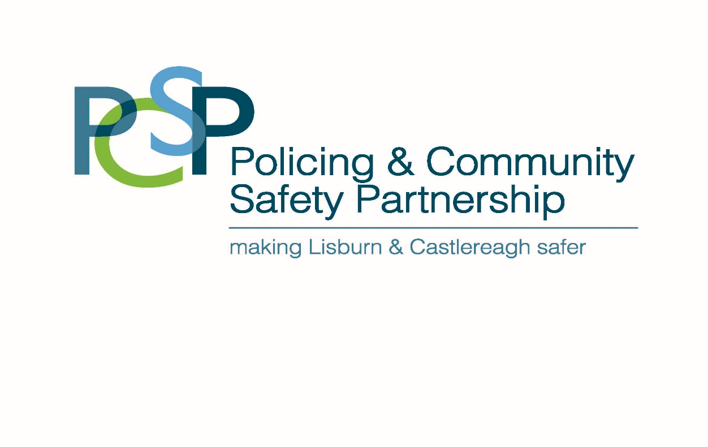
Lisburn & Castlereagh Policing and Community Safety Partnership Project Support Programme Application

Please return completed application no later than 1pm on the 29 May 2026 to:

Lisburn & Castlereagh Policing and Community Safety Partnership
Civic Headquarters
Lagan Valley Island
Lisburn
BT27 4RL

Applications can be either typed or clearly handwritten, or submitted online via www.smartsurvey.co.uk/s/PSP26-27/

Funding Available £500 to £5000 minimum of 20% matched funding which can be in kind support

Please outline below which of the Objective(s) you are making your application under (Guidance Notes pages 2 and 3 refer)

Organisation Name: ______________________________________________________________

Project Name: _________________________________________________________________

Project Address: _________________________________________________________________

Post Code: ________________________ Email: ______________________________________

Project Co-Ordinator: _____________________________________________________________

Telephone No: (work) ___________________________ Mobile No:_________________________

Postcode____________________ Email: _____________________________________________

Council Ward: __________________________________________________________________
(You must define the Council Ward where the beneficiaries of your project comes from)

Project Start Date: ________________________Project End Date: ________________________

Total Project Cost (inc Match Funding): _______________________________________________

Total Amount Requested from PCSP: ________________________________________________

Signature required by one of the following: Inspectors Barry Moore (Dundonald), Inspector Danielle Burke, Lisburn City/Rural) or Sergeants Dan Kenny, Paul Marsh or Natalie Campbell (Lisburn) or Sergeant Shelley Regan (Dundonald)

Name of PSNI Officer consulted re project:  _____________________________________  I confirm that it fulfils the objectives of this application. |  | Name :  Rank :  PSNI Station :
Signature : |  | Date :
 | 1. Please describe the main activities of your group

2. Outline the community safety issues which will be covered by the project.

3. Please describe the main aims and outcomes of the proposed project ie what the project will achieve and what differences it will make in your community including timescales.

4. Please outline what if any involvement the police will have in your project

5. Monitoring and Evaluation of Project (Guidance notes pages 4 & 7)

6. What is the total cost of your project? Please provide an itemised list of these costings

Item | Cost

Total Cost £

7. Match Funding

Please provide clear details of no less than 20% Match Funding in either cash or in kind contributions from other funding sources.

Organisation / Body Funding

Total Match Funding Secured £____________

Is your group VAT registered Yes / No
Please indicate any other funding applications you have submitted in relation to this project?

Name of Funder | Details of Application | Date of Application | Amount | Approved  Yes / No

If the application is from a community or voluntary organisation please note details will be supplied to the Government Funders database.

Government Data Protection Regulations (GDPR)

Lisburn & Castlereagh PCSP collects the data on this form for the purposes of grant administration. This information may be shared with the Police Service Northern Ireland and the Department of Justice as part of the assessment of the application.

Please ensure the following documents are enclosed with your completed application:

List of Committee/Board Members, Names and Addresses ESSENTIAL

Constitution (Signed and Dated)/Memorandum and Articles of Association ESSENTIAL
Or Equivalent Documents (not required for accredited Neighbourhood
Watch Schemes or Community Police Liaison Committees)

Annual Report (If Applicable) DESIRABLE

Applicant’s Bank Account Details/Supporting Financial Documentation ESSENTIAL

Contact Details of Office Bearers ESSENTIAL

Copy of Insurance Certificate (if appropriate) ESSENTIAL

Confirmation of VAT position (and/or) Charity Registration Number ESSENTIAL

Letter of Confirmation in writing of at least 20% Match Funding Secured ESSENTIAL
Any other information relevant to your project ESSENTIAL

If your group intends to work with children/young people you must have an ESSENTIAL
Adopted Child Protection Policy and members must be Access NI cleared

NB: FAILURE TO SUPPLY ESSENTIAL DOCUMENTATION WILL RESULT IN THE
APPLICATION RENDERED NULL AND VOID

DECLARATION

I declare that we are submitting this application on behalf of the above group which will deliver the project as described. We will submit the evaluation and final claim form by 26 February 2027.

This application form must be signed by the Chairperson and the Treasurer of the management board of the organisation making the submission.

1st Signature: _________________________ 2nd Signature:_________________________

Print Name: __________________________ Print Name: __________________________

Position: _______________ Date: _______ Position: ________________ Date:________

Please return completed application form and enclosures either online or in a sealed envelope marked Policing and Community Safety Partnership – Project Support Programme Application 2026-27 to the PCSP Manager no later than 1.00pm on Friday 29 May 2026.

Lisburn & Castlereagh Policing and Community Safety Partnership
Civic Headquarters
Lagan Valley Island
Lisburn
BT27 4RL

