**Annual Customer Feedback Report 2024/25**

Lisburn & Castlereagh City Council (LCCC) aims to provide an effective and efficient service to all its ratepayers and customers. If on occasions, the service is not as our customers would expect, the Council would like to know about it.

Compliments and complaints are captured on the Council’s Customer Care System and Complaints are dealt with through the Council’s complaints handling procedure.

Reporting on complaints and compliments is carried out monthly to the Council’s Corporate Management Team and quarterly to Council.

The following links will provide access to the dashboard reports which details the key data regarding complaints and compliments in Quarter 1 (April – June inclusive), Quarter 2 (July – September inclusive), Quarter 3 (October - December inclusive) and Quarter 4 (January – March) of 2024/25.

**Stage 1 Complaints**

Total complaints logged through the Councils Customer Care System at stage 1 in 24/25 were 806, in comparison with 713 received during 23/24.

This is an increase of 93 (13%)

Total compliments received during 24/25 were 249, an increase of 58 (30%)from 191 for the period 23/24.

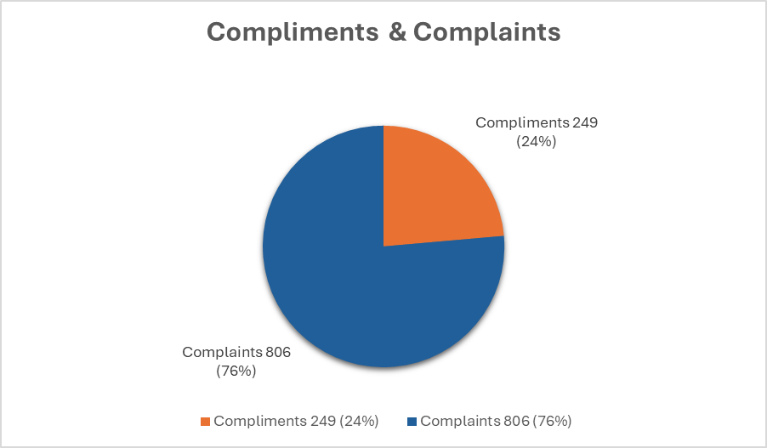

Most complaints continue to relate to Environmental Services at 53% with Leisure & Community Services at 39%.

**COMPLAINT OUTCOMES**

|  |  |  |  |  |  |  |  |
| --- | --- | --- | --- | --- | --- | --- | --- |
| **Upheld** | **Not Upheld** | **Partially upheld** | **Resolved** | **Redacted outcome** | **Remedy Offered** | **Withdrawn** | **Non Council** |
| **303 (37.59%)** | **161 (19.98%)** | **77**  **(9.55%)** | **160**  **(19.85%)** | **98**  **(12.16%)** | **1**  **(<1%)** | **2**  **(<1%)** | **4**  **(0.5%)** |

Complaint response time extended: 16 (2%)

Complaints responded to outside the timeframe: 44 (5%)

**Stage 1 Learnings**

A brief summary of key learning outcomes from complaints received are as follows:

* Citywide Winter Magazine – Proof reading processes of electronic versions reviewed and enhanced - multiple checks now in place.
* Castle Gardens light show – Council advised all security staff to ensure they are aware that dogs should not be allowed into the gardens if they are not on a lead.
* Street Cleansing – Pathway has been cleansed as requested and added to the weekly schedule.
* Hillsborough Forest Parking - Council have considered ways to allow residents quicker access to the forest on busy days and consulted residents on this. We have also asked staff on duty to do all that they can to prevent the queue extending beyond the main gate which should reduce the time people are waiting on spaces.
* Hillsborough toilets - the standard of cleaning with the contractors has been addressed and the toilets are now being checked on a regular basis.
* Castle Gardens toilets closed during event – Council reminded Eventsec of the ‘Accessaloo’ and its location so they can advise users. We have also raised the matter of the shortage of sanitary products in the facilities with our contractor and asked them to ensure that they remain well stocked
* Buddy Cards - Information sharing across our systems needs to be reviewed. A meeting was held with the relevant HOS and a review of the Buddy Card System is planned.
* Castle Gardens light show date of closure incorrect – Economic Development raised this at our team debrief and will endeavour to be consistent in our marketing message across the Council departments for future events.
* Torwood Gate (Moira) not open – Council reminded the contractor of the importance of making sure all gates are open at the correct time.
* Potential Data Breach (Building Control) - Query and cross reference legal requests for information - site plans will now be requested identifying property from conveyancing solicitors to confirm the actual site plot and not rely on their due diligence in correctly identifying the address.
* Billy Neill Gym closed – There is only one member of staff assigned to Billy Neil at weekends. We have made arrangements with the staff at Billy Neil to ensure that they contact the manager directly should they not be able to make it in to work which will allow us to put preventive measures in place on the day to at least get the facility open for users.
* Dogs accessing Moira Demesne Food Fayre – Council will place additional staff on the entrances to the event. Council will also include dog etiquette messaging for all visitors in pre-event publicity and signage and will review how the space is managed going forward.
* Gate not being closed after refuse collection – All crews have been spoken to and reminded that the gate must be closed before leaving.
* Indiana Land incident (Older children using the younger children play areas) – A further review of staffing protocols has been carried out and further action has been taken to minimise the likelihood of this happening again in the future.
* Bryson crew not returning boxes correctly – Council have contacted Bryson and raised the issue with them to prevent any further issues.

**Stage 2 Complaints**

18 complaints were escalated to stage 2 (Director) during the year 24/25.

Outcomes as follows:

* Not Upheld 11
* Upheld 5
* Upheld in part 1
* Withdrawn 1

They related to the areas of:

* Leisure & Community Services 3 (Swimming lessons, customer service, BMX Club
* Regeneration & Growth 7 (Planning
* Environmental Services 7 (Noise, Cemeteries, parking, attendance at Committee meetings, litter bin provision, data breach, abandoned dog
* Finance & Corporate Services 1 (accident)

**Stage 2 Learnings**

* Damage to grave – Communications between Directorates has been improved.
* Customer Service – (Dundonald International Ice Bowl) Where possible all points raised by the complainant should be addressed at Stage 1.
* Request for litter bins - A review of the provision of litter bins in the area was requested by the Director of Environmental Services and as a result a suitable additional location has been identified along Lough Moss Road at the junction with Lough Moss Mews. This will be programmed into the works schedule. The Councils criteria for suitable locations is that they must be an adopted surface for fixing purposes and which allows public to use them and our staff to service them safely.

Council is also increasing patrols by our Enforcement Officers for a period, their visible presence in the area will hopefully deter offenders.

* Data Breach - The Service has progressed an improvement to its procedures to avoid any future repeat of this error happening again.

**Stage 3 Complaints – NIPSO**

***FOUR*** complaints were escalated to stage 3 (NIPSO) during the year 24/25.

• Regeneration & Growth – Planning (3)

• Environmental Services – Environmental Health (1)

***THREE*** stage 3 complaints were not upheld – no further action.

• Regeneration & Growth – Planning (2)

• Environmental Services – Environmental Health (1)

***ONE*** complaint remains open – awaiting final decision from NIPSO.

• Regeneration & Growth – Planning (1)

**Customer Satisfaction**

There were 97 Customer Satisfaction Surveys sent out during the year 24/25. There was a response rate of 16% (15).

The response to the surveys was as follows:

* Excellent 13 (88%)
* Good 1 (6%)
* Acceptable 0
* Poor 1 (6%)