Development Plan
Position Paper 11: Tourism
November 2019

Development Plan

Position Position Paper 11:

Tourism

December 2017

Contents Page
Contents Page

Executive Summary 2

- Introduction 3
- Regional Policy Context 3
- Existing Development Plan and Other Key Documents 7
- Tourism Profile within Lisburn & Castlereagh City Council 11
- Key Findings and Conclusion 25

Figures

Figure 1 Lagan Valley Regional Park Nodes 13
Figure 2 Slievenacloy Nature Reserve 14

Tables

Table 1 LCCC Tourism - Estimated Overnight Trips, Nights and Expenditure 19
Table 2 Overnight Trips in Lisburn & Castlereagh City Council by reason 20
for visit 2016-2018
Table 3 LCCC Visitor Attractions and their number of visitors 2013-2018 20
Table 4 Employee Jobs 2015 and 2017 21

Appendices

Appendix 1 Hotel-Related Planning Applications 26
Executive Summary

This Position Paper provides an overview in relation to tourism provision in Lisburn & Castlereagh City Council area to assist in the preparation of the Local Development Plan 2032.

The Local Development Plan is made within the context of a Sustainability Appraisal under the provision of Planning (Northern Ireland) Act 2011. This paper is therefore intended to provide a baseline position on which policy and proposals for tourism development in the Local Development Plan can be shaped over the plan period.

It is important to stress that in compiling the Position Paper the best information available has been used however further revisions may be required in light of the release of any new data or updated policy, advice or information.

This paper provides an update on the previous Position Paper which was produced as part of the preparation of the Preferred Options Paper and has been informed by consultations with the relevant statutory consultees including Tourism NI.

The aims of the paper are:

- to provide baseline information which will inform the Local Development Plan;
- to assess the future land use needs of Lisburn & Castlereagh City Council to consider the adequacy of existing provision; and
- to provide the spatial representation of the Council’s Community Plan having regard to other plans and strategies being undertaken by the Council.

- INTRODUCTION

  - This Position Paper examines the provision of tourism related development in Lisburn & Castlereagh City Council area and how it will be addressed in the future.

  - Chapter 2 sets out the regional context on tourism development which is formulated within the context of the Regional Development Strategy (RDS) 2035, the Strategic Planning Policy Statement for Northern Ireland (SPPS) and regional Planning Policy Statements (PPSs).

  - Chapter 3 outlines the current policy approach in the existing Plan context.

  - Chapter 4 provides an overview of the tourism profile in the Council area, and a summary of the Council’s key tourism assets.

  - The key findings and conclusion are provided in Chapter 5.

- REGIONAL POLICY CONTEXT

2.1 The regional policy context is provided by the Regional Development Strategy (RDS) 2035, Strategic Planning Policy Statement for Northern Ireland (SPPS) and regional Planning Policy Statements (PPSs) where relevant. A summary of these documents in relation to plan making and waste management policy is provided in the following paragraphs.

Regional Development Strategy (RDS 2035)
  - The RDS provides an overarching strategic framework to facilitate and guide development in the public and private sectors in support of the Programme for Government (PfG). The RDS has a statutory basis prepared under the Strategic Planning (Northern Ireland) Order 1999.

  - Promoting a sustainable approach to the provision of tourism infrastructure (RG4) is one of five elements of regional guidance set out in the RDS aimed at underpinning sustainable economic growth in Northern Ireland.

  - The guidance set out in RG4 seeks to apply this sustainable approach to tourism development in the following ways:-
- Promote a balanced approach that safeguards tourism infrastructure while benefiting society and the economy. The RDS recognises that all new or extended infrastructure required to support the tourism industry needs to be sensitively sited with proper regard to both the tourism need and the natural and built environment.
- Improve facilities for tourists in support of the Tourist Signature Destination. The RDS encourages a joined up approach amongst stakeholders in regard to investment in access, accommodation and visitor facilities so as to effectively support the Destinations and secure maximum tourism benefit.
- Encourage environmentally sustainable tourism development. The RDS recognises that the development of tourism infrastructure needs to be appropriate to the location to ensure that the natural assets are protected and enhanced.

Northern Ireland Tourism Strategy 2020
2.5 The Department for the Economy (DfE) are publishing a new Tourism Strategy within the context of a refocused Industrial Strategy for Northern Ireland. A public consultation on the Industrial Strategy entitled ‘Economy 2030’ was launched in 2017, however finalisation of the document has been delayed due to the absence of Ministers. The Department is now considering extending the draft Tourism strategy period to 2030 to align to the draft Industrial Strategy ‘Economy 2030’ timeframe. A revised draft of the Strategy looking towards 2030 is being developed and is included as an ‘Action’ within the NICS Outcomes Delivery Plan published in June 2018 and within DfE’s 2019-20 Business Plan.

Strategic Planning Policy Statement (SPPS)

  - The SPPS was published by the former Department of the Environment in September 2015. The provisions of the SPPS must be taken into account in the preparation of Local Development Plans, and are also material to all decisions on individual planning applications and appeals.

  - The SPPS sets regional policy objectives for tourism development which are to:-
- facilitate sustainable tourism development in an environmentally sensitive manner;
- contribute to the growth of the regional economy by facilitating tourism growth;
- safeguard tourism assets from inappropriate development;
- utilise and develop the tourism potential of settlements by facilitating tourism development of an appropriate nature, location and scale;
- sustain a vibrant rural community by supporting tourism development of an appropriate nature, location and scale in rural areas;
- ensure a high standard of quality and design for all tourism development.

Role of Local Development Plan

  - The SPPS states that in plan making councils should consider best how to facilitate the growth of sustainable tourism in their areas by bringing forward a tourism strategy, together with appropriate policies and proposals that must reflect the aim, objectives and policy approach of the SPPS, tailored to the special circumstances of the plan area.

  - The following strategic policy should be taken into account in the LDP preparation:-
- There will be a general presumption in favour of tourism development within settlements
- Policies must facilitate appropriate tourism development in the countryside where this supports rural communities and promotes a healthy rural economy and tourism sector
- Policies for major tourism development in the countryside may be provided for in exceptional circumstances
- Policies for safeguarding tourism assets from unnecessary, inappropriate or excessive development.

  - In plan-making councils should consider how best to facilitate growth of sustainable tourism. The LDP tourism strategy should reflect wider government tourism initiatives and should address the following:-
- How future tourism demand is best accommodated;
- Safeguarding of key tourism assets;
- Identification of potential tourism growth areas;
- Environmental considerations; and
- Contribution of tourism to economic development, conservation and urban regeneration.

Planning Policy 16 (PPS16) Tourism

  - PPS16 Tourism sets out the Department’s policies on Tourism development and applies regionally.

  - PPS16 provides the same series of policy objectives as the SPPS in relation to tourism development, along with the role of the Local Development Plan.

  - It states that the extent to which a development plan engages in the preparation of a tourism development strategy is largely a matter for local determination and may depend upon existing or anticipated levels of tourism activity in the plan area or the identification of locally important tourism issues. The promotion of tourism through the Tourism Signature Projects and the Tourism Priorities for Action Plan should be recognised by development plans where relevant.

  - The first policy TSM1 relates to tourism development in settlements, whilst policies identifying proposals for tourism development in the countryside is facilitated through policies TSM2-TSM7. The safeguarding of Tourism assets is provided for under the final policy TSM8.

Transitional Period

2.15 A transitional period will operate until such times as a Plan Strategy for the Lisburn & Castlereagh City Council area has been adopted. During the transitional period planning authorities will apply existing policy contained within Planning Policy Statement 16 Tourism together with the SPPS. Any conflict between the SPPS and any policy retained under the transitional arrangements must be resolved in the favour of the provisions of the SPPS.

- EXISTING DEVELOPMENT PLAN

Belfast Metropolitan Area Plan 2015 (BMAP)
  - The Belfast Metropolitan Area Plan 2015 is a development plan prepared under the provisions of Part 3 of the Planning (Northern Ireland) Order 1991 by the former Department of the Environment (DOE). The Plan covers the City Council areas of Belfast and Lisburn and the Borough Council areas of Carrickfergus, Castlereagh, Newtownabbey and North Down. The Plan was adopted on 9th September 2014, however the Court of Appeal declared the adopted plan unlawfully adopted on 18th May 2017.

  - As a result, the existing Development Plans covering the Council area are as follows:
- Belfast Urban Area Plan (BUAP) 2001
- Lisburn Area Plan (LAP) 2001
- Carryduff Local Plan 1988-1993
- Ballymacoss Local Plan
- Lisburn Town Centre Plan
- Lagan Valley Regional Park Local Plan 2005

3.3 BMAP in its post-inquiry form was at an advanced stage and therefore remains a material consideration. Draft BMAP (November 2004) in its pre-inquiry form also remains a material consideration in conjunction with recommendations of the Planning Appeals Commission Public Local Inquiry Reports.

  - Volume 3 and Volume 5 of BMAP 2015 sets out policies on the former Lisburn and Castlereagh Districts respectively (“District Proposals”). These policies have been developed in the context of the Plan Strategy and Framework contained in Volume 1 of the Plan and are in general conformity with the RDS.

  - The Belfast Metropolitan Area Plan (BMAP) 2015 includes a Tourism Strategy which comprises of promoting sustainable tourism development, protecting a varied range of tourism development opportunities and facilitating the development of tourism infrastructure. It also promotes enhancing the urban environment with particular emphasis on ‘first impression’ points at major gateways and in city and town centres.

  - BMAP identifies Lisburn City as the main focus for tourism in the District with its linen heritage, and the Irish Linen Centre and Lisburn Museum situated in the central retail core. It identifies the regeneration of the Historic Quarter in the City Centre including the Island Civic Centre. It notes the various recreational opportunities within Lisburn & Castlereagh along the River Lagan which are further complemented by Lisburn’s indoor recreational facilities and parks, along with Dundonald International Ice Bowl Complex and Billy Neill Soccer School of Excellence within Castlereagh.

  - BMAP acknowledges Lisburn’s significant number of tourism assets which provide a diverse range of attractions. It notes Lisburn’s proximity to the Belfast Hills and the River Lagan with its Canal, Towpath and wider Lagan Valley Regional Park offering further outdoor recreation opportunities. BMAP acknowledges that expansion of a night time economy and further development of accommodation options across the City are priority areas for future tourism development.

OTHER KEY DOCUMENTS

Lisburn & Castlereagh City Council Tourism Strategy 2018
3.8 The Council’s Tourism Strategy (February 2018) is a blueprint for developing tourism across the Council area and is summarised in the Council’s Vision for Tourism, 2018 – 2022. It defines several development priorities including:
- Hillsborough – founded on Historic Royal Palaces major investment in Hillsborough Castle and Gardens, the Old Fort and Courthouse; the village itself; Hillsborough Forest Park and its facilities; and encouraging an events programme and visitor accommodation
- Lisburn Historic Quarter – potential to develop a new hotel, relocation of The Island Arts Centre to Castle Street and relocation of the Irish Linen Centre and Lisburn Museum to more suitable premises
- Moira – as a ‘foodie’ destination
- Down Royal Racecourse including the need for a quality hotel development in the surrounding area
- Maze Long Kesh (MLK) and a new National Museum – significant opportunity exists to enhance the transformational scope of MLK
- Lagan Valley Regional Park and Navigation – providing further local and wider opportunities to attract tourism to this natural resource. It includes the Discover Waterways Lisburn Project which proposes restoration of the Lagan Navigation heritage and buildings and restoration of Union Locks
- Castlereagh Hills and Dundonald International Ice Bowl – whilst this area is topographically challenged it benefits from the popular National Trust Walkway at Lisnabreeny. Significant renewal plans are underway for Dundonald International Ice Bowl which will provide a major leisure asset with tourism potential. Other proposals include revamping the caravan park, and possible development of a budget hotel.

Lisburn City Centre Masterplan Review 2019 (Draft)
3.9 The document seeks to ensure that Lisburn plays a significant role within the region by developing a range of facilities and attractions expected of a regionally significant city. The need to develop 200 hotel bedrooms and explore future opportunities with respect to the evening / night-time economy is emphasised.

3.10 The Masterplan recognises that public realm improvements could be linked to areas around the Cathedral and Castle Gardens and on to the Civic Centre to provide an attractive walking route through the City Centre and ultimately reconnect the city with the River Lagan.

Laganbank Quarter Development Scheme (February 2015)
  - The Laganbank Quarter Development Scheme sets out the former Department for Social Development (now Department for Communities) proposals for the redevelopment of the Laganbank Quarter area and includes land on both sides of the River Lagan as it flows through Lisburn City Centre. The aims of this scheme in relation to tourism, open space and recreation are:
- Comprehensive and integrated redevelopment of the Laganbank Quarter
- Maximising and capitalising on the undeveloped riverside location
- Enhancement of the overall attractiveness of the City Centre
- Major environmental and public realm improvements in the surrounding streets and public spaces.

3.12 It is considered that the Development Scheme will help establish Lisburn as an attractive and compact city for residents and tourists.

Castlereagh Urban Integrated Framework
3.13 The Castlereagh Urban Integrated Development Framework is a joint project undertaken on behalf of Castlereagh Borough Council and the Department for Social Development. It focuses on the commercial centres of Carryduff, Dundonald and Forestside and sets out a long term, high level vision up to the year 2022.

3.14 It considers how to improve the appearance of areas, pedestrian linkages and accessibility and proposals for Dundonald Leisure Park which include a tourist standard hotel.

4.0 TOURISM PROFILE IN LISBURN & CASTLEREAGH CITY COUNCIL AREA

  - The potential to attract tourism and to sustain interest and investment in this field has been historically based on a mixture of both private and public interests and investment. In line with strategic thinking on the matter, Natural and Built Heritage resources are often deemed to be the key players in the ability to generate and attract tourism and associated revenue. This approach is seen not just in Lisburn & Castlereagh City Council area, but wider afield as a sustainable basis from which tourism and tourism growth should be founded; however it is not the only basis from which tourism attraction is founded. Key segments in the industry also include the ability to attract visitors through the hosting of events and through the activities available in the area.

  - Situated to the south west of Belfast City, Lisburn City was awarded city status in May 2002 and is the third largest city in Northern Ireland. Due to its location just off the M1 Motorway and the A1 main arterial route, the City of Lisburn offers significant scope as a base for those visiting Northern Ireland and the South of Ireland. The city centre still retains many architectural buildings and streets dating from the 18th century but it is also a lively bustling modern city. Lisburn & Castlereagh City Council area has a diverse range of tourism assets and attractions. These include outdoor attractions, the River Lagan with its Canal Towpath and the wider Lagan Valley Regional Park which offers further outdoor recreation opportunities and indoor attractions such as Dundonald International Ice Bowl which is the only public Olympic sized ice rink in Northern Ireland.

Lagan Valley Regional Park
  - The Lagan Valley Regional Park (LVRP) is a unique asset for the population of Lisburn & Castlereagh and beyond - approximately half of the Regional Park and most of the Lagan Valley Area of Outstanding Natural Beauty is situated within the Council area. It is a significant recreational resource and has variable urban and rural character, mature woodland, agricultural fields and much grassland diversity. While the majority of the Regional Park within the Council area is in agricultural use, there are areas within the Settlement Development Limit of Lisburn City which consist of amenity parklands and casual recreation areas focused on the riverside corridor. These recreation areas make a major contribution to the enjoyment of the Park, as well as playing a vital role in sustaining the well-established parkland character.

  - BMAP designated several nodes within the Lagan Valley Regional Park where it is considered appropriate to locate recreational, tourist, interpretative or educational facilities. Within these nodes, favourable consideration is given to the provision of seating, picnic areas, lighting, signage, public art, footbridges, pathways and viewpoints of an appropriate scale and location provided they visually integrate into the Park. Within Lisburn & Castlereagh City Council there are 6 such nodes:-
    - Designation LN 09 Adjacent to Lisburn Distillery – this node has since been developed and is known as McIlroy Park
    - Designation LN 10 Glenmore Activity Centre
    - Designation LN 11 Island at former Barbour Threads Mill
    - Designation LN 12 Lisburn Civic Centre
    - Designation LN 13 Union Bridge
    - Designation LN 14 Hillsborough Road

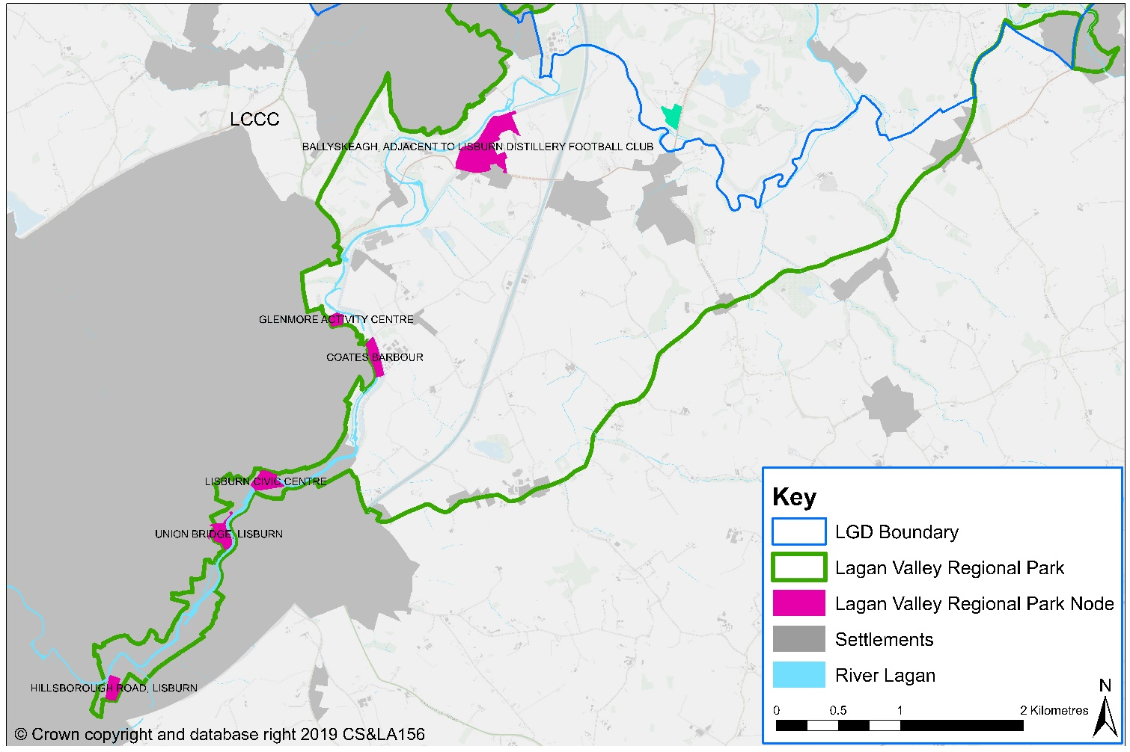
Figure 1 Lagan Valley Regional Park Nodes

  - There is potential to restore the 27 mile route of the Ulster Canal from Belfast Harbour through Lisburn and on to Lough Neagh. The Lagan Canal was one of the most successful commercial navigations in Ireland and boasts the only flight of 4 locks (Union Locks) in the Irish Waterway network. These locks lifted the barges 26 feet over a distance of 100 yards.

  - The re-opening of the Navigation could potentially bring the creation of a new water based tourism product along with opportunities for recreation (walking, cycling, angling etc.). This in turn could contribute to booking rates for local accommodation of all types and there will also be the potential for other jobs within the hospitality and leisure industries.

  - In 2019 the Council agreed £2.4 million of investment with the Lagan Navigation Trust to provide for an additional 1.5 miles of towpath/National Cycling Network route, re-watering the basin at the Union Locks for recreational use and the refurbishment of Navigation House as a flagship visitor and educational destination. The Council, in partnership with the Trust and other land owners is examining the route of the proposed Lagan Navigation Greenway and Blueway to Lough Neagh.

  - Slievenacloy Nature Reserve, located within the Belfast Hills is believed to have been an important sacred landscape during the Neolithic and Bronze Ages. There are the remains of five farmsteads within the nature reserve and also the site of a false WWII runway which was used to distract German bombers from targeting Aldergrove.
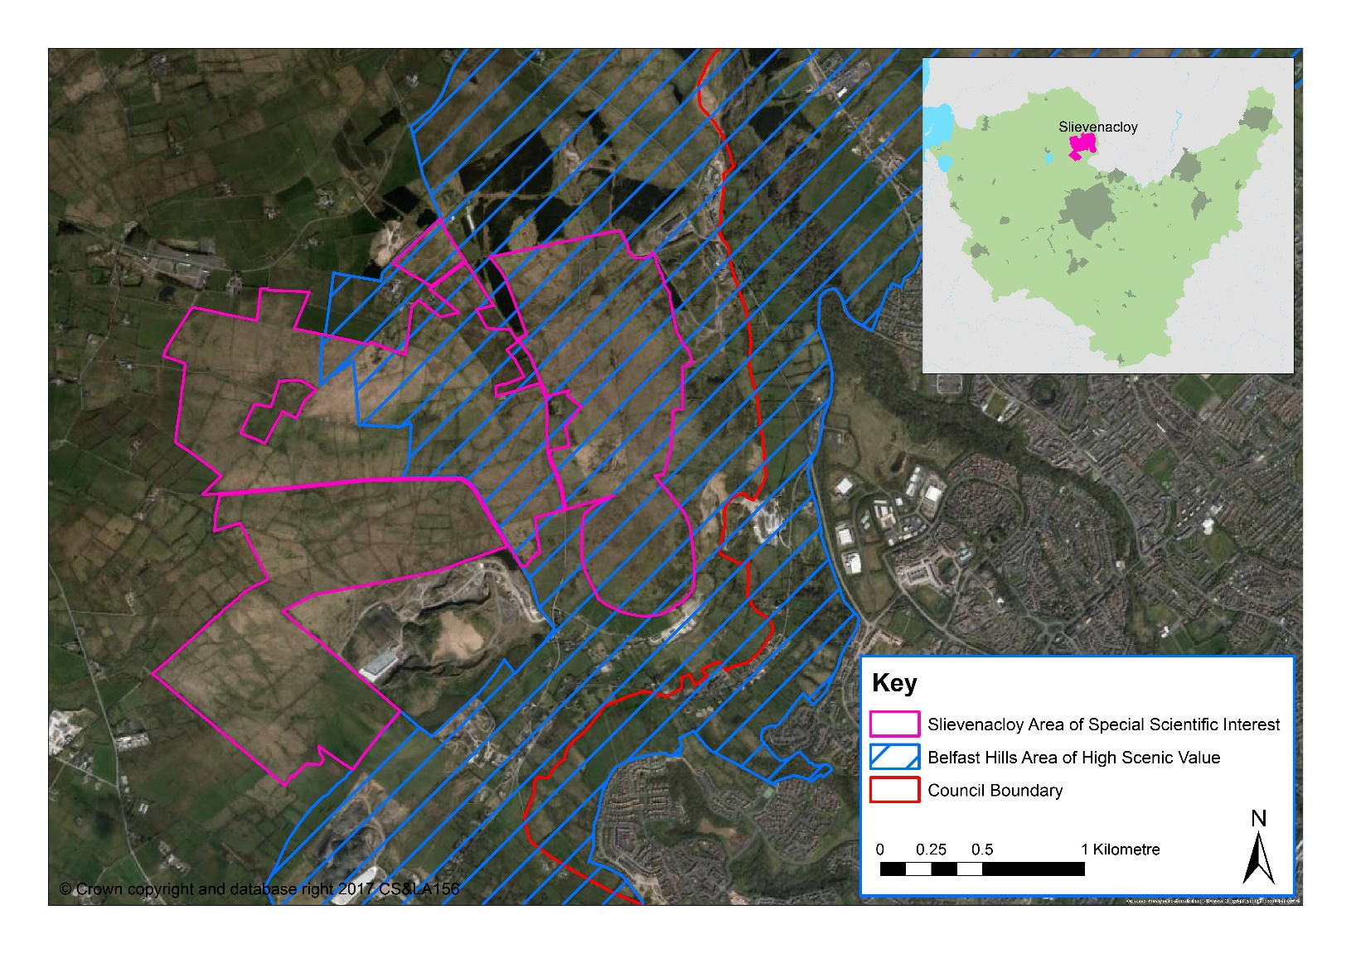
Figure 2 Slievenacloy Nature Reserve

  - Tourists can also take advantage of the many parks and gardens which include – Castle Gardens, Wallace Park, Hillsborough Forest, Moira Demesne and Portmore Lough Nature Reserve.

Activity Tourism
  - Activity Tourism was identified as a key target within the draft NI Tourism Strategy 2020. It covers a range of ‘active’ holidays involving canoeing, climbing, horse riding and mountaineering, to the less physical, yet still activity-focused areas of nature watching, food trails or local culture and heritage trails. DETI and Tourism NI identify Activity and Special interest breaks as a key target market worthy of support in Northern Ireland. Activities include golf, angling, walking, gardens, cruising and cycling amongst others.

  - Activity Tourism in Northern Ireland is valued at £90m to £100m per annum. The activity industry has grown significantly since 1998 and today there are 214 private sector operators offering 42 activities. (Source: TNI)

  - NI has the potential to become a significant destination for outdoor activities. Activities support the Tourism Strategy for NI by making better use of our natural resources and Tourism NI’s corporate plan by delivering quality visitor experiences. It is a young and vibrant industry representing a confident NI.

Angling
  - Domestic and visiting anglers can make a valuable contribution to the economy and evidence shows that the visiting angler is as valuable to the NI economy as a visiting golfer, walker, cyclist or horse-rider. Based on the number of licences issued, the number of visiting anglers from outside Northern Ireland appears to be slowly increasing (Source: ‘A Strategic Review of Angling in Northern Ireland’ published by DCAL in July 2013).

  - Angling is one of the most popular pastimes on water in the LCCC area and given its location close to Lough Neagh and along the River Lagan, it is strategically placed in a prime position to avail of the tourism opportunities angling can bring. Coarse and game angling can be enjoyed at many locations including Lough Neagh, Stoneyford Reservoir, Hillsborough Forest Lake, Lough Erne, Ballykeel and Brookhall Trout Fishery.

  - The main beneficiaries of increased angling tourism in the LCCC area would be service providers including pubs, restaurants, hotels, holiday lets and B&Bs. With some notable exceptions there is a lack of awareness among these providers of the potential opportunities to service visiting anglers which would attract new summer business and also extend their season.

Watersports
  - Lough Neagh, as the largest freshwater lake in the British Isles, is generally viewed as an underused resource in terms of its potential. According to the ‘Lough Neagh and its Waterways Tourism Destination Management Plan 2014-2019’ there are 4 main canals linked to the Lough. Currently, these canals are not in full public use and there is no direct boating route through the whole of Northern Ireland. The Lagan Canal is the only canal situated within the LCCC area. As discussed earlier (see para 5.5) the re-opening of the Navigation could potentially bring the creation of a new water based tourism product along with opportunities for recreation (walking, cycling, angling etc).

  - There are nine recognised Canoe Trails in Northern Ireland, one of which is directly accessible within the LCCC area – the ‘Lough Neagh Canoe Trail’. This trail has many access points along the entire shoreline of Lough Neagh and can be accessed at Rams Island.

  - There are also many more opportunities for water based activities within LCCC area including Lough Aghery Waterski Club, Meteor Waterski Club and Lisburn City Paddlers based at Glenmore Activity Centre.

Golf
  - The draft Tourism Strategy for Northern Ireland 2020 highlights the opportunity for growing golf tourism nationally and internationally to position Northern Ireland as a premier golf destination. Such is the potential to obtain strong growth through this market, TNI published a study in December 2014 called ‘Strategic Review of Golf Tourism in Northern Ireland 2015-2020.’ The Strategy aims to amongst other objectives, grow the value of golf visitation to Northern Ireland to £50m per annum by 2020.

  - There are many golf courses within the LCCC area ranging from the Council owned courses of Aberdelghy and Castlereagh Hills Golf Course, including privately owned courses at Down Royal and Rockmount.

Cycling
  - Mountain biking and cycling is experiencing a surge in popularity. There are now approximately 100km of official, purpose built mountain bike trails across Northern Ireland (however none are situated within LCCC area) with an estimated visitor usage of some 100 000 people a year (Source: ‘Mountain Biking Guide’ NITB, January 2013).

  - There are ten, unsigned cycle routes between 20 and 40 miles in length, within the LCCC area, from the canal towpath sections to the more challenging Dromara Hills. These routes are detailed on www.cycleni.com and tourists can explore the routes online.

  - Lisburn & Castlereagh City Council has opened Northern Ireland’s first Cycle Hub at the Billy Neill Halt on the junction of the Comber Greenway. The Cycle Hub, completed in November 2017, is part of the National Cycle Network and has created 24 hour access to the only car park adjacent to the Comber Greenway making it an ideal location for commuting to work by bicycle.

Equestrian
  - There are many equestrian centres in the LCCC area which provide experienced riders and novices with the opportunity to enjoy trekking and horse riding activities. Local riding schools include Ballyknock Riding School, Drumaknockan House Stables, Mill Yard Equestrian Centre and Tullynewbank Stables.

Events Tourism
  - Events Tourism is a form of tourism attraction that can drive visitor numbers to an area by the showcasing of events, such as home-grown festivals to major international events such as the Giro D’Italia. In terms of impact on the economy, there is a direct correlation between the ability to attract visitor numbers to the generation of increased spend. In terms of lasting legacies and social impact, such forms of tourism also provide platforms for the visitor to interact with local culture, local people and explore our scenic landscapes and cities.

  - The Tourism NI (TNI) Events Unit supports the development of the NI Events Industry, in order to grow visitor numbers and visitor spend in line with targets set by the draft Tourism Strategy. The Events Unit also develops and administers the delivery of the Tourism Event Funding Programme for National and International Tourism Events occurring in Northern Ireland. The main support mechanism available for the Events Industry from NITB is the Tourism Event Funding Programme, an annual funding programme designed to support International and National Tourism Events.

  - According to TNI statistics, there were 61 local events in Northern Ireland in 2019-20 which obtained sponsorship in Northern Ireland by the TNI Events Fund. Of these 61, two were within the LCCC area:-

- Balmoral Show, Maze Long Kesh, Lisburn; and
A further international event also received funding: –
- Ulster Grand Prix at Dundrod.

4.28 Many other events are due to take place within the LCCC area during 2019/20 such as:- the Lisburn Light Festival; Down Royal Festival of Racing; European Indoor Archery Championship; Lisburn Half Marathon; and the Spring Farm Plant Machinery Show.

Food Tourism
4.29 Visitors are increasingly seeking to gain a sense of local cultures and places and food tourism can deliver authentic experiences, encourage dwell time and boost local communities through regional and seasonal spread.

4.30 With food and drink expenditure accounting for 30% of visitors’ total spend in Northern Ireland in 2018 (£350 million), it is clear that eating and drinking are an essential part of the Northern Irish tourism offer.

Visitor Numbers and Attractions 2016 - 2018
Table 1: LCCC Tourism - Estimated Overnight Trips, Nights and Expenditure

Trips, Nights & Spend | 2016 | 2017 | 2018 | 2018 v 2017 | 2018% of NI
Trips | 169,863 | 150,837 | 189,366 | +26% | 4%
Nights | 592,083 | 615,567 | 725,493 | +18% | 4%
Spend | £27.2.m | £26.6m | £30.5m | +15% | 3%
Average length of stay (nights) | 3.5 | 4.1 | 3.8
Average spend per trip | £160 | £176 | £161
Average spend per night | £46 | £43 | £42

Source: Local Government District Tourism Statistics Administrative Geographies NISRA

4.31 There were almost 190,000 overnight trips taken to the Lisburn & Castlereagh City Council area in 2018, showing an increase in visitors of 26% when compared to 2017. While the number of nights spent increased by 18% (615,567 in 2017 and 725,493 in 2018), the average length of stay decreased. However the total spend in the same period increased by 15%, from £26.6m in 2017 to £30.5m in 2018.

4.32 The top visitor attractions is Lisburn & Castlereagh City Council area in 2018 are the Irish Linen Centre & Lisburn Museum, Streamvale Open Farm and the Island Arts Centre.

Table 2: Overnight Trips in Lisburn & Castlereagh City Council by reason for visit 2016-2018
Holiday/Pleasure  /Leisure (HPL) |  |  | Visiting Friends and Relatives (VFR) |  |  | Business |  |  | Other |  |  | All
Nos | % HPL | % LGD | Nos | % VFR | % LGD | Nos | % Busi-ness | % LGD | Nos | % Other | % LGD | Nos |  | % NI
42,793 | 2% | 25% | 108,302 | 6% | 64% | 14,946 | 4% | 9% | 3,981 | 3% | 2% | 170,022 | 3%

Source: Local Government District Tourism Statistics NISRA

  - There was 189,366 overnight trips taken within the Lisburn & Castlereagh City Council area between 2016 and 2018, with almost two thirds of the overnight trips (64%) being visits to friends / relatives.

Table 3: LCCC Visitor Attractions and their number of visitors 2013-2018
Attraction | 2013 | 2014 | 2015 | 2016 | 2017 | 2018
Clip’n Climb |  |  | 25,408 | 25,525 | 44,066 | 26,592
Irish Linen Centre & Lisburn Museum | 74,025 | 82,759 | 95,028 | 111,273 | 157,814 | 158,810
Island Arts Centre | 72,838 | 68,764 | 121,643 | 125,364 | 116,255 | 114,795
Lisnabreeny |  |  | 50,000 | 25,000 | 43,772 | 44,000
R-Space Gallery |  |  |  | 1,271 | 1,890 | 1,464
Slievenacloy Nature Reserve |  | 7,500 |  | 5,000 |  | 4,898
Spruce Meadows Activity Farm | 10,000 | 8,000 | 8,000 | 7,000 | 10,000 | 10,000
Streamvale Open Farm | 40,000 | 60,000 | 65,000 | 70,000 | 122,333 | 125,000
The Ballance House | 1,140 | 1,500 |  | 1,050 | 1,360 | 1,482

Source: Local Government District Tourism Statistics NISRA

Table 4: Employee Jobs 2015 & 2017
 | Accommo-dation for visitors | Food & Beverage Serving Activities | Transport | Sporting & Recreation Activities | Other | Tourism Jobs | Non-Tourism
2015 | 329 | 2,501 | 113 | 719 | 144 | 3806 | 50286
NI Total | 10233 | 35537 | 3763 | 7504 | 4226 | 61263 | 655842
2017 | 315 | 2826 | 125 | 757 | 191 | 4,179 | 51,848
NI Total | 10,548 | 35,537 | 3,763 | 7,274 | 4,546 | 64,856 | 679,600
Change 2015-2017 | -4% | 13% | -20% | 5% | 33% | 10% | 3%
NI Total | 3% | 8% | 7% | -3% | 8% | 6% | 4%

Source: Local Government District Tourism Statistics NISRA

4.34 The overall number of people employed in tourism related jobs in Northern Ireland rose between 2015 and 2017 from 58,042 to 64,856 (+6%) whilst the figure for tourism related employment within the Lisburn and Castlereagh City Council Area increased from 3,806 in 2015 to 4,179 in 2017 (+10%). The majority of tourism related jobs were within the Food and Beverage Sector, with an increase between 2015 and 2017 of 13% (from 2,501 to 2,826). The number of people employed in the Sporting & Recreational Activities sector increased slightly, from 719 in 2015 to 757 in 2017 (an increase of 5%). The Accommodation for Visitors sector has decreased between 2015 and 2017 from 329 to 315 (-4%).

4.35 The Lisburn City Council Sub-economic Profile & Economic Forecast Report 2010 to 2020 (Oxford Economics 2011) predicts that should the City Centre Masterplan be fully implemented a total of 90 additional new jobs in hotels & restaurants could be created. Should the Laganbank Quarter Development Scheme progress as a standalone project to the overall City Centre Masterplan, the Lisburn City Council Sub-economic Profile & Economic Forecast Report predicts a total of 80 additional new jobs in hotels and restaurants could be created.
OPPORTUNITIES FOR FURTHER TOURISM GROWTH

Hillsborough Castle
4.36 Hillsborough Castle, built in the 18th Century has gone from being a simple country house to becoming the official royal residence in Northern Ireland and the place where many of the formal and informal stages of the Peace Process happened. Historic Royal Palaces (HRP) took over responsibility for the management of the castle in April 2014 and opened the doors to the public in 2018 following a £16m transformation project that will increase access to visitors, conserve the heritage and provide learning and participation opportunities.

4.37 The Council commissioned a Hillsborough Tourism Masterplan which was completed in November 2015 and included an Action Plan of priority projects. This commission had been contextualised by Historic Royal Palaces’ plans to refurbish Hillsborough Castle and Grounds with an investment of £16m leading up to the formal opening in 2018.

4.38 The purpose of the Hillsborough Tourism Masterplan was also to make recommendations for the development and marketing of Hillsborough that complemented the investment by Historic Royal palaces, thus enabling Hillsborough as a whole to offer the highest standards of experience and service available. Part of this overall Masterplan is the Hillsborough Forest project. The Council is embarking on a £4m project to develop Hillsborough Forest into a first class, innovative and natural recreational area for residents and visitors through the provision of a woodland themed play park, picnic area, upgraded car parking, sculpture trails and sympathetic improvements to the existing forest paths.

4.39 The Public Realm Scheme aims to provide an improved environment, creating an environment which is welcoming to local people and visitors and strengthening the visual and physical linkages including connections to the Castle, Fort, Lake and Forest Park.

Hotel in City Centre Location
  - There are currently 4 hotels within the Council area;
- the Premier Inn in Lisburn;
- The Ballymac in Stoneyford;
- The Ivanhoe, Carryduff; and
- Le Mon Hotel and Country Club in Castlereagh.

4.41 Further opportunity exists for development of a new hotel within Lisburn City Centre which would encourage tourists to stay, shop and be entertained within the city centre. It could also provide residents and visitors with an opportunity to enjoy an evening attraction in the City Centre.

  - As discussed previously, the Lisburn City Centre Masterplan highlighted the need to provide additional hotel bedrooms within the City Centre. Plans have been approved for a 70 bedroom / 60 apartment ‘apart-hotel’ at Lisburn Leisure Park and a 52 bedroom hotel at Lisburn Square whilst procurement options are underway for an 80 bedroom hotel on Castle Street. A new hotel within the city centre could also help invigorate a night time economy within the city (See Appendix 1 for a list of recent hotel approvals within the LCCC area).

Tourism & the Night-Time Economy

  - The night-time economy of an area can make an important contribution to the overall economy of an area. A range of activities in a city or town can increase viability and vitality and contribute to the creation of inclusive communities. The night-time economy creates jobs, attracts people to an area and generates spend, all of which would be beneficial to those living / staying in the Council area.

  - Development of the evening and night time economy in urban centres in Northern Ireland is part of the draft Tourism Strategy for Northern Ireland 2020. The Purple Flag project was initiated in Northern Ireland by Pubs of Ulster, The Department of Justice and the Association of Town Centre Management with funding support through Tourism NI’s Tourism Innovation Fund. This was part-financed by the European Regional Development Fund under the European Sustainable Competitiveness programme for Northern Ireland.

  - Currently five towns and cities in Northern Ireland have achieved Purple Flag status for offering visitors a great night out – Belfast, Enniskillen, Bangor, Armagh and Derry – Londonderry. These urban areas have all been recognised for showing evening visitors an entertaining, diverse and safe night out.

  - Going forward, it is essential that visitors to the Lisburn & Castlereagh Council area are offered a range of entertainment activities in the evening.

  - In addition to the opportunity for the city centre hotel developments outlined previously, restaurants, pubs, retail and cultural venues are important parts of the night time economy and there is considerate opportunity for these to be developed further, to offer greater diversity and to attract a wider age range of people through Arts, Culture and Gastronomical Tours. There may also be scope for adventure activities to take place at night, e.g. guided walking tours through forests, or night angling for fishing enthusiasts or cultural activities such as art tours.

  - The night time economy can also be associated with negative factors including noise, safety issues and drunken behaviour. Good design is therefore essential in designing out crime and providing a safe and inclusive place for people to meet and socialise.

  - Further consideration should be given to providing a joined up approach to the tourism offer across the Council area, such as heritage trails between Castlereagh and Lisburn.

5.0 KEY FINDINGS

  - A summary of the key findings are as follows:-

- There is a wealth of tourism assets within Lisburn & Castlereagh City Council area; however major opportunity exists for the expansion of the tourism industry across the Council area to attract investment, jobs and visitors
- Further opportunities should be explored for expanding hotel provision within the Council area, with particular regards to Lisburn City Centre to provide for the increasing visitor numbers and provide a much needed boost to the night-time economy
- Further opportunity exists for expansion of tourism with the potential reopening of the navigation canal from Belfast to Union Locks
- The benefits of tourist attractions to the night-time economy should be recognised both in social and economic terms
- Opportunities exist for a joined-up approach across the Council area in terms of provision of ‘tourist trails’ and promotion of major attractions and events, for example the Balmoral Show at the Maze, and the creation of new world class visitor attractions.

CONCLUSION

5.2 Following on from the original Position Paper in December 2015, the purpose of this paper has been to update the baseline information regarding tourism development within the Lisburn & Castlereagh City Council area and examine the need for further growth. This baseline will support the preparation of the Plan Strategy and Local Policies Plan, and as the process evolves will be updated/amended as necessary taking account of all relevant new information made available.

Appendix 1: Hotel-Related Planning Applications
Reference | Address | Proposal | Status
LA05/2018/1222/F | Premier Inn, 136-144 Hillsborough Road, Lisburn BT27 5QY | Construction of three storey extension to the existing hotel to facilitate an additional 51 bedrooms | Granted
LA05/2018/1150/F | Unit 15, Lisburn Square, Lisburn BT28 1TS | Change of use of Unit 15, the first floor of Unit 20, the vacant retail storage of units 9 to 14 and the Lisburn Suite offices to hotel use incorporating ground floor reception, lobby, bar and restaurant, 45 first floor bedrooms, hotel residents' gym and conference room and basement storage areas. New first floor bedroom windows on northern elevation. Car parking and servicing from existing basement car park and service yard and related ancillary development. | Granted
LA05/2018/1061/O | Sprucefield Park, Lisburn BT27 5UQ | Erection of new buildings for retail use (Class A1) and restaurant and hotel uses (Both Sui Generis). Alteration of existing vehicular access and egress arrangements. Reconfiguration of existing, and provision of new internal vehicle, pedestrian and cycle routes, Landscaping and Public Realm. Reconfiguration of public and staff car parking area, servicing arrangements and other ancillary works and operations. | Consult  -ations  Issued
S/2011/0400/F | Premier Inn Hotel, Hillsborough Road, Lisburn | 30 additional bedrooms | Granted
S/2011/0269/F | 4 Glenavy Road, Upper Ballinderry | 66 bed hotel with leisure & conference facilities, restaurants & bars | Granted
S/2010/0689/F | 126 Hillsborough Road, Lisburn | Demolition of existing dwelling, construction of new 100 bed hotel with function rooms, health suite & free standing interpretative centre | Granted
S/2009/0201/F | Adj to Down Royal, Racecourse, Kesh Road, Maze | 50 bed hotel with 2 function rooms, restaurant, bar, gym | Refused
Y/2008/0495/F | Lands north of Brackenvale Petrol Station, Saintfield Road, Carryduff | 60 bed hotel & family restaurant | Granted
S/2008/0551/F | Lisburn Leisure Park, Governor’s Road, Lisburn | Apart-hotel comprising 70 bedrooms, 35 suites & 25 apartments | Granted
S/2008/0304/F | 261 Hillhall Road, Hillhall | Hotel & Spa facility | Granted
S/2008/0052/F | Laurel House, 99 Carryduff Road, The Temple | Change of Use from licensed restaurant & guest house to hotel with alterations & new bedroom extension | Granted
S/2006/1399/F | Trench Road, Hillsborough | Hotel & Country Club to include conference facilities, hotel bar & restaurant, leisure complex & golf course club house | Granted

Source; Tourism NI

