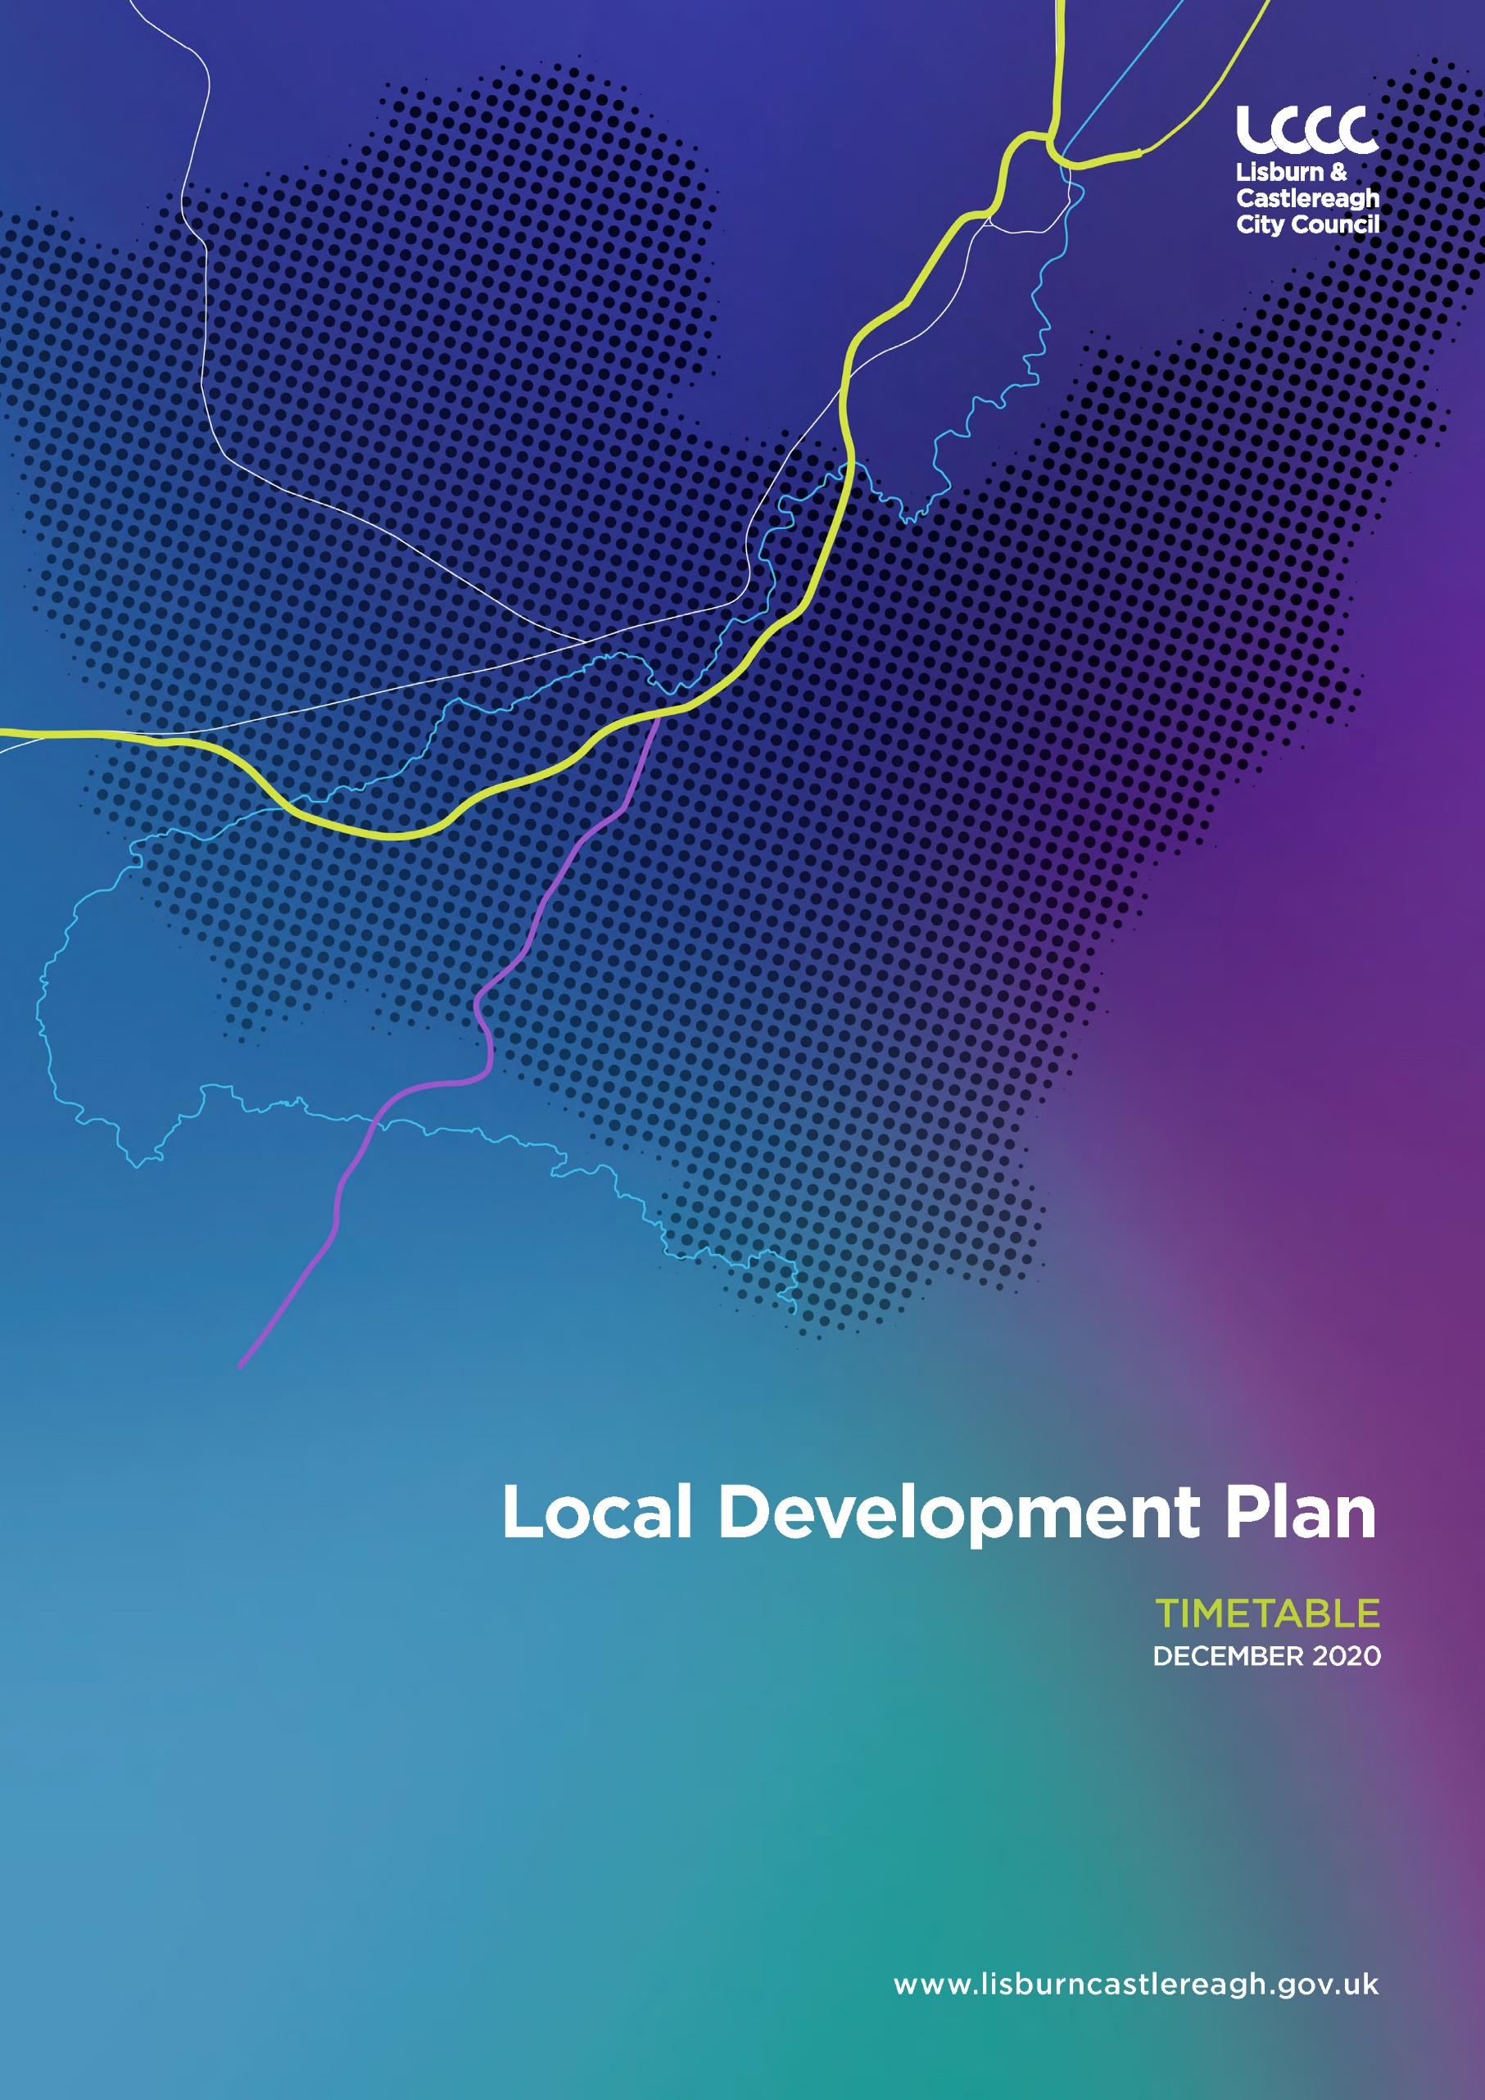

Getting in Touch

Should you have a planning query, you can contact the Council’s Planning Unit in the following ways:

By email to: planning@lisburncastlereagh.gov.uk

By post to:
Planning Unit,
Lisburn & Castlereagh City Council,
Civic Headquarters,
Lagan Valley Island,
Lisburn,
BT27 4RL.

By telephone on: 028 9250 9250

To ensure all consultation documents are accessible to everyone, Lisburn &
Castlereagh City Council, on request, will take all reasonable steps to provide documents in alternative formats and in minority languages to meet the needs of those who are not fluent in English.

- Introduction
1.1 The purpose of this Timetable is to set out the key stages and the indicative timeframe for the production of Lisburn & Castlereagh City Council’s new Local Development Plan 2032 (LDP).

1.2 The Timetable meets the legislative requirements of the Planning Act (Northern Ireland) 2011 and the Planning (Local Development Plan) Regulations (Northern Ireland) 2015. In addition it has been approved by resolution of the Council and agreed with Central Government in accordance with Regulation 7 of the Planning (Local Development Plan) Regulations (Northern Ireland) 2015.

- Purpose of the Local Development Plan

2.1 The purpose of the Lisburn & Castlereagh City Council LDP is to inform the public, statutory authorities, developers and other interested parties of the policy framework and land use proposals that will implement the strategic objectives of the Regional Development Strategy and guide development decisions within the Council area up to 2032.

2.2 The LDP will be prepared within the context of the Council’s Corporate Plan and will take account of the Council’s Community Plan to enable us to plan positively for the future of our Council area. It will ensure that lands are appropriately zoned and that our infrastructure is enhanced to develop the Council area for future generations.

2.3 The LDP must also take account of the regional policy context set by the Northern Ireland Executive and Central Government Departments. This includes, amongst others, the Sustainable Development Strategy, the Regional Development Strategy, the Strategic Planning Policy Statement and Planning Policy Statements.

3.0 Status of the Local Development Plan

3.1 The new Local Development Plan for the Council will replace the range of current extant Development Plans for the Lisburn & Castlereagh City Council area.

3.2 Following publication of the Preferred Options Paper, the Plan is produced in two parts consisting firstly of a Plan Strategy followed by a Local Policies Plan. The Plan Strategy will set the aims, objectives, growth strategy and strategic policies applicable to the Plan Area. The Local Policies Plan will provide site specific policies and proposals, including settlement limits, land use zonings and environmental designations.
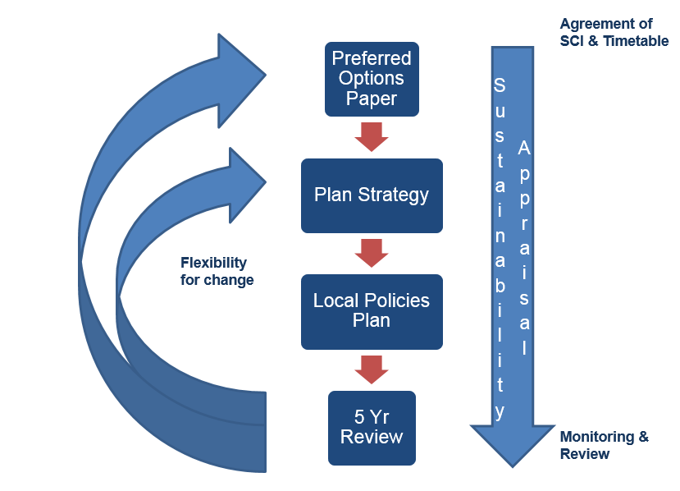
3.3 The Council will undertake an ongoing process of Sustainability Appraisal which will run parallel to the preparation of the Preferred Options Paper, Plan Strategy and Local Policies Plan. An integral part of the Sustainability Appraisal is the Strategic Environmental Assessment (SEA) which will examine the environmental effects of the LDP proposals. The Sustainability Appraisal process aims to ensure that the policies and proposals in the LDP are socially, economically and environmentally sustainable. Relevant reports will be published at each of the key stages of the plan making process which will all be made available online.

4.0 The Timetable

4.1 The Timetable provides indicative dates for a number of key stages in the production of the Lisburn & Castlereagh City Council Local Development Plan. These stages are set out in calendar year quarters and a brief summary is provided below. The full Timetable is set out on Pages 8-9.

STAGE 1
- Statement of Community Involvement – This sets out how the Council intends to engage with the local community during the preparation of our new LDP.
- Preferred Options Paper - The Preferred Options Paper (POP), published in March 2017 is a public consultation document which sets out the key plan issues for the Council area and the preferred options available to address them. A Public Consultation Report (published September 2017) containing an overview of the key issues raised during the public consultation period is available to view on the Council’s website at www.lisburncastlereagh.gov.uk

STAGE 2
- Draft Plan Strategy - The draft Plan Strategy is a public consultation document which will give an indication of the Council’s intentions in relation to the future development of the Council area.
- Independent Examination - An Independent Examination will be held to determine the soundness of the draft Planning Strategy, taking into account any representations or counter representations. Following the Independent Examination, an Advisory Report of its findings will be issued to Central Government.
- Binding Report – following consideration of the Advisory Report, Central Government will issue a Binding Report to the Council. The Council must incorporate any changes outlined in the Binding Report into the Plan Strategy.
- Adoption of Plan Strategy- Following the Independent Examination, and direction from the Central Government, the Plan Strategy will be formally adopted by the Council.

STAGE 3
- Local Policies Plan - The Local Polices Plan is the final document comprising the LDP. The draft Local Polices Plan is a public consultation document and will contain the Council’s detailed land use proposals in relation to the future development of the Council area.
- Independent Examination - An Independent Examination will be held to determine the soundness of the draft Local Policies Plan, taking into account any representations or counter representations. Following the Independent Examination, an Advisory Report of its findings will be issued to Central Government.
- Binding Report - following consideration of the Advisory Report, Central Government will issue a Binding Report to the Council. The Council must incorporate any changes outlined in the Binding Report into the Local Polices Plan.
- Adoption of Local Policies Plan - Following the Independent Examination and direction from Central Government, the Local Polices Plan will formally adopted by the Council.

STAGE 4
- Monitoring & Review of LDP - The LDP will be reviewed every 5 years.

4.2 In addition to undertaking a Sustainability Appraisal (incorporating Strategic Environmental Assessment (SEA)), the Council is also required to carry out a number of assessments to accompany preparation of the LDP including:
- Habitats Regulations Assessment (HRA) for the LDP to consider the potential impact of LDP policies and proposals on European nature conservation sites.
- Equality Impact Assessment for the LDP to consider if the LDP is likely to have an impact on different sections of the community and any mitigating measures required as a result.

5.0 Delivery of the Local Development Plan

5.1 Meeting the attached timetable is dependent upon Member involvement, adequate resourcing and careful risk management.

5.2 A Steering Group and Project Management Team/Stakeholder Group has been established, to oversee the development of the LDP, the former comprising of the relevant Council Committees, and the latter being Senior Council Officers and representatives from the key Statutory/non-statutory consultees.

5.3 The Council and Central Government will be informed as necessary on progress in meeting the Timetable.

5.4 Progress reports on the LDP will be submitted regularly to the relevant Council Committees.

6.0 Review

6.1 In the event that the Plan Timetable requires amendment, the Council has the power under the Planning Act 2011 to publish a revised Timetable. Any amendments will be publicised and made available on the Council’s website at www.lisburncastlereagh.gov.uk following the agreement of Central Government.

Lisburn & Castlereagh City Council Local Development Plan Timetable
Key Stages | Key Actions | Timescale
1  Plan Preparation | Informal Community Engagement carried out for 8 week period (last quarter 2015)  - Consult PAC and other consultation bodies;  - Seek agreement with DfI following Council approval of timetable (4 weeks)  - Commission specific studies required;  - Identification of key issues with relevant statutory consultees and key stakeholders;  - Consult with Consultation Bodies on scope of Sustainability Appraisal (SA);  - Initial EQIA and HRA Screening;  - Consult with Council in advance of publication  - Publish SA Scoping and Interim Reports;  - Minimum 8 week statutory consultation period  - Input representations on LDP database  Q1 2017  Publish Preferred Options Paper with Sustainability Appraisal Interim Report  Q2 2016  Q3 2016  Q4 2016  Agree and publish Timetable for LDP  Agree/Publish Statement of Community Involvement  Utilise Evidence Base in consultation with statutory consultees and key stakeholders
2  Plan Strategy | Prepare Public Consultation Report for Council  Publish Draft Plan Strategy & Associated documents for informal viewing – 4 weeks*  - 8 week statutory consultation period for representations;  - 8 week statutory period for counter representations;  - Consideration of representations (statement including summary of main issues)  - Consideration of any focussed or minor changes  Q3 2017  Publish Draft Plan Strategy with Sustainability Appraisal Report (incorporating SEA)  Consider responses to POP  Q3 2019 –Q4 2020  *Includes SA Report, draft Habitats Regulations Assessment, EQIA and Rural Proofing;  - Submit documents to Department for IE;  - Advisory Report from PAC sent to DfI; - DfI issues Binding Report to Council;  - Council considers Binding Report  - Changes made to finalise Plan Strategy;  - Publish Sustainability Appraisal Adoption Statement (incorporating SEA);  - Publish Habitats Regulations Assessment, EQIA and Rural Proofing  Soundness Based Independent Examination  Q1 2021 -  Q1 2022  ADOPTION OF PLAN STRATEGY  Q2 2022 – Q4 2022
3  Local Policies Plan | - Council considers Binding Report  - Changes made to finalise Local Policies Plan  - Publish Sustainability Appraisal Adoption Statement (incorporating SEA);  - Publish Habitats Regulations Assessment, EQIA and Rural Proofing  - Submit documents to Department for IE;  - Advisory Report from PAC sent to DfI; - DfI issues Binding Report to Council;  *Includes SA Report, draft Habitats Regulations Assessment, EQIA and Rural Proofing;  Publish Local Policies Plan & Associated documents for informal viewing – 4 weeks*  - 8 week statutory consultation period for representations;  - 8 week statutory period for counter representations;  - Consideration of representations  (statement including summary of main issues)  Soundness Based Independent Examination  Q4 2024  Q4 2025  ADOPTION OF LOCAL POLICIES PLAN  Q4 2023  Publish Draft Local Policies Plan with Sustainability Appraisal Report (incorporating SEA)
4MonitoMonitor and Review | - Annual Monitoring including Housing Monitor Reports;  - 5 and 10 year review leading to commencement on a replacement LDP;  - Monitoring of SA and other Assessments  Monitoring and Review of Local Development Plan  On-going

Department for Infrastructure
See Development Plan Practice Note 06 Soundness, DfI

