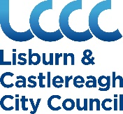
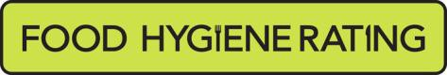

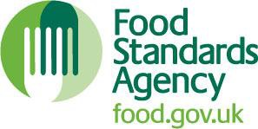
Food Hygiene Rating Scheme: Appeal form

Notes for businesses:
- As the food business operator of the establishment you have a right, under Section 3 of the Food Hygiene Rating Act (Northern Ireland) 2016, to appeal the food hygiene rating given following your inspection if you do not agree that the rating reflects the hygiene standards found at the establishment at the time of the inspection.
- You have 21 days (including weekends and bank holidays) from the date of receipt of the notification letter to lodge an appeal.
- Please use the form below and return it to your district council – contact details are provided with the written notification of your food hygiene rating.
- Your appeal will be determined by an authorised officer and the outcome of your appeal communicated to you within 21 days from the date the appeal was received.

Business details
Food business operator/proprietor

Business name

Business addresses

Business tel. number Business email

Inspection details

Date of inspection Food hygiene rating given

Date notified of rating

Appeal
I do not agree with the food hygiene rating given by the food safety officer because (please explain below under each of the three headings).

Compliance with food hygiene and safety procedures

Compliance with structural requirements

Confidence in management/control procedures

Signature

Name in capitals

Position Date

Please now return this form to: Food Control Section, Lisburn & Castlereagh City Council, Lagan Valley Island, Lisburn, Co. Antrim, BT27 4RL

