Development Plan
Position Paper 9: Countryside Assessment
November 2019

Contents Page

Executive Summary 3

1.0 Introduction 4

2.0 Regional Policy Context 4

3.0 Countryside Assessment: 10
1. Environmental Assets Appraisal
2. Landscape Assessment
3. Development Pressure Analysis
4. Settlement Appraisal

4.0 Existing Development Plan 19

5.0 Key Findings and Conclusion 22

Maps: 1 Rural/Urban Area 24 2 Rural Housing Applications
3 Woodland
4 Lough Neagh, Portmore Lough and Stoneyford Reservoir

Executive Summary

This Position Paper provides an overview in relation to the Countryside Assessment in the Lisburn & Castlereagh City Council area to assist in the preparation of the Local Development Plan 2032.

The Local Development Plan is made within the context of a Sustainability Appraisal under the provision of Planning (Northern Ireland) Act 2011. This paper is therefore intended to provide a baseline position on which policy and proposals for the Countryside Assessment in the Local Development Plan can be shaped over the plan period.

It is important to stress that in compiling the Position Paper the best information available has been used however further revisions may be required in light of the release of any new data or updated policy, advice or information.

This paper provides an update on the previous Position Paper which was produced in December 2017 as part of the preparation of the Preferred Options Paper and has been informed by consultations with the relevant statutory consultees including the Department for Infrastructure (DfI) who have a responsibility for promoting a more sustainable approach to dealing with development in the Northern Ireland countryside through its strategic planning policies.

The aims of the paper are:
- To provide baseline information which will inform the Local Development Plan;
- To assess the current status of the countryside within the Council area; and
- To provide the spatial representation of the Council’s Community Plan and have regard to other plans and strategies being undertaken by the Council.

- INTRODUCTION

1.1 This position paper examines the Countryside Assessment for Lisburn & Castlereagh City Council area. This involves an assessment of existing rural assets.

1.2 Chapter 2 sets out the regional policy context for the Countryside Assessment, which is formulated within the context of the Regional Development Strategy (RDS) 2035, regional Planning Policy Statements (PPS) and the Strategic Planning Policy Statement for Northern Ireland (SPPS).

1.3 Chapter 3 outlines the current policy approach in the existing Plan context and an overview of the 4 component parts of the Countryside Assessment for the area.

1.4 Chapter 4 provides an overview of the existing rural assets, using information derived from the Department for Communities (DfC), Northern Ireland Environment Agency (NIEA), the Department for Infrastructure (DfI) and Council sources where specified.

2.0 REGIONAL POLICY CONTEXT

2.1 The regional policy context is provided by the Regional Development Strategy (RDS) 2035, Strategic Planning Policy Statement for Northern Ireland (SPPS) and regional Planning Policy Statements (PPSs) where relevant. A summary of these documents in relation to plan making and countryside assessment is provided in the following paragraphs.

Regional Development Strategy 2035
2.2 The RDS provides an overarching strategic framework to facilitate and guide development in the public and private sectors in support of the Programme for Government (PfG). The RDS has a statutory basis prepared under the Strategic Planning (Northern Ireland) Order 1999. Local development plans must ‘take account’ of the RDS.

2.3 Sustainable development is at the heart of the Regional Development Strategy. The RDS aims to meet the needs of the present without compromising the ability of future generations to meet their own needs.

2.4 The RDS recognises the importance of the rural area and its geographical links within the settlement structure. The RDS refers to the rural area as being areas outside the Belfast Metropolitan Area; Londonderry in the north-west; those settlements, referred to as hubs, and their relationship to one another as a cluster of hubs; and the corridors and gateways that link these clusters.

2.5 The RDS notes that given the relatively small geographic scale of the region and our dispersed settlement structure that arguably few areas could be regarded as truly ‘remote’. The majority of people live within 15 miles of a Hub and within 8 miles of a cluster where they can access most of the services they need. Smaller towns, villages and hamlets perform an important function for rural communities.

2.6 The RDS reinforces a commitment to keep our rural areas sustainable and ensure that people who live there, either through choice or birth, have access to services and are offered opportunities in terms of education, jobs, healthcare and leisure. To sustain rural communities, new development and employment opportunities which respect local, social and environmental circumstances are required. This means facilitating the development of rural industries, businesses and enterprises in appropriate locations, and ensuring they are integrated appropriately within the settlement or rural landscape. The expansion of rural tourism and associated development that is both sustainable and environmentally sensitive should be encouraged.

2.7 The RDS contains the following Spatial Framework Guidance which supports the environmental assets and rural areas of the Council, these are as follows:

SFG5: Protect and enhance the quality of the setting of the Belfast Metropolitan Urban Area (BMUA) and its environmental assets

2.8 The significance of the existing environmental assets is recognised along with protected areas of high scenic value.
- Protect areas of high scenic value, undeveloped coast line, Belfast Lough, the Lagan Valley Regional Park and the hills around the BMA from development;
- Protect and enhance the network of open spaces in the BMUA
- Make use of green space to help manage access to important wildlife sites and minimise the potential for damage due to visitor pressure.

SFG13: Sustain rural communities living in smaller settlements in the open countryside

  - The aim is to sustain the overall strength of the rural community living in small towns, villages, small rural settlements and the open countryside. This approach should be sensitive to local needs and environmental issues including the ability of settlements and landscapes to absorb development. Key considerations will be the role and function of rural settlements and accessibility to services.

  - A strong network of smaller towns supported by villages helps to sustain and service the rural community. A sustainable approach to further development will be important to ensure that growth does not exceed the capacity of the environment or the essential infrastructure expected for modern living.

SFG14: Improve Accessibility for rural communities

  - Rural communities can be disadvantaged by virtue of their remote location from a range of facilities and essential services. This disadvantage can be lessened by innovative use of existing services and the application of new and developing technologies.

Strategic Planning Policy Statement (SPPS)
2.12 The Strategic Planning Policy Statement (SPPS) was published by the former Department of the Environment (DoE) in September 2015. The provisions of the SPPS must be taken into account in the preparation of Local Development Plans, and are also material to all decisions on individual planning applications and appeals.

2.13 It recognises the countryside as one of our greatest assets, with its highly valued landscapes, an outstanding coastline, a complex variety of wildlife, rich built and cultural heritage, and for the ecosystem services it provides. In addition to its role and function as a recreational and tourist asset the countryside also supports our important agricultural industry, offers potential opportunities for sustainable growth in new sectors, and is home to a considerable rural population.

2.14 The SPPS policy objectives for development in the countryside are to:
- manage growth to achieve appropriate and sustainable patterns of development which supports a vibrant rural community;
- conserve the landscape and natural resources of the rural area and to protect it from excessive, inappropriate or obtrusive development and from the actual or potential effects of pollution;
- facilitate development which contributes to a sustainable rural economy; and
- promote high standards in the design, siting and landscaping of development.

2.15 Planning and other environmental policies must therefore play their part in facilitating sustainable development in the countryside but not at the expense of the region’s rich natural assets and not at the expense of the natural and built environment.

Role of the Local Development Plan
2.16 The SPPS states that in plan making, the Council should bring forward a strategy for sustainable development in the countryside, together with appropriate policies and proposals that must reflect the aims, objectives and policy approach of the SPPS, tailored to the specific circumstances of the plan area.

2.17 The policy approach must be to cluster, consolidate, and group new development with existing established buildings, and promote the re-use of previously used buildings. This sustainable approach facilitates essential new development, which can benefit from the utilisation of existing services such as access and drainage, whilst simultaneously mitigating the potential adverse impacts upon rural amenity and scenic landscapes arising from the cumulative effect of one-off, sporadic development upon rural amenity and landscape character.

2.18 All development in the countryside must integrate into its setting, respect rural character, and be appropriately designed. Development must not mar the distinction between a settlement and the surrounding countryside, or result in urban sprawl. The policy approach for development in the countryside will also reflect and complement the overall approach to housing growth across a plan area.

2.19 Whilst the SPPS does not detail in full the requirements of a Countryside Assessment, PPS21 states that the Local Development Plan process will play an important role in the Council’s identification of key features and assets of the countryside, balancing the needs of rural areas and communities, with protection of the environment. This includes an environmental assets appraisal and landscape assessment, known as Countryside Assessments, as the evidence base for bringing forward an appropriate policy approach to development in the countryside.

2.20 Countryside Assessments normally include the following four interrelated strands:
• an Environmental Assets Appraisal;
• a Landscape Assessment;
• a Development Pressure Analysis; and
• a Settlement Appraisal
The Council has now concluded the work on these four strands as part of developing the evidence base for the draft Plan Strategy.

2.21 Arising from this process policies may be brought forward at Local Plan Policy stage to complement or amplify regional policies on matters specific to local circumstances, for example Areas of High Scenic Value or Special Countryside Areas. This will involve consultation with local communities and the public at the appropriate time in the Local Development Plan process.

Planning Policy Statement 21, Sustainable Development in the Countryside
2.22 Planning Policy Statement 21, Sustainable Development in the Countryside sets out the former Department of the Environment’s policies for development in the countryside. For the purpose of PPS21 the countryside is defined as ‘land lying outside of settlement limits as identified in development plans’.

2.23 The objectives of PPS 21 are:
• to manage growth in the countryside to achieve appropriate and sustainable patterns of development that meet the essential needs of a vibrant rural community;
- to conserve the landscape and natural resources of the rural area and to protect it from excessive, inappropriate or obtrusive development and from the actual or potential effects of pollution;
- to facilitate development necessary to achieve a sustainable rural economy; including appropriate farm diversification and other economic activity; and
- to promote high standards in the design, siting and landscaping of development in the countryside.

Transitional Period

2.24 A transitional period will operate until such times as a Plan Strategy for the Lisburn & Castlereagh City Council area has been adopted. During the transitional period planning authorities will apply existing policy contained within Planning Policy Statement 21 Sustainable Development in the Countryside together with the SPPS. Any conflict between the SPPS and any policy retained under the transitional arrangements must be resolved in the favour of the provisions of the SPPS.

3.0 COUNTRYSIDE ASSESSMENT

Environmental Assets Appraisal
3.1 In accordance with regional planning policy the Environmental Assets Appraisal seeks to establish and evaluate the environmental resources of the council area. It also assists in defining specific development plan designations.

3.2 The Environmental Assets Appraisal is structured in the following way:
- The Natural Heritage Section provides an overall evaluation of nature conservation resources and biodiversity which is referred to below; (see Position Paper 8 Natural Heritage for designations)
- The Built Heritage Section provides an overall evaluation of historic, architectural and archaeological resources; (see Position Paper 7 Built Heritage) and
- The Landscape Section contains an evaluation of landscape resources.

Natural Heritage
3.3 The Northern Ireland Biodiversity Strategy identifies a range of habitats across Northern Ireland. Those represented in the Council area include:
- wetlands including rivers, streams, lakes, swamp, fen and carr woodland.
- peatlands including heathland and bogs.
- woodlands including plantations and semi natural woodlands and hedges and other boundary features;
- grasslands including arable or cultivated land.

Wetlands
3.4 The council area contains several important wetland areas. Valuable wetland habitats such as grassland, fen, marsh and carr can be found at Stoneyford Reservoir, Monlough and areas around the River Lagan, Lough Neagh and Portmore Lough.

3.5 Rivers and Lakes – The River Lagan is the largest river in the council area. Many stretches of the River Lagan contain important habitats for wildlife including otter, nesting birds, coarse fish and Spuce’s bristle moss. Begney Lake, near Dromara is a Mesotrophic Lake in which otter and curlew have been recorded. Eutrophic Standing Waters include Portmore Lough which has extensive marginal fen and reed vegetation and supports curlew and Lough Aghery which has willow alder scrub with fen and supports marsh fritillary butterfly and Irish damselfly.

3.6 Coastal and Marine – The council area contains a section of Lough Neagh within its boundary to the north of Feumore. Stretches of these areas are internationally and nationally important for birdlife including roseate tern, golden plover, curlew and seabirds such as cormorants and shags.

Peatlands
3.7 Areas of shrub heath (upland heathland) are found around the summits and slopes of Slievenacloy.

Woodlands
3.8 Many of the woodland and treed areas in the council area have their origin in former demesnes and estates. Within these woodlands a mixture of mature broadleaves dominate, particularly beech, oak, lime, and sycamore, with ash, birch, elm, yew, maples and horse chestnut. Occasionally the woodlands contain Scots Pine, larch, a variety of exotic trees and shrubs or small conifer plantations. Examples would include those at Lissue Children’s Home and Belvedere.

3.9 Other woodland types found within the Plan Area include Upland Mixed Ashwoods, Wet Woodland and Upland Oakwoods. Upland Mixed Ashwoods are dominated by ash with hazel, alder, beech, birch, rowan or wild cherry for example at Craigantlet. Wet Woodlands dominated by willow and alder can be found at Stonyford Reservoir, the Glenavy River, the River Lagan, Portmore Lough and the Ravernet River.

3.10 Other notable wooded areas within the council area include areas along various rivers and glens including Derriaghy Glen and Drumbo Glen. Elsewhere patches of woodland are found around old quarries, as planting within parklands or around farmsteads.

Grasslands
3.11 Within the Council area there are several notable grassland areas. For example at Leathemstown, Slievenacloy, Ballynanaghten and Portmore Lough. Areas of rough grassland are found at Moss-side, Stoneyford Reservoir, Standing Stone Hill, Glenavy, Maghaberry and Aghnatrisk.

Landscape
3.12 The Department of the Environment, Agriculture and Rural Affairs (DAERA) has undertaken work to categorise Northern Ireland’s landscape character, it has two documents on landscape character. The first of these documents is the Northern Ireland Regional Landscape Character Assessment (NIRLCA) which was published with the purpose of providing a regional overview of landscape character. Northern Ireland is defined by 26 discrete regional landscape character areas (RLCA), 5 of these RLCAs, or portions of them, are contained within the Council Area (see Table 1). The second document is the Northern Ireland Character Assessment 2000 (NILCA). This documents 23 landscape character areas within the Council area.
Regional Landscape Character Areas within LCCC
Belfast and Lagan Valley
Down Drumlins and Holywood Hills
Lough Neagh Basin
South Antrim Hills and Six Mile Water
Mourne and Slieve Croob

Table 1: Regional Landscape Character Areas within LCCC

3.13 As part of the Local Development Plan process the Council has undertaken a review of the NILCA which, due to the passage of time, is an updated assessment and revision of the landscape character as surveyed in 1999. Due to the reform of local government the Council boundaries have been reorganised and as such the Landscape Character Assessment reflects the up to date character areas within the new boundaries of the Council.

3.14 Lisburn & Castlereagh City Council contains a diverse range of landscapes ranging from the Lagan Valley to a section of the Lough Neagh shoreline. The Landscape Character Review undertaken identifies, and in some cases amalgamates and renames existing character areas in to 15 LCAs. These are shown in Table 2 below.

Landscape Character Areas LCCC
East Lough Neagh
Portmore
Kilwarlin
Dromara
Hillsborough
Ravernet
Castlereagh
Craigantlet
Castlereagh
Lower Lagan
Upper Lagan
Upper Ballinderry
Derrykillultagh
Divis
West Belfast

Table 2: Local Landscape Character Areas within LCCC

3.15 Position Paper 8: Natural Heritage deals with the other aspects relating to Landscape Assessment including Areas of High Scenic Value; Rural Landscape Wedges; Local Landscape Policy Areas (LLPAs); and The Lagan Valley Regional Park.

Development Pressure Analysis

3.16 Whilst the SPPS is silent on the issue of a development pressure analysis it is referred within PPS 21 (Section 4.0 The Role of Development Plans - Countryside Assessments). The development pressure analysis seeks to identify areas where significant pressure has occurred and/or where local rural character is under threat of significant change.

3.17 PPS 21 has provided the policy context for all development in the countryside since its introduction in 2010, and it will continue to do so until such times as the Council’s operational policies contained in the LDP have been adopted. The analysis is based on the Department’s electronic records of planning applications submitted for countryside areas of Lisburn & Castlereagh City Council that are located beyond any of the settlement development limits.

3.18 Map no. 1 Rural/Urban Split shows the distribution of housing stock in the rural area of the Lisburn & Castlereagh City Council area indicating a relatively high density of rural housing stock throughout the Council area. Map no. 2 is a representation of the following rural housing applications.

Rural Dwellings (All Categories)
3.19 From the period 1st April 2011 to 31st May 2014 there was an estimated 679 planning applications submitted relating to single dwellings in the countryside across the Lisburn & Castlereagh City Council area. 650 decisions were issued (approval or refusal) with the remaining 29 applications being withdrawn prior to the issuing of a decision. The annual approval rate for April 2011 to May 2014 ranged between 81% -86%. Map no. 2 indicates the level of planning applications and the subsequent approvals versus refusals within the Council area.

3.20 All rural residential planning applications between April 2015, when the Council assumed the role of planning authority, and April 2019 (excluding alterations and extensions) have been identified via the Planning Portal (ePIC).The following is an analysis of applications since 2015.

Rural Dwellings (All Categories)
3.21 Within the analysis period 2015 – 2019, 851 planning applications for rural dwellings have been submitted to Lisburn & Castlereagh City Council. The number of annual approvals have been; 147 (74%) in 2015/2016; 212 (83%) in 2016/2017; 170 (76%) in 2017/2018; and 132 (76%) 2018/2019. Cumulatively this equates to 661 (78%) of planning applications being approved, 120 (14%) refused and 70 (8%) withdrawn, before a decision by the Planning Department.

Rural Dwellings (New Dwellings)
3.22 During the period 2015 to 2019, approximately 46% of all planning approvals in the rural area of Lisburn & Castlereagh City Council related to new dwellings.

Rural dwellings (Replacements)
3.23 It is important to note that in the same period, 54% of all planning approvals in the rural area of Lisburn & Castlereagh City Council related to the replacement of existing housing stock.

General Patterns of Development Pressure
3.24 These figures establish a baseline of decisions taken by Lisburn & Castlereagh City Council for rural housing development over the 5 years since it assumed the role of planning authority. Approval of rural dwellings has been in accordance with the planning policies of PPS21. Going forward with this policy, and the Council’s own operational policies once the LDP is adopted, these baseline figures will be kept under review. A review, as part of the annual housing monitor, will ensure that any emerging trends in rural planning applications, beyond the baseline, are identified, to ensuring minimal impacts on the landscape character of our rural areas. The Landscape Character Assessment is a further tool that identifies where development of rural dwellings may place pressure on our rural environment and it will be considered where negative trends may emerge following adoption of the LDP.

Settlement Appraisal
3.25 Appraisals of the towns, villages and small settlements within the BMA have provided the basis for identifying Settlement Development Limits and other Plan Proposals including policies, zonings and designations. Each appraisal is structured into, where applicable, a short description of character, availability of facilities, assets and constraints on future development and a justification of identified Settlement Development Limits, that takes into account relevant factors.

3.26 The information contained in the Countryside Assessment will assist in the definition of land use zonings, the designation of development limits, and will form the basis for the definition of the following protective designations:
• Sites of Local Nature Conservation Importance (SLNCIs)
• Areas of Townscape Character (ATCs)
• Areas of Significant Archaeological Interest
• Areas of Archaeological Potential
• Local Landscape Policy Areas (LLPAs)

3.27 Arising from the process of Countryside Assessment local policies may be brought forward in the development plan to complement or amplify regional policies on matters specific to the local circumstances of particular countryside areas e.g. Areas of High Scenic Value. This will involve consultation with local communities and the public.

3.28 In addition there are some areas of the countryside with exceptional landscapes, such as stretches of the coast or lough shores, and certain views or vistas, wherein the quality of the landscape and unique amenity value is such that development should only be permitted in exceptional circumstances. Based upon the Countryside Assessment, these areas will be identified and designated as Special Countryside Areas in development plans and local policies brought forward to protect their unique qualities.

3.29 The countryside is a unique resource. It contains landscapes of considerable quality and amenity, important indications of our cultural heritage and is also significant in terms of nature conservation and biodiversity by providing habitats for wildlife, flora and fauna. It is a recreational resource and a considerable tourist asset. The countryside is also home to our agricultural industry and to a considerable and growing rural community.

3.30 However, while the countryside has traditionally contained a substantial number of individual houses and other buildings, significant concern has been expressed by many about development trends and the enhanced pressures being exerted on the countryside, particularly in view of the Executive’s commitment to sustainable development.

3.31 Over development in the open countryside would have the potential to bring with it significant environmental, financial and social costs. These can be manifest through for example suburban sprawl, habitat loss and adverse impact upon water quality particularly from the increased use of non-mains sewerage systems. It also has the potential to impact upon the sustainable growth of our towns and villages.

3.32 Agriculture continues to be of major importance to the economy of the rural area. With the restructuring of the industry ongoing in response to the continuing change to agricultural support measures by the European Union, agricultural diversification is likely to increase in importance as a means of maintaining or increasing farm income and employment. The planning system will therefore continue to sympathetically view appropriate farm diversification schemes.

3.33 Opportunities also exist for tourism growth, particularly through the sympathetic conversion or re-use of existing buildings in the countryside. Exceptionally, new build accommodation may also be acceptable.

3.34 Appropriate industrial and commercial enterprises, including minerals development and necessary infrastructure will be facilitated, as well as proposals for new community buildings and uses where these meet local needs.

4.0 EXISTING DEVELOPMENT PLAN

4.1 The Draft Belfast Metropolitan Area Plan 2015 (BMAP) was prepared under the provisions of Part 3 of the Planning (Northern Ireland) Order 1991 by the former Department of the Environment (DOE). The Plan covers the City Council areas of Belfast and Lisburn and the Borough Council areas of Carrickfergus, Castlereagh, Newtownabbey and North Down. The Plan was adopted on 9th September 2014, however the Court of Appeal declared the adopted plan unlawfully adopted on the 18th May 2017.

4.2 As a result, the existing Development Plans covering the Council area are as follows:
- Belfast Urban Area Plan (BUAP) 2001
- Lisburn Area Plan (LAP) 2001
- Carryduff Local Plan 1988-1993
- Ballymacoss Local Plan
- Lisburn Town Centre Plan
- Lagan Valley Regional Park Local Plan 2005

4.3 BMAP in its post-inquiry form was at an advanced stage and therefore remains a material consideration. Draft BMAP (November 2004) in its pre-inquiry form also remains a material consideration in conjunction with recommendations of the Planning Appeals Commission Public Local Inquiry Reports.

4.4 Volume 3 and Volume 5 of draft BMAP 2015 sets out policies on Lisburn and Castlereagh Districts respectively. These policies have been developed in the context of the Plan Strategy and Framework contained in Volume 1 of the Plan and are in general conformity with the RDS.

4.5 Volume 1 of draft BMAP 2015 sets out the strategy for the rural assets of Lisburn & Castlereagh City Council in its BMA Countryside and Coast Strategy. This strategy aims to encourage vibrant rural communities in the towns, villages and small settlements; sustain and diversify the rural economy by making provision for employment/industrial use in towns and villages; conserve and enhance the rural landscape, ensuring the protection of the metropolitan setting; and protect the Coastal Area.

4.6 The Rural Community: the focus is on accommodating more housing in the main towns and villages in order to meet local need, maintaining a strong network of settlements in the rural area, and sustaining the rural community.

4.7 The Rural Economy: it is recognised that a living and working countryside requires a strong, diversified and competitive rural economy. Agriculture remains important to the rural economy and is also a significant factor in shaping and maintaining landscapes. The Plan Proposals provide new opportunities for business development to facilitate the growth and diversification of the rural economy by zoning land for business and industry in a number of towns and villages in the rural area, including Carryduff and Moira.

4.8 Agriculture: is particularly important in the rural areas. In common with the rest of Northern Ireland, farm incomes in the Plan Area are falling in real terms, leading to an increased demand for alternative employment on and off the farm. The need for farmers to diversify into non-agricultural activities in order to supplement their farming income is accepted.

  - Woodland and Forestry: Forest Service (DAERA) carries out forestry operations within the Plan Area. The Forest Service also assists in the planting and management of privately owned woodlands through the payment of grants. The National Trust and other bodies manage and enhance (by providing interpretative material) the biodiversity and amenity value of a number of Parks. See Map No. 3.

  - Fishing: Recreational fishing takes place along inland rivers such as the Glenavy River. The Department of Agriculture, Environment and Rural Affairs (DAERA) has brown and rainbow trout lakes in the council area, including Stoneyford Reservoir. The western boundary of the council area is defined by a section of Lough Neagh. This supports a substantial commercial fishery, mainly for eels. This supports a valuable export market and sustains local employment. See Map No. 4.

  - Minerals: Mineral exploration and development provides employment and necessary materials for construction in localised areas where useful deposits occur. However, extraction and processing can have a significant impact on the countryside. The need for a sustainable approach that takes account of the need to protect and conserve environmental resources is recognised.

  - The Rural Environment: The rural environment throughout Northern Ireland/the council area is undergoing significant change in response to the restructuring of agriculture and increasing urban dispersal pressures. The challenge throughout the rural area is to accommodate future development while protecting and caring for the environment, and maintaining the rural character of the countryside.

4.13 Countryside and Coast Policies and Proposals: Within the BMA, landscapes which are particularly sensitive because of their quality/location/pressures for development are afforded special protection. These have been referred to in Position Paper 8: Natural Heritage.

5.0 KEY FINDINGS AND CONCLUSION

5.1 A summary of the key findings are as follows:-
- To consider ways for managing development and plan for future development within the rural area of Lisburn & Castlereagh City Council taking into account the details of the Countryside Assessment.

- Environmental Assets – there is a wealth of environmental assets both built and natural across the Council area. Opportunities may exist to identify new features considered worthy of protection. Additionally access to these assets could be further considered, opening up opportunities for sympathetic development that contribute towards improving people’s health and well-being.

- Landscape Assessment – the variety of landscape types across the Council area adds to the character and setting of the towns, villages and small settlements. These should be taken into account with any future proposals resulting from the Settlement Appraisal.

- Development Pressure Analysis – this analysis indicates the trend of rural house builds across the Council area. From the period 1st April 2011 to 31st May 2014 there was an estimated 679 planning applications submitted relating to single dwellings in the countryside across Lisburn & Castlereagh City Council with an approval rate of between 81% - 86%.

- Settlement Appraisal – to consider any future need for growth of settlements within the Council area, taking into account the environmental and landscape characteristics, and considering ways to manage those areas which have experienced, or are continuing to experience, development pressure.

CONCLUSION

5.2 Following on from the original Position Paper in December 2015, the purpose of this paper has been to update the baseline information regarding the elements of the countryside assessment within the Lisburn & Castlereagh City Council area. This baseline will support the preparation of the Plan Strategy and Local Policies Plan, and as the process evolves will be updated/amended as necessary taking account of all relevant new information made available.

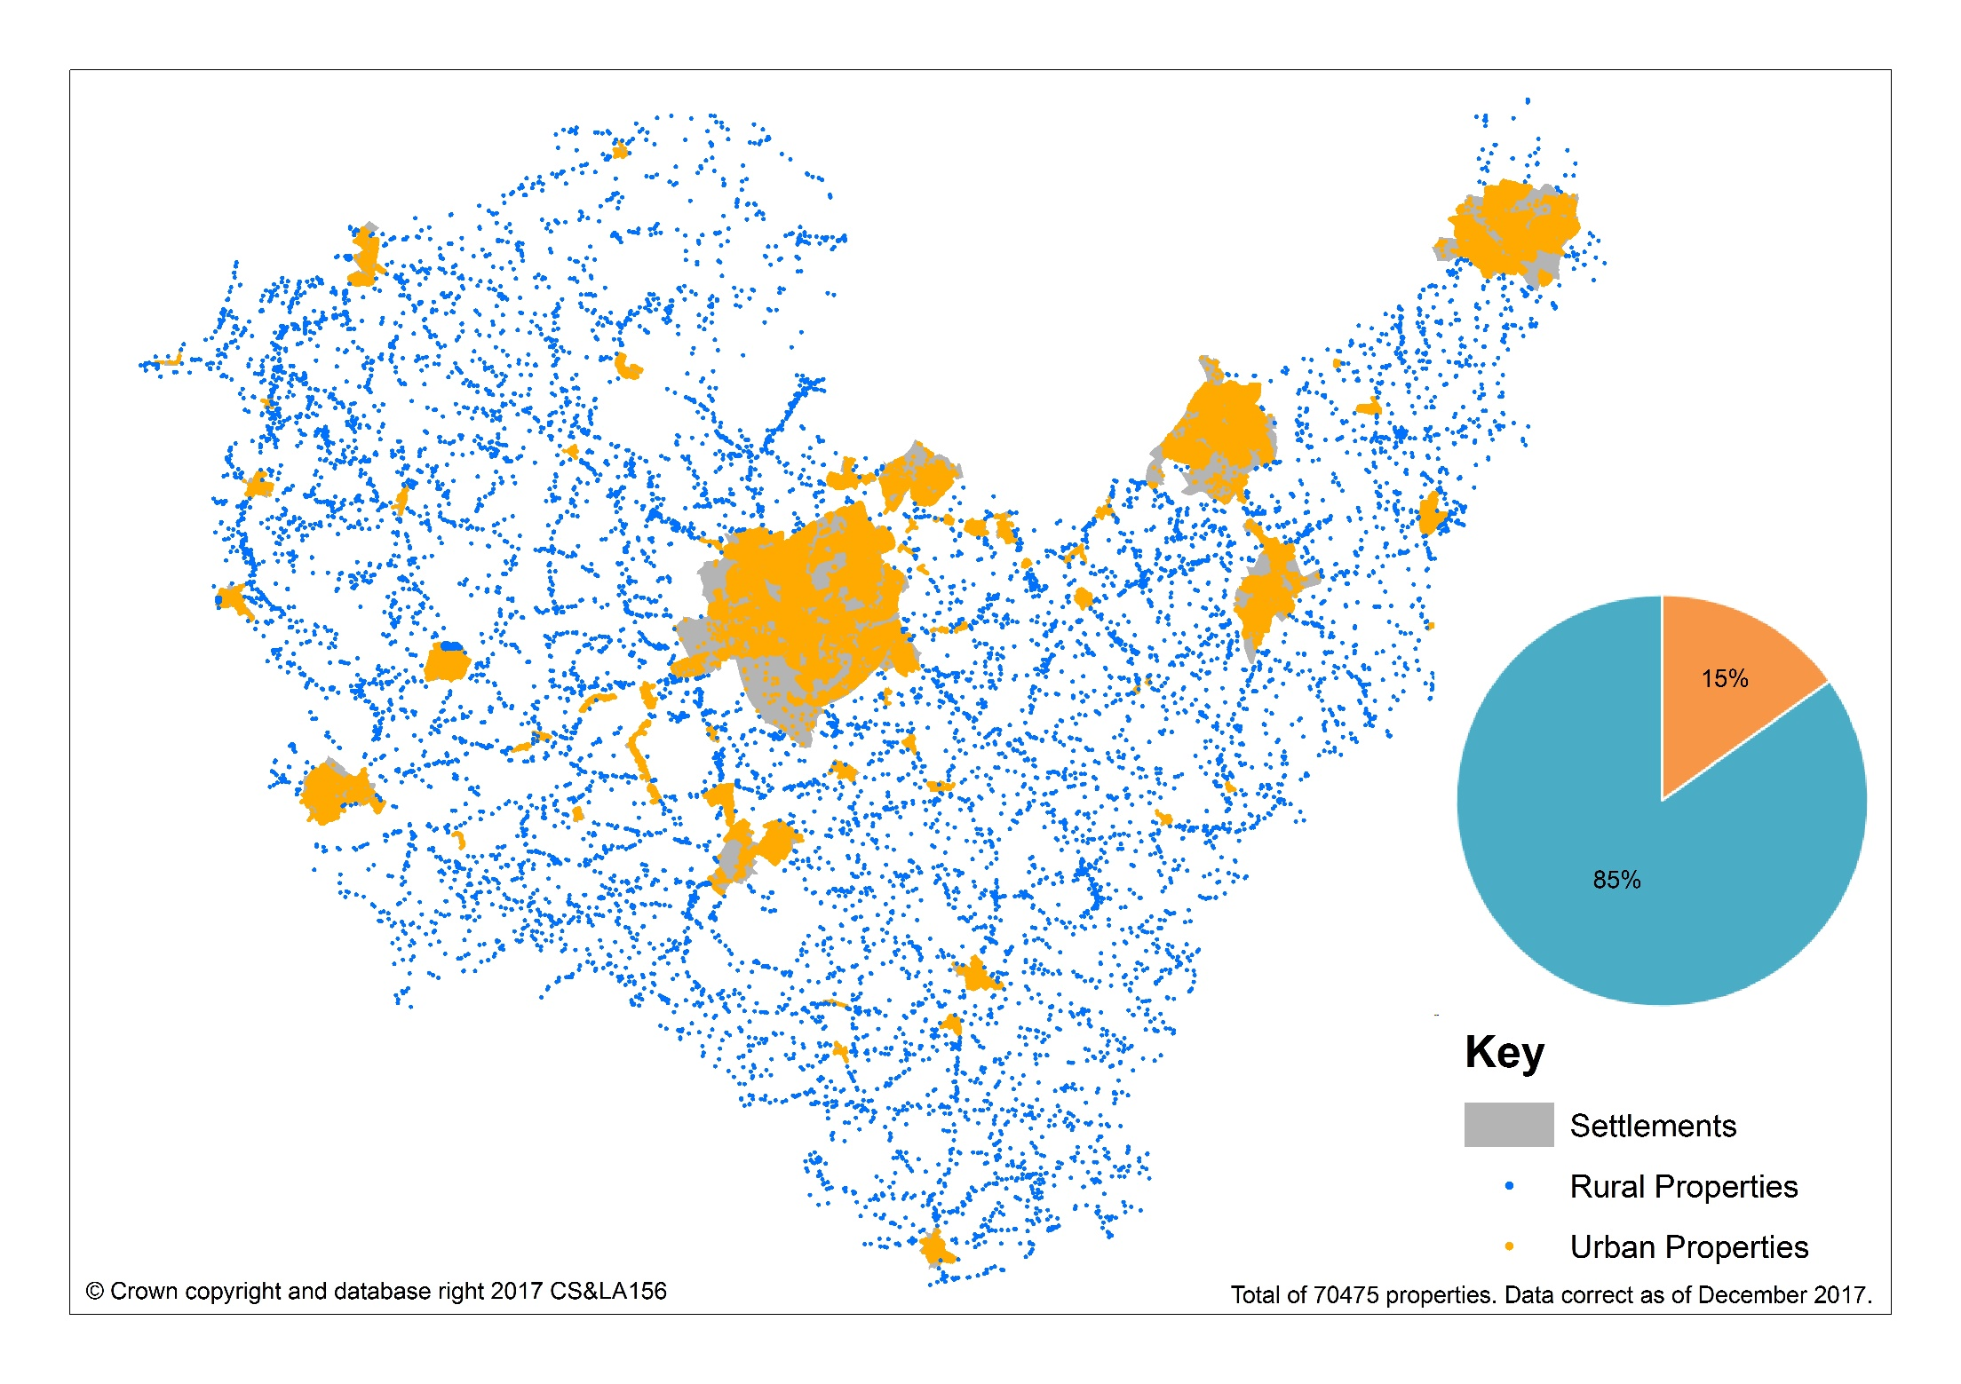
Map 1: Urban/Rural Split

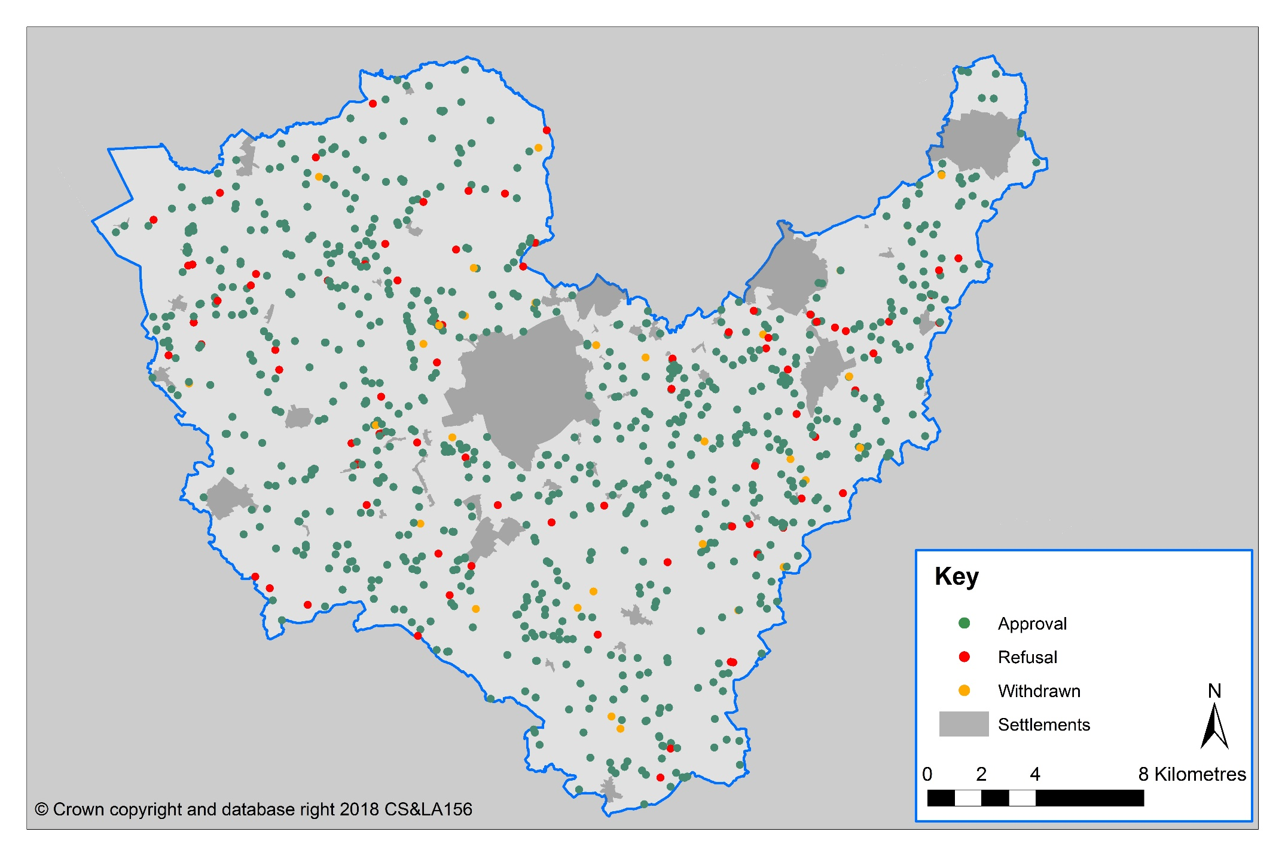
Map 2: Rural Housing Applications

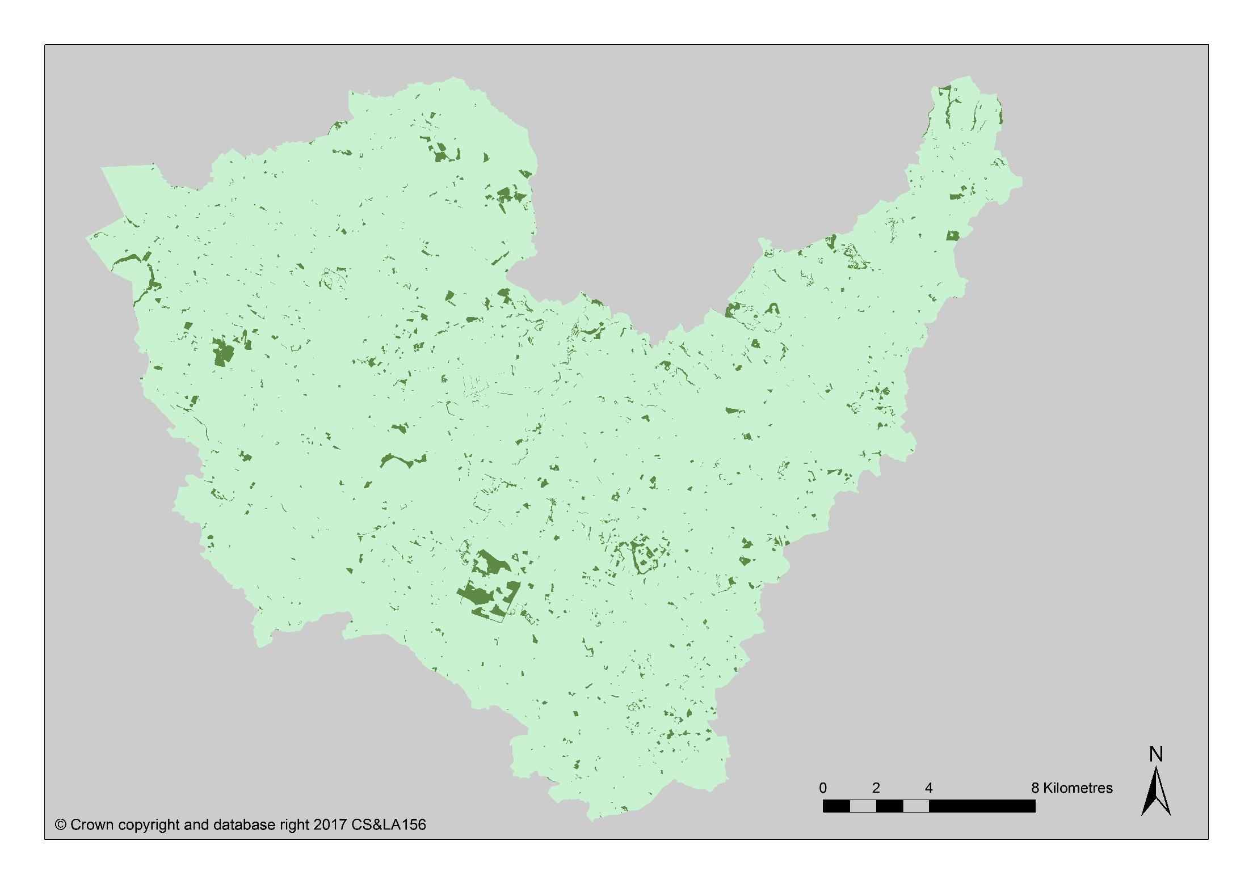
Map 3: Woodland

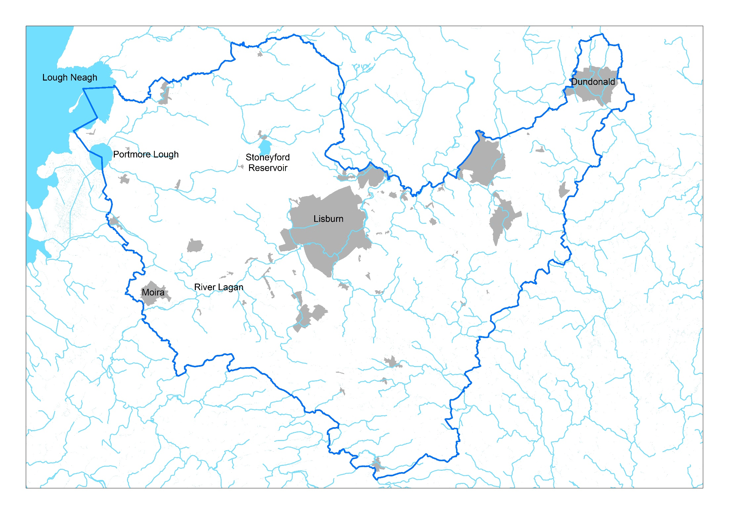
Map 4: Lough Neagh/Portmore Lough, Stoneyford, Lagan and River Basins

DoE (2015) Belfast Metropolitan Area Plan (BMAP) 2015 Draft Plan: Technical Supplement 11. Vol. 1. Countryside Assessment.
DoE (2015) Belfast Metropolitan Area Plan (BMAP) 2015 Draft Plan: Technical Supplement 11. Vol. 1 Countryside Assessment.
See Technical Supplement 6 Countryside Assessment
DoE (2015) Belfast Metropolitan Area Plan (BMAP) 2015 Draft Plan: Technical Supplement 11. Vol.1. Countryside Assessment.

