Development Plan
Position Paper 7: Historic Environment
November 2019

Contents Page

Executive Summary 3

1.0 Introduction 4

2.0 Regional Policy Context 5

3.0 Existing Development Plan 12

4.0 Profile of Built Heritage Assets 14

5.0 Other Key Documents 24

6.0 Key Findings and Conclusion 27

Appendix 1: The Social & Economic Value of
the Historic Environment (NIEA) 28

Appendix 2: The Northern Ireland Monuments
and Buildings Record (NIEA) 30

Appendix 3: Maps (1-4) 31

Executive Summary

This Position Paper provides the Council with an overview of the historic environment in Lisburn & Castlereagh City Council, to assist in the preparation of the Local Development Plan 2032.

The Local Development Plan is made within the context of a Sustainability Appraisal under the provision of Planning (Northern Ireland) Act 2011. This paper is therefore intended to provide a baseline position on which policy and proposals for built heritage in the Local Development Plan can be shaped over the plan period.

It is important to stress that in compiling the Position Paper the best information available has been used however further revisions may be required in light of the release of any new data or updated policy, advice or information.

This paper provides an update on the previous Position Paper which was produced as part of the preparation of the Preferred Options Paper and has been informed by consultations with the Department for Communities, Historic Environment Division (HED), who are the relevant statutory consultee with responsibility for the identification and protection of heritage assets. HED seek to ensure development proposals affecting these assets are carried out in a sustainable manner through appropriate operational planning policies of the Local Development Plan.

The aims of the paper are:

- To provide baseline information which will inform the Local Development Plan;

- To assess the current status of the built heritage assets within the Council area; and
- To provide the spatial representation of the Council’s Community Plan and having regard to other plans and strategies being undertaken by the Council.

1.0 INTRODUCTION

  - This position paper examines the historic environment assets within the Lisburn & Castlereagh City Council area.

1.2 Chapter 2 sets out the regional policy context for the historic environment, which is formulated within the context of the Regional Development Strategy (RDS), the Strategic Planning Policy Statement for Northern Ireland (SPPS) and regional Planning Policy Statements (PPSs).

1.3 Chapter 3 outlines the current policy approach in the existing Plan context.

1.4 Chapter 4 provides an overview of the historic environment profile/baseline of the Council area. Information (including digital data) has been derived from the Northern Ireland Environment Agency (NIEA), the Department for Communities (DfC) and other Council sources where specified.

1.5 The key findings and conclusion are provided in Chapter 5.

2.0 REGIONAL POLICY CONTEXT

2.1 The regional policy context is provided by the Regional Development Strategy (RDS) 2035, the SPPS and other regional planning policy statements (PPSs) where relevant. A summary of these documents as they relate to plan making and historic environment assets are outlined in the following paragraphs.

Regional Development Strategy (RDS 2035)
2.2 The RDS provides a framework for strong sustainable economic growth across the region and recognises that a growing regional economy needs a co-ordinated approach to the provision of services, jobs and infrastructure. It seeks to balance the needs of a “resilient, outward looking, more dynamic economy, whilst preserving and sustaining quality of life” and promotes a sustained urban renaissance in the cities and towns of the region. The Strategy provides a framework within which the physical and social progress of Northern Ireland can be improved. The shared vision of the region is described as:

“Working together to create an outward looking, dynamic and liveable Region with a strong sense of place in the wider world; a Region of opportunity where people enjoy living and working in a healthy environment which enhances the quality of their lives and where diversity is a source of strength rather than division”

2.3 The policy sets out that the approach to this vision has to be; sustainable, cohesive, competitive and community-focused, in order for this vision to be achieved.

2.4 Sustainable development is at the heart of the Regional Development Strategy. The RDS aims to meet the needs of the present without compromising the ability of future generations to meet their own needs. Our society and economies are completely dependent on the environment which encompasses them and are therefore bound to its limits and capabilities.

2.5 The Region has a rich and diverse built heritage which contributes to our sense of place and history. It is a key tourism and recreational asset and sustainable management of the built heritage makes a valuable contribution to the environment, economy and society. The built heritage embraces many sites of local and international interest which once lost cannot be fully replaced.

2.6 The RDS provides the following Regional Guidance with respect to the environment;

‘Conserve, protect and, where possible, enhance our built heritage and our natural environment’ (RG 11).

2.7 This regional guidance outlines the following with respect to the built environment:

Identify, protect and conserve the built heritage, including archaeological sites and monuments and historic buildings.

Northern Ireland’s archaeological sites and monuments provide a tangible link to the distant past, as well as more modern remains. For example, the suite of historic monuments in State Care in the Region ranges from the earliest known dwelling-sites and burial monuments through to twentieth-century fortifications. New discoveries are made every year that contribute to our understanding of the past and its place in the future landscape. Continuing work to identify these built heritage assets, on land, along the coast and within coastal waters helps inform future decisions about development and land-use change.

Identify, protect and conserve the character and built heritage assets within cities, towns and villages.

Historic buildings and monuments are key elements of our historic townscape, Conservation Areas, key civic and publicly-accessible buildings, as well as everyday dwellings and shops. If these assets are recognised and managed they can make a positive contribution to regeneration. This will allow the maintenance of craft skills, and the development of a sense of place that can be respected by future development.

Maintain the integrity of built heritage assets, including historic landscapes.

Historic sites, buildings and landscapes do not exist in isolation. Their appropriate management and wider integration with their surroundings will help contribute to local character, and ensure that these assets continue to make a valuable contribution to our tourism economy.

Strategic Planning Policy Statement (SPPS)
2.8 The Strategic Planning Policy Statement for Northern Ireland (SPPS) was published by the former Department of the Environment in September 2015. The provisions of the SPPS must be taken into account in the preparation of Local Development Plans, and are also material to all decisions on individual planning applications and appeals.

2.9 The regional strategic objectives of the SPPS are to:

- secure the protection, conservation and, where possible, the enhancement of our built and archaeological heritage;
- promote sustainable development and environmental stewardship with regard to our built and archaeological heritage; and
- deliver economic and community benefit through conservation that facilitates productive use of built heritage assets and opportunities for investment, whilst safeguarding their historic or architectural integrity.

Role of Local Development Plans (LDPs)
2.10 The SPPS states that in preparing its Local Development Plan the Council should identify the main built and archaeological heritage features, where they exist in the plan area and bring forward appropriate policies or proposals for their protection, conservation and enhancement. The plan should also take into account the implications of its other local policies and proposals on all features of the archaeological and built heritage and their settings. The following should be considered in the preparation of the Local Development Plan:

- Archaeological Sites and Monuments: monuments in State Care and scheduled monuments and all other sites and monuments located within the plan area. Where appropriate, the Plan should designate Areas of Significant Archaeological Interest (ASAIs) which seek to identify particularly distinctive areas of the historic landscape. They are likely to include a number of individual and related sites and monuments and may also be distinguished by their landscape character and topography. Local policies or proposals for the protection of the overall character and integrity of these distinctive areas should be included in LDPs, where relevant. LDPs should also highlight, for the information of prospective developers, those areas within settlement limits, where, on the basis of current knowledge, it is likely that archaeological remains will be encountered in the course of continuing development and change. These will be referred to as areas of archaeological potential.

- Historic Parks, Gardens and Demesnes: A Register of Parks, Gardens and Demesnes of special historic interest in Northern Ireland, based on a comprehensive inventory, is held by the Department for Communities. There are also a number of parks, gardens and demesnes which retain only some elements of their original form. These are included in an appendix to the main register as ‘supplementary’ sites. The Council will identify Historic Parks, Gardens and Demesnes along with their settings through the Plan, having regard to the register and supplementary lists; and bring forward local policies or proposals for the protection of the overall character and integrity of these distinctive areas, in consultation with the Department.

- Conservation Areas (CAs): Existing Conservation Areas have been designated by the Department under the Planning (NI) Order 1991. These are areas of special architectural or historic interest, the character and appearance of which it is desirable to preserve or enhance. The Plan will identify existing Conservation Areas within the Council area and include local policies or proposals for their protection and/or, enhancement. Proposed new Conservation Areas or alterations to existing designations may also be brought forward by the Council or the Department, where appropriate.

- Areas of Townscape or Village Character: Many areas within settlements do not have the distinctive character to warrant Conservation Area designation. However, because of their own unique identity, it will be appropriate to identify and define these as areas of townscape or village character. Local policies or proposals and guidance for such areas will also be included in the Plan.

- Local Landscape Policy Areas (LLPAs): Consisting of features and areas within and adjoining settlements considered to be of greatest amenity value, landscape quality or local significance and therefore worthy of protection from undesirable or damaging development. The Plan will designate LLPAs and bring forward policies and guidance to maintain them.

- Listed Buildings: These are designated as being of ‘special architectural or historic interest’ under Section 80 of the Planning Act (NI) 2011. Whilst it may be impractical for the Plan to identify all current listed buildings throughout the plan area, it may be appropriate to highlight particular listed buildings and their settings which are integral to the character and inform broader heritage designations. These could include areas of townscape/village character or Local Landscape Policy Areas within and adjoining settlements.

Planning Policy Statement 6: Planning, Archaeology and the Built Heritage
2.11 Planning Policy Statement 6: Planning, Archaeology and the Built Heritage sets out policies for the protection and conservation of archaeological remains and features of the built heritage.

2.12 In summary, PPS6 recognises the importance of:

Archaeological and historic features such as tombs and forts, castles and churches, townhouses and farmhouses, grand architecture and vernacular buildings, industrial features and planned parklands. These are all significant sources of information about our past, and are often landmarks in our present surroundings.

2.13 The physical survivals of our past are to be valued and protected for their own sake, as a central part of our common cultural heritage. They are an irreplaceable record which contributes to our understanding of both the present and the past. Their presence adds to the quality of our lives, by enhancing the familiar and cherished local scene and sustaining the sense of local distinctiveness which is such an important aspect of the character and appearance of our cities, towns, villages and countryside.

2.14 In the pursuit of sustainable development it is recognised that our archaeological and built heritage is a finite resource which requires effective stewardship so that it may be enjoyed today and passed on in good order to inform future generations. The aim of stewardship of our archaeological and built heritage is not therefore to halt change, rather to manage it positively in ways which allow us as a society to weigh up and regularly re-evaluate what we regard as important.

2.15 The responsibility for stewardship of the archaeological and built heritage is not solely the preserve of the Department. It is shared by everyone - other government departments and agencies, councils, business, voluntary bodies, churches, and by individual citizens as owners, users and visitors of historic monuments and buildings. Public support and understanding is crucial for the protection and conservation of our archaeological and built heritage.

2.16 Government policy seeks to promote economic vitality and growth through the ongoing regeneration of our built environment. One way this may be achieved is by ensuring that, to the fullest possible extent, the built heritage remains in continuing use or active re-use, as an integral part of the living and working community.

2.17 Conservation itself can play a key part in promoting economic prosperity by ensuring that an area offers attractive living and working conditions which will encourage inward investment. In return, economic prosperity can secure the vitality of historic areas and buildings.

2.18 Careful and sensitive exploitation of the built heritage resource to achieve social, economic and environmental benefits can result in high quality sustainable solutions to the regeneration of urban and rural areas. In addition the cultural and environmental value of features of the archaeological and built heritage can help promote an area as a visitor destination which can generate widespread economic benefits through tourism and leisure, for example.

Transitional Period
2.19 A transitional period will operate until such times as a Plan Strategy for the Lisburn & Castlereagh City Council area has been adopted. During the transitional period the Council will apply existing policy contained within Planning Policy Statements together with the SPPS. Any conflict between the SPPS and the policy retained under transitional arrangements must be resolved in favour of the provisions of the SPPS.

3.0 EXISTING DEVELOPMENT PLAN

3.1 The Belfast Metropolitan Area Plan (2015) was prepared under the provisions of Part 3 of the Planning (Northern Ireland) Order 1991 by the former Department of the Environment (DoE). The Plan covers the City Council areas of Belfast and Lisburn and the Borough Councils of Carrickfergus, Castlereagh, Newtownabbey and North Down. The Plan was adopted on 9th September 2014, however the Court of Appeal declared the adopted plan unlawfully adopted on 18th May 2017.

3.2 As a result, the existing Development Plans covering the Council area are as follows:
- Belfast Urban Area Plan (BUAP) 2001
- Lisburn Area Plan (LAP) 2001
- Carryduff Local Plan 1988 – 1993
- Ballymacoss Local Plan
- Lisburn Town Centre Plan
- Lagan Valley Regional Park Local Plan 2005

3.3 BMAP in its post-inquiry form was at an advanced stage and therefore remains a material consideration. Draft BMAP (November 2004) in its pre-inquiry form also remains a material consideration in conjunction with recommendations of the Planning Appeals Commission Public Local Inquiry Reports.

3.4 Volume 3 and Volume 5 of draft BMAP 2015 sets out policies on Lisburn and Castlereagh Districts respectively. These policies have been developed in the context of the Plan Strategy and Framework contained in Volume 1 of the Plan and are in general conformity with the RDS.

3.5 Volume 1 of BMAP 2015 outlines the following with respect to the built heritage features of Lisburn & Castlereagh:

- Identifies conservation areas, areas of townscape character, areas of village character and historic parks, gardens and demesnes. Urban design criteria have also been included for Lisburn City Centre and for the town centre of Carryduff to protect areas of architectural, townscape and landscape importance.
- The Lisburn Historic Quarter, situated within a Conservation Area in the centre of the City, has an attractive 18th Century streetscape and provides a focus for the physical and economic regeneration of the area. The Lisburn Historic Quarter Partnership created in 2000, has brought a number of key stakeholders together in order to rejuvenate the older part of the City.

4.0 PROFILE OF BUILT HERITAGE ASSETS

State Care Sites
4.1 Archaeological sites and monuments are taken into the care of the Department for Communities under the Historic Monuments and Archaeological Objects (NI) Order 1995. State Care sites and monuments represent all periods of human settlement in Ireland from circa 8,000 BC to the 21st century. They are protected and managed as a public asset by the Historic Environment Division (DfC), and there is an ongoing programme to carry out repair and conservation work, and provide information for visitors.
4.2 Within the Council area 7 State Care Sites are noted as follows;
Table 1: State Care Sites within LCCC
State Care Sites within LCCC by DEA
Site | District Electoral Area (DEA)
1-Rath & Burnt Mounds, Lissue, Lisburn. | Lisburn South
2-Rough Fort, Bivallate Rath, Moira. | Downshire West
3-Richhill Gates, Hillsborough | Downshire West
4-Moira Station and Signal Box, Magheramesk. | Downshire West
5-Duneight Motte and Bailey | Downshire East
6-Artillery Fort and Rath, Hillsborough | Downshire West
7-Courthouse, Hillsborough | Downshire West
(See Map No. 1)

Archaeological Sites and Monuments
4.3 Archaeological sites and monuments may be taken into the care of the Department for Communities or scheduled for protection under the Historic Monuments and Archaeological Objects (NI) Order 1995. Any site identified in the Northern Ireland Sites and Monuments Record (NISMR) is defined as a site of archaeological interest in the Planning (General Development) Order 2015.
4.4 While it is impractical, for reasons of scale, to depict all currently known archaeological remains on development plan maps, monuments in State Care and scheduled monuments are identified. All sites and monuments located within or adjoining settlements are also identified and some of these may then be designated as Local Landscape Policy Areas.

4.5 Within the Council area there are approximately 749 archaeological sites/ monuments, 7 of these are under State Care and 74 are Scheduled Monuments (See Map No. 1).

World Heritage Sites
4.6 At present, there is only one World Heritage Site in Northern Ireland, the Giant’s Causeway. Local development plans, when applicable, will identify World Heritage Sites and their settings and will normally include local policies or proposals to safeguard such areas.

Historic Parks, Gardens and Demesnes
4.7 The character and appearance of the modern landscape of Northern Ireland owes much to ornamental parks and gardens associated with our country houses, institutions and public parks. For over three centuries they have been an important feature of the countryside. Many are distinguished by their carefully composed designs of trees, meadow and water, perhaps as a setting for a building; some boast a valuable collection of trees, shrubs or plants; others may provide a significant historic record, either of a particular era or showing how the design has changed over the centuries. Aside from their contribution to the quality and character of our local landscape, those that are open to the public provide an important recreational resource.

4.8 Within Lisburn & Castlereagh City Council the following 6 Historic Parks, Gardens and Demesnes are noted:

Table 2: Historic Parks, Gardens & Demesnes within LCCC
Historic Parks, Gardens & Demesnes within LCCC area by DEA
Site | DEA
Wallace Park | Lisburn North
Hillsborough Castle | Downshire West
Moira Castle | Downshire West
Kilwarlin Moravian Church | Downshire West
Larchfield | Downshire East
Lisburn Castle Gardens | Lisburn North

4.9 Six supplementary sites are also noted within the Council area as follows;
Table 3: Historic Parks, Gardens & Demesnes (Supplementary Sites) within LCCC
Historic Parks, Gardens & Demesnes within LCCC area (Supplementary Sites) by DEA.
Site | DEA
Belevedere | Downshire East
Brookhill | Killultagh
Portmore | Killultagh
Seymour Hill | Lisburn North
Springfield | Killultagh
Purdysburn House | Castlereagh South
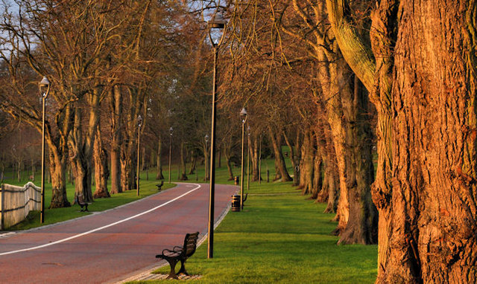
(See Map No. 2)

Fig. 1. Wallace Park, Lisburn © Copyright Albert Bridge
Listed Buildings
4.10 Statutory listing of buildings began in Northern Ireland in 1974 and the First Survey took over 20 years to complete. Heritage Buildings Designation Branch of Department for Communities are currently progressing a Second Survey of all of Northern Ireland's building stock to update and improve on the first list of buildings of special architectural or historic interest.

4.11 Article 80 of the Planning Act (Northern Ireland) 2011 requires the Department of the Environment to compile a list of buildings of special architectural or historic interest. Such buildings are important for their intrinsic value and for their contribution to the character and quality of settlements and the open countryside in Northern Ireland.

4.12 Article 81 of the Planning Act (Northern Ireland) 2011 provides the Council with powers to temporarily list buildings through serving a ‘building preservation notice’ if it appears that a building within its district which is not a listed building is

  - of special architectural or historic interest; and
  - is in danger of demolition or of alteration in such a way as to affect its character as a building of such interest.
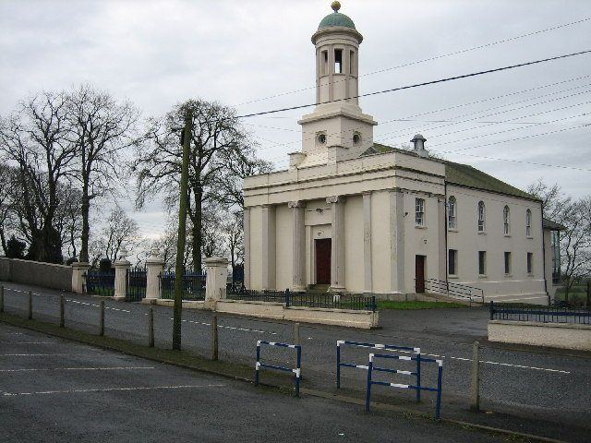

Fig. 2. Castlereagh Presbyterian Church (Grade B+ Listed Building)
4.13 Within the Council area there are approx. 472 Listed Buildings/Structures. It is noted that with time this list changes, as a result of de-listing and demolition etc. Of these there are 9 Grade A Buildings/Structures, 35 B+, 149 B1, 248 B2 Buildings/Structures and 31 Record only Buildings/Structures (See Map No. 4).

Table 4: Grade A Listed Buildings/Structures within LCCC
HB Reference | Address | Extent | Date of Construction | Current Use
HB19/05/001 A | St. Malachy's Parish Church of Ireland, Main Street  Hillsborough  County Down  BT26 6AE | Church & boundary walls | 1760 - 1779 | Church
HB19/05/001 B | Gate Screen and Lodges  St. Malachy's Parish Church of Ireland, Main Street  Hillsborough  County Down BT26 6AE | Gate Screen, Gate Lodges and gate stops | 1760 - 1779 | Gates/ Screens/ Lodges
HB19/18/013 A | Christ Church of Ireland  22 Derriaghy Road  Magheralave, Lisburn  Co.Antrim BT28 3SH | Church, gatescreen, gate and boundary walling | 1860 - 1879 | Church
HB19/22/001 | Saint John's Parish Church of Ireland, Main Street  Moira, County Down | Church and gatescreen | 1720 - 1739 | Church
HB19/05/030 | The Courthouse, The Square  Hillsborough, County Down  BT26 6AG | Former courthouse | 1760 - 1779 | Gallery/ Museum
HB19/03/048 | 4 Trummery Lane, Trummery  Maghaberry, Craigavon  Co. Antrim, BT67 0JN | House and barn | 1600 - 1649 | House
HB19/05/114 | Marquis of Downshire Monument  Monument Road  Hillsborough, County Down | Monument | 1840 - 1859 | Memorial
HB19/16/001 A | Cathedral of Christ Church  (aka Lisburn Cathedral)  24 Castle Street, Lisburn  County Antrim BT27 4XD | Cathedral and gate screen. | 1700 - 1719 | Church
HB19/17/004 B | Wolfenden Tomb  Lambeg Parish Churchyard  Church Hill, Lambeg North  Lisburn, Co.Antrim BT27 4SB | Tomb including gate and walling | 1650 - 1699 | Mausoleum
Source: Historic Environment Division

Conservation Areas

4.14 Article 104(1) of the Planning Act (Northern Ireland) 2011 provides the Council with the power to designate conservation areas, i.e. areas of special architectural or historic interest within its district the character or appearance of which it is desirable to preserve or enhance.

4.15 Article 104(2) of the Planning Act (Northern Ireland) 2011 provides the power for the Department, from time to time, to determine that any part of an area within a council’s district which is not for the time being designated as a conservation area is an area of special architectural or historic interest the character or appearance of which it is desirable to preserve or enhance; and, if the Department so determines, it may designate that part as a conservation area.

4.16 The Plan will identify existing conservation areas and include local policies or proposals for their protection and enhancement. Proposed conservation areas or alterations to existing areas may also be identified in local development plans.

4.17 Within Lisburn & Castlereagh City Council the following Conservation Areas are noted:

Table 4: Conservation Areas within LCCC by DEA
Conservation Area | DEA
Lisburn | Lisburn North
Moira | Downshire West
Hillsborough | Downshire West

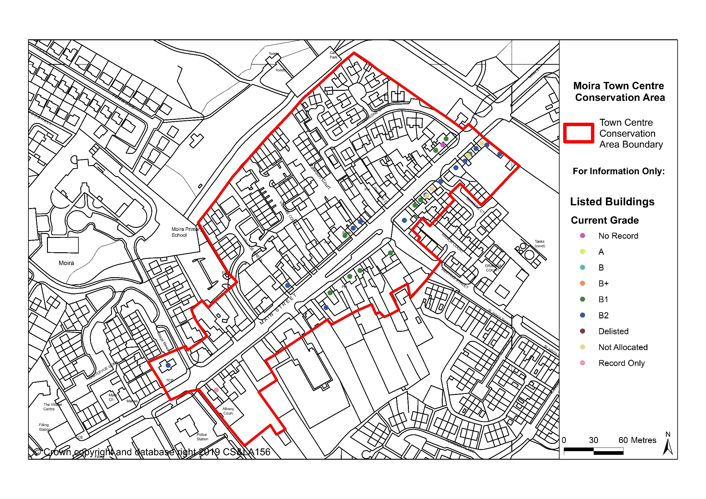
Fig. 3. Moira Conservation Area

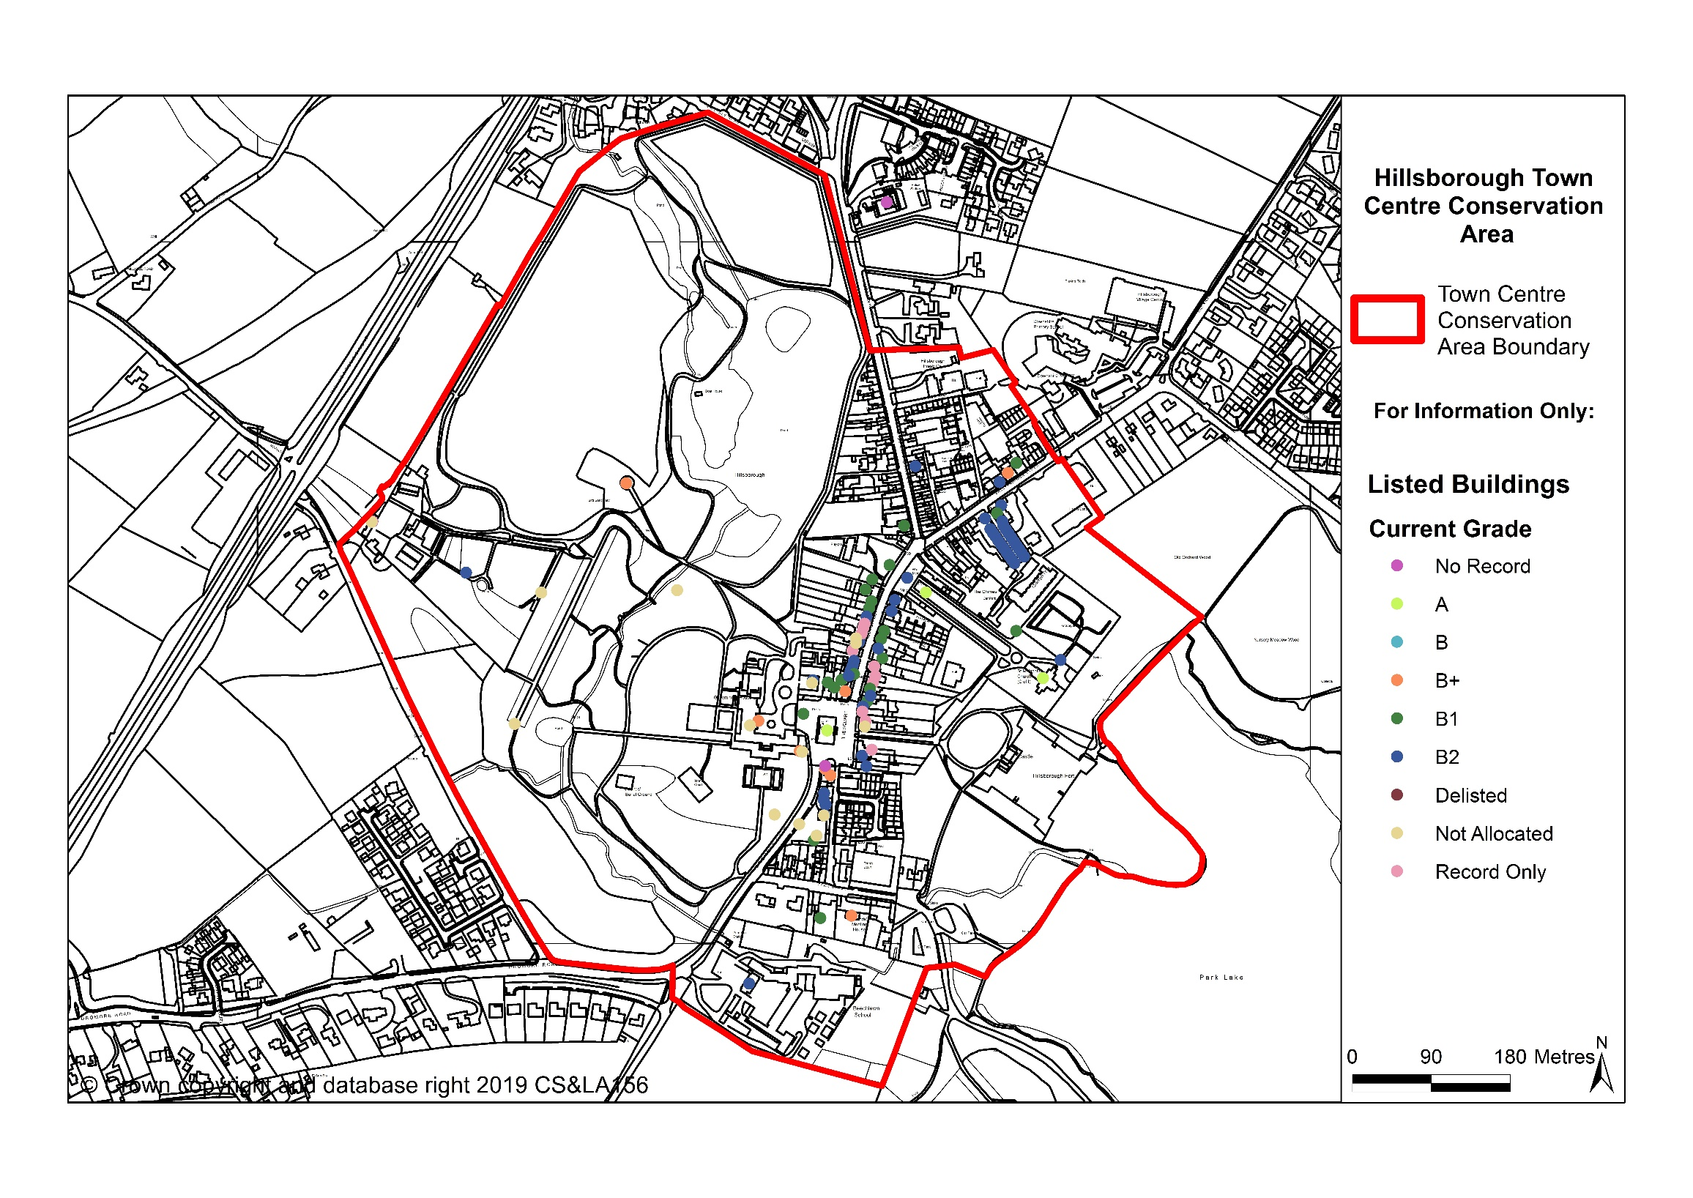
Fig. 4. Hillsborough Conservation Area

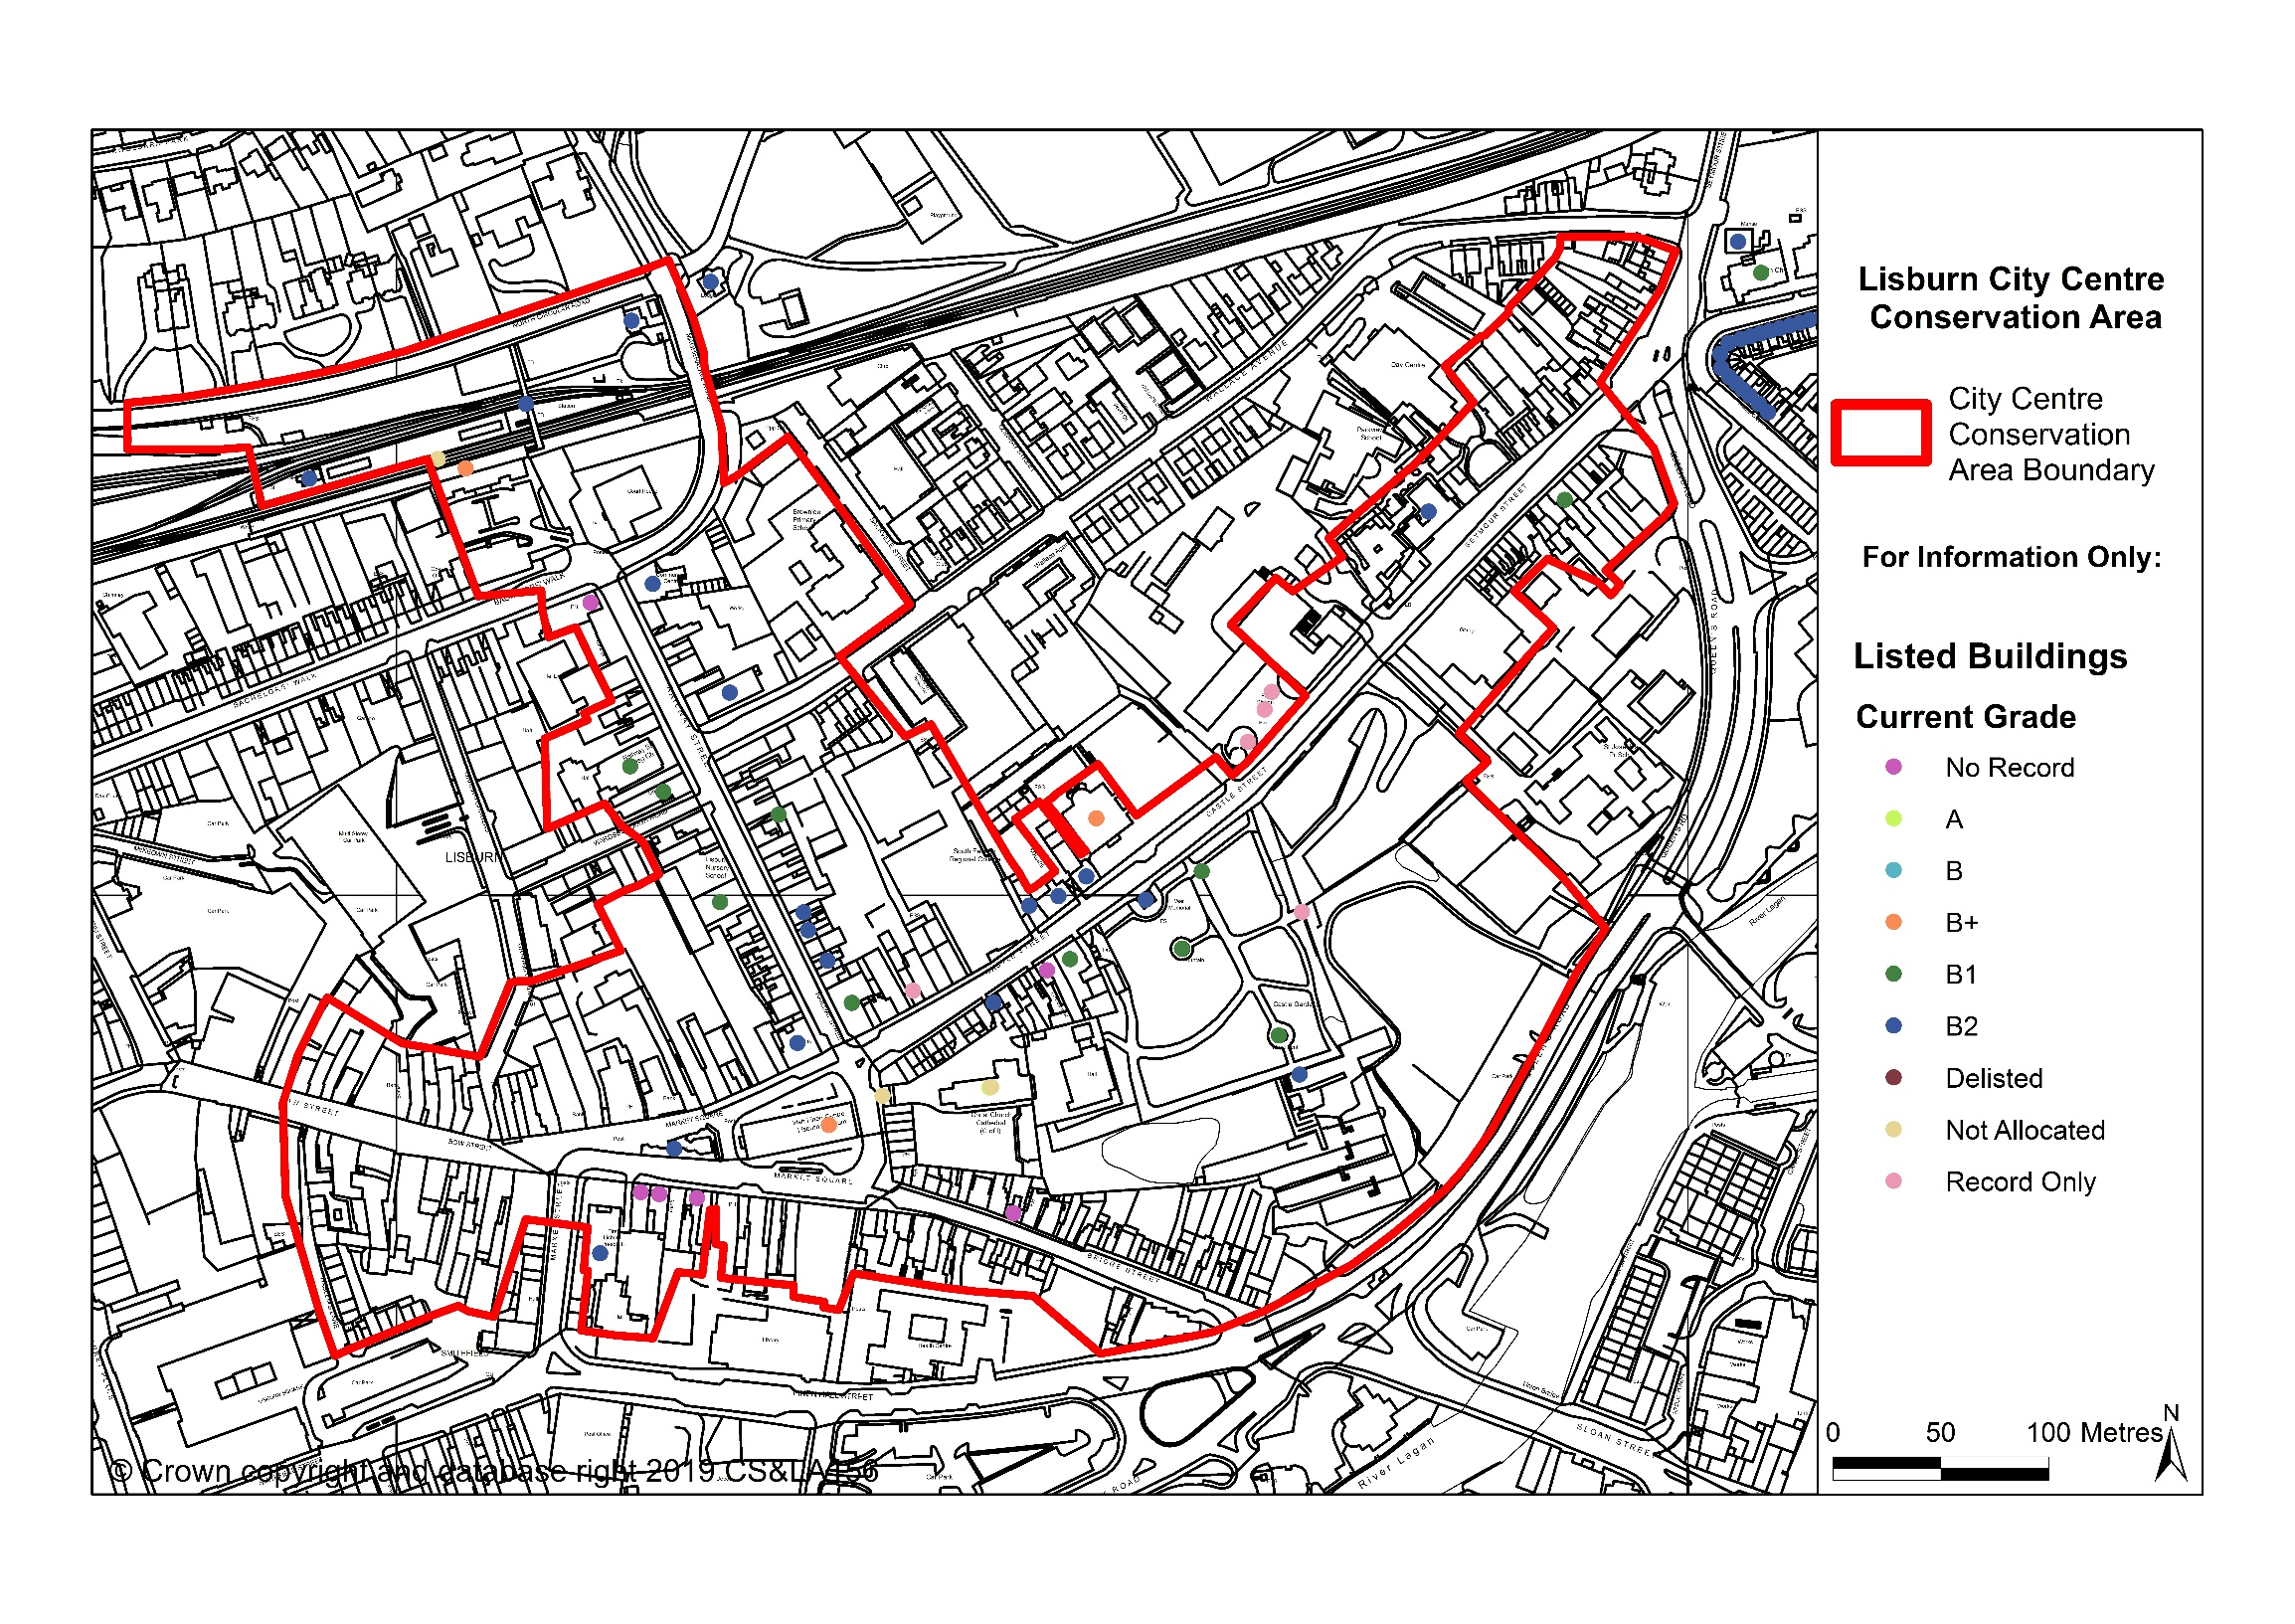
Fig. 5 Lisburn Conservation Area

Areas of Townscape or Village Character
4.18 There are certain areas within our cities, towns and villages which exhibit a distinct character normally based on their historic built form or layout. Some of these have merited statutory designation as conservation areas by virtue of their special architectural of historic interest, but for others it may be more appropriate to define areas of townscape or village character.

4.19 Within Lisburn & Castlereagh City Council, 7 Areas of Townscape Character and 7 Areas of Village Character are noted. These are outlined within the following table:

Table 5: Areas of Townscape and Village Character within LCCC
Areas of Townscape Character | Areas of Village Character
Bachelors Walk | Drumbeg
Hilden | Glenavy
Seymour Street | Lower Ballinderry
Wallace Park | Upper Ballinderry
Warren Park | Lambeg
Dundonald | Purdysburn
Newtownbreda | Moneyreagh
(See Map No. 3)

5.0 OTHER KEY DOCUMENTS

Lisburn City Centre – Public Realm Scheme
5.1 During the development of the Council’s Lisburn City Centre Masterplan, one of the main priorities identified and agreed was the need for innovative regeneration of the public realm, which primarily focused on the main City Centre streets. The project was completed in 2015, providing high quality Public Realm Works in two priority areas of Lisburn City Centre, namely, Market Square and Bow Street. These works were subsequently extended to the adjoining streets of Haslem's Lane, Market Street and Graham Gardens.

5.2 The project has significantly raised the quality of the environment helping Lisburn City Centre attract and retain a strong retail offering. This will in turn attract business and leisure activities that help to sustain activity in the city centre outside traditional business hours. Public realm improvements in Railway Street, Antrim Street and Bachelors Walk are currently under construction.

5.3 Key features of the public realm improvements include:

•A redesigned high quality public realm treatment which, where applicable, the pedestrian has priority;
•Removal of street “clutter”;
•A choice of materials and design that is a modern response to the historic character of the Conservation Area but not a pastiche of it;
•Robust materials that ensure Market Square can be used for performances and events in the future;
•Power/utilities connections to ensure that Market Square is suitable for events; and
•A design that frames vistas of the Irish Linen Centre and the cathedral from Bow Street and helps to define pedestrian priority spaces.

Hillsborough – Public Realm Scheme
5.4 Paul Hogarth Company were appointed by the Council as the Design Team for Hillsborough Public Realm Scheme in April 2015. The formal PAN (Pre Application Notice) process commenced with Public Consultation in January 2018 along with the PAD (Pre Application Discussion) to support the pending planning application.

Moira – Public Realm Scheme
5.5 AECOM were appointed by the Council as the Design Team for Moira Public Realm Scheme in June 2015. This project is still at initial design stage and funding has not yet been identified. Therefore the timeframes, scale and deliverability have not yet been determined.

Defence Heritage
5.6 The Council area contains a wide range of defense heritage features ranging from airfields, anti-aircraft batteries, observation posts, pillboxes and hangers to machine gun ranges. The majority of these are derelict, some have been reused or altered, and others are in a state of decay or have been demolished.

5.7 In 1995 the Defence of Britain Project was launched by The Council for British Archaeology (CBA) to coordinate recording work undertaken by volunteers. Two years later Northern Ireland joined the project with the Defence Heritage Project (DHP). A small number of dedicated volunteers has amassed an impressive record of many aspects of our defense heritage, and over 300 sites of interest have been recorded, although coverage is not yet complete.

5.8 Following on from the successful 1997 Defence Heritage Project, the Department for Communities (Historic Environment Division) is now looking for volunteers to help record the remaining 20th-century defenses so they can be added to the Defence Heritage Record. The information gathered through the project will be made accessible to the public and become part of the Northern Ireland Monuments and Buildings Record (NIMBR), helping the Department to safeguard Northern Ireland’s defense heritage through policy and legislation.

Industrial Heritage
5.9 The Council area contains a wide range of industrial heritage features ranging from old mills, bridges and tanneries to railway stations. These are all reminders of the area’s economic/industrial history. The Lagan Canal which flows through Lisburn City is an important industrial heritage feature of the council area. Numerous other sites of industrial heritage can be found throughout the Council area.

5.10 The Department for Communities Monument and Buildings Record (MBR) includes “The Industrial Heritage Record” which is a map-based archive that can be accessed by members of the public via NIEA, Built Heritage, Waterman House, 5-33 Hill Street, Belfast .

6.0 KEY FINDINGS AND CONCLUSION

6.1 A summary of the key findings are as follows:-
- There is a wealth of built heritage assets across the Council area.

- Opportunities exists for further enhancing/maximising the economic & tourism potential of built heritage features across the Council area.

- Conservation Areas provide a high-quality built environment that have the potential to attract tourism and economic opportunities. Consideration should be given to ways to promote/enhance/maximise this opportunity e.g. signage & public realm enhancements etc.

- Consideration should be given to protecting any built heritage features the Council consider to be at risk.

- Consideration should be given to identify any new built heritage features the Council considers worthy of protection.

CONCLUSION

6.2 Following on from the original Position Paper in October 2015, the purpose of this paper has been to update the baseline information regarding the built heritage profile within Lisburn City & Castlereagh Council. This baseline will support the preparation of the Plan Strategy and Local Policies Plan, and as the process evolves will be updated/amended as necessary taking account of all relevant new information made available.

Appendix 1: The Social and Economic Value of the Historic Environment

The historic environment has an important role to play in the development of Northern Ireland’s economy and society.

Economic Value

- Contribution to tourism. Northern Ireland Tourism Board (NITB) research has shown that historic monuments and buildings are a major draw, particularly for visitors from outside the region. There is scope to expand the tourism industry and good management and coordination of historic assets will help.

- Added Value to regeneration schemes. Historic buildings and monuments provide great character to a place. Such character can have a positive impact upon rents and also upon the reputation of businesses or agencies located in them.

- Attracting business. Inward investment is increasingly mobile. The historic environment helps to distinguish Northern Ireland from elsewhere. This can contribute to attracting business to the region.

- Contribution of sector to economy. Significant funds are invested in the historic environment every year in Northern Ireland. This sustains jobs, skills and knowledge. NIEA’s listed building grant scheme for example, leverages an average investment of £5.70 for every £1 invested. This is an important contribution to sustaining the building industry.

Social Value
- Sense of Place. Historic buildings, monuments and landscapes make a huge contribution to how Northern Ireland perceives itself. Forming less than 2% of our building stock, historic structures make up the principal features of towns, cities, villages and rural area.

- Pride. Well conserved, our historic environment is often a source of pride to communities large and small across the region.

- Quality of life indicators. Attractive places to live contribute positively to such indicators. The historic environment, well conserved, is a key component.

- Community harmony. Heritage is a common resource for all sections of society. It is also a repository of information about history and often a reminder that this was much more complex than commonly assumed.

Appendix 2: The Northern Ireland Monuments and Buildings Record

The Northern Ireland Monuments and Buildings Record (NIMBR) makes available to the public information on sites of archaeological interest contained in the Northern Ireland Sites and Monuments Record (NISMR), as well as information on listed and other historic buildings and structures, industrial heritage features and historic parks, gardens and demesnes 2. It is held and updated as necessary by the Department for Communities, Northern Ireland Environment Agency, 1-7 Bedford Street Belfast BT2 7EG. It can also be accessed via the internet at the following link;

https://www.communities-ni.gov.uk/contact

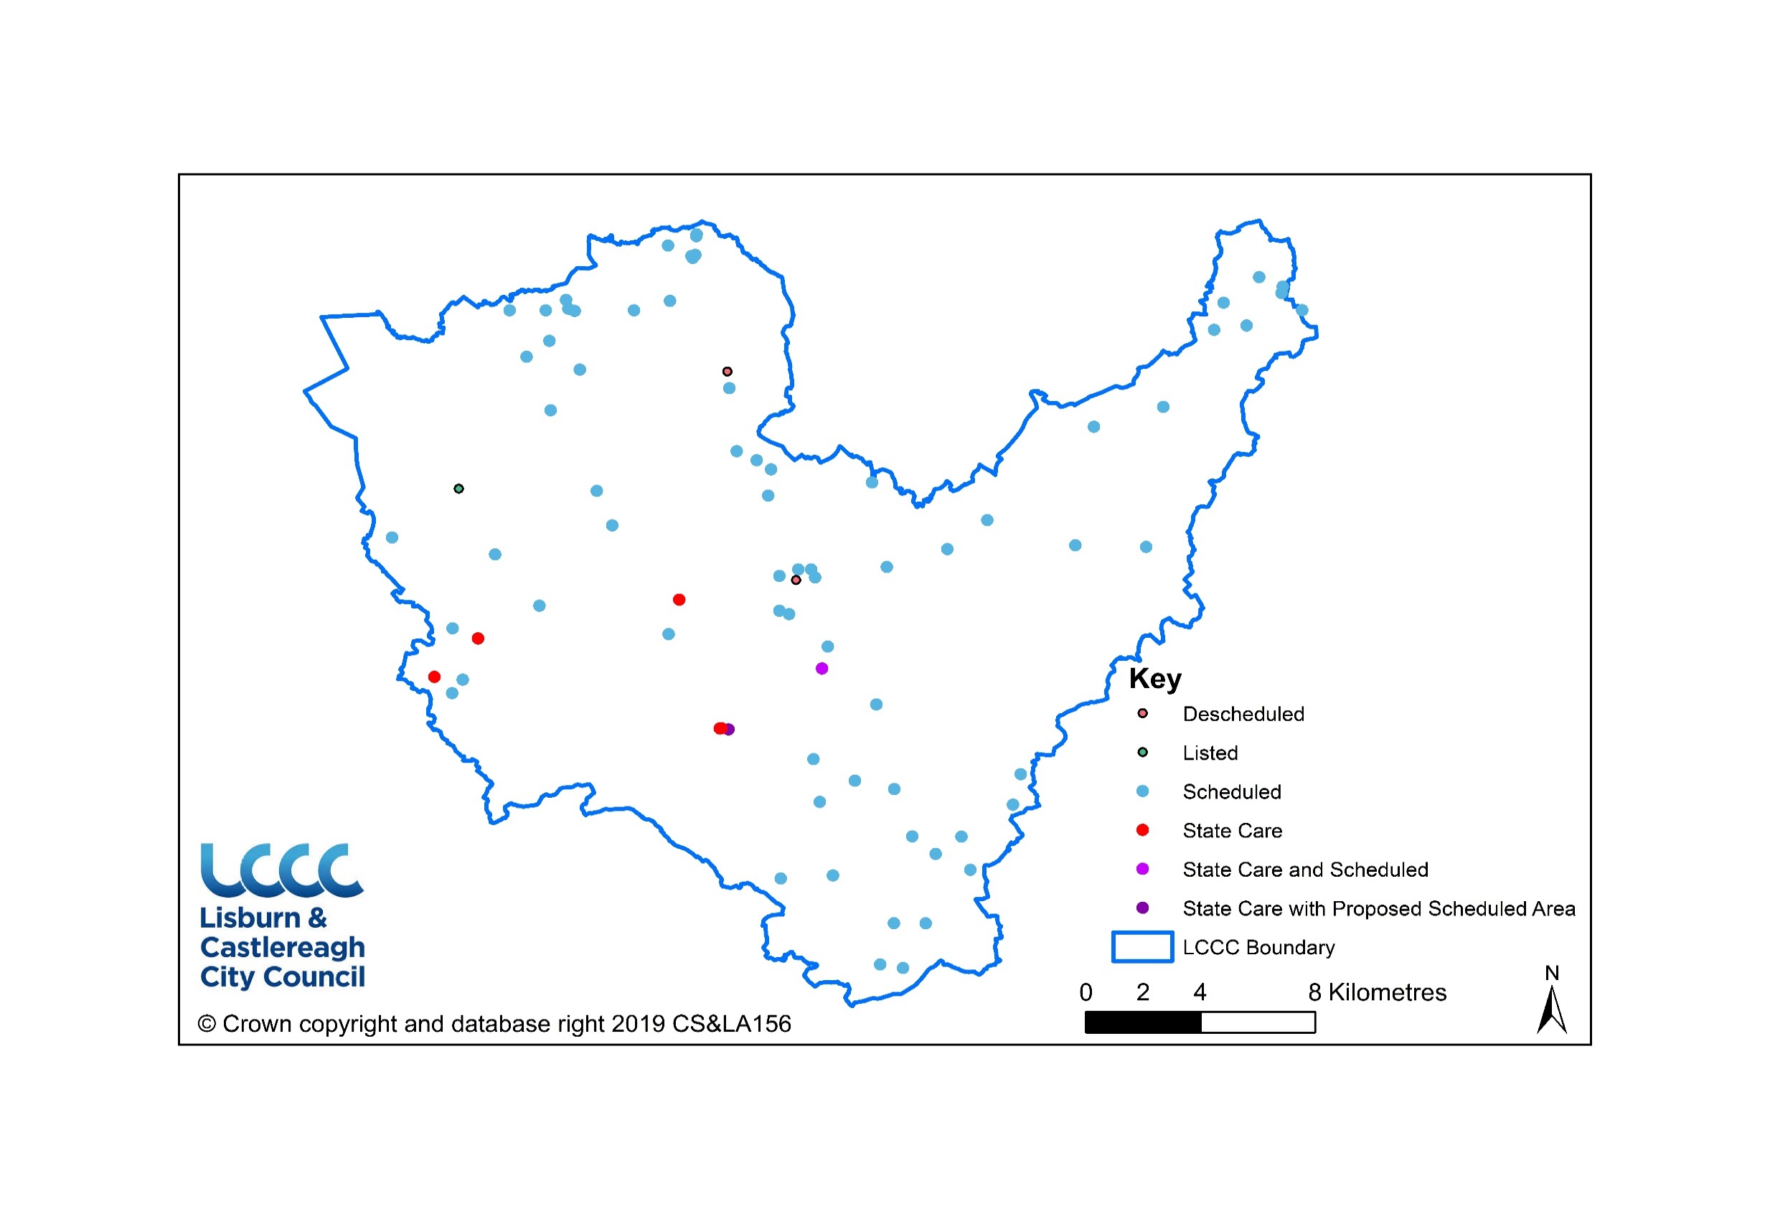
Appendix 3: Maps
Map 1: State Care and Scheduled Monuments

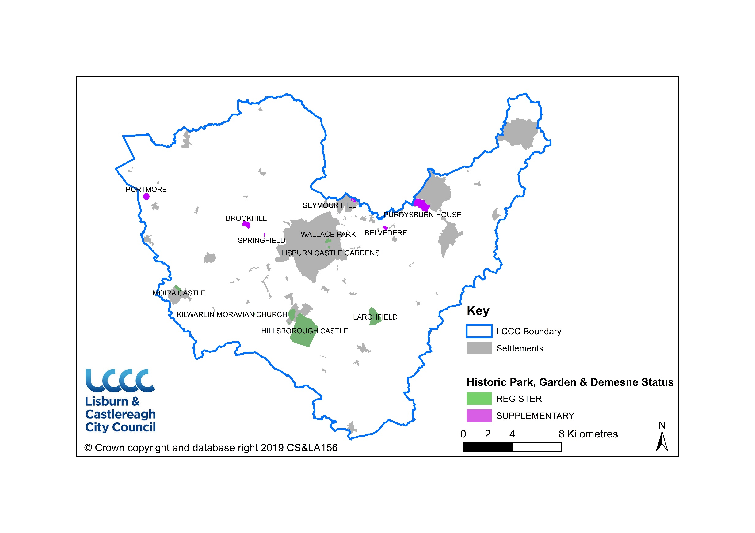
Map 2: Historic Parks, Gardens & Demesnes

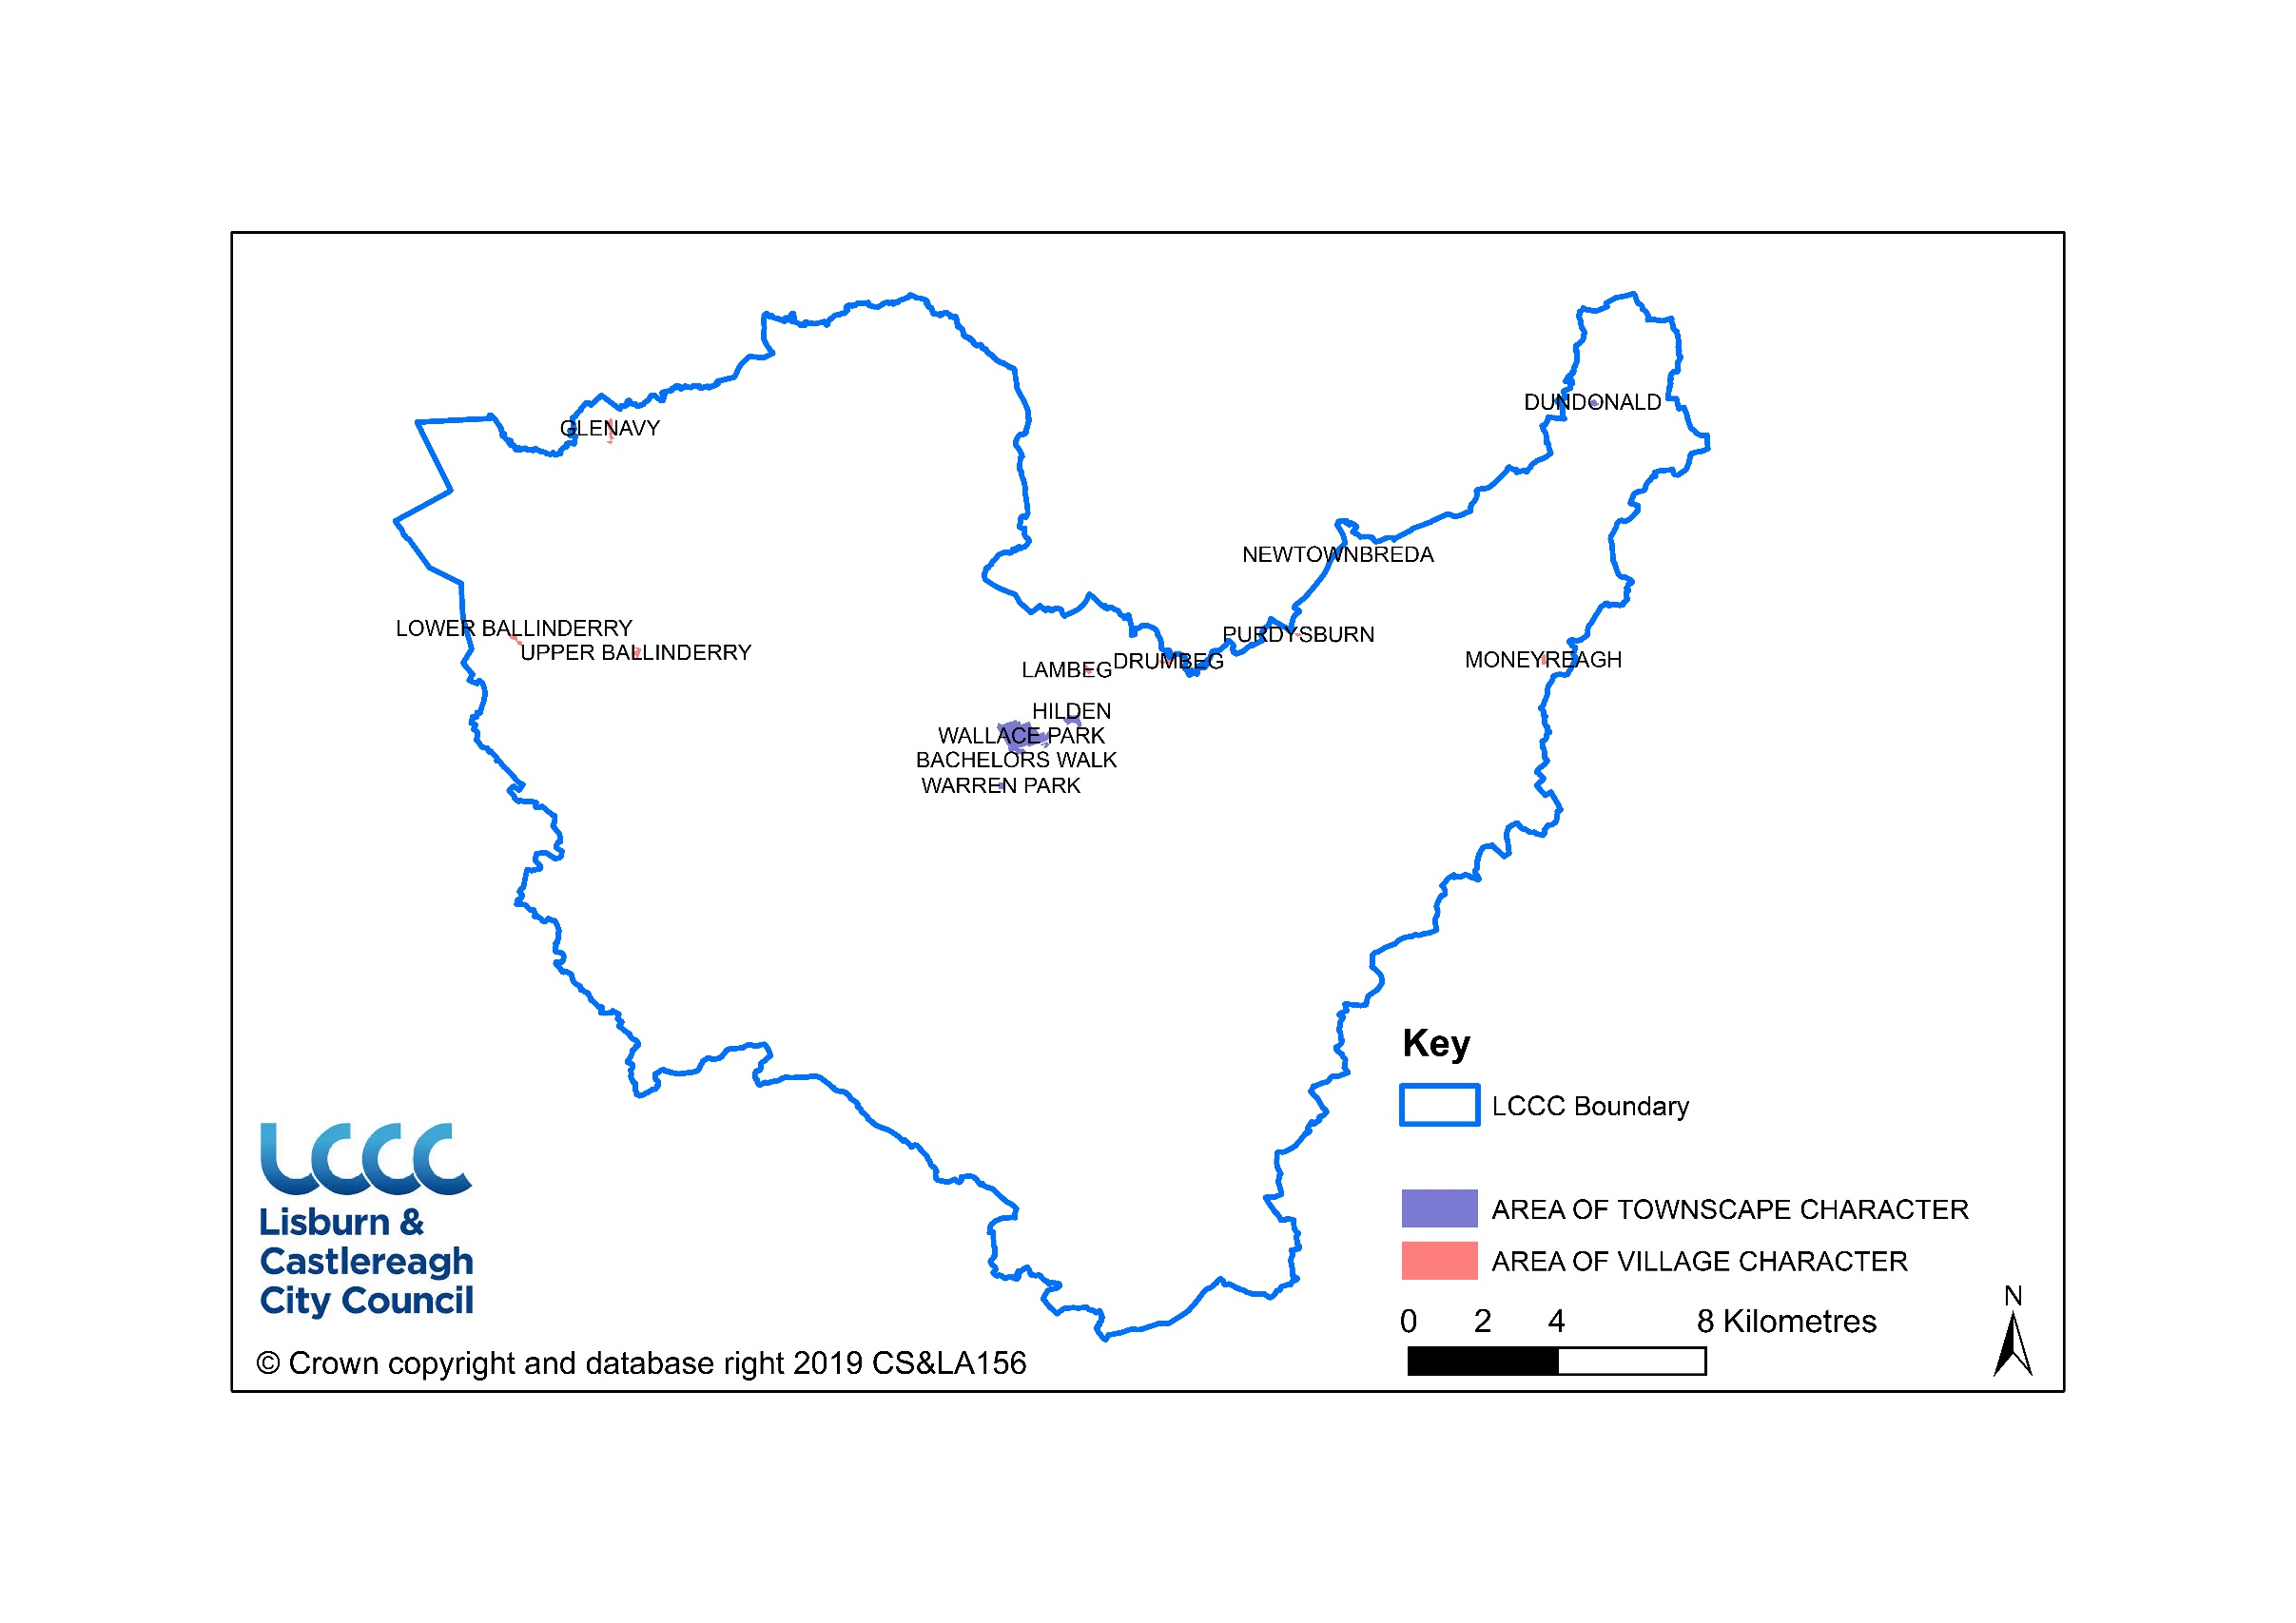
Map 3: Built Heritage Assets

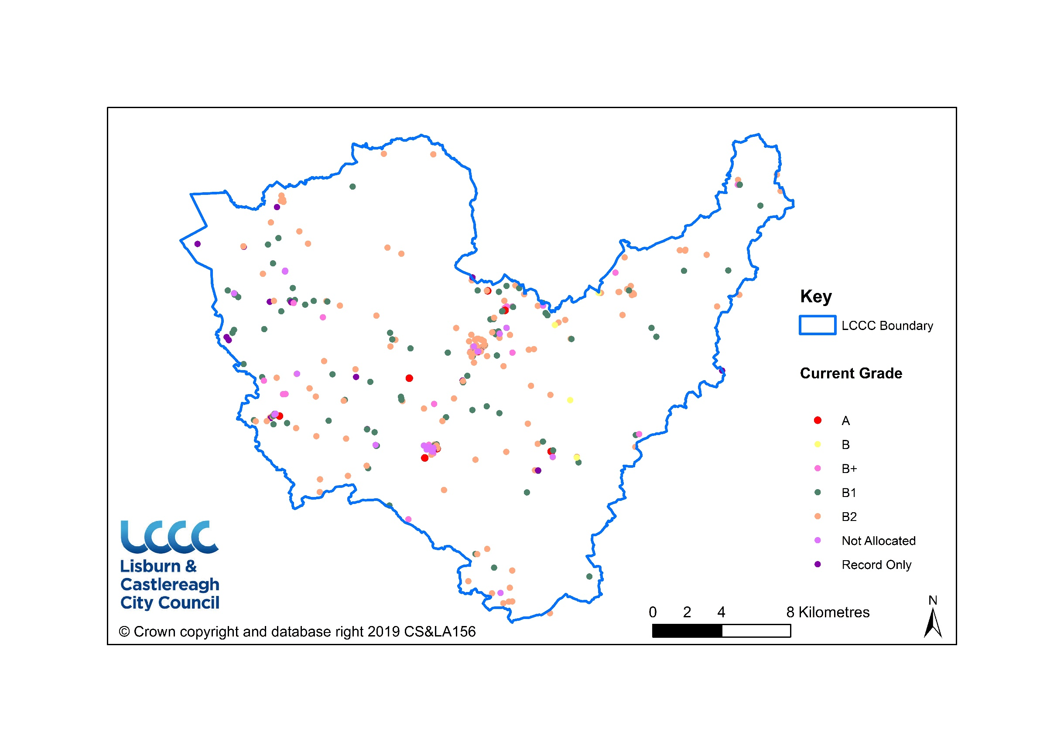
Map 4: Listed Buildings

https://www.communities-ni.gov.uk/topics/historic-environment
RDS 2035, DRD, March 2012: The RDS 2035.
The Department for Communities has the responsibility for identifying, recording and protecting our archaeological and built heritage through scheduling historic monuments, listing buildings of special architectural or historic interest and designating other sites and areas of heritage significance.
DOE Belfast Metropolitan Area Plan: District Proposals Lisburn. Part 4. Vol. 3
DOE Belfast Metropolitan Area Plan: District Proposals Castlereagh. Part 4. Vol. 5.
http://s0.geograph.org.uk/geophotos/02/74/09/2740932_4c148c7c.jpg
http://freepages.genealogy.rootsweb.ancestry.com/~rosdavies/photos/CastlereaghPresbyterian.JPG
Further details can be found via the following link https://www.nidirect.gov.uk/articles/accessing-built-heritage
https://www.communities-ni.gov.uk/services/historic-environment-map-viewer
https://www.nidirect.gov.uk/articles/accessing-built-heritage

