

**Local Development Plan**

**Technical Supplement 6: Telecommunications, Public Services & Utilities**

**November 2019**

**Contents Page**

Executive Summary 2

1.0 Introduction 3

2.0 Regional Policy Context 3

3.0 Existing Development Plan 14

4.0 Profile of Telecommunications,

Public Services and Utilities 16

5.0 Key Findings and Conclusion 29

**Executive Summary**

This Position Paper provides the Council with an overview of Telecommunications,

Public Services and Utilities in Lisburn & Castlereagh City Council, to assist in the preparation of the Local Development Plan 2032.

The Local Development Plan is made within the context of a Sustainability Appraisal under the provision of Planning (Northern Ireland) Act 2011. This paper is therefore intended to provide a baseline position on which policy and proposals for telecommunications, public services and utilities in the Local Development Plan can be shaped over the plan period.

It is important to stress that in compiling the Position Paper the best information available has been used however further revisions may be required in light of the release of any new data or updated policy, advice or information.

This paper provides an update on the previous Position Paper which was produced as part of the preparation of the Preferred Options Paper and has been informed by consultations with the statutory consultees who have responsibility for promoting a more sustainable approach to dealing with the services and utilities in Northern Ireland.

The aims of the paper are:

* To provide baseline information which will inform the Local Development Plan;
* To assess the provision of Telecommunications, Public Services and Utilities in Lisburn & Castlereagh City Council; and
* To provide the spatial representation of the Council’s Community Plan having regard to other plans and strategies being undertaken by the Council.

1. **INTRODUCTION**
   1. This position paper examines the existing provision of Telecommunications, Public Services and Utilities in the Lisburn & Castlereagh City Council area. The need for additional telecommunications, public service and utilities up to 2032 is also considered.
   2. Chapter 2 sets out the regional policy context for telecommunications, public services and utilities, which is formulated within the context of the Regional Development Strategy (RDS) 2035, the Strategic Planning Policy Statement for Northern Ireland (SPPS) and existing Planning Policy Statements (PPS).
   3. Chapter 3 outlines the current policy approach in the existing Plan context.
   4. Chapter 4 provides an overview of the telecommunications, public services and utilities baseline of the Council area along with an evaluation of the need for future facilities across the Council area up to 2032. Information on existing provision has been derived from the relevant providers of the facilities.
   5. The key findings and conclusion are provided in Chapter 5.

1.6 The position paper deals with the following Public Services and Utilities:

**Utilities**: Water; Sewerage; Cemeteries; Electricity; and Natural Gas; and Renewable Energy

**Public Services**: the Fire Authority; the Police Service of Northern Ireland; Military; Emergency Services; Health and Social Services and Education.

**Waste disposal** is dealt with in a separate position paper.

**2.0 REGIONAL POLICY CONTEXT**

2.1 The Regional Policy Context is provided by the Regional Development Strategy (RDS) 2035, Strategic Planning Policy Statement for Northern Ireland (SPPS) and regional Planning Policy Statements (PPSs). A summary of these documents as they relate to Telecommunications, Public Services and Utilities are provided in the following sections.

2.2 The RDS provides an overarching strategic framework to facilitate and guide development in the public and private sectors in support of the Programme for Government (PfG).

2.3 Sustainable development is at the heart of the RDS. The RDS aims to meet the needs of the present without compromising the ability of future generations to meet their own needs.

**Telecommunications**

**Regional Development Strategy 2035 (RDS)**

2.4 Regional Guidance (RG3) of the RDS seeks to implement a balanced approach to telecommunications infrastructure that will give a competitive advantage. Northern Ireland’s core telecommunications network is world class. However, the telecommunications market is fast moving and competitive advantage can be quickly eroded or lost if the region fails to continue to invest in its infrastructure. Working with industry and the Telecommunications Regulator, the key challenges for the region will be to improve international and internal connectivity and to ensure that the opportunities provided by access to high quality telecommunications services are fully exploited. Objectives of this guidance are to:

• Invest in infrastructure for higher broadband speeds.

• Improve telecom services in smaller rural areas to minimise the urban/rural divide.

• Increase the usage of broadband.

• Capitalise on direct international connectivity.

**Strategic Planning Policy Statement (SPPS)**

2.5 The Strategic Planning Policy Statement (SPPS) was published by the former Department of the Environment in September 2015. The provisions of the SPPS must be taken into account in the preparation of Local Development Plans, and are also material to all decisions on individual planning applications and appeals.

2.6 The SPPS considers modern telecommunications are an essential and beneficial element of everyday living for the people and visitors to this region. It is important to continue to support investment in high quality communications infrastructure which plays a vital role in our social and economic well-being.

2.7 The aim of the SPPS in relation to telecommunications is to facilitate the growth of new and existing telecommunications in an efficient and effective manner whilst keeping the environmental impact to a minimum.

2.8 The SPPS does not introduce any significant changes to those objectives set out in PPS10 Telecommunications (see below).

Role of the Local Development Plan

2.9 The SPPS states that in plan-making councils should bring forward policies and proposals to set out the detailed criteria for consideration of new telecommunications development in their local area which should address important planning considerations such as: siting, design, and impact upon visual amenity.

2.10 In particular planning authorities should take account of the potential effects of new telecommunications development, and any necessary enabling works, on visual amenity and environmentally sensitive features and locations. Applicants will be required to submit sufficient information which demonstrates that such considerations have been thoroughly assessed and mitigated. Operators will be encouraged to site share wherever possible. New masts should only be considered where site sharing is not feasible or offers an improved environmental solution.

2.11 Applications for the development of telecommunications equipment should be accompanied by a statement declaring that when operational the development will meet the 1998 International Commission on Non-Ionizing Radiation Protection (ICNIRP) guidelines for public exposure to electromagnetic fields.

2.12 Due to the cost associated with retrofitting telecommunications infrastructure planning authorities should encourage applicants to consider provision for such technology as early as possible in the design stage of proposals where appropriate.

2.13 The SPPS states that the Council may, in its plan preparation, consult with telecommunications operators, and other relevant stakeholders, in relation to the anticipated extent of the network coverage required over the plan period. In certain circumstances and, subject to technical limitations on location and siting, the Council may, through its Local Development Plan, allocate specific sites for major new telecommunications development. The council through its public consultation will consult with Ofcom (the telecommunications industry regulator) and code system operators. At draft Plan Strategy there are no proposals to allocate specific sites for major new telecommunications development.

**Planning Policy Statement (PPS) 10 Telecommunications**

2.14 The main objectives of PPS 10 are to:

• Facilitate continued telecommunications development in an efficient and effective manner;

• Ensure that where appropriate new telecommunications development is accommodated by mast and site sharing;

• Ensure visual and environmental impacts of telecommunications development is kept to a minimum;

• Encourage appropriate provision of telecommunications systems in the design of other forms of development.

**Energy**

**Regional Development Strategy 2035 (RDS)**

2.15 Regional Guidance (RG5) of the RDS deals with the delivery of a sustainable and secure energy supply. Northern Ireland requires a robust and sustainable energy infrastructure. This should deliver reliable and secure sources of energy to communities and businesses across the region. New generation or distribution infrastructure must be carefully planned and assessed to avoid adverse environmental effects, particularly on or near protected sites.

2.16 Decision makers will have to balance impacts against the benefits from a secure renewable energy stream, and the potential for cleaner air and energy for industry and transportation. Objectives of this policy are to:

• Increase the contribution that renewable energy can make to the overall energy mix.

• Strengthen the grid.

• Provide new gas infrastructure.

• Work with neighbours.

• Develop “Smart Grid” Initiatives.

2.17 Regional Guidance (RG9) of the RDS seeks to reduce our carbon footprint and facilitate mitigation and adaptation to climate change whilst improving air quality. Climate change is increasingly seen as one of the most serious problems facing the world. Air pollution from particulate matter is currently estimated to reduce the life expectancy of every person in the UK by an average of 7-8 months. In addition, emissions of sulphur (SO2), nitrogen (NOX) and ammonia (NH3) can be deposited on land and water causing either acidification, or nutrient enrichment (eutrophication).

2.18 Whilst action is required internationally, it is important that Northern Ireland plays its part by reducing air pollution and greenhouse gas emissions and preparing for the impacts of climate change. These include the effects on species and habitats and on health as a result of warmer temperatures, storms, floods and coastal erosion.

2.19 Consideration needs to be given on how to reduce energy consumption and the move to more sustainable methods of energy production. The use of fossil fuels and greenhouse gas emissions can be reduced by recycling waste and recovering energy from it.

**Strategic Planning Policy Statement (SPPS)**

2.20 In terms of overhead cables the SPPS states that the planning system should play its part in supporting the Executive and wider government policy and strategies in efforts to address any existing or potential barriers to sustainable development. This includes strategies, proposals and future investment programmes for, amongst others, key energy infrastructure (including the electricity network).

2.21 In addition any proposal for the development of new power lines should comply with the 1998 International Commission on Non-Ionizing Radiation Protection (ICNIRP). Furthermore, such proposals will be considered having regard to potential impact on amenity and should avoid areas of landscape sensitivity, including Areas of Outstanding Natural Beauty (AONBs).

2.22 The SPPS continues to support the growth in renewable energy sources with the aim of facilitating the siting of renewable energy generating facilities in appropriate locations within the built and natural environment in order to achieve Northern Ireland’s renewable energy targets and to realise the benefits of renewable energy without compromising other environmental assets of acknowledged importance. The policy objectives set out in the SPPS are:

* + ensure that the environmental, landscape, visual and amenity impacts associated with or arising from renewable energy development are adequately addressed;
  + ensure adequate protection of the region’s built, natural, and cultural heritage features; and
  + facilitate the integration of renewable energy technology into the design, siting and layout of new development and promote greater application of the principles of Passive Solar Design.

Role of the Local Development Plan

2.23 The SPPS is silent with regard to energy infrastructure and its position within the process of plan-making. The Plan will however bring forward operational policies for the consideration of such proposals including compliance with ICNIRP requirements, potential impacts on amenity and the avoidance of areas of landscape sensitivity, including Areas of Outstanding Natural Beauty (AONBs).

2.24 The SPPS requires the Council to set out policies and proposals in its Local Development Plan that support a diverse range of renewable energy development. The plan must take account of the aim and policy objectives of the SPPS; local circumstances; and, the wider environmental, economic and social benefits of renewable energy development. A cautious approach should be applied to renewable energy infrastructure within designated landscapes of significant value. Operational planning policies will be an important part of the Local Development Plan to ensure the environmental impact of renewable energy proposals are balanced against the economic and social benefits for the region as a whole.

**Planning Strategy for Rural Northern Ireland**

2.25 The RDS is complemented by the Department’s Regional Planning Policy PSU 11 Overhead Cables (in relation to power lines) of the Planning Strategy for Rural Northern Ireland. Policy PSU 11 aims to allow development proposals that:

• avoid areas of landscape sensitivity;

• avoid sites and areas of nature conservation or archaeological interest;

• minimise visual intrusion;

• follow the natural features of the environment; and

• ensure that wirescape in urban areas is kept to a minimum with preference given to undergrounding services where appropriate.

**Planning Policy Statement 18 – Renewable Energy**

2.26 PPS 18 seeks, through its policy objectives to ensure that with all renewable energy proposals the environmental, landscape, visual and amenity impacts associated with or arising from the development are adequately addressed; ensure adequate protection of the region’s built, natural, and cultural heritage features; and, to facilitate the integration of renewable energy technology into the design, siting and layout of new development and promote greater application of the principles of Passive Solar Design.

**Water, Sewerage and Flood Risk**

**Regional Development Strategy 2035 (RDS)**

2.27 Regional Guidance (RG12) of the RDS promotes a more sustainable approach to the provision of water and sewerage services and flood risk management. Changes in population distribution, household formation, urban development, and our lifestyles continue to put increased pressure on our water resources and drainage systems. Climate change will also have an impact on our water environment. Without action there are expected to be discrepancies between water demand and availability leading to the potential for water stress in some areas, more water quality problems in the natural environment and increased flood events from drainage systems, rivers, the sea and surface water run-off.

2.28 Planning for the provision of water and sewerage infrastructure and treatment facilities is both a practical and environmental necessity for regional development. Objectives of this guidance are to:

• Integrate water and land-use planning. Land-use planning should be informed by current water and sewerage infrastructure and future investment programmes.

• Manage future water demand. Reducing water consumption by reducing waste can lead to a lower carbon footprint as less water will need to be abstracted, treated and pumped.

• Encourage sustainable surface water management. Greater use of Sustainable Drainage Systems (SuDS) should be encouraged and if designed appropriately can help control flows into rivers and drains thereby reducing the risk of flooding.

**Strategic Planning Policy Statement (SPPS)**

2.29 In terms of waste water treatment works the regional policy objectives of the SPPS are:

* + promote development of waste management and recycling facilities in appropriate locations;
  + ensure that detrimental effects on people, the environment, and local amenity associated with waste management facilities (e.g. pollution) are avoided or minimised; and
  + secure appropriate restoration of proposed waste management sites for agreed after-uses.

2.30 The SPPS policy objectives in relation to flood risk are:

* + prevent inappropriate new development in areas known to be at risk of flooding, or that may increase the flood risk elsewhere;
  + ensure that the most up to date information on flood risk is taken into account when determining planning applications and zoning / designating land for development in Local Development Plans (LDPs);
  + adopt a precautionary approach to the identification of land for development through the LDP process and the determination of development proposals, in those areas susceptible to flooding where there is a lack of precise information on present day flood risk or future uncertainties associated with flood estimation, climate change predictions and scientific evidence;
  + manage development in ways that are appropriate to the four main sources of flood risk in Northern Ireland, i.e. fluvial, coastal, surface water and water impoundment (reservoir) breach or failure;
  + seek to protect development that is permitted within flood risk areas by ensuring that adequate and appropriate measures are employed to mitigate and manage the flood risks;
  + promote sustainable development through the retention and restoration of natural flood plains and natural watercourses as a form of flood alleviation and an important environmental and social resource;
  + promote sustainable development through encouraging the use of sustainable drainage for new development and redevelopment / regeneration schemes;
  + promote public awareness of flood risk and the flood risk information that is available and of relevance to undertaking development; and
  + promote an integrated and sustainable approach to the management of development and flood risk which contributes to:
* the safety and well-being of everyone,
* the prudent and efficient use of economic resources,
* the conservation and enhancement of biodiversity, and
* the conservation of archaeology and the built heritage.

Role of the Local Development Plan

2.31 The SPPS states that the preparation of its Local Development Plan is an opportunity for the Council to engage with relevant government departments and agencies with responsibility for both waste water treatment and the management of flood risk. In terms of waste water the SPPS makes it a requirement of the developer to demonstrate a need for the facility. In terms of flooding the Council must apply a precautionary approach to development in areas that may be subject to flood risk presently or in the future as a result of climate change predictions.

**PPS 11, Planning and Waste Management**

2.32 PPS 11 provides policy objectives in relation to the waste water treatment works (WwTWs), which requires satisfactory provision of such works; and, to ensure detrimental effects on people, the environment, and local amenity are avoided or minimised.

**PPS 15, Planning and Flood Risk.**

2.33 The policy objectives of PPS15 are to:

• seek to prevent inappropriate new development in areas known to be at risk of flooding, or that may increase the flood risk elsewhere;

• ensure that the most up to date information on flood risk is taken into account when determining planning applications and zoning / designating land for development in development plans;

• adopt a precautionary approach to the identification of land for development through the development plan process and the determination of development proposals, in those areas susceptible to flooding where there is a lack of precise information on present day flood risk or future uncertainties associated with flood estimation, climate change predictions and scientific evidence;

• manage development in ways that are proportionate and appropriate to the 4 main sources of flood risk present in Northern Ireland, ie fluvial, coastal, surface water and water impoundment (reservoir) breach or failure;

• seek to protect development that is permitted within flood risk areas by ensuring that adequate and appropriate measures are employed to mitigate and manage the flood risks to the development and elsewhere;

• support the retention and restoration of natural flood plains and natural watercourses as a form of flood alleviation and an important environmental and social resource, and ensure that this is recognised in the decision making process;

• promote sustainable development through encouraging the use of sustainable drainage for new developments and redevelopment / regeneration schemes;

• promote public awareness of flood risk and the flood risk information that is available and of relevance to undertaking development;

• promote an integrated and sustainable approach, both locally and at catchment scale, to the management of development and flood risk which contributes to:

- the safety and wellbeing of everyone;

- the prudent and efficient use of economic resources; and

- the conservation and enhancement of the natural environment and biodiversity;

- the conservation of archaeology and the built heritage.

**Other Public Services and Utilities**

2.34 The SPPS states that in relation to other utilities the Local Development Plan should allocate sufficient land to meet the anticipated needs of the community in terms of health, education and other public services. This is a matter for consideration at Local Policies Plan stage, should statutory consultees identify a deficiency for the needs of the community.

**Transitional Period**

2.35 A transitional period will operate until such times as a Plan Strategy for the Lisburn & Castlereagh City Council area has been adopted. During the transitional period the Council will apply existing policy contained within Planning Policy Statements together with the SPPS. Any conflict between the SPPS and the policy retained under transitional arrangements must be resolved in favour of the provisions of the SPPS.

1. **EXISTING DEVELOPMENT PLAN**
   1. The Belfast Metropolitan Area Plan 2015 was prepared under the provisions of Part 3 of the Planning (Northern Ireland) Order 1991 by the former Department of the Environment (DOE). The Plan covers the City Council areas of Belfast and Lisburn and the Borough Council areas of Carrickfergus, Castlereagh, Newtownabbey and North Down. The Plan was adopted on 9th September 2014, however the Court of Appeal declared the adopted plan unlawfully adopted on 18h May 2017.
   2. As a result, the existing Development Plans covering the Council area are as follows:

* Belfast Urban Area Plan (BUAP) 2001
* Lisburn Area Plan (LAP) 2001
* Carryduff Local Plan 1988 – 1993
* Ballymacoss Local Plan
* Lisburn Town Centre Plan
* Lagan Valley Regional Park Local Plan 2005

3.3 BMAP in its post-inquiry form was at an advanced stage and therefore remains a material consideration. Draft BMAP (November 2004) in its pre-inquiry form also remains a material consideration in conjunction with recommendations of the Planning Appeals Commission Public Local Inquiry Reports.

3.4Volume 3 and Volume 5 of BMAP 2015 sets out policies on the former Lisburn and Castlereagh Districts respectively. These policies have been developed in the context of the Plan Strategy and Framework contained in Volume 1 of the Plan and are in general conformity with the RDS.

3.5 Volume 1 of the Belfast Metropolitan Area Plan (BMAP) 2015 sets out a strategy for public services and utilities within the Plan area. Draft BMAP states that Government Departments, Agencies and statutory bodies, as well as the councils in the Plan area are primarily responsible for the provision of public services and utilities. The private sector is however playing an increasingly important role. The main public services are water and sewerage provision, drainage, waste disposal, cemeteries, electricity, natural gas and telecommunications. As written at the time, the role of renewable energy is also likely to increase over the Plan period. This has subsequently materialised over the intervening period. The main public services are noted to be water and sewerage provision, drainage, waste disposal, cemeteries, electricity, natural gas and telecommunications. Further detail on the provision of these public services in the Council area are set out in **Section 4.**

3.6 Within the Lisburn District Proposals, draft BMAP acknowledges a planning approval for a new cemetery on land between no. 3- 5 Lisburn Road in Moira.

3.7 There are no specific telecommunication, utilities or public service proposals for the Castlereagh area mentioned within draft BMAP.

1. **PROFILE OF TELECOMMUNICATIONS, PUBLIC SERVICES AND PUBLIC UTILITIES IN LISBURN & CASTLEREAGH CITY COUNCIL**

4.1 This section provides an overview of Telecommunications, Public Service and Public Utilities in Lisburn & Castlereagh City Council within the context of Northern Ireland as a whole, and examines the current state situation across the region.

**Telecommunications**

4.2 The NI Executive and the RDS (RG3) recognise the need for modern, efficient telecommunications infrastructure to give Northern Ireland a competitive advantage. The SPPS aims to facilitate the growth of new and existing telecommunications in an efficient and effective manner whilst keeping the environmental impact to a minimum.

4.3 Northern Ireland’s core communication network is of a high quality which is necessary for sustainable economic growth and investment. Access to high speed reliable digital infrastructure is seen to be one of the most important enabling infrastructures in terms of economic development and social uplift[1]. The economic and social benefits of advanced telecommunications to Northern Ireland can only be achieved if the necessary infrastructure is developed, including the networks of base stations. However, rural deficiencies in both mobile infrastructure and broadband exist in some rural parts of Lisburn & Castlereagh City Council.

4.4 ***Mobile Infrastructure:*** Telecommunications has not been devolved to the Northern Ireland Executive but is controlled centrally by the Department of Culture, Media and Sport (DCMS) in London. In 2014, the UK’s four Mobile Network Operators signed an agreement with Government committing to provide a voice service to 90% of the UK landmass by 31 December 2017. All of the operators complied with this requirement, however mobile networks also handle electronic data at increasing levels and the level of coverage for this falls short of that for voice services.

4.5 The quality of mobile telecommunications, in terms of voice and data coverage continues to vary between different parts of the Council, the disparity is most evident between settlements and rural areas. Previous government initiatives have sought to address this urban/rural disparity. In 2011 DCMS announced up to £150m funding to improve mobile coverage and quality across the UK – known as the Mobile Infrastructure Project (MIP). The MIP was time-limited and largely tackled areas where there was no mobile network coverage, Lisburn & Castlereagh did not fall within this category and it is unlikely any benefits arose from the scheme.

4.6 In 2019 the Government announced a further £1 billion initiative to extend 4G mobile coverage to 95% of the UK population. Half the cost of this initiative would come from Government, the other half from the mobile companies. This initiative remains a plan only and it is not known if this will proceed in the coming years.

4.7 5th Generation mobile networks are now being rolled out across the UK, but remain unavailable within the Council area.

4.8 ***Broadband Infrastructure:*** Now considered an important component of business infrastructure, broadband allows businesses to: have sufficient capacity to handle large amounts of business related data; allows for remote working; conference calls and other operations. These all factor into the success of the business in terms of the ability to respond to colleagues, suppliers and customers worldwide speedily, as well as impacting on the economic viability of the business by saving space and money on physical storage and saving on time and travel expenses.

4.9 Northern Ireland currently has the best fixed line broadband infrastructure in the UK, in terms of speed and access. However, there remain fixed broadband not-spots in rural areas.[2] This adversely impacts on Small and Medium-Sized Enterprises (SMEs) which dominate the rural economy, and residential users. The provision of broadband to rural areas through a rural exchange can result in higher costs to the customer and slower access speeds (bandwidth), impacting on business functionality.

4.10 The rollout of Project Kelvin, has improved the international telecommunication infrastructure between Northern Ireland and North America and Europe and there are a number of Project Kelvin Hubs which can access speeds from 10MB to 10GB. Businesses can now avail of low latency, reliable and competitively priced communications to North America and Europe. This international link increases the potential of financial institutions, Internet-enabled businesses, academia, media companies and any other high-bandwidth entity coming into NI and conducting business.

4.11 The Northern Ireland Broadband Improvement Project is aimed at providing basic broadband in areas that have no service and to improve broadband service in certain areas where the choice is poor or broadband speeds are low. Some of these are in rural and remote parts of Northern Ireland. The scheme will lay new fibre optic telephone lines from existing exchanges to new small broadband exchanges in remote areas. This will improve telecommunications infrastructure provided by telephone lines. Rolled out in February 2014, the improvement scheme is being rolled out in three phases. Improvement work was due to be completed in June 2018.

4.12 Broadband improvement work has taken place in:

• Castlereagh

• Hillsborough

• Lisburn

• Maze

• Stoneyford

• Tullynacross

Source: NI Direct Website

4.13 Like mobile telecommunications, coverage continues to vary between different parts of the Council, the disparity is most evident between settlements and rural areas. Within settlements ultrafast or superfast broadband coverage is widely available, this rapidly drops to standard broadband speeds in rural areas immediately outside settlements.

**Public Services & Utilities**

4.14A range of public services are provided through government funding to people living within Lisburn & Castlereagh City Council, either directly (through the public sector) or by financing the provision of services.

**Water**

4.15The abstraction, treatment and supply of water is the responsibility of NI Water. Lisburn & Castlereagh City Council is supplied by a series of impounding reservoirs, managed by NI Water, as detailed in the following list.

* Boomers Reservoir
* Leathemstown Reservoir
* Stoneyford Reservoirs

In addition the following NI Water reservoirs will be regarded as controlled reservoirs within the Council area.

* Breda
* Danescroft
* Lisnabreeny (1)
* Lisnabreeny (2)
* Magheraliskmisk
* Purdysburn

4.16 Two further service reservoirs (Poleglass & Ballyhanwood, located in neighbouring Council areas) also inundate into the Lisburn & Castlereagh City Council area.

**Sewerage**

4.17 The conveyance and treatment of sewage is the responsibility of NI Water, who are also responsible for further improvements/upgrade/refurbishment of these works. NI Water has invested £4 million in a programme of work to upgrade Lisburn's sewerage system. This work, largely evident on Linenhall Street, Antrim Street and Antrim Road, is now complete, and will protect the quality and appearance of one of the city's greatest natural assets, the River Lagan, to present-day standards as well as catering for future housing and commercial development

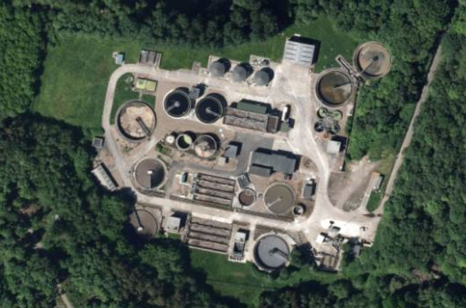

**Sewage Treatment**

4.18Below is a list of the Waste Water Treatment Works in Lisburn & Castlereagh.

**Table 2: Waste Water Treatment Works serving Lisburn & Castlereagh City Council**

|  |  |
| --- | --- |
| **WwTW Name** | **Address** |
| Annahilt | 7 Ballycrune Road, Hillsborough |
| Ballynadolly | Tansy Road, Ballinderry Upper |
| Dromara | 22 Hillsborough Road, Dromara |
| Drumbeg | 221 Ballylesson Road, Drumbeg |
| Hillsborough | 15 Culcavy Road, Hillsborough |
| Hooks Corner | 20 Kesh Road, Lisburn |
| Moneyreagh | 66 Hillsborough Road, Moneyreagh |
| New Holland | 4 Tulnacross Road, Hilden |
| Poundburn | Magheraconluce Road, Lisburn |
| Ravernet | 59 Ravernet Road, Lisburn |
| Stoneyford | Moss Road, Stoneyford |

Source: BMAP Technical Supplement

4.19The followinginformation has been received from NI Water in relation to the capacity of existing Waste Water Treatment Work (WwTWs) in the various settlements across the district.





4.20 As of August 2019 the NI Water website advises of upgrading works to Moneyreagh WwTW with delivery within the current business plan period up to 2020/21. Wastewater network capacity issues are emerging due to sewer network modelling in the areas of Lisburn, Moneyreagh, Annahilt, Dromara, Ravernet, Glenavy and Newtownbreda. As a result, new connections are being declined in parts of the catchment[3]

**Cemeteries**

4.21The following is a list of cemeteries and burial grounds maintained by Lisburn & Castlereagh City Council;

* Lisburn New Cemetery
* Friends Burial Ground
* Blaris Graveyard
* Trummery Burial Ground
* Lisburn Cemetery
* Aghalee Burial Ground
* Portmore Burial Ground
* Templecormac Burial Ground
* Knockbreda Cemetery

*NB: Roselawn Crematorium in Crossnacreevy is maintained by Lisburn & Castlereagh City Council in collaboration with Belfast City Council.

**Electricity**

4.22There are several suppliers of electricity for domestic customers in Northern Ireland, including:

- SSE Airtricity

- Budget Energy Ltd

- Electric Ireland

- Power NI (formerly NIE Energy)

An electricity supplier buys energy and sells it to customers. It is the company that issues your electricity bill and deals with any queries you have about your bill. Suppliers need a licence from the Utility Regulator to supply electricity to customers in Northern Ireland.

4.23Within the Council area the transmission network includes a 275/110kV-grid supply point at Manse Road, Castlereagh. The 110kV system includes underground, steel tower and wood pole circuits that carry power to the various substations/Bulk Supply Points or BSPs across the council area. Each BSP in turn transforms the voltage from 110,000V down to 33,000V and acts as a source for the 33kV network.

4.24 The 33kV network supplies 33kV/11kV substations (generally outside Belfast) known as primary distribution substations. These in turn supply the 11,000V infrastructure and finally the low voltage system which directly supplies customers.

4.25 The supply of the network is generally a response to new developments on greenfield sites and redevelopment of existing areas. It will also be driven by the need to replace assets due to age and condition.

**Natural Gas**

4.26Phoenix Natural Gas Ltd owns and operates the gas distribution network in the Greater Belfast area, including Lisburn and Carryduff. Other energy providers have the ability to have their own gas supplies transported through this distribution system to consumers.

4.27 Since 2016 Phoenix Natural Gas Ltd has been undertaking works to extend its licence to distribute gas to East Down, this includes the provision of natural gas infrastructure to Hillsborough and Annahilt in the south of Council area. Figure 2 shows progress on this infrastructure provision as of 2018.

**Figure 2: Map Showing Phoenix Gas East Down Project 2018**

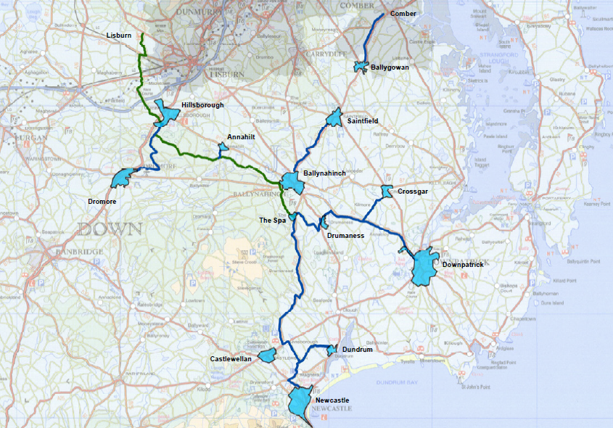

Source: Phoenix Natural Gas Website

|  |  |  |  |  |
| --- | --- | --- | --- | --- |
| **Town** | **Start Year** | **Km** | **Properties Passed** | **Completion Year** |
| Hillsborough | 2017 | 21.3 | 2200 | 2020 |
| Annahilt | 2017 | 5.7 | 470 | 2019 |

**Renewables**

4.28 The RDS emphasizes the importance of cutting environmental costs generally, by reducing the consumption of natural resources and energy from non-renewable sources, such as oil, coal and gas.

4.29 ***Wind Farms*:** Lisburn & Castlereagh City Council has a relatively low number of wind energy applications, as is shown in Figure 3. Only 2 Wind Farms have been approved in the Lisburn & Castlereagh LGD (period from 2002-2014). However there are ongoing pressures for single wind turbines.

**Figure 3:** **LCCC Single Wind Turbine Planning Applications Decided 2002-2017**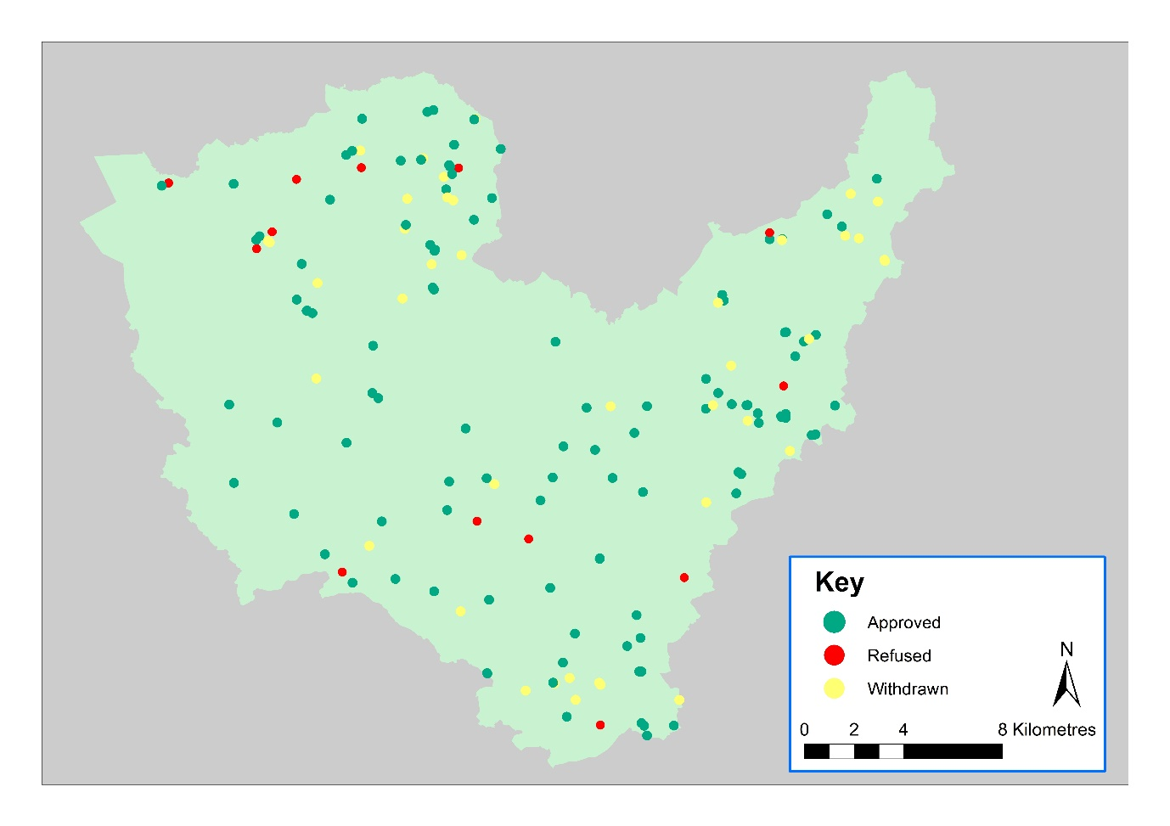

Source: Department for Infrastructure

4.30 ***Solar Energy***: Solar energy is a growing industry, with developments for large scale ‘solar farms’ increasing in recent years. Following approval, construction of solar farms have now been completed on Ballinderry Road Lisburn, at Maghaberry and on Lough Road Ballinderry (2 sites). The Council area did see a rise in the number of solar panels in householder developments (most of which did not require planning permission provided certain permitted development criteria is met), however these have tailed off in recent years.

**Fire**

4.31The Northern Ireland Fire and Rescue Service occupies 3 sites in Lisburn and 1 in Carryduff:-

* 1 Prince William Way (wholetime and retained[4]).
* Headquarters at 1 Seymour Street, Lisburn
* Property Services at 71 Antrim Street
* Carryduff, 7 Comber Road (retained)

(The Lisburn base falls within the Northern Area and the Carryduff station lies within the Southern Area.)

**Police**

4.32The Police Service of Northern Ireland is responsible for the protection of citizens and has moved to an 11-Council setup, in line with the new local authorities. The stations within the Lisburn & Castlereagh LGD include;

* + Carryduff (not open to the public)
  + Dundonald (not open to the public)
  + Lisburn City (opening hours: Monday to Friday 9am - 9pm, Saturday and Sunday 10am - 8pm)

4.33The changes to policing in Northern Ireland will mean that Lisburn & Castlereagh have one Neighbourhood Policing Team based in Lisburn station. It will be mobile and sent to areas where it is most needed.

The PSNI will be working closely with the local council, health trusts, schools and other key organisations to ensure that the very best service is provided to the community.

**Military**

4.34The British Army (‘Lisburn HIVE’ an information centre available to all forces personnel and their families) is located at Thiepval Barracks. Lisburn also receives an outreach service from Holywood and Aldergrove HIVE.

**Emergency Services**

4.35Lisburn & Castlereagh City Council has 3 bases for ambulances:

* + Lisburn Ambulance Station, Lagan Valley Hospital, Lisburn, BT28 1JP
  + Ulster Hospital, Dundonald, BT16 1RH
  + Derriaghy Ambulance Station, Unit 39, City Business Park, The Cutts, Derriaghy, BT17 9HU

**Health and Social Services**

4.36 The Department of Health, Social Services and Public Safety retains overall authority for health and social care services (provided by Health and Social Care Trusts). The following trusts cover the Council area:

Belfast – covering Belfast and part of Castlereagh

South Eastern – covering North Down, Lisburn and part of Castlereagh.

4.37 The Knockbracken Healthcare facility is a significant site within the Council area which provides care for those in institutional care.

4.38 In terms of hospital provision, the Council benefits from 2 major hospitals at:

* Lagan Valley Hospital
* Ulster Hospital, Dundonald

**Education**

4.39 The Department of Education (DE) and the Department for Employment and Learning (DEL) retain overall responsibility for education, policy and finance. Responsibility for the provision of primary and post-primary educational facilities along with library services in the Council area rests with the South Eastern Education and Library Board

4.40 Further details are provided in Position Paper 14 Education, Health, Community and Cultural Facilities.

4.41 The Northern Ireland Library Authority (Libraries NI) has the statutory responsibility for the provision of public library services in the Council area. The Council benefits from the following libraries in the Council area:

* Lisburn City Library, 23 Linenhall Street, Lisburn
* Moira Library, 21A Backwood Road, Moira
* Carryduff Library, Church Road, Carryduff
* Newtownbreda Library, Saintfield Road.

**5.0 KEY FINDINGS AND CONCLUSION**

5.1 A summary of the key findings are as follows:-

* Consideration should be given to continued improvements in telecommunications as necessary, particularly in terms of broadband provision and how it can attract business/investment and support a growing economy (taking into account environmental or other constraints).
  + - The supply of key public utilities, such as water, sewerage, electricity, and gas, requires continued co-operative liaison with the relevant statutory authorities to determine where future facilities or improvements are required to support the Council’s growth strategy.
  + Renewable energy proposals should continue to be supported in to accord with central government commitments on reducing the effects of climate change. Renewable energy proposals should however offer a balance between the benefits it brings to society and potential detrimental impacts upon our natural and historic environments.
  + In relation to public services, such as health care and education, co-operative liaison with the relevant authorities will ensure future needs of society are taken into account.
  + To consider the provision of other public services, such as cemeteries
  + Identify any key priorities for future growth.

**CONCLUSION**

5.2Following on from the original Position Paper published in October 2015, the purpose of this paper has been to update the baseline information regarding the utilities profile within the Lisburn & Castlereagh City Council area. This baseline will support the preparation of the Plan Strategy and Local Policies Plan, and as the process evolves the paper will be updated/amended as necessary taking account of all relevant new information made available.

1. digitalNI2020.com
2. ICBAN –Central Border Strategic framework – Infrastructural Supporting Document
3. Source: www.niwater.com/wastewater-capacity/
4. **\***Wholetime - a professional firefighter who may have full-time employment outside of the fire service but responds to emergency calls within their local area as and when required. Retained firefighters are therefore required to live or work near to the fire station they serve.

  