

**Development Plan**

**Position Paper 4: Retailing, Town Centres and Other Uses**

**November 2019**

**Contents Page**

Executive Summary 3

1.0 Introduction 4

2.0 Regional Policy Context 4

3.0 Existing Development Plan 10

4.0 Retailing Profile 14

5.0 Key Findings and Conclusion 28

Appendix 1: Lisburn City Centre Primary Retail Core

& Primary Retail Frontage

Appendix 2: Sprucefield Regional Shopping Centre

Appendix 3: Carryduff Town Centre Boundary

Appendix 4: Forestside District Centre

**Executive Summary**

This Position Paper provides an overview of the retailing baseline in the Lisburn & Castlereagh City Council area to assist in the preparation of the Local Development Plan 2032. It also provides an update on the Council’s other key strategies, such as the Lisburn City Centre Masterplan, Comprehensive Development Scheme Laganbank Quarter and the Castlereagh Urban Integrated Development Framework.

The Local Development Plan is made within the context of a Sustainability Appraisal under the provision of Planning (Northern Ireland) Act 2011. This paper is therefore intended to provide a baseline position on which policy and proposals for retailing in the Local Development Plan can be shaped over the plan period.

It is important to stress that in compiling the Position Paper the best information available has been used however further revisions may be required in light of the release of any new data or updated policy, advice or information.

This paper provides an update on the previous Position Paper which was produced as part of the preparation of the Preferred Options Paper and has been informed by consultations with the relevant statutory consultees.

The aims of the paper are:

* to provide baseline information which will inform the Local Development Plan;
* to assess the future retailing need in Lisburn & Castlereagh City Council; and
* to provide the spatial representation of the Council’s Community Plan having regard to other plans and strategies being undertaken by the Council.

**1.0 INTRODUCTION**

* 1. This paper examines the existing baseline for retailing provision within the existing city/town centres in the Lisburn & Castlereagh City Council area. The need for any additional retailing provision up to 2032 is also considered.
  2. Chapter 2 sets out the regional policy context for development, which is formulated within the context of the Regional Development Strategy (RDS) 2035, the Strategic Planning Policy Statement for Northern Ireland (SPPS) and regional Planning Policy Statements (PPSs).
  3. Chapter 3 outlines the current policy approach in the existing Plan context.
  4. Chapter 4 provides an overview of the retailing baseline of the Council area along with an evaluation of the need for future retail across the Council area up to 2032.

1.5 The key findings and conclusion are provided in Chapter 5.

**2.0 REGIONAL POLICY CONTEXT**

2.1 The regional policy context is provided by the Regional Development Strategy (RDS) 2035, the Strategic Planning Policy Statement for Northern Ireland (SPPS) 2015 and regional Planning Policy Statements (PPSs) where relevant. A summary of these documents as they relate to plan making and retailing development policy is provided in the following paragraphs.

**Regional Development Strategy 2035 (RDS)**

2.2 The RDS provides an overarching strategic framework to facilitate and guide development in the public and private sectors in support of the Programme for Government (PfG).The RDS has a statutory basis prepared under the Strategic Planning (Northern Ireland) Order 1999. Local development plans must ‘take account’ of the RDS.

2.3 The RDS 2035 provides a Spatial Framework for strong sustainable development across the region and includes regional guidance under three themes Economy, Society and the Environment. The Strategy provides opportunities for the physical and social progress of Northern Ireland up to 2035.

2.4 The RDS Spatial Framework Guidance relates to the five key components of the framework. One of these components refers specifically to the Belfast Metropolitan Urban Area (BMUA).

2.5 A substantial part of the Lisburn & Castlereagh City Council area is contained within the BMUA.[1] Strategic Framework Guidance recognises the important role of Lisburn with in the BMUA at the meeting points of the Belfast/Dublin economic corridor and the East/West transport corridor. Potential exists to grow the retail offer and create high quality office provision through the creation of employment in business services. This could also generate a new driver for the night-time economy provided by a range of flexible commercial accommodation and business parks at differing locations such as Blaris and the Maze/Long Kesh.

* 1. SFG1 recognises the high development potential of Lisburn City as a major employment and commercial centre. This is due to Lisburn being strategically located at the meeting of key transport corridors. This is also based on the increase in employment levels across the former Lisburn District Council area. This increase in employment is projected to continue over the period 2008 to 2028.
  2. A vibrant Lisburn city centre is also noted with a strong focus on leisure provision, sports and the arts. Potential exits to grow the leisure offer this would be primarily centred at the Lagan Valley LeisurePlex. The creation of high quality office offer is also cited through the creation of employment in business services.

2.8 Sprucefield will continue to retain its status as a regional out-of-town shopping centre.

2.9 SFG4 highlights the need for an efficient transport system to facilitate a successful economy but promoting social inclusion and a move away from the private car across the entire BMUA.

* 1. SFG5 illustrates the overall significant natural setting of the BMUA. This setting reinforces the uniqueness of the area bringing benefits to the economy and society in general.

**Strategic Planning Policy Statement (SPPS)**

2.11 The Strategic Planning Policy Statement for Northern Ireland (SPPS) was published in September 2015. The provisions of the SPPS apply to the whole of NI. They must also be taken into account in the preparation of Local Development Plans. A number of Departmental publications were cancelled by the introduction of the SPPS specific to this paper Planning Policy Statement 5: Retailing and Town Centres was cancelled. All regional Strategic Objectives and Policy are now contained in the SPPS.

2.12 The regional strategic objectives for town centres and retailing are to:

* secure a town centres first approach for the location of future retailing and other main town centre uses[2];
* adopt a sequential approach to the identification of retail and main town centre uses in Local Development Plans (LDPs) and when decision-taking;
* ensure LDPs and decisions are informed by robust and up to date evidence in relation to need and capacity;
* protect and enhance diversity in the range of town centre uses appropriate to their role and function, such as leisure, cultural and community facilities,
* promote high quality design to ensure that town centres provide sustainable, attractive, accessible and safe environments; and
* maintain and improve accessibility to and within the town centre.

Role of the Local Development Plan

2.13 The SPPS identifies the following strategic policy which must be taken into account in the preparation of the LDP:

* the council must adopt a town centre first approach for retail and main town centre uses
* ensure LDPs and decisions are informed by robust and up to date evidence in relation to need and capacity
* define a network and hierarchy of centres
* a sequential approach to the identification of retail and main town centre uses in LDPs and decision-taking
* protect and enhance diversity in the range of town centre uses appropriate to their role and function.

2.14 Under the implementation section the preparation of a LDP provides the opportunity to address the needs, challenges and opportunities facing town centres and retailing in the plan area. Given the wide range and complexity of issues that influence the development, role, function and success of town centres councils should work collaboratively with other relevant stakeholders to inform plan preparation.

2.15 The SPPS states that town centre health checks and their regular update (at least once every five years) will help form the evidence base for LDPs. They will contain information on a range of indicators, including:

* existing town centre uses, including resident population;
* vacancy rates;
* physical structure and environmental quality – including opportunities;
* designations, constraints;
* footfall;
* retailer representation;
* attitudes and perceptions;
* prime rental values and
* commercial yields.

2.16LDPs should include a strategy for town centres and retailing, and contain appropriate policies and proposals that must promote town centres first for retail and other main town centre uses

2.17 LDPs should also:

* define a network and hierarchy of centres - town, district and local centres, acknowledging the role and function of rural centres;
* define the spatial extent of town centres and the primary retail core;
* set out appropriate policies that make clear which uses will be permitted in the hierarchy of centres and other locations, and the factors that will be taken into account for decision taking;
* provide for a diverse offer and mix of uses, which reflect local circumstances; and
* allocate a range of suitable sites to meet the scale and form of retail, and other town centre uses.

**3.0 EXISTING DEVELOPMENT PLAN**

**Belfast Metropolitan Area Plan 2015 (BMAP)**

3.1The Belfast Metropolitan Area Plan 2015 is a development plan prepared under the provisions of Part 3 of the Planning (Northern Ireland) Order 1991 by the former Department of the Environment (DOE). The Plan covers the City Council areas of Belfast and Lisburn and the Borough Council areas of Carrickfergus, Castlereagh, Newtownabbey and North Down. The Plan was adopted on 9th September 2014,

3.2 Although formally adopted in 2014, this process of final BMAP adoption was declared unlawful as a result of a judgement in the court of appeal delivered on 18 May 2017. This means the Belfast Urban Area Plan (BUAP) 2001, Lisburn Area Plan 2001 and the other Development Plans provides the statutory plan context for the area.

3.3 BMAP, in its most recent, post-examination form remains a significant material consideration in future planning decisions. It was at the most advanced stage possible prior to formal adoption.

3.4Volume 3 and Volume 5 of draft BMAP 2015 sets out policies on the former Lisburn and Castlereagh Districts respectively. These policies have been developed in the context of the Plan Strategy and Framework contained in Volume 1 of the Plan and in general conformity with the RDS.

3.5 Within BMAP 2015 the settlement hierarchy in Lisburn District consists of Lisburn City, Metropolitan Lisburn, the small towns of Moira and Hillsborough, 12 villages and 30 small settlements. The settlements in Lisburn District are identified in Designation SETT 1 in Part 3, Volume 1 of the Plan. The District Proposals designate Settlement Development Limits, zone land and designate Land Use Policy Areas in these settlements in accordance with the BMA Settlement Strategy. Please note that Edenderry has now moved into the Belfast Local Government District from April 2015.

3.6 Within BMAP 2015 the settlement hierarchy in Castlereagh consists of Metropolitan Castlereagh, the town of Carryduff, the village of Moneyreagh and the small settlements of Ballyknockan, Crossnacreevy, and Ryan Park as identified in Designation SETT 1 in Part 3, Volume 1 of the Plan. Please note that Loughview has now moved into the Belfast Local Government District from April 2015.

* 1. BMAP 2015 sets the following objectives for the development of Lisburn:
     + Recognise the high development potential of Lisburn;
     + Promote the town’s continued development as a strong service and employment base;
     + Acknowledge Lisburn’s strong identity;
     + Maintain good linkages with the rest of the Belfast Metropolitan Area; and
     + Protect the town’s attractive local setting.

3.8 Within BMAP 2015 the following proposals are set out as follows:

**Lisburn City Centre:**

* The BMA Retail Strategy seeks the promotion of Lisburn City Centre as the main foci for additional retail capacity.
* The district proposals designate a Lisburn City Centre boundary with additional designations of a primary retail core and primary retail frontage within that Lisburn City Centre boundary (See Appendix 2) The Primary Retail Core defining the main focus of retail activity and retail investment during the Plan period. It includes the main retail outlets along the pedestrianised Bow Street and comprises the Bow Street Mall, accessed via Bow Street and Antrim Street. The Primary Retail Core also contains banks and professional offices within Market Square and along Bow Street. This designated area also contains the Irish Linen Centre/Lisburn Museum at Market Square. The primary retail frontage is located along Market Square and Bow Street and extends along the northern side of Chapel Hill.
* DSD is committed to promoting a vital and viable City Centre for Lisburn by the use of its statutory powers to facilitate the regeneration of Lisburn City.
* An Area of Parking Restraint is designated in Lisburn City Centre allied with other traffic management measures will assist in maintaining and enhancing the vitality of the City Centre by making better use of parking spaces.

**Sprucefield:**

* The BMA Retail Strategy notes the expansion of Sprucefield for bulky comparison goods only. Sprucefield Regional Shopping Centre (Policy R4 in Part 3 Volume 1) gives the criteria for development at that location (see Appendix 3). The PAC report of January 2009 recommended the removal of the reference to Sprucfield in the BMA Retail Strategy and deletion of policy R4.

**Carryduff Town Centre Boundary:**

* The Carryduff Town Centre boundary is designated to encompass the existing concentration of uses which have a town centre function, including retailing, professional services, restaurants, banking, community and other office uses (See Appendix 4). The District Plan Proposals will seek to strengthen the Town Centre, facilitate regeneration and address design issues.

**Forestside:**

* Forestside Shopping Centre is designated as a District Centre (See Appendix 5). This centre co-exists with other centres and fulfils a complementary role.

**Local Centre:**

* A local centre is identified at Dundonald. This centre provides shoppers in Dundonald with accessible convenience and non-bulky comparison shopping close to where they live. Boundaries are delineated around both the distict and local centres the control retail activity.

**4.0 RETAILING PROFILE**

4.1As part of the preparation of the SPPS a study was undertaken by GL Hearn on behalf of DOE Planning to research issues surrounding town centres and retailing in Northern Ireland (January 2014). This included health checks for existing town/city centres as designated in adopted plans using a variety of health check indicators. This research also included an assessment of town centre and retail trends. Overall the town centre health checks did not identify any towns that were performing badly, but equally there was little evidence of any particularly strong performance. Therefore there is room for improvement in the vitality and viability of town centres and a policy stance which seeks to protect and enhance town centre performance and diversity will contribute to uplifting existing centre vitality and viability.

4.2 In compiling the GL Hearn study town centre composition data was obtained from Experian Goad who carry out physical town centre surveys and prepare occupier plans for most town centres in the UK. Some of the key findings regarding town centres in Northern Ireland included:

* Lisburn City Centre has a footprint floorspace of 117,760 sqm, Portadown 71,430sqm, Lurgan 56,620 sqm, Craigavon 45,410sqm, Antrim 32,680 sqm, Armagh 59,280sqm and Banbridge 52,800sqm. In comparison to the rest of the UK towns, Northern Irish towns tend to have smaller catchment areas.
* Diversity of uses shows the importance of the service sector in town centres (42%), followed by non-food shops (35%). Service uses take up a larger proportion of town centres by unit number, reflecting the smaller sized unitsthese uses tend to occupy.
* Convenience good floorspace is focused in a proportionately small number of larger units reflecting the wider UK trend of the dominance of larger supermarkets in meeting shopping needs.
* Independent operators typically comprise 76% of town centre occupiers. In most centres, independents have a strong offer in food, non-food and service sectors. Unlike many town centres in the rest of the UK, local independent food retailers remain a feature of Northern Irish towns. Lisburn City Centre has a good representation of independent long-established family businesses offering convenience and comparison retailing and service uses.
* The proportion of other town centre uses was notably higher in NI than the UK average. The other category includes transport services, employment and commercial activities, religious buildings, wholesale trade, civic and unclassified buildings.
* Having a range of other uses within town centres should be considered a positive attribute which confirms town centres are performing as a hub for a range of activities thereby contributing to overall vitality and viability.
* The Northern Ireland vacancy rate is notably higher, both by floorspace and unit numbers than the UK average. The 2015 vacancy rate for NI is 16.3%. Vacancy rates in Lisburn City Centre and nearby towns are as follows: Lisburn City Centre 19%, Armagh 20.37%, Antrim 15%, Banbridge 14.33%, Craigavon 5.63%, Lurgan 17.32% and Portadown 22.63% average at 18.57%.
* Vacancy rates for 2013 (both by unit numbers and floorspace) are shown in the graphs below (Figures 1 and 2).

(**Please note, further detail on the main findings of the town centre health checks for the Lisburn and Castlereagh City Council Area is provided in Technical Supplement 5: Retail Capacity Study, October 2019 which accompanies the publication of the draft Plan Strategy.)**

4.3 The GL Hearn report highlighted that out-of-centre retailing is focused outside larger town centres or on strategic routes (particularly the M1) – e.g. Westwood Centre, Boucher Shopping Park and Park Centre South Belfast. Floorplate sizes are typically much larger than within traditional town centres. Only Craigavon Rushmere offers similar quality floorspace.

4.4 In terms of function, the role of the parks is almost exclusively retail. Unlike the rest of the UK, leisure uses such as cinemas and bowling alleys are not commonly found in these locations. Whilst some retail parks are dominated by bulky goods retailers, this is not exclusively the case. Sprucefield, Showgrounds in Omagh, Lisnagelvin in Londonderry and Boucher Retail Park and Park Centre in Belfast include a wide range of core comparison, particularly clothing retailers.

4.5 Sprucefield, although not similar to regional shopping centres in the rest of the UK such as Bluewater, Meadowhall, Lakeside or Braehead in its form of development, comprising an agglomeration of large unit retail parks, is acknowledged to be the only floorspace capable of exerting a regional attraction by virtue of its location and M&S as an anchor tenant.

4.6 In the case of Newtownabbey, the Abbey Centre plays a dominant role over the traditional town centre, including service functions, and is augmented by an agglomeration of other bulky goods retail units. The Outlet (now named ‘The Boulevard’) at Banbridge is a dedicated factory outlet shopping centre comprising a large number of smaller units.

4.7 In Belfast, Forestside, Connswater and the Kennedy Centre are modern covered shopping centres in out of town centre locations which are popular and have notable national multiple anchors and retailers. They do not however have the diversity of town centres. Similarly the Bloomfield Shopping Centre on the outskirts of Bangor is a modern covered centre with Marks and Spencer as an anchor store. The covered shopping centre is also supported by an adjoining retail park.

4.8 The Junction One development outside Antrim comprises an outlet centre with a range of national multiple ‘outlet’ and ‘factory’ format stores together with an Asda superstore, retail warehousing and leisure including multiplex cinema. Out of centre retail parks and shopping centres have a high proportion of national multiple retailers.

4.9 There are also a number of town centre issues facing Northern Ireland towns which are summarised in Table 1 below. The weaknesses and threats identified by GL Hearn “indicate that it would be appropriate to have a stronger policy stance on protecting and enhancing town centres, encouraging private sector investment and development and making town centres the focus for not just retail but other significant footfall generating uses”.

**Table 1: Town Centre Issues**

|  |  |
| --- | --- |
| **Strengths/Opportunities** | **Weaknesses/Threats** |
| • Diversity of existing town centres | • Vacancies and potential obsolesce of some floorspace |
| • Strong local independent retail offer | • Low and falling retail rents |
| • Good quality physical environment | • Amount and profile of out of centre retailing |
| • Town centre parking, particularly short stay ‘on street’ provision. | • Development pipeline |
| • Employment uses within town centres | • Limited private sector town centre development /investment |
| • Good accessibility and public transport hubs. | • Heavy traffic flows and congestion leads to conflict with shoppers |

4.10 The retail sector is constantly evolving and adapting in response to consumer and lifestyle trends and other market influences. Much of this change has been the growth in both personal income and disposable consumer spending, coupled with population growth. Such trends and influences have and will continue to transform traditional high street retailing and commercial leisure development. The economic downturn has had a negative effect on consumer spending. As a consequence of the recession, retail spending year on year for the next three to four years is expected to be low.

4.11National trends in consumer expenditure show a growth in home shopping and electronic commerce. The home shopping sector includes a number of retailing channels including catalogue sales, direct retailing, TV shopping and internet shopping. An increasing number of ‘high street’ retailers are now offering online shopping. (DOE NI- GL Hearn Report, January 2014). However, the growth in online shopping habits does not mean the end of the high street. Whilst online sales are increasing so too is ‘click and collect’ where consumers order online but visit the store to collect their goods. This service can help ensure that town centres will attract people and remain viable.

4.12Although there are far fewer retailers actively looking for stores in Northern

Ireland than elsewhere in the UK, certain retailers are taking new stores. These include discount stores; the likes of Home Bargains and Poundworld. The food sector including restaurants and coffee shops are also showing growth and coffee operators continue to be amongst the most active, with competitive tension and a desire to build, or at least maintain market share driving expansion. (The Lisney Belfast Commercial Property Report Quarter 3, 2017). This report also states there is a growing trend by national multiple retailers to achieve increasing economies of scale. This results in centralisation of services whereby larger stores serving an extensive catchment are replacing a number of smaller stores. These new forms of retailing are unlikely to be accommodated in existing town centres.

4.13The GL Hearn Report concludes that many of Northern Ireland’s towns have remained reasonably vital and viable mainly because many towns retain a good mix of uses, in particular services in the heart of the centre; most have reasonable/good accessibility on the street and nearby surface parking; most visits involve a number of linked trips; many have a high level of independent and long standing family businesses; there is a degree of loyalty to the town centre as being the heart of the community and some towns are beginning to find niche markets or their own ‘brand’ identities – cultural, visitation, seaside, gateway to countryside, specialist food etc. However, town centres do need to offer an experience over and above the average functional shopping trip which might otherwise be carried out online or at an out-of-town retail park. The outcome of this is ensuring that town centres are more attractive and viable to all age groups, that they have a diversity of uses and are adaptable to predicted future retail trends.

**Draft Plan Strategy**

4.14 In preparing the Plan Strategy a Retail Capacity Study and Town Centre Health Checks were commissioned. Detailed analysis of these are included in Technical Supplement 5 which accompanies the draft Plan Strategy. The draft Plan Strategy includes Strategic Policies 14 and 15 covering Town Centres, Retailing and Other uses and the Evening/Night-time Economy respectively. A Strategic Mixed Use policy SMU03 refers specifically to Sprucefield Regional Shopping Centre and contains a list of key site requirements.

4.15 All of these Strategic Policies are informed by regional and local policy and the Retail Capacity Study and Health checks seek to ensure the vitality and viability of what the Plan Strategy refers to as ‘A Vibrant Place’ through positive place making.

**Lisburn City Centre Masterplan**

4.16 In 2009, the former Department for Social Development (DSD) commenced a programme of developing and updating masterplans for city/town centres across Northern Ireland. The masterplans, which have a non-statutory status, were intended to assist in the planned development of city/town centres and to support their sustainability.

4.17 The former Lisburn City Council worked in partnership with DSD to produce the Lisburn City Centre Masterplan which was launched in September 2010.

4.18 Following the formation of Lisburn & Castlereagh City Council in April 2015, the Council completed a review of the Masterplan 2010 which was published in June 2015.

**Figure 3: Lisburn City Centre Masterplan Framework**

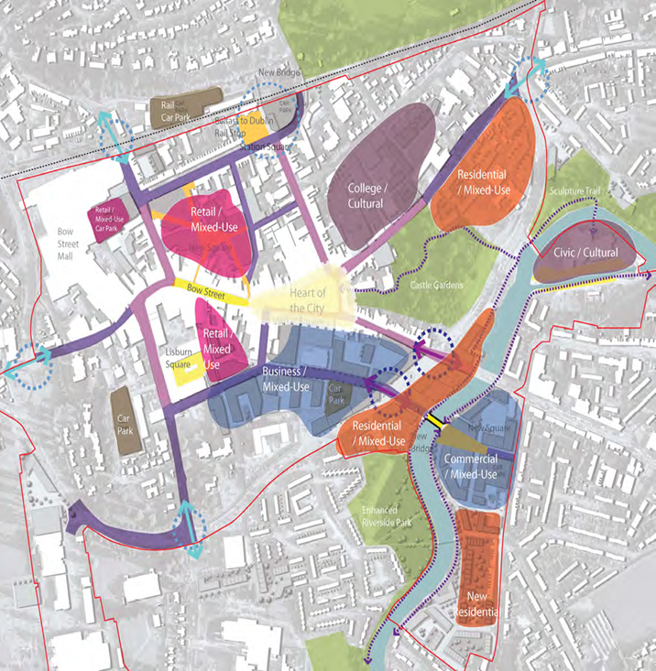

Source: Lisburn City Centre Masterplan 2010

4.19 The Masterplan is designed to show how Lisburn City Centre can achieve its full economic potential. In essence it provides:

* A series of regeneration objectives to guide development;
* A spatial plan to help guide appropriate development to the right locations where it will have the greatest impact;
* A series of strategic projects which are pivotal to the future success of the City Centre; and
* Design principles to guide development and ensure the highest standards of design quality in all development.

4.20 Regeneration responsibilities transferred to Council on 1st April 2016. Since the launch of the Masterplan the Council's Regeneration team has been working to develop and progress an initial portfolio of priority projects which include the City Centre Public Realm improvements; Laganbank Quarter Development Scheme and identifying Car Park Development Opportunity Sites.

4.21 In August 2019 Lisburn City Council put out for consultation a second public consultation draft of the masterplan entitled ‘Lisburn City Centre Masterplan 2019-2023’. Consultation on this plan closed on the 29th August 2019.

4.22 The vision is for a thriving, well connected and welcoming regional city centre with a vibrant and independent character. The objectives aim to provide a more vibrant and mixed-use city centre, an expanded city centre, a more diverse city centre shopping offer, a more welcoming and better connected city centre and a city centre public realm of distinction.

4.23 In the time period from the adoption of the 2010 masterplan significant improvements have occurred including the rejuvenation of shopfronts and refitting of vacant units funded by both public and private investment. Also a significant amount of public realm works have been completed including the light floor which acts as a focal point.

4.24 Development has also been ongoing in the Laganbank Quarter. Hotel development has been actively sought with planning permission granted in Lisburn Square and the Lisburn Leisure Park.

4.25 The CBRE research indicated that the overall vacancy rate was 21% (unit basis) however they suggest that there have been signs of improvement in recent years. CBRE highlight that for a shopping destination to be successful it must deliver 40% leisure/food and beverage, 40% retail and 20% other. Currently Lisburn has a split of 15%, 54% and 31% respectively in the above areas.

4.26 This review also makes reference to its relationship with the Local development Plan. Stating the LDP will ensure the proper stewardship and planning of the city Centre.

**2019 Masterplan Boundary Map**

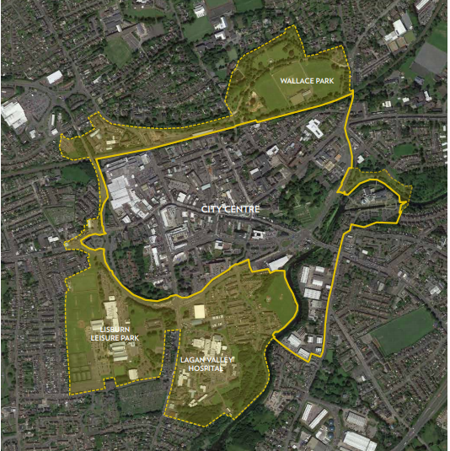

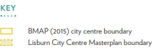

**Comprehensive Development Scheme Laganbank Quarter, Lisburn**

4.27 The Department of Social Development (DSD) in February 2015 adopted a Comprehensive Development Area with the objective of securing a comprehensive, major mixed use scheme, which will regenerate the Laganbank Quarter area of Lisburn, enhance the City Centre’s regional role, integrate with the surrounding urban fabric, and strengthen links with the River Lagan.

**The Castlereagh Urban Integrated Development Framework 2014**

4.28 The Castlereagh Urban Integrated Development Framework was a joint project undertaken on behalf of the former Castlereagh Borough Council and DSD, published in November 2014. It focuses on the commercial centres of Carryduff, Dundonald and Forestside and sets out a long term, high level, inspiring vision up to the year 2022.

**5.0 KEY FINDINGS AND CONCLUSION**

5.1 A summary of the key findings are as follows:-

* Further opportunity exists to develop Lisburn as a major employment, retailing and commercial centre;
* The dominance of roads infrastructure and traffic in the centre of Lisburn City and the resulting severance caused will require further consideration along with public transportation infrastructure and linkages to/from the main shopping areas;
* The existence of gap sites and underdeveloped backland areas behind principal streets and lack of residential development in the City Centre have an impact on the night-time economy;
* Lisburn Historic Quarter as identified in the Council’s revised Masterplan provides a high quality setting and potential for attracting further private to boost the tourism/retailing offering, with potential for a centrally located hotel which would assist in developing the night-time economy;
* Areas such as Market Square and Bridge Street and Lisburn Square are showing signs of retail vacancy and ‘to let’ property. Footfall drops quite dramatically after 5pm affecting development of the night-time economy;
* Opportunity also exists to redevelop Carryduff Town Centre, facilitate regeneration and address design issues. In May 2017, planning permission was granted for the demolition of existing buildings at Carryduff Shopping Centre and construction of 2514 m2 retail sales area, 185 m2 office units and 20 no apartments this project is currently ongoing.
* Lisburn Historic Quarter has been the subject of a successful Townscape Heritage Initiative which has primed the process of bringing historic buildings back into use. The £4.3m refurbishment of Castle Gardens has also made a significant contribution to the City Centre, and is accessible for all to enjoy. Market Square underwent public realm improvements in line with the Lisburn City Centre Masterplan which will provide a high quality setting and potential for attracting further private investment nearby. Further public realm works are ongoing
* The City Centre benefits from a wide range of independent stores but is under represented in terms of high street multiple retailers. Areas such as Market Square, Bridge Street and Lisburn Square are showing signs of retail vacancy and ‘to let’ property. Footfall drops quite dramatically after 5pm when most shops close.
* Historically, the City Centre has suffered from a lack of modern office accommodation to attract businesses. Most cultural/leisure facilities are located outside the ring road and the lack of a centrally located hotel is also a major barrier to development of the City Centre’s evening economy. Hotel provision has been addressed with further opportunities being explored within the city centre.
* The River Lagan is an important feature of the City Centre and is connected to Castle Gardens via an existing underpass under the busy ring road. Many people are not aware of the close proximity of the river to the City Centre. There is an opportunity to attract the public to make more use of the waterspace which would be an attractive setting for riverside development.

**CONCLUSION**

5.2Following on from the original position paper in October 2016, the purpose of this paper has been to provide baseline information on the retailing sector within the new Lisburn City & Castlereagh City Council Area and examine the need for further retailing. This baseline will support the preparation of the Plan Strategy and Local Policies Plan, and as the process evolves will be updated/amended as necessary taking account of all relevant new information made available.

5.3 Further detail regarding Retailing and Town Centre Health Checks is provided in Technical Supplement 5 Retail Capacity Study which accompanies the draft Plan Strategy 2017-2032.

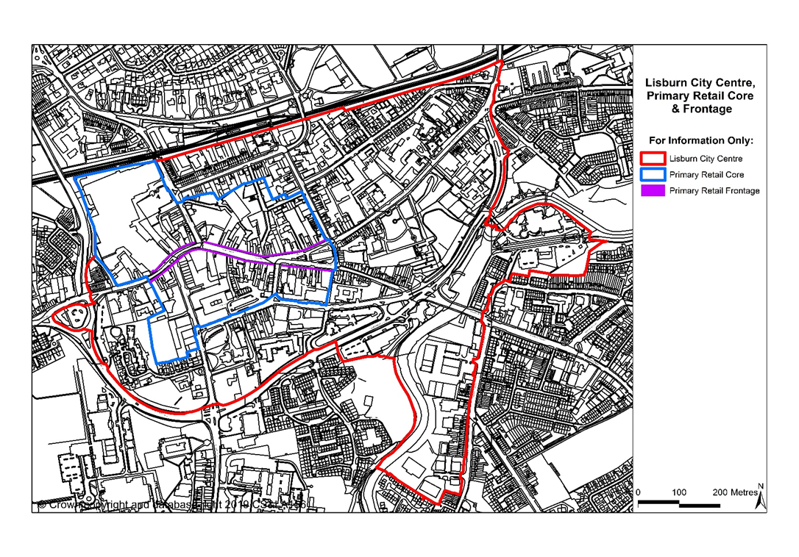**Appendix 1 Lisburn City Centre**

**Appendix 2 Sprucefield**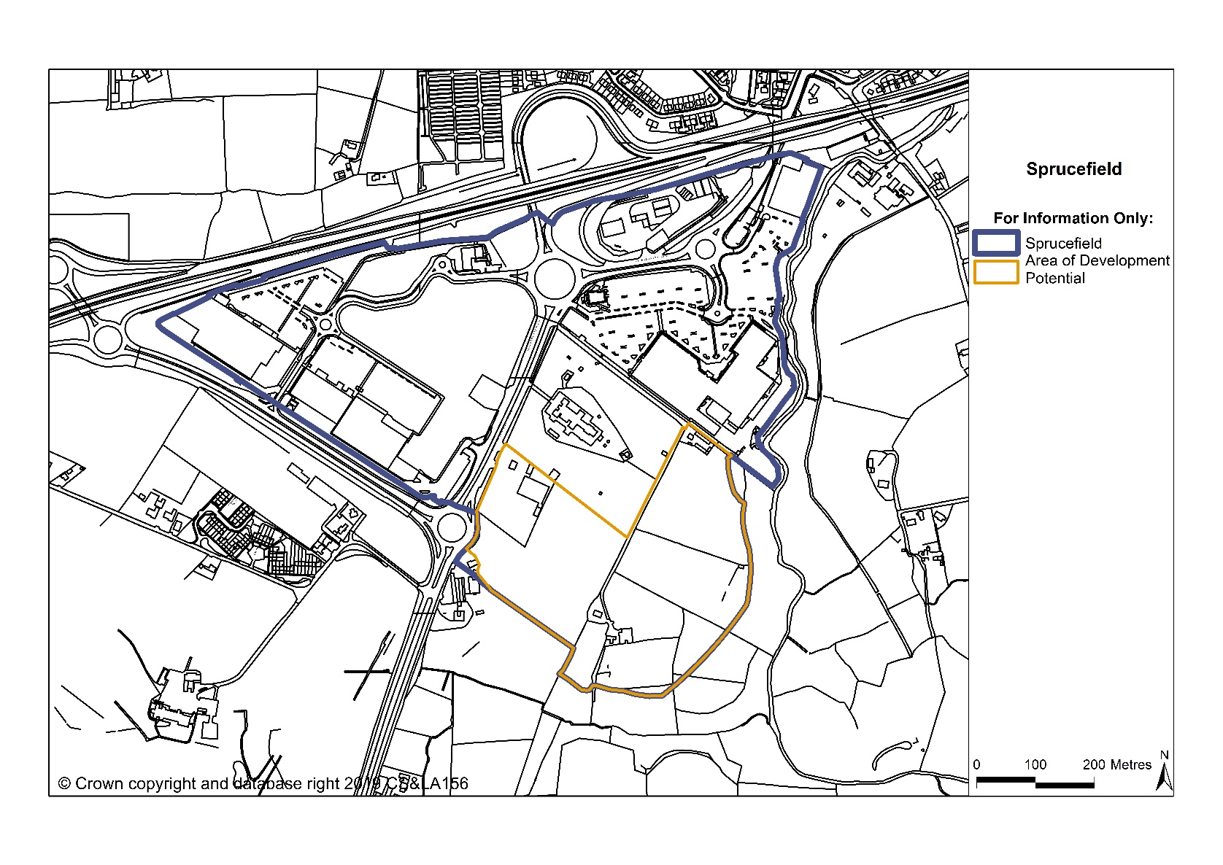

**Appendix 3 Carryduff**

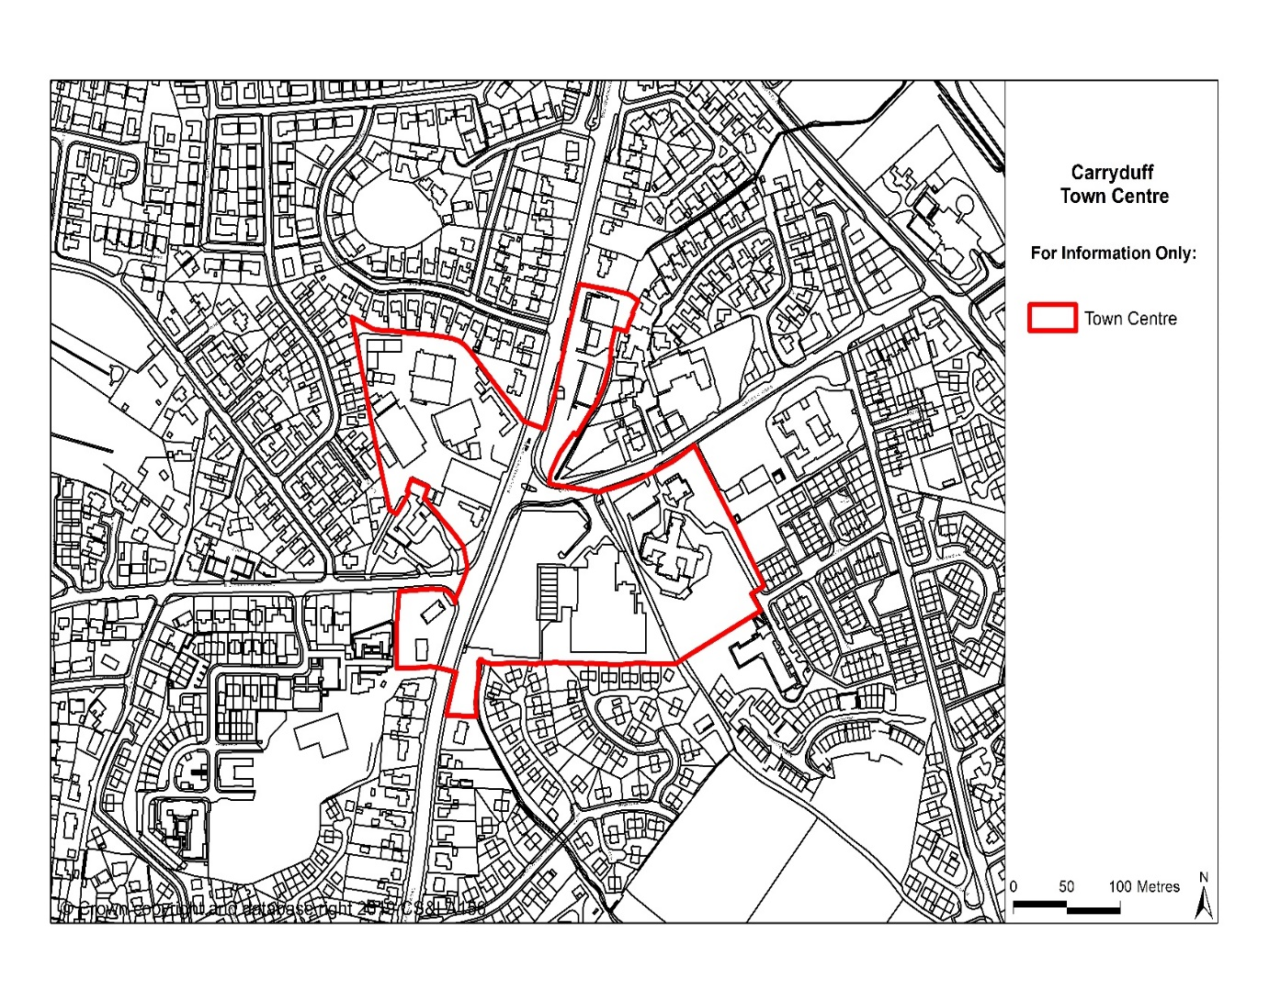

**Appendix 4 Forestside**

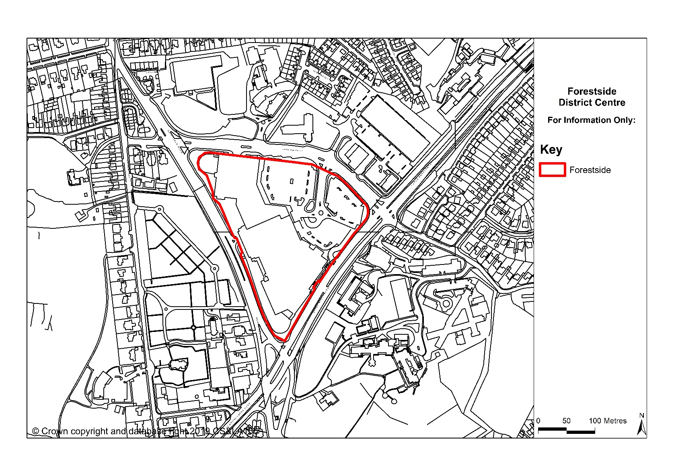

1. Lisburn City and Castlereagh form part of the Belfast Metropolitan Urban Area (BMUA). The nearest hubs are Craigavon and Banbridge to the South, Newtownards to the East and Antrim to the North.
2. Includes cultural and community facilities, retail, leisure, entertainment and businesses