Development Plan

Position Paper 1: Population and Growth
November 2019
Contents Page

Executive Summary 2
1.0 Introduction 3

2.0 Regional Policy Context 3

3.0 Existing Development Plan 6

4.0 Population Profile 7
5.0 Key Findings and Conclusion 31

Appendix
Appendix 1 - The Hierarchy of Settlements and Related
Infrastructure Wheel RDS 2035
Appendix 2 - Lisburn & Castlereagh City Council District Electoral Areas/Wards

Appendix 3 - District Electoral Area Profiles

Executive Summary

This Position Paper provides an overview of the population baseline and population growth in Lisburn & Castlereagh City Council to assist in the preparation of the Local Development Plan 2032.

The Local Development Plan is made within the context of a Sustainability Appraisal under the provision of Planning (Northern Ireland) Act 2011. This paper is therefore intended to provide a baseline position on which policy and proposals relating to population growth in the Local Development Plan can be shaped over the plan period.

It is important to stress that in compiling the Position Paper the best information available has been used however further revisions may be required in light of the release of any new data or updated policy, advice or information.

The paper provides an update on the previous Position Paper which was produced as part of the preparation of the Preferred Options Paper and has been informed by consultations with the relevant statutory consultees.

The aims of the paper are:

- to provide baseline information which will inform the Local Development Plan;
- to assess the future population growth of Lisburn & Castlereagh City Council; and
- to provide the spatial representation of the Council’s Community Plan having regard to other plans and strategies being undertaken by the Council.

1.0 INTRODUCTION

  - This paper examines the existing baseline and land availability for population growth in the Lisburn & Castlereagh City Council area.

  - Chapter 2 sets out the regional policy context for population growth, which is formulated within the context of the Regional Development Strategy (RDS) 2035 and the Strategic Planning Policy Statement for Northern Ireland (SPPS) and regional Planning Policy Statements (PPSs).

  - Chapter 3 outlines the current policy approach in the existing Plan context.

  - Chapter 4 provides an overview of the population baseline of the Council area along with an evaluation of future growth across the Council area up to 2032. It examines the existing population profile for Lisburn & Castlereagh City Council; additionally, for the purposes of comparison, data for the whole of Northern Ireland is also included. The paper explores the groups identified in Section 75 of the Northern Ireland Act 1998, spatial deprivation and the urban/rural divide. Population trends and population projections up are also considered. Information has been derived from the Northern Ireland Statistics and Research Agency (NISRA) and the Electoral Office NI.

1.5 The key findings and conclusion are provided in Chapter 5.

2.0 REGIONAL POLICY CONTEXT

The regional policy context is provided by the Regional Development Strategy (RDS) 2035, Strategic Planning Policy Statement for Northern Ireland (SPPS) and regional Planning Policy Statements (PPSs) where relevant. A summary of these documents in relation to plan making and population growth is provided in the following paragraphs.

Regional Development Strategy (RDS) 2035

2.1 The RDS provides an overarching strategic framework to facilitate and guide development in the public and private sectors in support of the Programme for Government (PfG). The RDS has a statutory basis prepared under the Strategic Planning (Northern Ireland) Order 1999. Local development plans must ‘take account’ of the RDS.

2.2 Sustainable development is at the heart of the Regional Development Strategy. The RDS aims to meet the needs of the present without compromising the ability of future generations to meet their own needs.

2.3 The RDS recognises that the population of Northern Ireland is projected to increase and reach 1.946 million by 2023, with a marked increase in the size of the population at older ages.

2.4 The Hierarchy of Settlements and Related Infrastructure Wheel (Annex 1) illustrates the range of public and private services needed to ensure citizens have access to the necessary economic, social and cultural opportunities.

2.5 This recognises that the population of rural hinterlands can also support services in urban centres, and access to services and facilities is important in meeting the needs of spatially dispersed populations.

2.6 The RDS provides strategic guidance through:

- Regional Guidance (RG); and

- Spatial Framework Guidance (SFG)

  - It recognises that diverse populations lead to more stable communities and can help reduce social isolation (RG 6).
  - The Spatial Framework of the RDS consists of 5 key components:
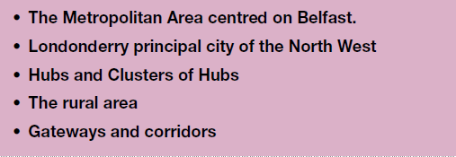

  - It states that within the Belfast Metropolitan Urban Area (BMUA) Lisburn benefits from its location at the meeting point of the Belfast/Dublin economic corridor and the East/West transport corridor.

  - In relation to the Rural Area, the RDS states that for the purpose of this spatial framework those places outside the Principal Cities, the Main and Local Hubs are identified as constituting the rural area. The population living in these places is around 40% of the total population of Northern Ireland. Recently the rural community living in small towns, villages, and small settlements in the countryside, has experienced the fastest rate of population growth. This reverses a long term trend of population decline.

Strategic Planning Policy Statement (SPPS)

  - The SPPS states that the objective of the planning system, consistent with Part 1, Section 1 of the Planning Act (Northern Ireland) 2011 (hereafter referred to as the 2011 Act), is to secure the orderly and consistent development of land whilst furthering sustainable development and improving well-being. This means the planning system should positively and proactively facilitate development that contributes to a more socially economically and environmentally sustainable Northern Ireland.
  - The planning system operates in the public interest of local communities and the region as a whole, and encompasses the present as well as future needs of society.

  - Sustainable development is at the heart of the SPPS and the planning system.

Role of the Local Development Plan

2.14 The SPPS states that the overarching purpose of the Plan Strategy is to provide the strategic policy framework for the plan area as a whole and to bring forward a local growth strategy.

3.0 EXISTING DEVELOPMENT PLAN

Belfast Metropolitan Area Plan 2015 (BMAP)

  - The Belfast Metropolitan Area Plan 2015 was prepared under the provisions of Part 3 of the Planning (Northern Ireland) Order 1991 by the former Department of the Environment (DoE). The Plan covers the City Council areas of Belfast and Lisburn, and the Borough Council areas of Carrickfergus, Castlereagh, Newtownabbey and North Down. The Plan was adopted on 9th September 2014, however the Court of Appeal declared the adopted plan unlawfully adopted on 18th May 2017.

  - As a result, the existing Development Plans covering the Council area are as follows:
- Belfast Urban Area Plan (BUAP) 2001
- Lisburn Area Plan (LAP) 2001
- Carryduff Local Plan 1988-1993
- Ballymacoss Local Plan
- Lisburn Town Centre Plan
- Lagan Valley Regional Park Local Plan 2005

3.3 BMAP in its post-inquiry form was at an advanced stage and therefore remains a material consideration. Draft BMAP (November 2004) in its pre-inquiry form also remains a material consideration in conjunction with recommendations of the Planning Appeals Commission Public Local Inquiry Reports.

3.4 Volume 3 and Volume 5 of Draft BMAP contain policies for the former Lisburn and Castlereagh Districts respectively. These policies were developed in the context of the Plan Strategy and Framework contained in Volume 1 of the Plan and in general conformity with the RDS.

3.5 The Plan sets out a settlement strategy and hierarchy which consists of:
- The Metropolitan Urban Area (Regional Capital; City/Towns; Small Towns); and
- The Metropolitan Rural Area (Small Towns; Villages; Small Settlements).

4.0 POPULATION PROFILE OF LISBURN & CASTLEREAGH

4.1 NISRA publishes population projections for Northern Ireland and also at Local Government level. These take into account migration, natural increase and other factors.

4.2 Population does not remain static, and while the Census 2011 provides us with a wealth of data regarding the profile of the District at that time, it cannot be used in isolation to determine the future needs of the area.
Population change occurs due to the combined effect of net migration (both in and out migration) and the level of natural increase which is the difference between the number of births and deaths.

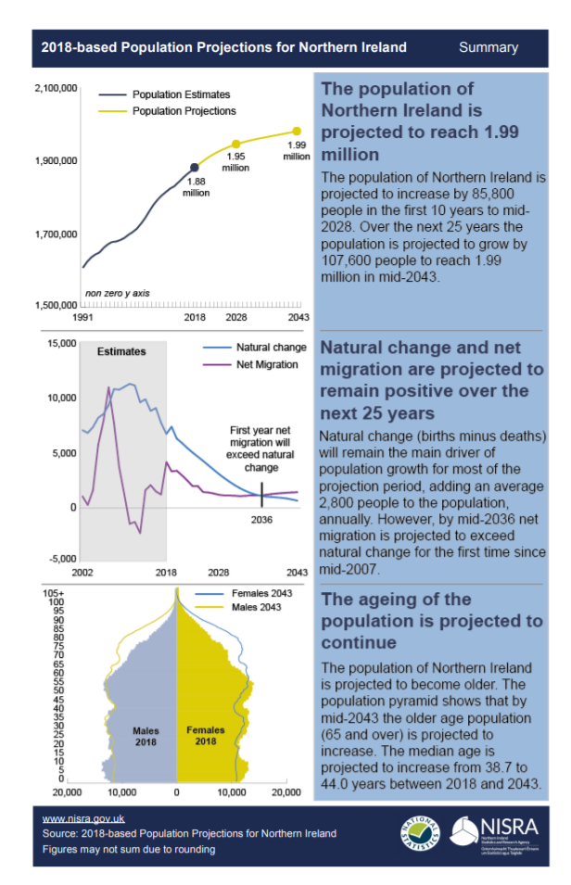

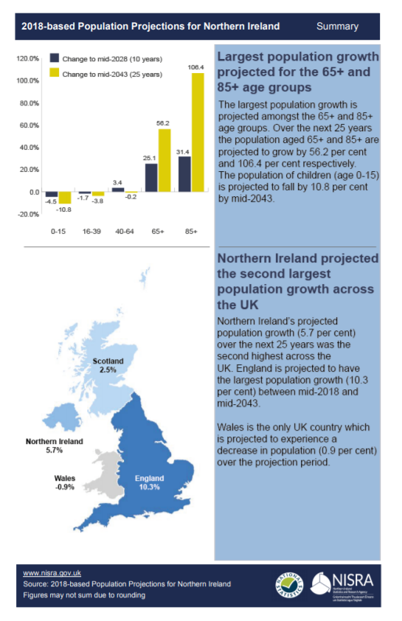

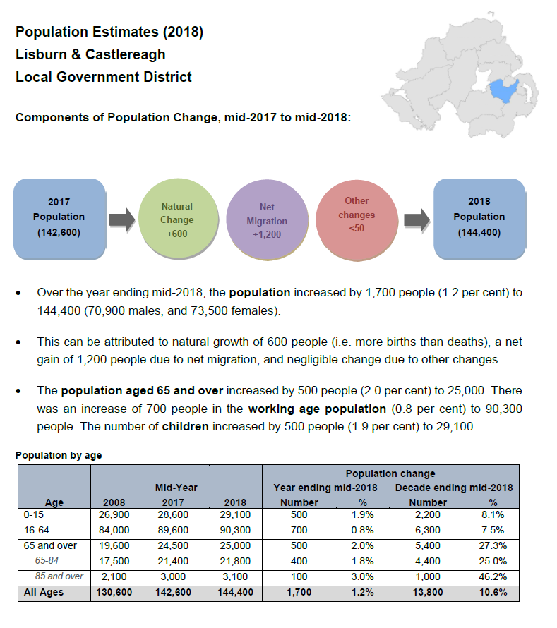

Source: NISRA 2018 Mid Year Population Estimates – Local Government District Factsheets

Table 1: Estimated Population Projections for Lisburn & Castlereagh City Council

 | 2019 | 2023 | 2027 | 2031 | 2036
Northern Ireland | 1,888,100 | 1,919,300 | 1,945,700 | 1,966,200 | 1,986,200
Lisburn & Castlereagh | 145,100 | 150,100 | 154,800 | 158,900 | 163,500

Source: NISRA Mid-2016 based population projections for areas within Northern Ireland, published on 26 April 2018. The next population projections (2018-based) will be released in 2020

4.2 Table 2 indicates the population and settlement hierarchy for settlements in Lisburn & Castlereagh City Council.

Table 2: Population by Settlement in Lisburn & Castlereagh City Council
Settlement Hierarchy | Lisburn & Castlereagh City Council Area | Total / % of District Total
City | Lisburn (45,410) | 45,410 (40%)
Lisburn Greater Urban Area | Lisburn Greater Urban Area (4,948) | 4,948 (4%)
Castlereagh Greater Urban Area | Castlereagh Greater Urban Area including Dundonald (30,717) | 30,717 (27%)
Towns | Carryduff (6,947)  Hillsborough & Culcavy (3,953)  Moira (4,584) | 15,484 (14%)
Villages | Aghalee (863); Annahilt (1045); Dromara (1,006); Drumbeg (813); Drumbo (375); Glenavy (1,791); Lower Ballinderry (912); Maghaberry (2,468); Milltown (1,499); Moneyreagh (1,379) Ravernet (564); Stoneyford (605); Upper Ballinderry (226) | 13,546 (12%)
Small Settlements | Ballyaughlis (99); Ballycarn (105); Ballyknockan; Ballylesson (111); Ballynadolly (79); Ballyskeagh (194); Boardmills; Carr; Crossnacreevy (317); Drumlough (74); Drumlough Road; Dundrod (193); Duneight (88); Feumore; Halfpenny Gate (80); Halftown (197); Hillhall (81); Kesh Bridge (122); Lambeg; Legacurry (82); Long Kesh (358); Lower Broomhedge (239); Lurganure (467); Lurganville (87); Lurgill; Magheraconluce (459); Morningside (55); Purdysburn; Ryan Park (141); St James (115); The Temple; Tullynacross (129); Upper Broomhedge (78) | 3,950 (3%)  3,492 (3%)
 | Total Population in Settlements (114,055)

(Source: BMAP 2015 & NISRA Headcount and Household Estimates for Settlements - March 2015) Please note: These settlements are based on settlement development limits provided for draft BMAP. The total population for the small settlements does not include any settlement with under 50 resident population. The settlements under 50 resident population are Boardmills, Carr, Drumlough Road, Feumore, Lambeg, Lurgill, Purdysburn, The Temple and Ballyknockan.

4.3 The total population of the Lisburn & Castlereagh City Council area is estimated to be approximately 144,381 (NISRA Mid-2018 Population Estimates for NI, published June 2019). Lisburn & Castlereagh City Council area comprises 7.7% of the population of N. Ireland.

Table 3: Population by Local Government District

Total NI Population | Local Government Districts | Population of District
1,881,641 | - Belfast | 341,877 (18.2%)
 | - Armagh City, Banbridge & Craigavon | 214,090 (11.4%)
 | - Newry, Mourne & Down | 180,012 (9.6%)
 | - Ards & North Down | 160,864 (8.5%)
 | - Derry City & Strabane | 150,679 (8.0%)
 | - Mid Ulster | 147,392 (7.8%)
 | - Lisburn & Castlereagh | 144,381 (7.7%)
 | - Causeway Coast & Glens | 144,246 (7.6%)
 | - Antrim & Newtownabbey | 142,492 (7.6%)
 | (10) Mid & East Antrim | 138,773 (7.4%)
 | - Fermanagh & Omagh | 116,835 (6.2%)

Source: NISRA Mid-2018 Population Estimates for NI published 26th June 2019

Section 75 Groups

4.4 The Northern Ireland Act 1998 places a statutory duty on public authorities to have due regard to the need to promote equality of opportunity:
- between persons of different religious belief, political opinion, racial
group, age, marital status or sexual orientation;
- between men and women generally;
- between persons with a disability and persons without; and
- between persons with dependants and persons without.
In addition, without prejudice to the above obligations, public authorities are required to have regard to the need to promote good relations between persons of different religious belief, political opinion or racial group.

4.4 The principle of promoting equality of opportunity and good relations between people must be a key objective behind the Local Development Plan and will be a central theme of the Equality Impact Assessment (EQIA). In land use planning terms this means ensuring everyone benefits from quality housing, employment, and access to public services and recreation facilities. These themes are addressed in more detail in the EQIA which is published alongside the draft Plan Strategy. However, this paper begins the process of identifying issues and needs facing different groups within the area over and above the general population, so that these can be considered at every stage of the plan making process. If an aim of the plan is also to help build a cohesive society then it must also be recognised that this can only be achieved by “sharing space” and “accessing opportunities”. Therefore, the paper also examines the extent to which segregation occurs and the pattern of multiple deprivation.

(A) Age Structure

4.5 The age structure of a population has implications for planning. A growing young population will impact on the demand for and provision of childcare facilities, nursery, primary and secondary schools. A growing working aged population would necessitate that planning provides adequate housing especially for those entering the housing market and seeking employment opportunities. For a growing elderly population, adequate services and housing to meet their specific needs must also be considered.

Table 4: Population Age Bands and Gender in Lisburn & Castlereagh
Age Band  Lisburn & Castlereagh | Gender  (Male) | Gender  (Female) | Total
0-15 | 15,075 | 14,051 | 29,126
16-39 | 21,582 | 20,973 | 42,555
40-64 | 23,068 | 24,680 | 47,748
65+ | 11,131 | 13,821 | 24,952
Total | 70,856 | 73,525 | 144,381

Source: NISRA Mid-2018 Population Estimates Age Bands and Gender - Administrative Areas, published June 2019

4.6 From the NISRA Mid-2018 Population Estimates Age Bands and Gender - Administrative Areas published June 2019, out of a total estimated population of 144,381 for the Council Area, of these 73,525 (50.9%) are Female and 70,856 (49.1%) are Male.

4.7 The most recent population estimates released by NISRA estimate Lisburn & Castlereagh City Council area has a population of 144,381 persons and 20.2% of these are under 16 years of age, 62.5% are aged 16-64 and 17.3% are over 65 years of age.

Table 5: Age Structure of Population – 2018

District | 0-15 years | 16-64 years | 65+ years
Lisburn & Castlereagh | 20.2% | 62.5% | 17.3%

Source: NISRA Mid-2018 Population Estimates

4.8 In 2018, around 20% of the population in Lisburn & Castlereagh was under 16. Given that young people do not have independent use of a car, the creation of safe and sustainable communities with access to recreation facilities, including play parks and sports grounds, remains high on the agenda.

4.9 Variations between age groups will require more targeted responses in regard to the type of services needed. The growing number of the elderly is a key factor in declining average household size. This has been taken into account by DRD when formulating the Regional Development Strategy 2035 Housing Growth Indicators. A Local Development Plan has a role in providing development land to meet these indicators (which will be discussed in the Housing Paper) and facilitate housing units to meet the needs of the elderly, particularly nursing homes, sheltered accommodation and smaller sized units. It also has a role in ensuring such units are accessible. Planning needs to ensure that housing for the elderly is sited where it is accessible to local services and transportation. These services include health and other community facilities along with recreation and shops. A rising elderly population will also increase demand for these, the development of which will need to be accommodated.

(B) Gender

4.10 The usually resident population in Lisburn & Castlereagh City Council and Castlereagh Borough Council is broadly split between males and females with 1.8% more females than males in 2018 (Table 6).

Table 6: Gender Balance in Lisburn & Castlereagh City Council
Sex | Lisburn & Castlereagh (%)
Male | 49.1%
Female | 50.9%

Source: NISRA 2018 Mid-Year Population Estimates

(C) Marital Status
4.11 The marital status of the population influences the composition of households and therefore the demand for housing. In Lisburn & Castlereagh in the total population aged over 16 years, 30.65% are not married and 53.78% are married. Only 0.1% are in a same-sex civil partnership, 3.27% are separated, 5.52% are divorced and 6.68% of the population are widowed.

Table 7: Marital Status in Lisburn & Castlereagh City Council
LGD2014 | All usual residents: Aged 16+ years | Single (never married or never registered a same-sex civil partnership): Aged 16+ years | Married: Aged 16+ years | In a registered same-sex civil partnership: Aged 16+ years | Separated (but still legally married or still legally in a same-sex civil partnership): Aged 16+ years | Divorced or formerly in a same-sex civil partnership which is now legally dissolved: Aged 16+ years | Widowed or surviving partner from a same-sex civil partnership: Aged 16+ years
Northern Ireland | 1,431,540 | 517,393  (36.14%) | 680,831  (47.56%) | 1,243  (0.09%) | 56,911  (3.98%) | 78,074  (5.45%) | 97,088  (6.78%)
Lisburn & Castle-reagh | 107,340 | 32,903  (30.65%) | 57,729  (53.78%) | 104  (0.1%) | 3,514  (3.27%) | 5,922  (5.52%) | 7,168  (6.68%)

Source: NISRA Local Government District 2014, Marital and Civil Partnership Status KS103NI (administrative geographies)

4.12 The role for planning is to adequately provide for appropriate housing to meet the needs of the population. This requires suitable housing units to be provided for single people. It is reasonable to assume that many single wage earners will not have the same purchase power of a double income household. Single people may also have different social needs to those who are married and have families. This grouping can be key to the economy of any town centres, providing a significant part of the market for a thriving night-time economy, e.g. pubs, clubs and restaurants. Conversely this can mask the level of social exclusion experienced by many single people, particularly the elderly, those on lower incomes, disabled and single parents. Single parents remain one of the most disadvantaged groups.

(D) Households With or Without Dependent Children

4.13 A “dependent child” is defined as 0-15 or aged 16-18 who is a full-time student and living in a family with his or her parent(s) or grandparent(s) (Census 2011). In both Northern Ireland and Lisburn City Council & Castlereagh City Council, the proportion of households (including lone parent households) with dependent children has declined.

In Lisburn & Castlereagh there are 3,518 lone parent households. From these households 1047 (29%) lone parents are in full time employment, 1269 (36%) are in part time employment and 1202 (34%) lone parents are not in employment.

Table 8: Lone Parent Households with Dependent Children
 | 2011
 | All lone parent households with dependent children: Lone parent aged 16-74 years | Lone parent households with dependent children: Lone parent aged 16-74 years in part-time employment | Lone parent households with dependent children: Lone parent aged 16-74 years in full-time employment | Lone parent households with dependent children: Lone parent aged 16-74 years not in employment
LGD2014 | All | All | All | All
Northern Ireland | 63921 | 20006 | 13945 | 29970
Antrim and Newtownabbey | 4893 | 1744 | 1336 | 1813
Ards and North Down | 4479 | 1608 | 1242 | 1629
Armagh City, Banbridge and Craigavon | 6337 | 1937 | 1599 | 2801
Belfast | 17036 | 5611 | 2775 | 8650
Causeway Coast and Glens | 4188 | 1181 | 899 | 2108
Derry City and Strabane | 7265 | 1939 | 1124 | 4202
Fermanagh and Omagh | 2788 | 735 | 656 | 1397
Lisburn and Castlereagh | 3518 | 1269 | 1047 | 1202
Mid and East Antrim | 4466 | 1512 | 1219 | 1735
Mid Ulster | 3485 | 993 | 789 | 1703
Newry, Mourne and Down | 5466 | 1477 | 1259 | 2730

Source: NISRA Lone Parent Households with Dependent Children: KS107NI (administrative geographies)

Retirement Benefits

4.14 In February 2016, 24,460 people living in Lisburn and Castlereagh were claiming retirement pension, 10,190 males aged 65+ and 14,270 females aged 60+. In the same year 4,150 living in Lisburn & Castlereagh received pension credit. Source NISRA Retirement Pension Claimants (administrative geographies).
(E) Household Size

Table 9: Household Composition in Lisburn & Castlereagh City Council

 | All Households | 1 Person Household (%) | 2 Person Household (%) | 3 Person Household (%) | 4 Person Household (%) | 5 or more Person Household (%)
NI | 736,470 | 205,233  (27%) | 228,266  (31%) | 120,080  (16%) | 106,443  (14%) | 76,448  (11%)
Lisburn & Castlereagh | 56,938 | 14,695  (26%) | 19,183  (34%) | 9,292  (16%) | 8,837  (16%) | 4,931  (9%)

Source NISRA 2016 – based household projections published 8th December 2018 for Local Government Districts

4.15 From the table above it can be identified that for Northern Ireland 2 person households are the most common at 31% and 1 person households the next largest at 27%. In Lisburn & Castlereagh 2 person households are also the most common at 34% with 1 person households the next most common at 26%.

4.16 It should also be noted that the average household size in 2019 for N. Ireland is 2.53 persons per household and for Lisburn & Castlereagh it is 2.51 persons per household. Projecting this forward to 2032 results in a decrease in household size to 2.46 and 2.44 respectively.

4.17 The Local Development Plan has a role in providing a range of houses types to meet the needs of different household sizes and to provide policy to facilitate those wishing to expand or downsize their houses to meet changing needs.

(F) Racial Group & Ethnicity

4.18 The 2011 Census figures indicate that 97.6% of the population in Lisburn & Castlereagh are White, 1% Asian, 0.5% Chinese, 0.2% Black, 0.4% Mixed and 0.1% Other.

4.19 An exception may be Irish Travellers who have been described as a different ethnic group. Their needs can be distinctive in terms of providing sites or supported housing for travellers. The housing needs assessment undertaken by the Northern Ireland Housing Executive addresses this matter and will be considered in a separate housing paper.

4.20 In terms of Country of birth Source: NISRA Country of Birth: KS204NI (administrative geographies) the following table identifies that the majority of people in Lisburn and Castlereagh (88%) are born in NI.

Table 10: NISRA Country of Birth: KS204NI (administrative geographies)
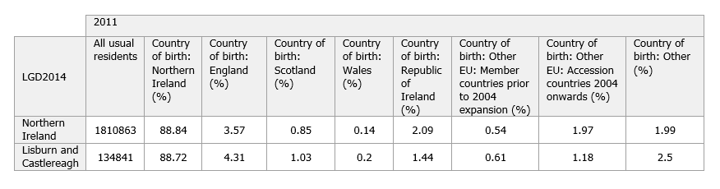
Source: NISRA

(G) Sexual Orientation

4.21 There are no specific figures available on how many people may be Gay, Lesbian, Bisexual or Transgender or Transsexual in Lisburn & Castlereagh City Council. People in this group can often feel excluded or marginalised in society. More importantly, they can also fall victim of discrimination and threat of physical violence. Whilst the Local Development Plan is unlikely to bring forward specific proposals and policies for this group, it is anticipated that many of the measures it contains, such as providing a range of house types, accessibility to employment and services, and improving safety and security, will benefit this group.

4.22 The Continuous Household Survey 2018/2019 (NISRA) found that 97.6% of all NI adult respondents identified themselves as heterosexual/straight with the remaining adults identifying as either gay/lesbian, bisexual, other or don’t know or not providing an answer.

Table 11: Continuous Household Survey – Sexual Identity
Persons aged 16 and over |  |  |  |  |  |  |  |  |  | Percentages
Sexual Identity | 2009-10 | 2010-11 | 2011-12 | 2012-13 | 2013-14 | 2014-15 | 2015-16 | 2016-17 | 2017-18 | 2018-19
Heterosexual/Straight | 93.0 | 94.1 | 94.6 | 95.0 | 94.7 | 95.9 | 97.9 | 97.7 | 97.8 | 97.6
Gay/Lesbian | 0.4 | 0.5 | 0.8 | 0.7 | 0.7 | 0.4 | 0.9 | 0.7 | 0.6 | 0.6
Bisexual | 0.4 | 0.3 | 0.6 | 0.9 | 0.9 | 0.5 | 0.5 | 0.3 | 0.5 | 0.6
Other | 0.4 | 0.5 | 0.1 | 0.6 | 0.6 | 0.7 | 0.3 | 0.4 | 0.3 | 0.6
Don't Know/Refusal | 5.9 | 4.7 | 4.0 | 2.9 | 3.1 | 2.4 | 0.4 | 0.9 | 0.7 | 0.5
Base=100% | 3,585 | 3,529 | 3,690 | 3,625 | 3,753 | 3,349 | 3,286 | 3,262 | 5,678 | 5,736
Source: Continuous Household Survey

(H) Disability & Health

4.23 On Census Day 27th March 2011, in Lisburn and Castlereagh Local Government District (2014):
- 18.29% of people had a long-term health problem or disability that limited their day-to-day activities;
- 82.13% of people stated their general health was either good or very good; and
- 12.51% of people stated that they provided unpaid care to family, friends, neighbours or others (KS301NI administrative geographies NISRA).

4.24 From NISRA figures for Adaptation of Accommodation, 90.49% of housholds in Lisburn & Castlereagh have no adaptation of accommodation. From the 10% that have adaptations, 4.82% are for wheelchair usage, 0.2% for visual difficulties, 0.43% for hearing difficulties, 5.3% for other physical or mobility issues and 0.16 adapted for other.

Table 12: NISRA Data set KS406NI Adaptation of Accommodation

 | 2011
LGD2014 | All households | Adapted accommodation: Wheelchair usage (%) | Adapted accommodation: Other physical or mobility difficulties (%) | Adapted accommodation: Visual difficulties (%) | Adapted accommodation: Hearing difficulties (%) | Adapted accommodation: Other (%) | No adaptation to accommodation (%)
Northern Ireland | 703275 | 6.4 | 6.48 | 0.27 | 0.55 | 0.2 | 87.96
Lisburn and Castlereagh | 52648 | 4.82 | 5.3 | 0.2 | 0.43 | 0.16 | 90.49

4.25 The link between health and wealth is well rehearsed as is the relationship between mobility and health. Therefore, as with other groups planning has a role in accommodating accessible housing, employment and services. Planning also has a role in helping to improve the health and well-being of people by avoiding development which would result in a deterioration in air or water quality; safeguarding and facilitating open space, sport and outdoor recreation; managing the adverse impacts of noise and nuisance by influencing the location, layout and design of new development. Planning also has a role in recognising and facilitating, where possible, development to meet the needs of carers (for example by adapting houses for those with special circumstances or extension of homes to include “granny annexes”).

- Religion

4.26 The Lisburn & Castlereagh population has a predominantly Protestant/Other Christian background, of almost 67%, which is much higher than the percentage for the region as a whole.

Table 13: Percentage of people & Religion belonging to or Religion in which they were brought up (2011)

 | 2011
LGD2014 | All usual residents | Religion or religion brought up in: Catholic (%) | Religion or religion brought up in: Protestant and Other Christian (including Christian related) (%) | Religion or religion brought up in: Other religions (%) | Religion or religion brought up in: None (%)
Northern Ireland | 1810863 | 45.14 | 48.36 | 0.92 | 5.59
Lisburn and Castlereagh | 134841 | 23.95 | 66.9 | 1.07 | 8.08
Source: NISRA Religion or Religion Brought Up In: KS212NI (administrative geographies)

Table 14: Percentage of people & Religion belonging to or Religion in which they were brought up - in Lisburn & Castlereagh City Council (2011)
 | 2011
SETT2015 | All usual residents | Religion or religion brought up in: Catholic (%) | Religion or religion brought up in: Protestant and Other Christian (including Christian related) (%) | Religion or religion brought up in: Other religions (%) | Religion or religion brought up in: None (%)
AGHALEE | 873 | 15.23 | 74.68 | 0.46 | 9.62
ANNAHILT | 1051 | 7.14 | 85.54 | 0.29 | 7.04
CARRYDUFF | 6961 | 49.85 | 42.24 | 1.36 | 6.55
DROMARA | 1006 | 21.77 | 68.89 | 0.99 | 8.35
DRUMBEG | 817 | 26.81 | 67.07 | 0.98 | 5.14
GLENAVY | 1784 | 84.19 | 11.94 | 0.39 | 3.48
HILLSBOROUGH AND CULCAVY | 3952 | 9.84 | 81.58 | 1.24 | 7.34
LISBURN CITY | 45370 | 22.24 | 67.32 | 1 | 9.44
LOWER BALLINDERRY | 917 | 23.99 | 65.21 | 0.65 | 10.14
MAGHABERRY | 2450 | 7.55 | 82.49 | 0.61 | 9.35
METROPOLITAN CASTLEREAGH (Pre Council Boundary Changes) | 55857 | 19.94 | 69.8 | 1.27 | 8.99
METROPOLITAN  LISBURN (Pre Council Boundary Changes) | 31186 | 77.31 | 18.79 | 0.6 | 3.3
MILLTOWN | 1499 | 37.69 | 53.3 | 0.87 | 8.14
MOIRA | 4591 | 19.45 | 71.55 | 1.18 | 7.82
MONEYREAGH | 1384 | 2.24 | 90.39 | 1.08 | 6.29
RAVERNET | 554 | 5.6 | 87 | 0.18 | 7.22
STONEYFORD | 605 | 35.87 | 53.72 | 0.83 | 9.59
Source: NISRA KS212NI (Settlement 2015)

4.27 The designation of settlements and provision of development opportunities needs to be carefully considered against the needs and spatial distribution of people of different religion or political opinion to prevent prejudice of any religious or political group and thus meet the requirements of Section 75 of the Northern Ireland Act.

(J) Political Opinion

4.28 In Northern Ireland, political opinion is viewed as being closely associated with religion affiliation. Table 15 shows the number of seats for each political party in the 7 District Electoral Areas (DEAs) in the Council Area. A profile of each of the District Electoral Areas is provided in the Appendix – Annex C.

Table 15: Political Opinion across Lisburn & Castlereagh City Council 2019

District Electoral Area | Number of Seats per Political Party
Castlereagh East | 3 DUP; 2 Alliance; 1 UUP
Castlereagh South | 2 Alliance; 1 DUP; 1 Sinn Fein; 1 SDLP; 1 UUP; 1 Green Party
Downshire East | 2 DUP; 2 UUP; 1 Alliance
Downshire West | 2 DUP; 2 UUP; 1 Alliance
Killultagh | 2 DUP; 1 UUP; 1 Sinn Fein; 1 Alliance
Lisburn North | 2 DUP; 2 UUP; 1 SDLP; 1 Alliance
Lisburn South | 3 DUP; 2 UUP; 1 Alliance
Total (40 Seats) | 15 DUP; 11 UUP; 9 Alliance; 2 SDLP; 2 Sinn Fein; 1 Green Party

Source: The Electoral Office of Northern Ireland

4.29 Care needs to be taken when making comparisons between communities of different religious/political persuasion as this can be extremely divisive and can unravel the definite progress made in bringing the two communities together.

Spatial Deprivation

4.30 Planning is required to be undertaken having regard to the need to promote equality of opportunity and to promote good relations. An important way of addressing this is to tackle social deprivation and inequalities in the labour market and public health. The Northern Ireland Multiple Deprivation Measure (NIMDM) 2017 identifies small area concentrations of multiple deprivation across Northern Ireland. The updated Northern Ireland Multiple Deprivation Measures (NIMDM 2017) were published by NISRA in 2017. NIMDM 2017 is the official measure of deprivation in Northern Ireland. It is based on the small area geography of 890 Super Output Areas (SOAs) which are ranked from 1 (most deprived) to 890 (least deprived). Many of these SOAs coincide with existing ward boundaries particularly the rural wards. The NIMDM brings together 38 different indicators which cover specific aspects of deprivation: Income, Employment, Health, Education, Proximity to Services, Living Environment and Crime & Disorder. These are combined to create the overall NIMDM.

4.31 The NIMDM 2017 provides information on seven types or ‘domains’ of deprivation and an overall multiple deprivation measure comprising a weighted combination of the seven domains. The majority of results are presented at the Super Output Area (SOA) geography. The 890 SOAs are ranked using an overall multiple deprivation measure where 1 is the most deprived and 890 the least deprived. Lisburn & Castlereagh has 67 SOAs. The most deprived SOA within the Lisburn and Castlereagh City Council area is Old Warren which is ranked 118 (which is amongst the top 15% most deprived in Northern Ireland). The least deprived SOA within the LCCC area is Galwally SOA which is ranked among the least deprived of the whole of Northern Ireland, ranking 883 in the overall multiple deprivation measure.

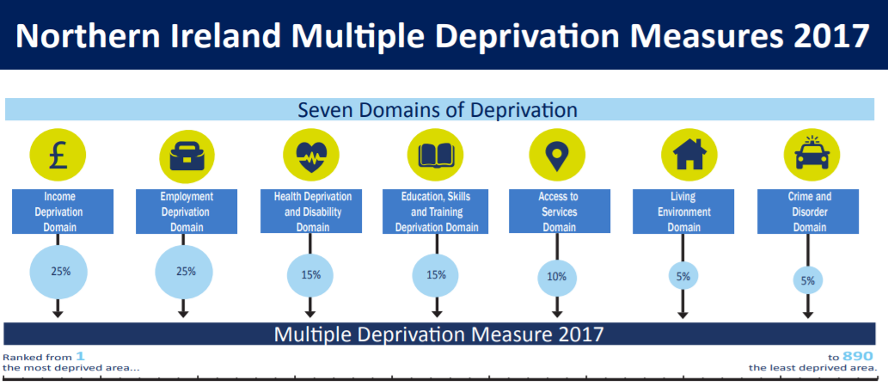Source: NISRA NI Multiple Deprivation Measure 2017 (NIMDM2017) released 23rd November 2017
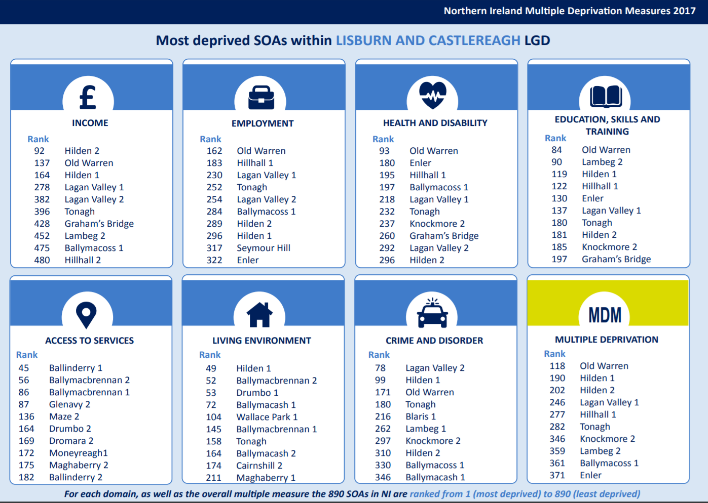

Source: NISRA NI Multiple Deprivation Measure 2017 (NIMDM2017) released 23rd November 2017
Multiple Deprivation Measure Rank  (where 1 is most deprived) | LGD2014NAME | 2015 Default Urban/Rural | SOA2001_name
118 | Lisburn and Castlereagh | Urban | Old Warren
190 | Lisburn and Castlereagh | Urban | Hilden_1
202 | Lisburn and Castlereagh | Urban | Hilden_2
246 | Lisburn and Castlereagh | Urban | Lagan Valley_1
277 | Lisburn and Castlereagh | Urban | Hillhall_1
282 | Lisburn and Castlereagh | Urban | Tonagh
346 | Lisburn and Castlereagh | Urban | Knockmore_2
359 | Lisburn and Castlereagh | Mixed urban/rural | Lambeg_2
361 | Lisburn and Castlereagh | Urban | Ballymacoss_1
371 | Lisburn and Castlereagh | Urban | Enler
380 | Lisburn and Castlereagh | Urban | Lagan Valley_2
410 | Lisburn and Castlereagh | Urban | Graham's Bridge
418 | Lisburn and Castlereagh | Urban | Seymour Hill
509 | Lisburn and Castlereagh | Urban | Blaris_1
511 | Lisburn and Castlereagh | Urban | Carrowreagh_2
535 | Lisburn and Castlereagh | Urban | Ballymacoss_2
567 | Lisburn and Castlereagh | Mixed urban/rural | Derryaghy_3
576 | Lisburn and Castlereagh | Urban | Knockmore_1
606 | Lisburn and Castlereagh | Mixed urban/rural | Lambeg_1
645 | Lisburn and Castlereagh | Rural | Glenavy_2
646 | Lisburn and Castlereagh | Rural | Maze_2
655 | Lisburn and Castlereagh | Urban | Ballymacash_1
659 | Lisburn and Castlereagh | Rural | Ballymacbrennan_2
673 | Lisburn and Castlereagh | Rural | Ballinderry_1
675 | Lisburn and Castlereagh | Rural | Dromara_2
690 | Lisburn and Castlereagh | Mixed urban/rural | Hillhall_2
695 | Lisburn and Castlereagh | Rural | Ballinderry_2
700 | Lisburn and Castlereagh | Rural | Ballymacbrennan_1
703 | Lisburn and Castlereagh | Rural | Glenavy_1
709 | Lisburn and Castlereagh | Rural | Drumbo_2
712 | Lisburn and Castlereagh | Rural | Maghaberry_1
723 | Lisburn and Castlereagh | Mixed urban/rural | Ballymacoss_3
725 | Lisburn and Castlereagh | Urban | Carryduff East_2
733 | Lisburn and Castlereagh | Urban | Beechill_2
740 | Lisburn and Castlereagh | Rural | Moneyreagh_2
742 | Lisburn and Castlereagh | Rural | Maghaberry_2
753 | Lisburn and Castlereagh | Urban | Magheralave_1
764 | Lisburn and Castlereagh | Rural | Drumbo_1
769 | Lisburn and Castlereagh | Rural | Dromara_1
784 | Lisburn and Castlereagh | Urban | Ballyhanwood_1
787 | Lisburn and Castlereagh | Rural | Maze_1
796 | Lisburn and Castlereagh | Rural | Moira_2
804 | Lisburn and Castlereagh | Rural | Moira_1
807 | Lisburn and Castlereagh | Urban | Dundonald_1
809 | Lisburn and Castlereagh | Urban | Lisnagarvey
812 | Lisburn and Castlereagh | Rural | Hillsborough_2
814 | Lisburn and Castlereagh | Urban | Carryduff East_1
815 | Lisburn and Castlereagh | Urban | Newtownbreda
821 | Lisburn and Castlereagh | Mixed urban/rural | Moneyreagh_1
827 | Lisburn and Castlereagh | Mixed urban/rural | Ballyhanwood_2
837 | Lisburn and Castlereagh | Mixed urban/rural | Blaris_2
838 | Lisburn and Castlereagh | Urban | Dundonald_2
842 | Lisburn and Castlereagh | Urban | Wallace Park_2
844 | Lisburn and Castlereagh | Urban | Ballymacash_2
845 | Lisburn and Castlereagh | Urban | Cairnshill_2
851 | Lisburn and Castlereagh | Mixed urban/rural | Carryduff West_1
852 | Lisburn and Castlereagh | Urban | Harmony Hill
853 | Lisburn and Castlereagh | Urban | Beechill_1
857 | Lisburn and Castlereagh | Urban | Magheralave_2
858 | Lisburn and Castlereagh | Urban | Wallace Park_1
860 | Lisburn and Castlereagh | Urban | Carrowreagh_1
862 | Lisburn and Castlereagh | Rural | Hillsborough_1
867 | Lisburn and Castlereagh | Urban | Knockbracken_2
870 | Lisburn and Castlereagh | Urban | Knockbracken_1
872 | Lisburn and Castlereagh | Urban | Carryduff West_2
880 | Lisburn and Castlereagh | Urban | Cairnshill_1
883 | Lisburn and Castlereagh | Urban | Galwally

Source: NISRA Multiple Deprivation Measure 2017 (NIMDM 2017) released 23rd November 2017 - (67 Super Output Areas (SOAs) in Lisburn & Castlereagh)

4.32 The advantage of this spatially led approach is that it identifies disparities between urban and rural areas and adjoining neighbourhoods. Generally speaking the existing urban areas of Lisburn & Castlereagh District have the more deprived SOAs. There are 67 SOAs within the Lisburn and Castlereagh Council area, over one third of the SOAs are ranked in the top 10% least deprived in the NIMDM 2017.

4.33 The highest concentrations of deprivation with respect to proximity to services (i.e. long distances to key services e.g. A&E hospital, GP premises, supermarket, leisure centres) occur outside towns and cities, for example Glenavy 2.

4.34 Deprivation is also reflected in economic activity. In 2017 the employment rate was 75% and was higher in Lisburn & Castlereagh City Council than the NI average of 69%. (Table 16). Lisburn & Castlereagh Local Government District also has the highest level of education with over 40% achieving degree level or above. (Table 17). The number claiming job seekers allowance was also lower in the Council District compared to the NI average (Table 18).

Table 16: Employment Rate (16-64) by Local Government District
Local Government District | Employment Rate (%)
Derry City and Strabane | 56.8
Causeway Coast and Glens | 61.0
Belfast | 65.1
Newry Mourne and Down | 65.5
Fermanagh and Omagh | 67.3
Northern Ireland | 69.0
Mid and East Antrim | 70.5
Armagh City, Banbridge and Craigavon | 73.2
Mid Ulster | 74.8
Lisburn and Castlereagh | 75.9
Ards and North Down | 75.9
Antrim and Newtownabbey | 76.0

Source: Labour Force Survey (LFS) Annual Report 2017 released 25th September 2018. The LFS is the largest regular household survey carried out in Northern Ireland.

Source: Labour Force Survey (LFS) Annual Report 2017 released 25th September 2018

Table 17: Highest Level of Qualification attained (16-64) by Local Government District 2017
Local Government District | No Qualifications (%) | Achieved below degree level (%) | Achieved degree level or above (%)
Lisburn and Castlereagh | 9.7 | 49.6 | 40.7
Antrim and Newtownabbey | 11.6 | 54.7 | 33.6
Ards & North Down | 14.9 | 50.3 | 34.7
Armagh City, Banbridge and Craigavon | 15.0 | 54.4 | 30.5
Mid and East Antrim | 15.6 | 54.0 | 30.4
Causeway Coast and Glens | 16.1 | 56.0 | 27.9
Fermanagh and Omagh | 16.1 | 52.2 | 31.6
Northern Ireland | 16.5 | 51.2 | 32.3
Derry City and Strabane | 17.3 | 55.4 | 27.3
Belfast | 18.8 | 46.0 | 35.2
Mid Ulster | 19.7 | 48.6 | 31.7
Newry Mourne and Down | 22.1 | 49.0 | 28.9
Source: Labour Force Survey 2017

Source: Labour Force Survey 2017

Table 18: Claimant Count by Local Government District (Job Seekers Allowance)

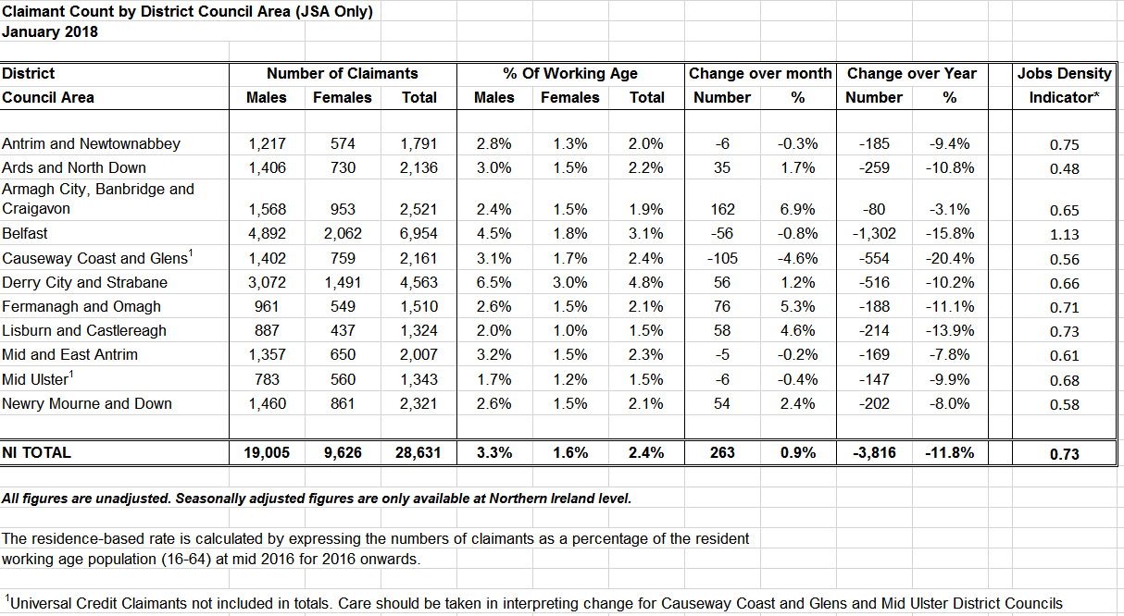

Source: NISRA Claimant Count by Local Government District January 2018

5.0 KEY FINDINGS AND CONCLUSION

5.1 A summary of the key findings are as follows:
- It is anticipated that the population of Lisburn & Castlereagh City Council will continue to grow over the Plan period.

- Over the Plan period, the demand for facilities to cater for the needs of older people will grow. Many older people have to live on reduced incomes, have disabilities and reduced mobility. This influences not only the number of new houses required but also the design (e.g. suitability for disabled residents); the need for more retirement homes, nursing and care homes and the need for housing support services. Ease of access to community facilities, general recreation and shops will also be important.

- An increase in pension age will increase the number of people of working age, resulting in the need for more jobs, particularly for women. The Plan should provide sufficient employment land to meet the expected employment needs.

- The community is not ethnically diverse with 97.6% described as ‘white’. However, the needs of minority groups such as Irish Traveller must be taken into account.

- Although recent trends would suggest that the proportion of children under 16 years is set to decline slightly, this group will influence the demand for and provision of childcare facilities, nursery, primary and secondary schools as well as accessibility to community and leisure facilities. Any such facilities identified by education providers will be reflected in the Plan.

- There are some communities within the Council area which experience problems of multiple deprivation particularly in parts of Lisburn City and Dundonald, where income and employment are the key concerns. The Plan can help tackle social deprivation and inequalities in the labour market by providing enough employment land which is accessible to the majority of people; improve local provision and access to social and community facilities.

- The location and design of development is likely to have a significant impact on equality of opportunity and community relations between different groups based on religion, political opinion, age, gender, disability and people with and without dependants. The new Local Development Plan will need to have special regard to these groups and their needs and any impact upon them are examined through the Equality Impact Assessment.

- Overall, the health of the area is improving with people living longer. However, there are inequalities in health across the area with long term disability being a particular problem. The Plan has a role in helping to improve the health and well-being of people by avoiding development which would result in a deterioration in air or water quality; safeguarding and facilitating open space, sport and outdoor recreation; managing the adverse impacts of noise and nuisance by influencing the location, layout and design of new development; supporting provision of jobs and services.

- Household size is expected to decrease with more single and mature single household formations, particularly with an older population. This will influence the number, type and size of houses needed. The Plan has a role in identifying appropriate sites for housing and can specify where the development of certain house types or a mix of house types will be required including social and affordable housing delivery.

CONCLUSION

5.2 Following on from the original Position Paper in September 2015, the purpose of this paper has been to update the baseline information regarding the population profile within the Lisburn & Castlereagh City Council area. This baseline will support the preparation of the Plan Strategy and Local Policies Plan, and as the process evolves will be updated/amended as necessary taking account of all relevant new information made available.

Appendix 1: The Hierarchy of Settlements and Related Infrastructure Wheel RDS 2035

(Source: RDS 2035)
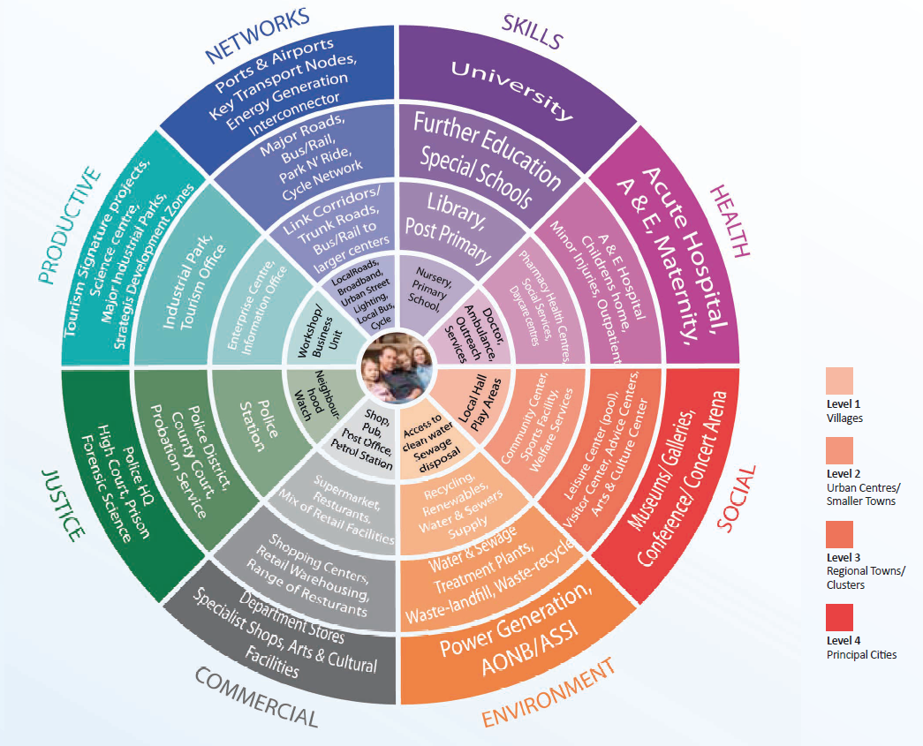
Appendix 2: Lisburn & Castlereagh City Council DEAs/Wards

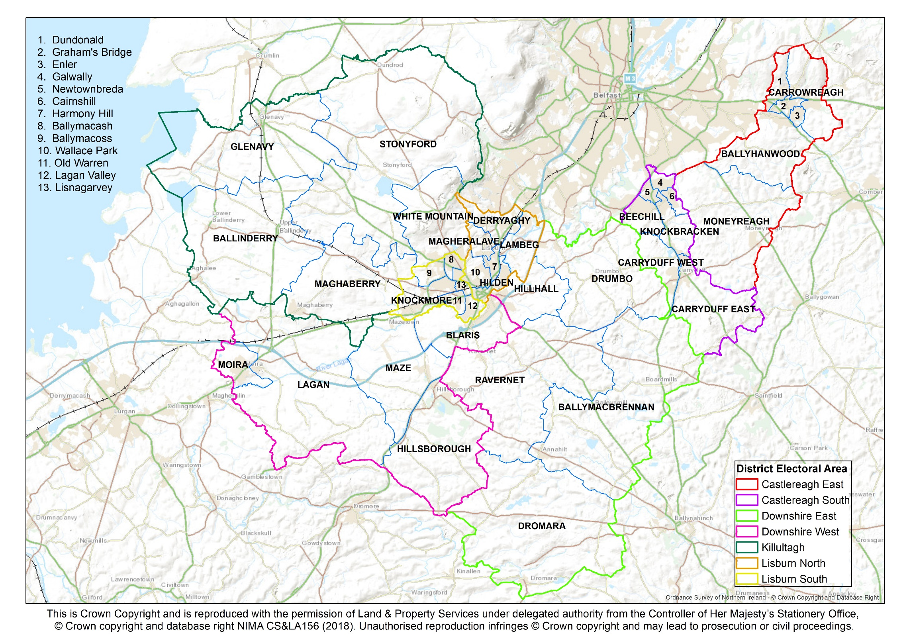

Appendix 3: The 7 District Electoral Area (DEA) Profiles in Lisburn & Castlereagh

- Castlereagh East
- Castlereagh South
- Downshire East
- Downshire West
- Killultagh
- Lisburn North
- Lisburn South

- CASTLEREAGH EAST

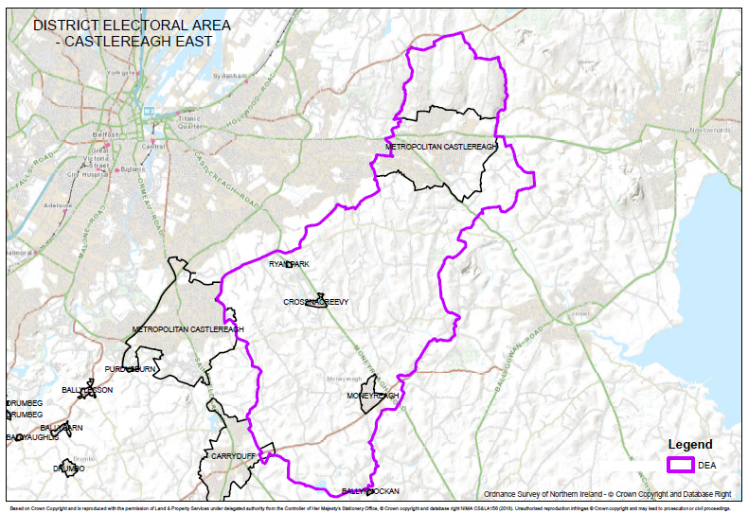
Population in DEA  (NISRA Mid 2017 Pop Estimates for DEAs – published Feb 2019) | 19,950
Political Opinion | 2019 Local Council Election Results  District Electoral Area (DEA) Number of Seats (Political Party)  Castlereagh East 3 (DUP); 2 (Alliance); 1 (UUP)  (Source: The Electoral Office of Northern Ireland)
Key Settlements | Castlereagh Greater Urban Area (Dundonald)  Moneyreagh  Crossnacreevy  Ryan Park  Small part of Carryduff and area around Cairnshill
Environmental Characteristics | Natural  2 Areas of High Scenic Value-Craigantlet Escarpment & Castlereagh Escarpment  4 Landscape Wedges-Carryduff, Comber, Newtownards & Dundonald  1 Area of Special Scientific Interest (ASSI)-Craigantlet Woods  Built  1 Area of Townscape Character – Dundonald  1 Area of Village Character – Moneyreagh
Level of Services/ Facilities | Services and Facilities:  Ulster Hospital, Dundonald Ice Bowl, Police Station – Upper Newtownards Road, Dundonald House Government Offices, Dundonald Enterprise Park, Carrowreagh Business Park, Maryland Industrial Estate  Schools in the DEA:  Approximately 2 primary schools, 1 high school, 1 special school and 3 nurseries  Recreational uses in the DEA include:  Dungoyne Community Centre, Ballyoran Community Centre, Enler Centre, Mount Ober Golf Club, Castlereagh Hills Golf Club, Streamvale Open farm  Other Services:  Roselawn Cemetery and associated landscaping
Transport Facilities | Comber Greenway  Major Road Proposal at Quarry Corner/Comber Road  The Glider Rapid Transit Scheme  The DEA contains some Transport NI Protected Routes:  A20, A22, A23
Key Challenges | - Ensure Dundonald attains own village individual identity  - Tackle traffic problems  - Support Active Travel and the Rapid Transit Scheme (The Glider)  - Maintain Landscape Wedges in the DEA  - Maintain recreation/tourism with Dundonald International Ice Bowl  - Promote tourism/recreation in Craigantlet Hills/Castlereagh Escarpment

- CASTLEREAGH SOUTH

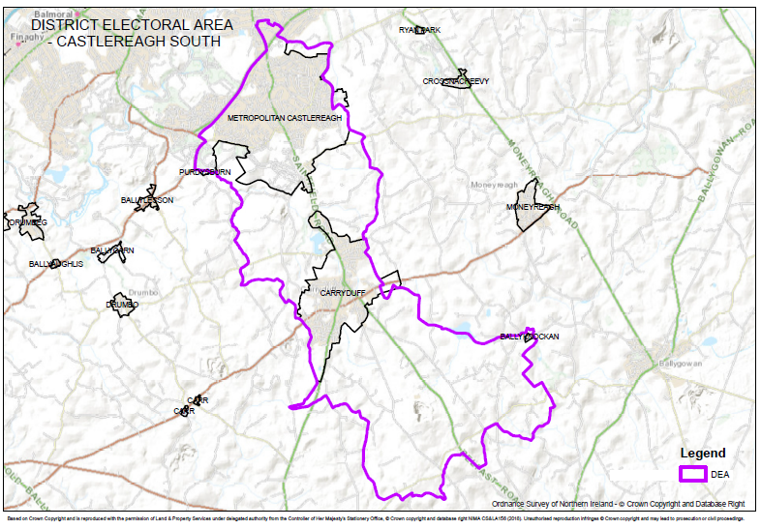
Population in DEA  (NISRA Mid 2017 Pop Estimates for DEAs – published Feb 2019) | 23,850
Political Opinion | 2019 Local Council Election Results  District Electoral Area (DEA) Number of Seats (Political Party)  Castlereagh South 2 (Alliance); 1 (DUP); 1 (Sinn Fein); 1 (SDLP); 1 (UUP); 1 (Green Party)  (Source: The Electoral Office of Northern Ireland)
Key Settlements | Castlereagh Greater Urban Area  Carryduff  Ballyknockan
Environmental Characteristics | Natural  2 Areas of High Scenic Value-Castlereagh Escarpment & Castlereagh Slopes  1 Area of Outstanding Natural Beauty- Lagan Valley  1 Regional Park-Lagan Valley Regional Park  2 Landscape Wedges-Glencregagh & Carryduff  Built  1 Area of Townscape Character – Newtownbreda  1 Historic Park, Garden and Demesne - Purdysburn House
Level of Services/ Facilities | Services and Facilities:  Forestside District Shopping Centre, Drumkeen Retail Park, Bradford Court Council Offices, Forster Green Hospital & City Mortuary, The Knockbreda Centre Health Care Offices, The Lindsay School Educational Facility, Mount Oriel Library, 2 doctor’s surgeries and 1 dentist, Beechill Business Park, Trading Standards Offices, Transport NI/Rivers Agency HQ –Eastern Division, Saintfield Road Shops, Knockbracken Healthcare Park, Four Winds Restaurant & Shopping Centre, Ivanhoe Hotel, Carryduff Business Park, Fire Station, City Auctions, Library, Carryduff Shopping Centre, Lowes Industrial Estate, Woodlawn Garden Centre.  Schools in the DEA:  Approximately 5 primary schools and 2 high schools.  Recreational uses in the DEA include:  Hydebank Playing Fields, Lough Moss Leisure Centre, Carryduff Park, Knockbracken Golf Academy  Other Services:  Knockbrackan Reservoir, Hydebank Young Offenders Prison, Hydebank Territorial Army Centre, Carryduff Recycling Civic Amenity Council Site
Transport Facilities | Cairnshill Park & Ride, Metro/Ulsterbus network  Major Road Proposal/Relief Road at Cairnshill/Outer Ring  Lack of rail/bus facilities  The DEA contains some Transport NI Protected Routes:  A7, A24, A55
Key Challenges | - Maintain green wedge between Castlereagh and Carryduff  - Reduce traffic congestion  - Regeneration of Carryduff town centre  - Maintain and control Forestside as a District Centre  - Promote Knockbracken Healthcare Park as a Strategic Mixed Use Site/Major Employment Location  - Promote tourism/recreation for Castlereagh Hills

- DOWNSHIRE EAST

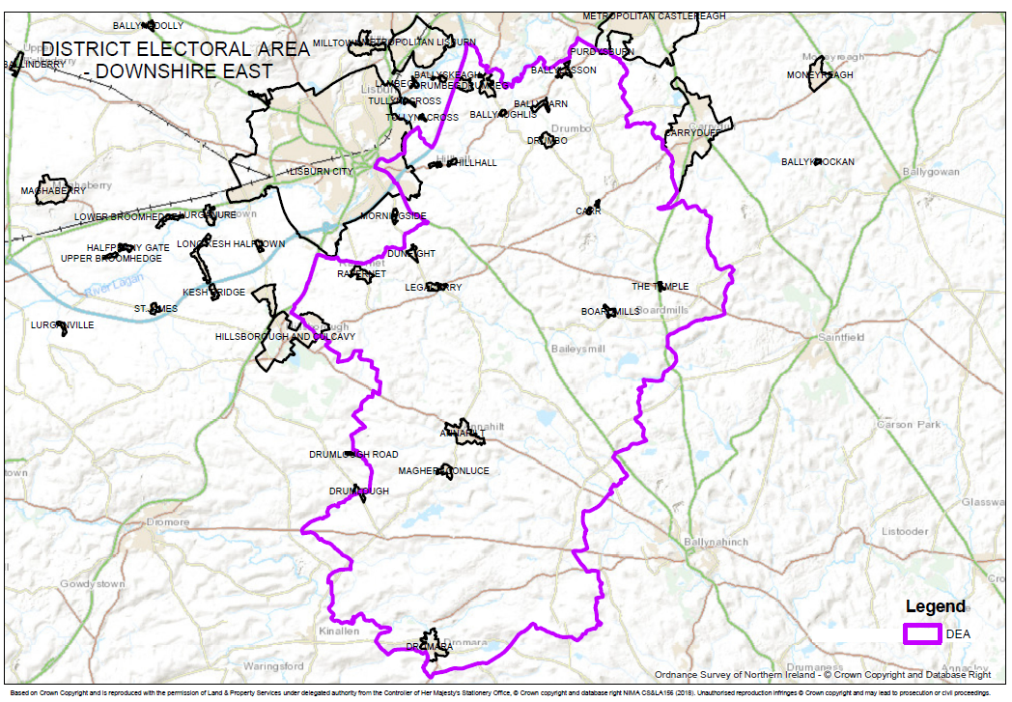
Population in DEA  (NISRA Mid 2017 Pop Estimates for DEAs – published Feb 2019) | 16,470
Political Opinion | 2019 Local Council Election Results  District Electoral Area (DEA) Number of Seats (Political Party)  Downshire East 2 (DUP); 2 (UUP); 1 (Alliance)  (Source: The Electoral Office of Northern Ireland)
Key Settlements | Part of Lisburn City  Part of Hillsborough & Culcavy  Annahilt  Dromara  Drumbeg  Drumbo  Ravernet  Ballyaughlis  Ballycarn  Ballylesson  Boardmills  Carr  Duneight  Hillhall  Legacurry  Magheraconluce  Purdysburn  The Temple  Part of Drumlough
Environmental Characteristics | Natural  2 Areas of High Scenic Value-Magheraknock Loughs & Castlereagh Slopes.  1 Area of Outstanding Natural Beauty-Lagan Valley.  1 Regional Park-Lagan Valley.  Built  2 Areas of Village Character – Drumbeg and Purdysburn  2 Historic Parks, Garden and Demesne – Belvedere and Larchfield
Level of Services/ Facilities | Services and Facilities:  Industrial sites – Hillhall Road/Orr’s Lane, Ballylesson garden centre  Schools in the DEA:  Approximately 6 primary schools.  Recreational uses in the DEA include:  Temple Golf Club, Dromara community centre, Dromara doctors surgery
Transport Facilities | A small section of the M1 passes through the DEA  Reliance on limited bus services for public transport  The DEA contains some Transport NI Protected Routes:  M1, A24, A49, B6, B23
Key Challenges | - Promote Lagan Valley Regional Park for tourism/recreation  - Improve traffic flow through small settlements on Hillhall Road  - Promote Magheraknock Loughs ASSI as a tourism/recreation attraction

- DOWNSHIRE WEST

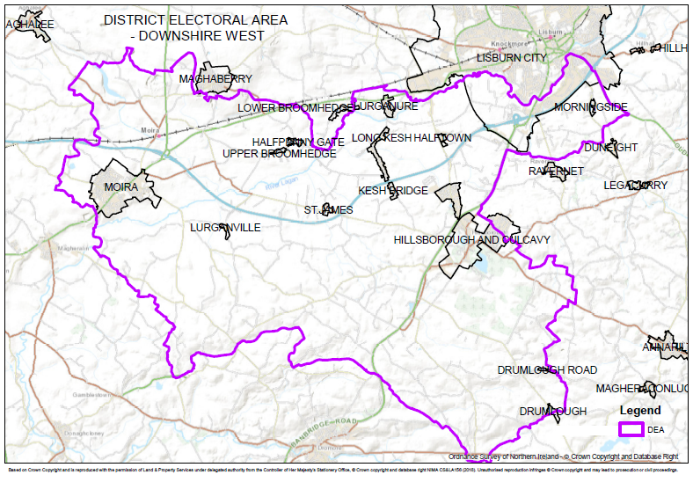
Population in DEA  (NISRA Mid 2017 Pop Estimates for DEAs – published Feb 2019) | 16,740
Political Opinion | 2019 Local Council Election Results  District Electoral Area (DEA) Number of Seats (Political Party)  Downshire West 2 (DUP); 2 (UUP); 1 (Alliance)  (Source: The Electoral Office of Northern Ireland)
Key Settlements | Part of Lisburn City  Hillsborough and Culcavy  Moira  Drumlough  Drumlough Road  Halfpenny Gate  Halftown  Kesh Bridge  Long Kesh  Lurganure  Lurganville  Morningside  St. James  Upper Broomhedge
Environmental Characteristics | Natural  1 Regional Park-Lagan Valley Regional Park.  2 Areas of Special Scientific Interest (ASSI)-Ballynanaghten & Clarehill, Moira.  Built  2 Conservation Areas – Hillsborough/Culcavy and Moira  3 Historic Parks, Gardens and Demesne – Moira Castle, Kilwarlin Moravian Church, Hillsborough Castle
Level of Services/ Facilities | Services and Facilities:  Hillsborough Castle and grounds, Hillsborough Heath Centre, Maze Long Kesh site, Sprucefield Regional shopping centre  Schools in the DEA:  Approximately 3 primary schools, 1 special school and 1 nursery school  Recreational uses in the DEA include:  Lisburn golf course, Down Royal racecourse and golf course, Hillsborough Village Community Centre, Moira Village Centre, Hillsborough Forest Park, Moira Demesne.
Transport Facilities | A large section of the M1, A1 and railway flow through the DEA  Major junction at Sprucefield  Most settlements have easy access to main trunk road network  The DEA contains some Transport NI Protected Routes:  M1, A1, A3, A26, A520  Rail halt at Moira
Key Challenges | - Proposed M1/A1 Strategic Link Road  - Proposed Knockmore Link Road  - Promote development at Sprucefield that does not have significant negative effects for Lisburn city centre  - Development of Maze Strategic Land Reserve  - Promote Hillsborough (Castle) as a tourist destination  - Maintain Moira as a commuter settlement, linking the railway station with the town

- KILLULTAGH

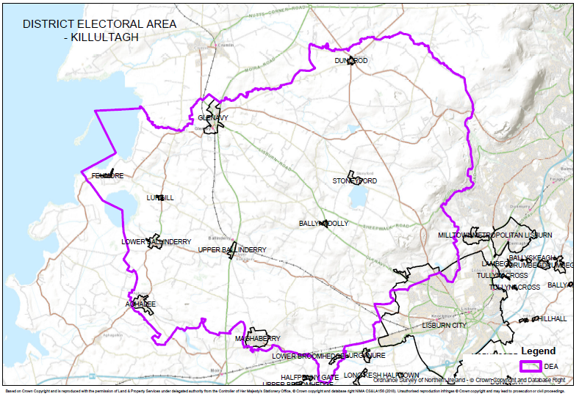
Population in DEA  (NISRA Mid 2017 Pop Estimates for DEAs – published Feb 2019) | 20,770
Political Opinion | 2019 Local Council Election Results  District Electoral Area (DEA) Number of Seats (Political Party)  Killultagh 2 (DUP); 1 (UUP); 1 (Sinn Fein); 1 (Alliance);  (Source: The Electoral Office of Northern Ireland)
Key Settlements | Part of Lisburn City  Aghalee  Glenavy  Lower Ballinderry  Maghaberry  Stoneyford  Upper Ballinderry  Ballynadolly  Dundrod  Feumore  Lower Broomhedge  Lurganville  Lurgill
Environmental Characteristics | Natural  1 Ramsar Site-Lough Neagh & Lough Beg  1 Special Protected Area – Lough Neagh & Lough Beg  4 Areas of Special Scientific Interest (ASSI) -Lough Neagh, Leathemstown, Slievenacloy, Maghaberry  2 Areas of High Scenic Value (AoHSV) - Portmore Lough & Belfast Basalt Escarpment  Belshaws Quarry – National Nature Reserve  Built  3 Areas of Village Character – Upper Ballinderry, Lower Ballinderry, Glenavy  3 Historic Parks, Gardens and Demesnes – Portmore, Brookhill, Springfield
Level of Services/ Facilities | Services and Facilities:  Ulster Farm Factory – Ballyvannon Road (Glenavy), Garden Nursery – Shore Road (Glenavy), Ballymac Hotel, Garden Nursery – Dornan’s Road (Feumore), Clinic – Lurgan Road, Aghalee, Maghaberry community centre, HMP Maghaberry  Schools in the DEA:  Approximately 4 primary schools, 1 special school and 1 nursery school
Transport Facilities | The DEA contains some Transport NI Protected Routes:  A26, B101  There is also a disused railway line running NW-SE of the DEA (Lisburn – Airport)
Key Challenges | - Re-activate Lisburn – International Airport railway  - Conserve/promote Lough Neagh for recreation/tourism  - Improve access for the enjoyment of Stoneyford Reservoir

- LISBURN NORTH

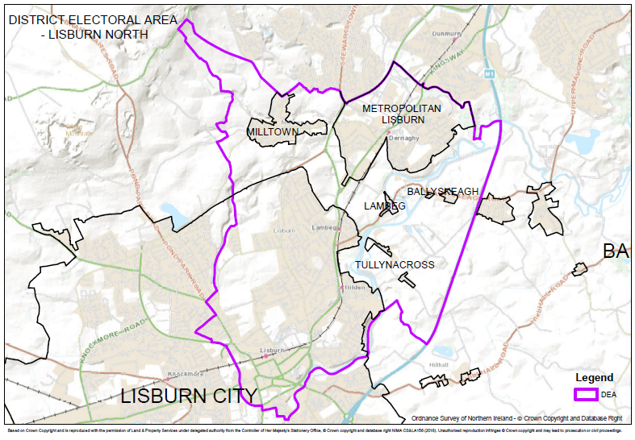
Population in DEA  (NISRA Mid 2017 Pop Estimates for DEAs – published Feb 2019 | 22,380
Political Opinion | 2019 Local Council Election Results  District Electoral Area (DEA) Number of Seats (Political Party)  Lisburn North 2 (DUP); 2 (UUP); 1 (SDLP); 1 (Alliance)  (Source: The Electoral Office of Northern Ireland)
Key Settlements | Part of Lisburn City  Lisburn Greater Urban Area  Milltown  Ballyskeagh  Lambeg  Tullynacross
Environmental Characteristics | Natural  1 Area of High Scenic Value-Belfast Basalt Escarpment  1 Area of Outstanding Natural Beauty-Lagan Valley AONB  1 Lagan Valley Regional Park  1 Landscape Wedge-Mosside  Built  1 Conservation Area – Lisburn City  4 Areas of Townscape Character – Bachelors Walk, Hilden, Seymour Street, Wallace Park  1 Area of Village Character – Lambeg  3 Historic Parks, Gardens and Demesnes – Seymour Hill, Wallace Park, Castle Gardens
Level of Services/ Facilities | Services and Facilities:  This DEA includes all of Lisburn City Centre including Bow Street Mall, Irish Linen Museum, Lisburn Square, Market Square, Smithfield Square, South Eastern Regional College, Health Centre, Library, Court House, Police Station, NI Fire and Rescue Service HQ, various Government Offices  Schools in the DEA:  Approximately 9 primary schools, 2 grammar schools, 1 high school, 1 nursery school  Recreational uses in the DEA include:  Aberdelghy Golf Club/driving range, BMX track (Queensway), Castle Gardens, Derriaghy Cricket Club, Glenmore Activity Centre, Lisburn Racquets, Lagan Valley Regional Park, canal and towpath, Milltown Community Centre, Seymour Hill Activity Centre, The Tom Robinson Park, Wallace Park, Derriaghy Linear Park, Belshaw's Quarry nature reserve  Other services:  Allotments (Queensway), The Cutts Civic Amenity Site, Drumbo Park Greyhound Stadium,  Derriaghy Industrial Park, Girdwood Barracks, Hilden Brewery, Lambeg Bottling Plant, Lambeg WwTW, Seymour Hill Industrial Estate, Thompson House Hospital, Tullynacross WTW
Transport Facilities | Protected Routes: M1, A1, A512  1 railway station - Lisburn  3 rail halts – Derriaghy, Hilden, Lambeg  Ulsterbus Station - Smithfield Street
Key Challenges | - Regenerate Lisburn City Centre including night-time economy  - Adhere to Lisburn City Centre Masterplan  - Link Lisburn City Centre to river  - Promote riverside development  - Maintain Landscape Wedge between Lisburn City and its surrounding smaller settlements  - Promote recreation/tourism with access to river  - Promote office development

- LISBURN SOUTH

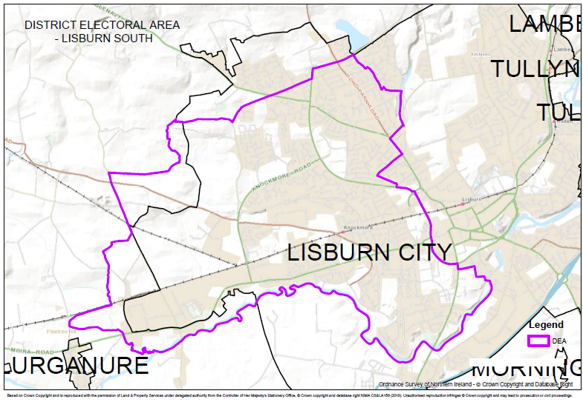
Population in DEA  (NISRA Mid 2017 Pop Estimates for DEAs – published Feb 2019) | 23,270
Political Opinion | 2019 Local Council Election Results  District Electoral Area (DEA) Number of Seats (Political Party)  Lisburn South 3 (DUP); 2 (UUP); 1 (Alliance)  (Source: The Electoral Office of Northern Ireland)
Key Settlements | Part of Lisburn City
Environmental Characteristics | Natural  1 Regional Park-Lagan Valley Regional Park  Built  1 Area of Townscape Character – Warren Park
Level of Services/ Facilities | Services and Facilities:  Driver Test Centre, Fire Station, Tesco/Lidl Supermarkets, Government Offices, Coca-Cola bottling plant, Crescent Business Park, Knockmore Business Centre, Knockmore Hill Industrial Estate, Lisburn Enterprise Centre, Lissue Industrial Estate, Rosevale Industrial Estate  Schools in the DEA:  Approximately 9 primary schools, 3 high schools, 1 special school and 1 nursery school  Recreational uses in the DEA include:  Community Centre – Dundrod Drive  Community Centre – Warren Park  Grove Activity Centre
Transport Facilities | The DEA contains some Transport NI Protected Routes:  A520, B101  Disused rail halt (Knockmore) which is accessible from West Lisburn
Key Challenges | - Proposed Knockmore Link Road/rail halt  - Continue to promote expansion for industry to the west of Lisburn  - North Lisburn Feeder Road to airport

Lisburn & Castlereagh City Council area forms part of the BMUA referred to in the RDS

