Development Plan
Position Paper 14: Education, Health, Community & Cultural Facilities

November 2019

Contents Page

Executive Summary 3

1.0 Introduction 5
2.0 Regional Policy Context 5
3.0 Existing Development Plan 8

4.0 Education Profile 10

5.0 Health Profile 20

6.0 Community Services Profile 24

7.0 Key Findings and Conclusion 25

Appendices

1. Sites zoned for Education, Health or Community Uses
in Belfast Metropolitan Area Plan 2015 (BMAP) 27

2. Profiles of 7 District Electoral Areas and Planning Decisions
related to Education, Health and Community Facilities 31

3. School Enrolments and Unfilled Places 49

4. Types of Educational Facilities 54

Executive Summary

This Position Paper provides an overview of education, health, community & cultural facilities in Lisburn & Castlereagh City Council to assist in the preparation of the Local Development Plan 2032.

The Local Development Plan is made within the context of a Sustainability Appraisal under the provision of Planning (Northern Ireland) Act 2011. This paper is therefore intended to provide a baseline position on which policies and proposals for education, health, community and cultural uses in the Local Development Plan can be shaped over the plan period.

It is important to stress that in compiling this Position Paper the best information available has been used however further revisions may be required in light of the release of any new data or updated policy, advice or information.

The provision for education and health does not lie within the remit of the Council. However, the Council does provide support and assistance to a range of community groups as well as maintaining buildings utilised for community and cultural uses. It is however important for the Local Development Plan to take account of future needs for the provision of schools, health and community facilities as part of the plan making process.

The paper provides an update on the previous Position Paper which was produced as part of the preparation of the Preferred Options Paper and has been informed by consultations with the relevant statutory consultees, including education and health authorities.

The aims of the paper are:

- To provide baseline information which will inform the Local Development Plan;

- To assess the future land use needs of a growing population in Lisburn & Castlereagh City Council and to consider the adequacy of existing provision;

- To provide the spatial representation of the Council’s Community Plan and have regard to other plans and strategies being undertaken by the Council.

- INTRODUCTION

This paper sets out the policy context for education, health, community and cultural services in Lisburn & Castlereagh City Council area. The need for any additional education, health, community or cultural facilities is also considered.

Chapter 2 sets out the regional policy context for such provision which is formulated within the context of the Regional Development Strategy 2035 (RDS), Strategic Planning Policy Statement for Northern Ireland (SPPS) for Northern Ireland (SPPS) and regional Planning Policy Statements (PPSs).

Chapter 3 outlines the current policy in the existing development plan context.

Chapters 4-6 provide an overview of the organisations responsible for Education, Health and Community services and the existing provision of Education, Health, Community and Cultural facilities in Lisburn & Castlereagh. Information on current enrolment figures across the various education sectors has been derived from the Education Authority (EA).

1.5 The key findings and conclusion are provided in Chapter 7.

- REGIONAL POLICY CONTEXT

The regional policy context is provided by the Regional Development Strategy (RDS) 2035, Strategic Planning Policy Statement for Northern Ireland (SPPS) and regional Planning Policy Statements (PPSs) where relevant. A summary of these documents in relation to plan making and provision of education, healthy, community and cultural facilities, is provided in the following paragraphs.

Regional Development Strategy (RDS) 2035

The RDS provides an overarching strategic framework to facilitate and guide development in the public and private sectors in support of the Programme for Government (PfG). The RDS has a statutory basis prepared under the Strategic Planning (Northern Ireland) Order 1999. Local development plans must ‘take account’ of the RDS.

One of its aims is to promote development which improves the health and well-being of communities. It recognises that Lisburn & Castlereagh is part of the Metropolitan Area and this area should be developed for employment, services and range of cultural and leisure facilities. Lisburn benefits from its location at the meeting point of the Belfast/Dublin economic corridor and the East/West transport corridor.

The PfG provides key indicators for Government relating to education, health and community to: improve educational outcomes, reduce education inequality, improve the quality of education, reduce health inequality, improve cultural participation and increase the confidence and capability of people and communities.

Strategic Planning Policy Statement (SPPS)

The Strategic Planning Policy Statement for Northern Ireland (SPPS) reiterates Policy PSU 1 of PSRNI. In the context of Public Utilities the SPPS states that Local Development Plans should allocate sufficient land to meet the anticipated needs of the community, in terms of health, education and other public services (Page 95). The SPPS also states that the planning system has an active role to play in helping to better the lives of people and communities and in supporting the Executives key priority of improving health and well-being.

It is widely recognised that well designed buildings and successful places can have a positive impact on how people feel. The way in which places and buildings are configured, patterns of movement in the space around us and the level of access to quality open space are all factors that can make us feel good. Successful places also influence the choices we make which may contribute positively to improving our health and well-being e.g. whether to walk or cycle, or whether to stay longer in a good place.

The SPPS goes on to list a number of ways in which the planning system can contribute to improved health either through the plan making process or through the decision making process:
- safeguarding existing and facilitating quality open space, sport and outdoor recreation;
- providing for safe and secure age-friendly environments;
- encouraging and supporting quality, environmentally sustainable design;
- better connected communities with safe pedestrian environments;
- better integration between land-use planning and transport;
- facilitating the protection and provision of green and blue infrastructure
- supporting the provision of jobs, services and economic growth;
- supporting delivery of homes to meet the full range of housing needs, contributing to balanced communities; and
- supporting broader government policy aimed at addressing for example obesity, and health and well-being impacts arising through pollution.

Role of the Local Development Plan

2.8 The SPPS advises that the plan making process may involve liaison with bodies and agencies with health remits to understand and take account of health issues and the needs of local communities where appropriate. It also directs that where appropriate the council may bring forward local policies that contribute to improving health and well-being as well as those which promote social cohesion and the development of social capital, the provision of health, security, community and cultural infrastructure and other local facilities.

Planning Strategy for Rural Northern Ireland (PSRNI)

Regional planning policies for community needs are currently set out in the Planning Strategy for Rural Northern Ireland (PSRNI). The aim of Policy PSU 1 is to allocate sufficient land to meet the anticipated needs of the community, in terms of health, education and other public facilities.

Planning Policy Statement 21 (PPS 21) Sustainable Development in the Countryside

The Department’s planning policy for education, health and community facility development in rural areas is set out in PPS 21 Sustainable Development in the Countryside. The countryside is defined as land lying outside the settlement limits as identified in development plans. Supplementary guidance is contained in DCAN 9: Residential and Nursing Homes and DCAN 13: Creches, Day Nurseries and Pre-School Playgroups.

Transitional Period

2.11 A transitional period will operate until such times as a Plan Strategy for the Lisburn & Castlereagh City Council area has been adopted. During the transitional period planning authorities will apply existing policy contained within the above mentioned policy together with the SPPS. Any conflict between the SPPS and any policy retained under the transitional arrangements must be resolved in favour of the provisions of the SPPS.

3.0 EXISTING DEVELOPMENT PLAN

Belfast Metropolitan Area Plan 2015 (BMAP)

  - The Belfast Metropolitan Area Plan 2015 was prepared under the provisions of Part 3 of the Planning (Northern Ireland) Order 1991 by the former Department of the Environment (DoE). The Plan covers the City Council areas of Belfast and Lisburn, and the Borough Council areas of Carrickfergus, Castlereagh, Newtownabbey and North Down. The Plan was adopted on 9th September 2014, however the Court of Appeal declared the adopted plan unlawfully adopted on 18th May 2017.

  - As a result, the existing Development Plans covering the Council area are as follows:
- Belfast Urban Area Plan (BUAP) 2001
- Lisburn Area Plan (LAP) 2001
- Carryduff Local Plan 1988-1993
- Ballymacoss Local Plan
- Lisburn Town Centre Plan
- Lagan Valley Regional Park Local Plan 2005

3.3 BMAP in its post-inquiry form was at an advanced stage and therefore remains a material consideration. Draft BMAP (November 2004) in its pre-inquiry form also remains a material consideration in conjunction with recommendations of the Planning Appeals Commission Public Local Inquiry Reports.

3.4 BMAP Plan Strategy and Framework Document Volume 1 under Policy CF1 ‘Protection of land for Education, Health, Community and Cultural Facilities’ states that planning permission will not be granted for alternative uses on lands identified for the provision of education, health, community uses or cultural facilities.

  - Land proposed for education, health, community or cultural uses by the relevant providers are identified in the District Proposals (Volumes 3 and 4). Exceptionally, where lands identified for community uses become surplus to requirements, alternative uses may be acceptable.

  - In Lisburn City two sites are identified for health and education. Proposal LC 40 identifies the rear of the Lagan Valley Hospital for health use. This proposal will cater for an expansion of the services and facilities associated with the hospital. Proposal LC 41 identifies land between Brokerstown Road, Knockmore Road and Limetree Avenue for education use associated with Parkview Special School. (See maps Appendix 1)

  - In Moira, the Plan makes reference to Community Facilities and a new cemetery and crematorium on lands opposite Nos. 3 and 5 Lisburn Road which was approved early in 2012. This includes a 9,000 plot cemetery, access roads and around 300 parking spaces.

  - In Metropolitan Castlereagh, land is zoned for Mixed Use at Knockbracken Healthcare Park under MCH 13. This is a large site of over 85 hectares and may be suitable for health, community and cultural use. The Plan has also identified two additional sites for health use. These are located at Forster Green, Upper Knockbreda Road under Proposal MCH 42/01 and land North East of the Ulster Hospital, Dundonald under Proposal MCH 42/02 associated with any expansion in services and facilities associated with the existing hospital. (See maps Appendix 1)

- EDUCATION PROFILE IN LISBURN & CASTLEREAGH CITY COUNCIL

4.1 The population of Lisburn & Castlereagh City Council is expected to grow from 141,500 in 2016 to 158,600 by 2030 (Population projections published by NISRA, May 2016). This will have implications for policy makers in the delivery of education, health and community services. In the education sector, a decline in pupil numbers will have implications for the sustainability of the existing network of schools. An increase in the elderly population will have implications for health services such as hospitals and access to GP surgeries, additional residential care homes and community facilities.

Organisations Responsible for Education

4.2 The Department of Education (DE) has overall responsibility for education policy.

4.3 In addition, a single Education Authority (EA) was established on 1st April 2015 to replace the five Education and Library Boards and the Staff Commission for Education and Library Boards and will now oversee the delivery of education, youth and library services throughout Northern Ireland. It is envisaged that there will be no change to how services are provided with the five sub-regional offices remaining at the existing education and library board sites. The Education Authority for the South Eastern Region is based at Grahamsbridge Road in Dundonald.

4.4 The Department of Education’s main areas of responsibility cover pre-school, primary, post-primary and special education; the youth service; the promotion of community relations within and between schools; and teacher education and salaries. Its primary statutory duty is to promote the education of the people of Northern Ireland and to ensure the effective implementation of education policy.

4.5 Within the context of Lisburn & Castlereagh City Council, the South Eastern Regional Office of the Education Authority, and the Council for Catholic Maintained Schools (CCMS), the Northern Ireland Council for Integrated Education (NICIE) are the key players.

Education Policy Context

4.6 Education is one of the most significant investments in developing the individual, society and the economy and the overall vision of the Department of Education (the Department) is to see “every young person achieving to his or her full potential at each stage of his or her development”.

4.7 In recent years there have been a number of influential publications which set out to all those involved in the education sector a challenge to consider new approaches. This includes sharing facilities which would promote a more cohesive and tolerant society and assist a better use of the resources available to education.

4.8 The most significant document published has been an Independent Strategic Review of Education, more commonly referred to as the Bain Review (2006). The Bain Review commented that the multi-sector school system, combined with the rural nature of parts of Northern Ireland, single-sex schools and a selective system of education had resulted in a large number of schools and a high proportion of small schools. While the report made 61 recommendations, the governing principle in judging the future of any school must be the quality of education provided – but said there must be a review of the future of small schools and recommended minimum enrolment figures for primary schools in urban and rural areas and post-primary schools.

4.9 Building on the issues highlighted in the Bain Report, the Department introduced the Sustainable Schools Policy (SSP) in 2009, followed by the Area Planning process (2011) which is designed to address the long-term primary school needs from 2012-2025. The overall output of these is the assessment of schools against a set of criteria for sustainable enrolment levels, delivery of quality education and financial sustainability.

School Provision in Lisburn & Castlereagh City Council

4.10 Lisburn & Castlereagh currently has 25 Pre-Schools, 3 Nursery Schools, 38 Primary Schools, 2 Preparatory Schools, 9 Post Primary Schools (Secondary/Grammar) and 5 Special Schools, details of which are provided in the tables and maps below. Additional figures showing enrolment figures and spare capacity is provided at Appendix 3.

Table 1: Location of Pre-Schools in Lisburn & Castlereagh City Council
School Name | Address | Settlement | Postcode | Management  Type
Mount Oriel Playgroup | 45 Saintfield Road | Castlereagh | BT8 6HJ | Private
Grove Community Playgroup | Grove Activity Centre, 15 Ballinderry Park | Lisburn | BT28 1ST | Voluntary
Ballybeen Women's Centre Pre-School | 34 Ballybeen Square | Dundonald | BT16 2QE | Voluntary
Sunshine Community Playgroup | Killultagh Hall, Legaterriff Road | Upper Ballinderry | BT28 2EY | Voluntary
Anahilt Pre-School Playgroup | 29a West Winds Terrace | Annahilt | BT26 6BS | Voluntary
Legacurry Playgroup | Legacurry Church | Legacurry | BT27 5EY | Voluntary
Rainbow Corner Playgroup | 2 Main Street | Moira | BT67 0LE | Voluntary
Busy Bees Playgroup | Elim Pentecostal Church, 85 Moira Road | Hillsborough | BT26 6DY | Voluntary
Rhyme Times Playgroup | Thiepval Barracks, Magheralave Road | Lisburn | BT28 3BN | Voluntary
Dromara Playgroup | Dromara Primary School | Dromara | BT25 2BL | Private
Brownlee Playgroup by Little Rays | C/O Brownlee Primary School | Lisburn | BT27 4AA | Private
Little Oaks Pre-School | St Colman's Primary School | Lisburn | BT27 4QS | Voluntary
Carryduff Pre-School Playgroup | 20a Church Road | Carryduff | BT8 8DT | Voluntary
Ballymacward Pre-School Playgroup | Ballymacward Primary School | Lisburn | BT28 3SU | Voluntary
Oakwood Integrated Children's Centre | 48 The Cutts | Lisburn Greater Urban Area | BT17 9HN | Voluntary
Seymour Hill Pre-School Playgroup | C/O Seymour Hill Primary School | Belfast | BT17 9QX | Voluntary
Carr Pre-School | 336 Comber Road | Carr | BT27 6TB | Voluntary
Jolly Pirates Pre-School | 47 Antrim Road | Lisburn | BT28 3EB | Private
Little Gems Day Nursery | 1 Dunlady Road | Dundonald | BT16 1TT | Private
First Steps Day Nursery | Ward 15, Lagan Valley Hospital, Hillsborough Road | Lisburn | BT28 1JP | Private
Little Rays Day Nursery | 3 Main Street | Moira | BT67 0LE | Private
Peter's Patch Day Nursery | 31 Carnreagh | Hillsborough | BT26 6LJ | Private
Little Rays Day Nursery | 102 Queensway | Lisburn | BT27 4QP | Private
First Steps Day Nursery | Ulster Hospital | Dundonald | BT16 1RH | Private
Helping Hands Daycare | 6 Tullynacross Road | Tullynacross | BT27 5SP | Private

Source: Department of Education, NI School Census - Location of Pre-Schools 2018/19
To note: Data is based on pupils enrolled on Census day i.e. The Friday of the first full week in October (In 2018/19 this was the 5 October 2018)

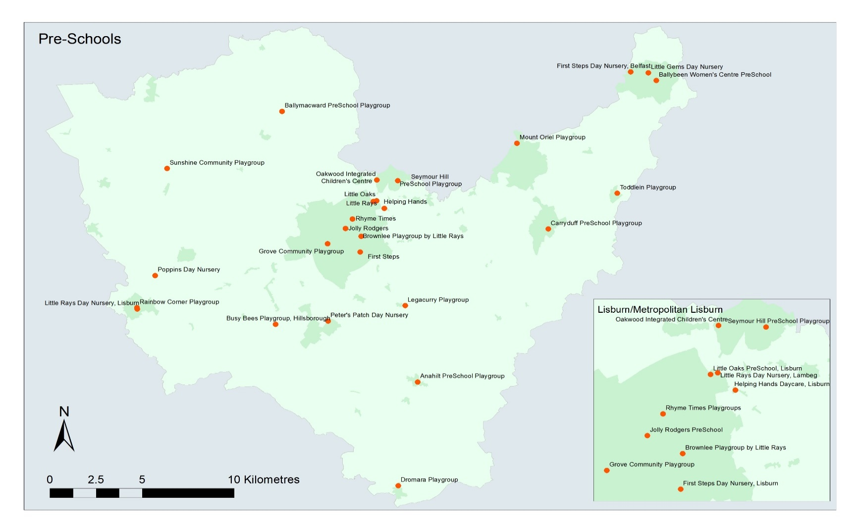

Table 2: Location of Primary Schools in Lisburn & Castlereagh City Council
School Name | Address | Settlement | Postcode | Management Type
McKinney Primary School Dundrod | 3 Leathemstown Road | Dundrod | BT29 4HX | Controlled
Ballycarrickmaddy Primary School | 1A Killultagh Road | Ballynadolly | BT28 2NX | Controlled
Largymore Primary School | Hillhall Road | Lisburn | BT27 5BT | Controlled
Brownlee Primary School | Wallace Avenue | Lisburn | BT27 4AA | Controlled
Lisburn Central Primary School | 52-56 Hillsborough Road | Lisburn | BT28 1JJ | Controlled
Seymour Hill Primary School | 2C Hazel Avenue | Lisburn Greater Urban Area | BT17 9QX | Controlled
Tonagh Primary School | Tonagh Avenue | Lisburn | BT28 1DQ | Controlled
Carr Primary School | 336 Comber Road | Carr | BT27 6TB | Controlled
Dundonald Primary School | 10 Church Green | Dundonald | BT16 2LP | Controlled
Anahilt Primary School | 248 Ballynahinch Road | Annahilt | BT26 6BP | Controlled
Dromara Primary School | 36 Hillsborough Road | Dromara | BT25 2BL | Controlled
Moneyrea Primary School | 36 Church Road | Moneyrea | BT23 6BB | Controlled
Cairnshill Primary School | 6A Cairnshill Drive | Castlereagh | BT8 6RT | Controlled
Carryduff Primary School | Killynure Road | Carryduff | BT8 8EE | Controlled
Harmony Hill Primary School | 50 Harmony Hill | Lisburn | BT27 4ES | Controlled
Knockmore Primary School | Hertford Crescent | Lisburn | BT28 1SA | Controlled
Moira Primary School | 21 Backwood Road | Moira | BT67 0LJ | Controlled
Old Warren Primary School | 147 Drumbeg Drive | Lisburn | BT28 1QP | Controlled
Killowen Primary School | 20 Laurelhill Road | Lisburn | BT28 2UH | Controlled
Ballinderry Primary School | 8D Crumlin Road | Lower Ballinderry | BT28 2BF | Controlled
Pond Park Primary School | 63 Pond Park Road | Lisburn | BT28 3BF | Controlled
Maghaberry Primary School | 17A Maghaberry Road | Maghaberry | BT67 0JE | Controlled
Ballymacash Primary School | 16 Brokerstown Road | Lisburn | BT28 2EE | Controlled
Brooklands Primary School | 2A Brooklands Avenue | Dundonald | BT16 2PA | Controlled
Riverdale Primary School | 288 Ballynahinch Road | Legacurry | BT27 5LX | Controlled
Meadow Bridge Primary School | 3 Lany Road | St. James | BT26 6JR | Controlled
Downshire Primary School | 7 Ballynahinch Road | Hillsborough | BT26 6AR | Controlled
Ballymacward Primary School | 22 Rock Road | Stoneyford | BT28 3SU | Catholic Maintained
Ballymacrickett Primary School | 41 Scroggy Road | Glenavy | BT29 4NE | Catholic Maintained
St Joseph's Primary School, Lisburn | 42 Castle Street | Lisburn | BT27 4XE | Catholic Maintained
St Joseph's Primary School, Carryduff | 8 Knockbracken Drive | Carryduff | BT8 8EX | Catholic Maintained
St Aloysius Primary School | 7 Ballinderry Road | Lisburn | BT28 1TB | Catholic Maintained
St Colman's Primary School | 109 Queensway | Lisburn | BT27 4QS | Catholic Maintained
St Ita's Primary School | 4 Alderwood Hill | Castlereagh | BT8 6YY | Catholic Maintained
Fort Hill Integrated Primary School | Low Road | Lisburn | BT27 4TJ | Controlled Integrated
Oakwood Integrated Primary School | 48 The Cutts | Lisburn Greater Urban Area | BT17 9HN | GMI
Millennium Integrated Primary School | 139A Belfast Road | Near Carryduff/Saintfield | BT24 7HF | GMI
Rowandale Integrated Primary School | 18 Clarehill Road | Moira | BT67 OPB | GMI
Friend's School  (Prep) | 6 Magheralave Road | Lisburn | BT28 3BH | Voluntary
Wallace High School (Prep) | 12a Clonevin Park | Lisburn | BT28 3AD | Voluntary

Source: Department of Education, NI School Census - Location of Primary Schools 2018/19
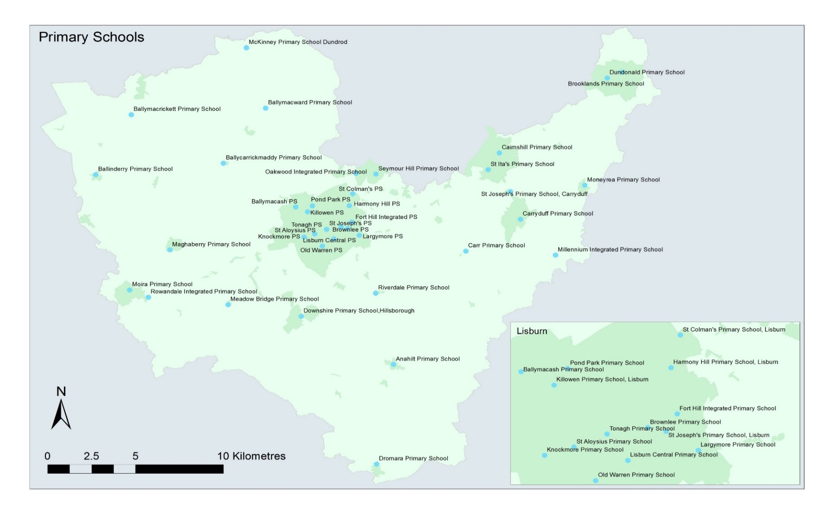
To note: Data is based on pupils enrolled on Census day i.e. The Friday of the first full week in October (In 2018/19 this was the 5 October 2018)

Table 3: Location of Nursery Schools in Lisburn & Castlereagh City Council
School Name | Address | Settlement | School Type | School Management
Barbour Nursery School | 73 Ashmount Gardens | Lisburn | Nursery | Controlled
Pond Park Nursery School | 20 Redpoll Avenue | Lisburn | Nursery | Controlled
Holy Trinity Nursery School | 4 Trinity Terrace | Lisburn | Nursery | Catholic Maintained

Source: Department of Education, NI School Census - Location of Nursery Schools 2018/19
To note: Data is based on pupils enrolled on Census day i.e. The Friday of the first full week in October (In 2018/19 this was the 5 October 2018)

Table 4: Location of Special Schools in Lisburn & Castlereagh City Council
School Name | Address | Settlement | Postcode | Management Type
Beechlawn | 3 Dromore Road | Hillsborough | BT26 6PA | Controlled
Brookfield | 6 Halfpenny Gate Road | Near Halfpenny Gate | BT67 0HP | Controlled
Longstone | Millar's Lane | Dundonald | BT16 2DA | Controlled
Parkview | 2 Brokerstown Road | Lisburn | BT28 2EE | Controlled
Tor Bank | 5 Dunlady Road | Dundonald | BT16 1TT | Controlled

Source: Department of Education, NI School Census - Location of Special Schools 2018/19
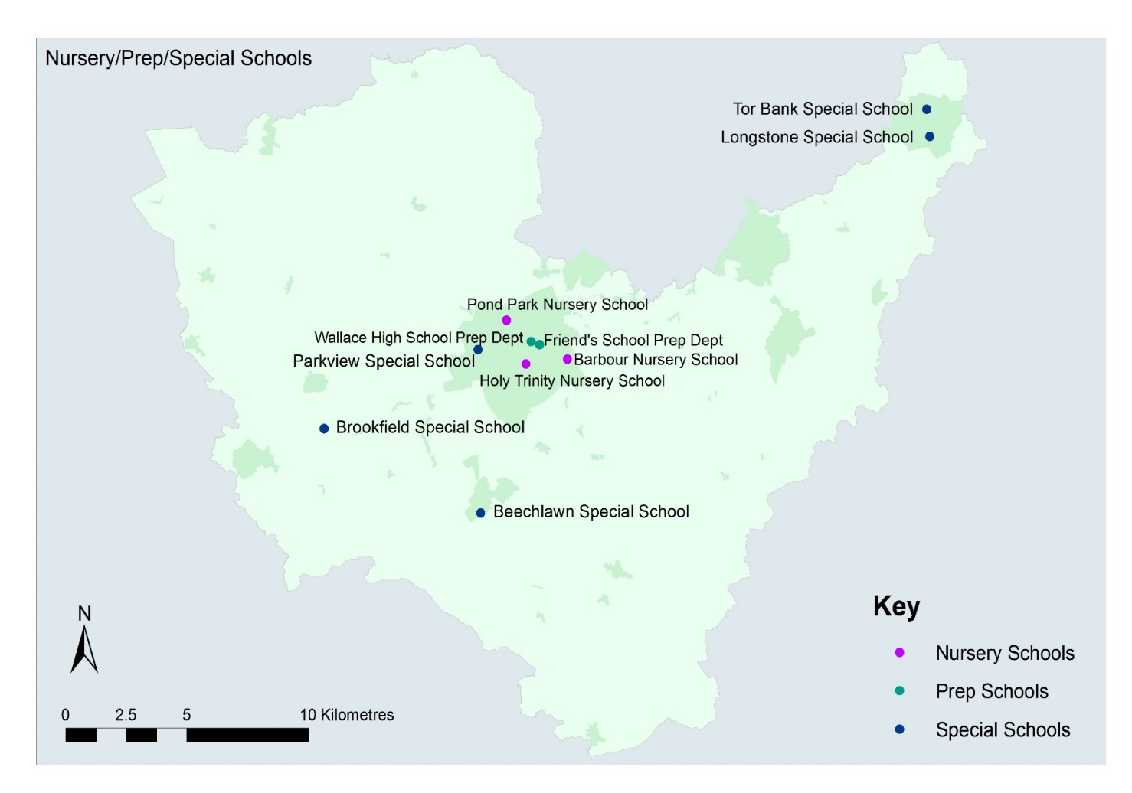
To note: Data is based on pupils enrolled on Census day i.e. The Friday of the first full week in October (In 2018/19 this was the 5 October 2018)

Table 5: Location of Post Primary Schools (Secondary/Grammar) in Lisburn & Castlereagh City Council
School Name | Address | Settlement | Postcode | Management Type
Lisnagarvey High School | Warren Gardens | Lisburn | BT28 1HN | Controlled
Laurelhill Community College | 22 Laurelhill Road | Lisburn | BT28 2UH | Controlled
Dundonald High School | 764 Upper Newtownards Road | Dundonald | BT16 1TH | Controlled
Breda Academy | Newtownbreda Road | Castlereagh | BT8 6PY | Controlled
St Patrick's Academy | Ballinderry Road | Lisburn | BT28 1TD | Catholic Maintained
Fort Hill College | Belfast Road | Lisburn | BT27 4TL | Controlled Integrated
Lagan College | 44 Manse Road | Castlereagh | BT8 6SA | GMI
Friends' School | 6 Magheralave Road | Lisburn | BT28 3BH | Voluntary
Wallace High School | 12A Clonevin Park | Lisburn | BT28 3AD | Voluntary

Source: Department of Education, NI School Census - Location of Post Primary Schools 2018/19
To note: Data is based on pupils enrolled on Census day i.e. The Friday of the first full week in October (In 2018/19 this was the 5 October 2018)
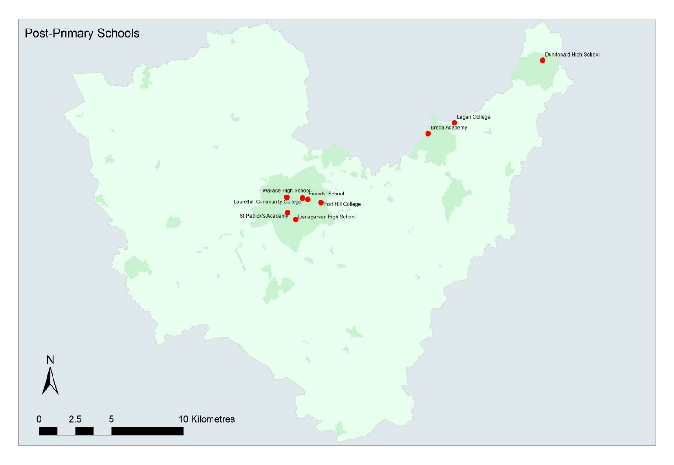

New Educational facilities and improvements proposed by Education Authority
4.11 A number of projects for additional education accommodation is provided in the table below:
Location | Proposal
Breda Academy | New build for Breda Academy – building work projected to begin on or before April 2018.
Friends School, Lisburn | School Enhancement Programme/project to extend school and demolish Old Harding House building – completed November 2016.
Millennium Integrated Primary School, Carryduff | Extension - completed October 2015.
Wallace High School, Lisburn | Two storey extension and refurbishment – work commenced September 2016.
St Patrick’s Academy, Lisburn | Extension for sports hall and new block to accommodate music, art and design and home economics – work commenced 28th August 2017.

4.12 In addition, the Fresh Start Agreement makes provision for up to £50m of new capital funding per year for each of the next 10 years for a programme of investment in shared and integrated education projects.

4.13 On 23 March 2016, a further list of capital projects to benefit under the first tranche of this funding package was announced by Theresa Villiers, Secretary of State for Northern Ireland. This announcement includes projects in the Lisburn and Castlereagh City Council area for:
- Millennium Integrated Primary School, Carryduff
- Rowandale Integrated Primary School, Moira
- Fort Hill Integrated Primary School, Lisburn; and
- Fort Hill Integrated College, Lisburn

4.14 The Department of Education are in the process of commissioning a site search for suitable sized available sites within the schools catchment areas.

4.15 Additional information on the range of health, education and community facilities and any relevant planning permissions are available in Appendix 2: District Electoral Area Profiles.

5.0 HEALTH PROFILE IN LISBURN & CASTLEREAGH CITY COUNCIL

Organisations Responsible for Health

5.1 The Department of Health has overall responsibility for health policy. In addition, Northern Ireland is divided into 5 Health Trusts. Lisburn & Castlereagh City Council is within the South Eastern Health and Social Care Trust. The Trust is committed to delivering safe, timely, high quality and cost-effective care and its purpose is to improve health and wellbeing and reduce inequalities by using its size as a force for good and working in partnerships with other organisations such as those responsible for housing and education.

Health Policy Context

5.2 The context for health is set out in the mission statement identified by the Department of Health who retain overall responsibility for health. It aims to improve the health and social well-being of the people of Northern Ireland. It endeavours to do so by leading a major programme of cross-government action to improve the health and well-being of the population and reduce health inequalities. This includes interventions involving health promotion and education to encourage people to adopt activities, behaviours and attitudes which lead to better health and well-being. The aim is a population which is much more engaged in ensuring its own health and well-being and also ensuring the provision of appropriate health and social care services, both in clinical settings such as hospitals and GPs' surgeries, and in the community through nursing, social work and other professional services.

5.3 With population projections for Northern Ireland indicating a marked increase in the size of the population at older ages, the growth in the number of the very elderly (over 85 population) will present a considerable challenge. It is Department of Health policy to maximise independent living and reduce reliance on hospital and residential care. In the future, advances in medicine, care and technology will continue to drive change in the range of services that can be provided safely in the community. This will enable more people to be diagnosed, treated and cared for at home or close to where they live.

5.4 ‘Transforming Your Care: A Review of Health and Social Care in Northern Ireland’ (TYC) was published in 2011 and set out proposals for change across a range of health and social care services. In 2013, the post-consultation report on the TYC review set out key recommendations for change across a number of important service areas including primary care, older people’s services and acute services for those with long-term conditions. There was also a focus on prevention, early intervention, integrated care and promotion of personalised care to enable more services to be provided in the community. This will result in a significant shift from provision of services in hospitals to the provision of services in the community, where it is safe and effective to do this.

5.5 Sir Liam Donaldson was subsequently commissioned to carry out a review into Northern Ireland’s health service (The Donaldson Review) noting that the TYC programme had established that elsewhere in the UK a population of 1.8 million people would likely to be served by 4 acute hospitals compared to the 10 that currently exist in Northern Ireland. The report made 10 recommendations, the crux of which was that TYC was not being properly implemented and a new costed, timetabled implementation plan was needed quickly to address a series of deficiencies across a wide range of health care services.

5.6 To date, progress has been made to implement the Integrated Care Partnership (ICP) initiatives which were funded towards the end of 2013/14 year which will make care more joined-up with £150 million being invested in the development of 5 ‘hub and spoke’ models to provide care in the community. Other initiatives include early intervention work, increasing the amount of community-based mental health services and developing alternatives to A&E attendance or hospital admission. However, given the scope of change required on an economically-challenged environment together with increased demands on A&E departments, there are significant challenges ahead in how best to deliver health and social services.

Existing Health Provision in Lisburn & Castlereagh City Council

Hospitals

5.7 There are currently 2 hospitals in Lisburn & Castlereagh City Council. The location of these hospitals is identified in the table below. In addition facilities are located at Knockbracken Health Care Park that specialises in Mental Health and Forster Green Hospital.

Name of Hospital
Lagan Valley Hospital, Lisburn
Ulster Hospital, Dundonald

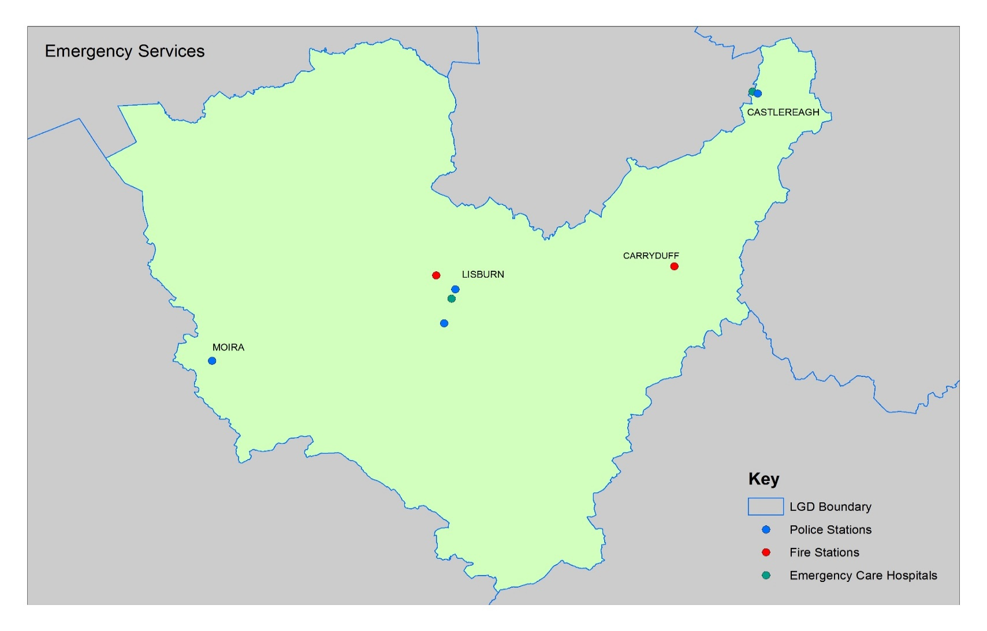

Health Centres/GP Surgeries

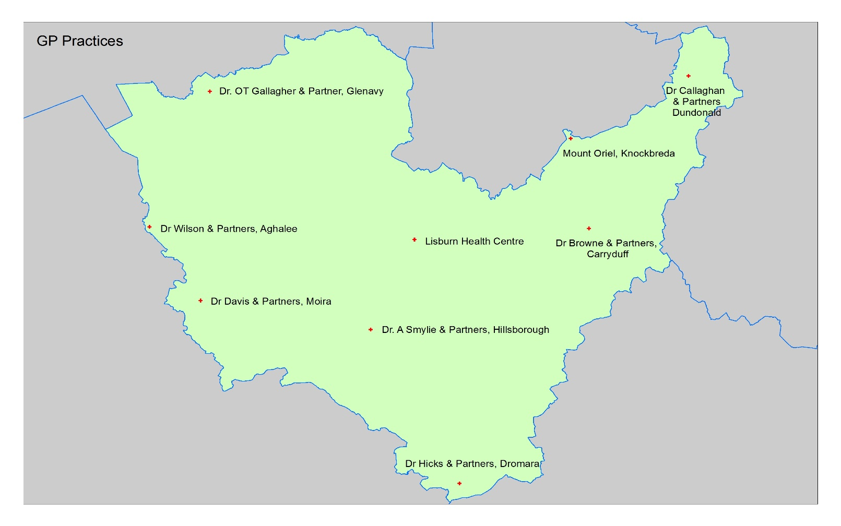
5.8 There are a number of GP practices, pharmacies and dentists operating in Lisburn & Castlereagh City Council (see maps).

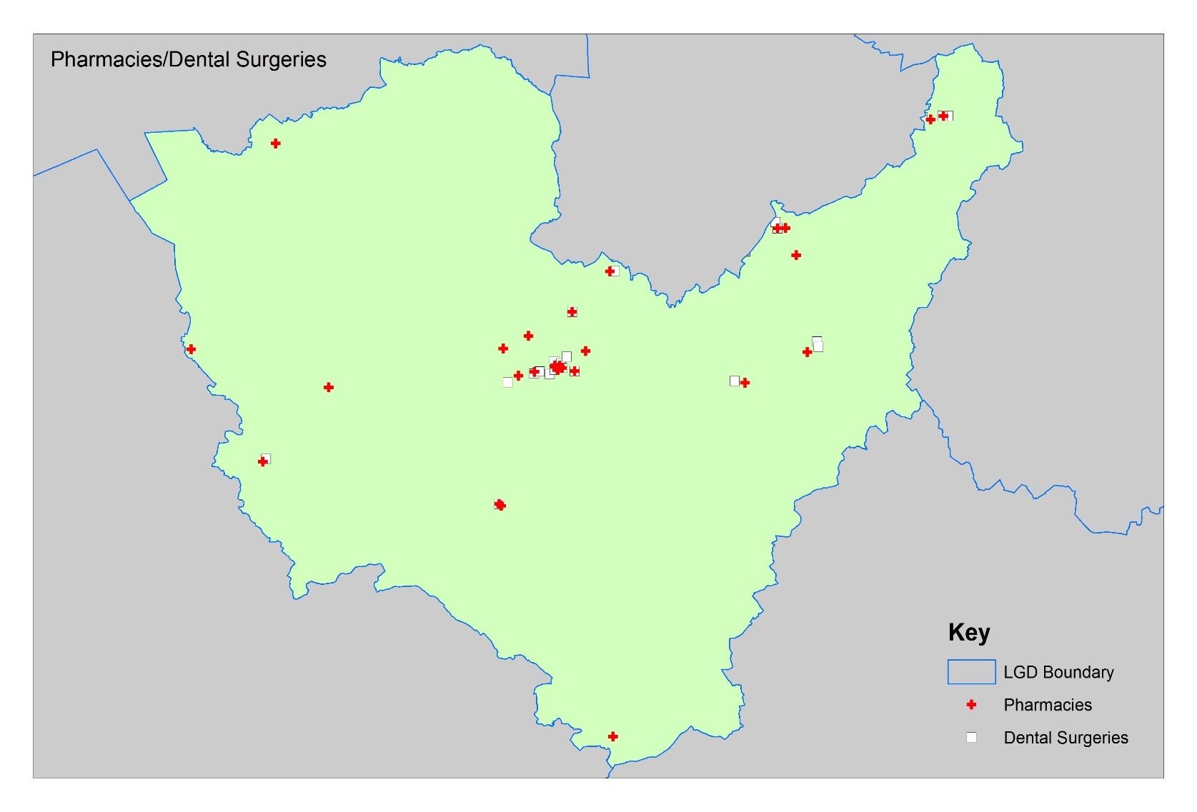

Care for Elderly/Vulnerable

5.9 The majority of Residential/Nursing Homes are privately run facilities, independent of the health trusts but are answerable to the Royal and Quality Improvement Authority (RQIA) in terms of level and quality of care provided.

6.0 COMMUNITY SERVICES PROFILE IN LISBURN & CASTLEREAGH CITY COUNCIL

Organisations Responsible for Community Services

Community Centres
6.1 Lisburn & Castlereagh City Council is the main public body responsible for providing or facilitating community facilities within the plan area. There are 9 community centres owned or supported by the Council located in Lisburn & Castlereagh City Council.

Other community centres are community owned and are located in the Council area, many of which are subsidised by the Council. Significant community activity takes place in Orange Halls, GAA Halls and Church Halls.

Police Stations
6.2 There are 4 operational police stations within the Plan area with two in Lisburn City, and one in Dundonald and Moira (see Emergency Service Map).

Fire Stations
6.3 Fire and Rescue Services are provided by the NI Fire and Rescue Services (NIFRS). There are 2 fire stations within the Plan area with the Headquarters located in Lisburn City and the other at Carryduff (see Emergency Service Map).

Library Provision
6.4 Libraries NI are the body with overall responsibility for the provision of library services in Northern Ireland. There are 5 Libraries within the Plan area in Lisburn City, Newtownbreda, Carryduff, Dundonald and Moira. A mobile library also operates around Lisburn.

- KEY FINDINGS AND CONCLUSION

7.1 A summary of the key findings are as follows:-
- The provision of health and education facilities within the plan area is the responsibility of a number of Government Departments and Statutory Bodies, with Lisburn & Castlereagh City Council having a role in relation to community uses. External providers will have their own long term strategies and investment plans.
- However, the Local Development Plan can aid a joined-up approach in the matter of public interest to ensure there is the necessary flexibility to allow for new health, education and community services.
- The Plan can also inform the community and potential investors as to the health, education and community proposals which are likely to occur.
- The Community Plan will assist in the preparation of the Local Development Plan.
- When formulating the Local Development Plan, should any of the statutory providers identify a land need, this may be protected for that use by designating land use zonings at the Local Policies Plan Stage. If providers identify any land surplus to requirements the Local Development Plan can zone alternatives uses.
- The Local Development Plan can stipulate Key Site Requirements on land use zonings for health, education and community needs.

CONCLUSION

7.2 Following on from the original Position Paper in September 2015, the purpose of this paper has been to update the baseline information regarding the education, health, community and cultural profile within the Lisburn & Castlereagh City Council area and examine the need for further provision. This baseline will support the preparation of the Plan Strategy and Local Policies Plan, and as the process evolves will be updated/amended as necessary taking account of all relevant new information made available.

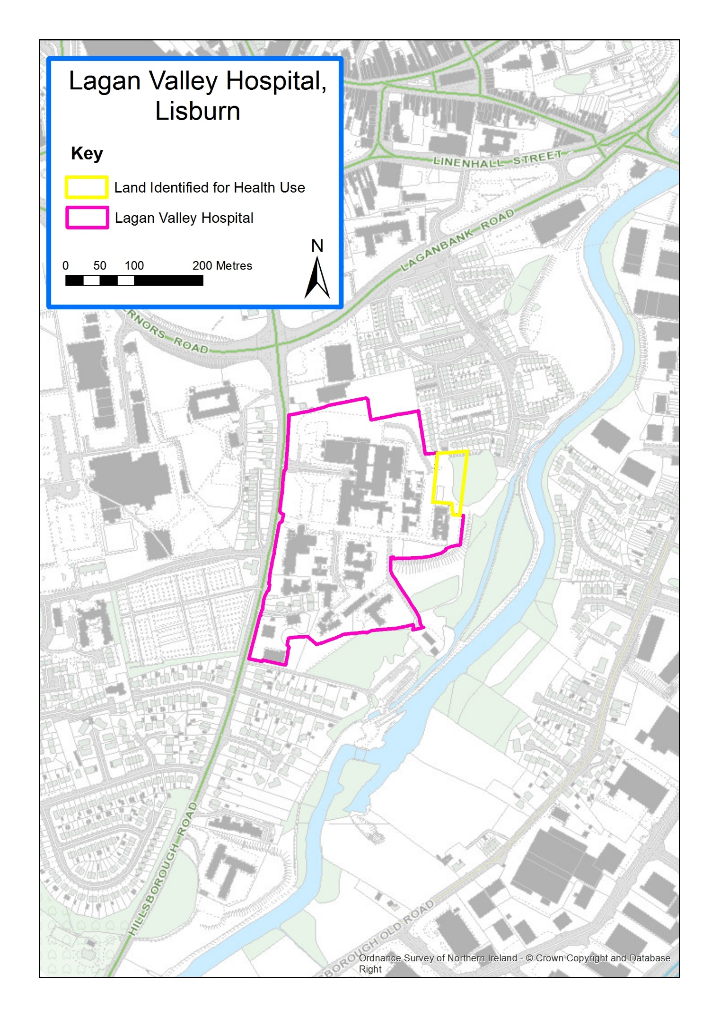
Appendix 1: Sites Zoned in BMAP 2015 for Health and Educational/Mixed Use

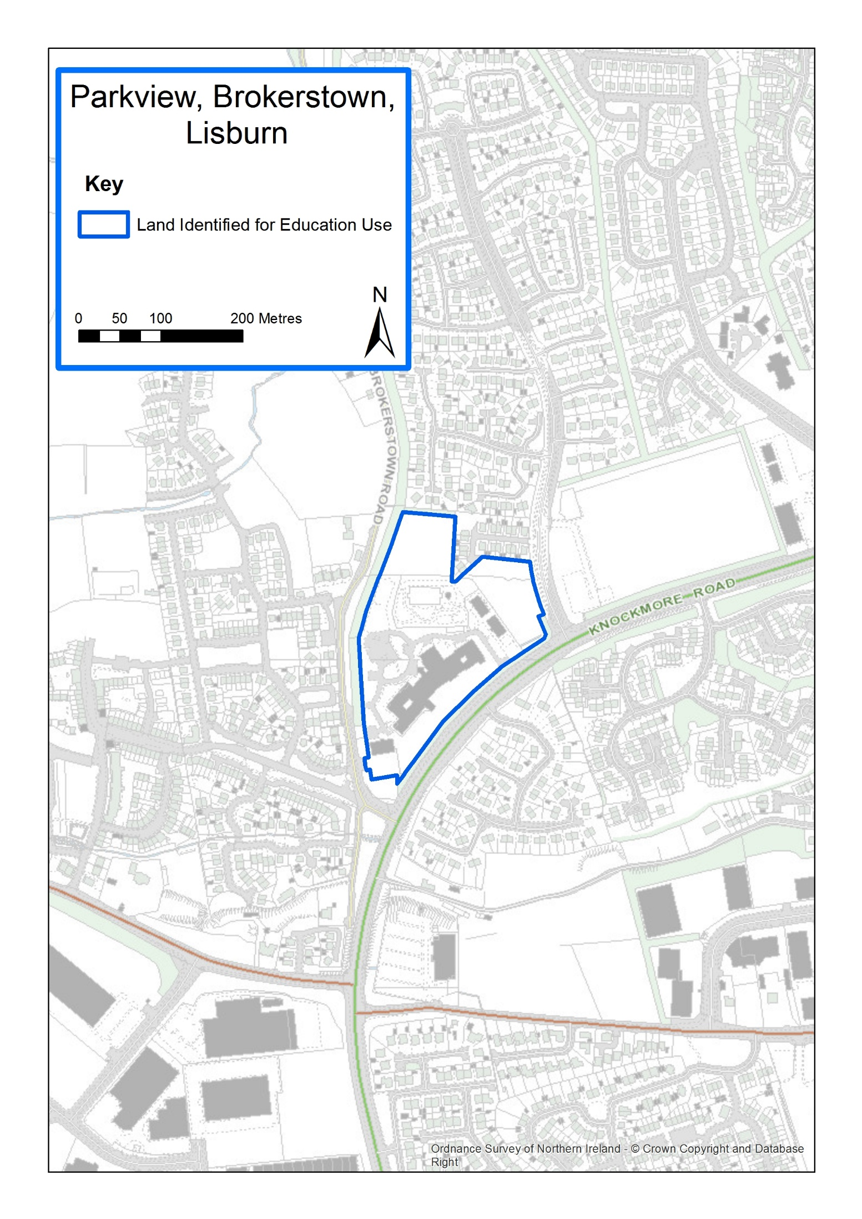

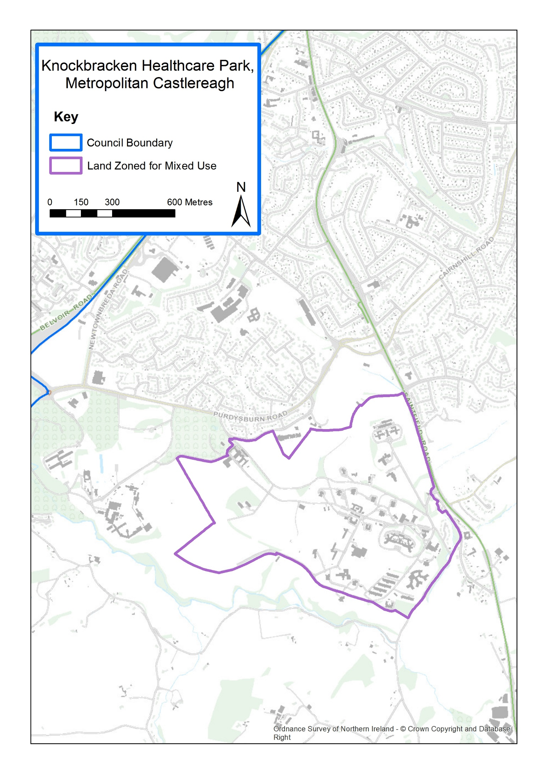

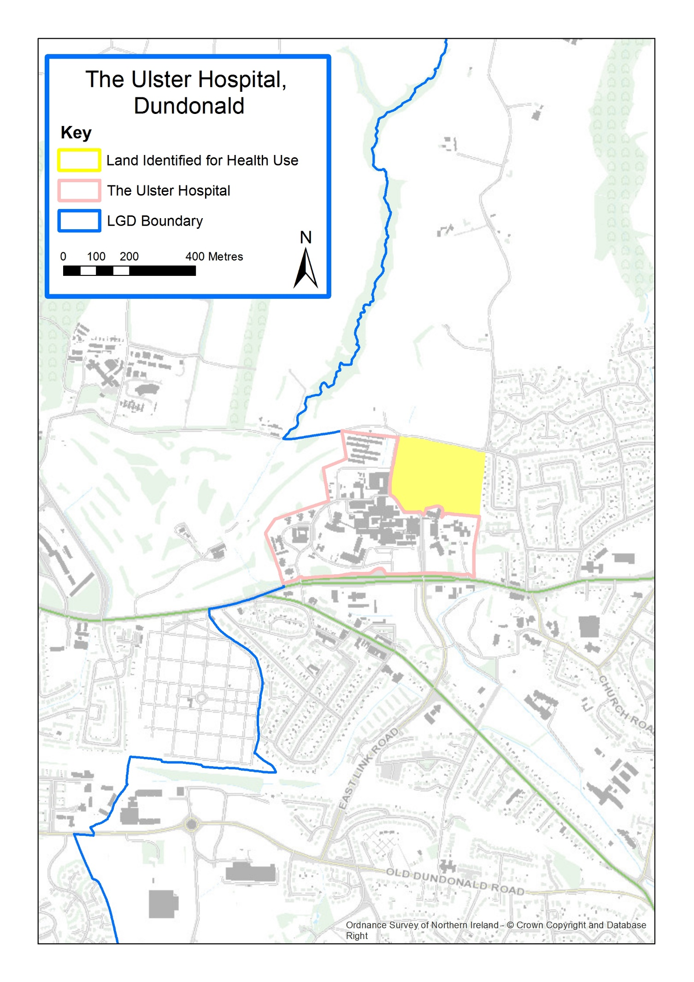

Appendix 2: 7 District Electoral Area Profiles in Lisburn & Castlereagh City Council
CASTLEREAGH EAST DEA

Wards | BALLYHANWOOD  CARROWREAGH  DUNDONALD  ENLER  GRAHAM’S BRIDGE  MONEYREAGH
Key Settlements, Population and Households  (Source: NISRA Headcount & Household Estimates for Settlements – March 2015) | SETTLEMENT | POPULATION | HOUSEHOLDS
 | DEA Total Settlements (4) | DEA Total Population  (approx. 18,588 in DEA) | DEA Total Households  (approx. 7704 in DEA)
 | METROPOLITAN CASTLEREAGH (approx. 50% in DEA) | 30,717 (50% = approx. 16,599 in DEA) | 12,324 (50% = approx. 6,902 in DEA)
 | MONEYREAGH | 1,379 | 516
 | CROSSNACREEVY  RYAN PARK | 317  141 | 133  61
Environmental Characteristics  (see attached maps) | Natural  2 Areas of High Scenic Value-Craigantlet Escarpment & Castlereagh Escarpment  4 Landscape Wedges-Carryduff, Comber, Newtownards & Dundonald  1 Area of Special Scientific Interest (ASSI)-Craigantlet Woods  Built  1 Area of Townscape Character – Dundonald  1 Area of Village Character – Moneyreagh
Level of Services/ Facilities | Services and Facilities:  Ulster Hospital, Dundonald Ice Bowl, Police Station – Upper Newtownards Road, Dundonald House Government Offices, Dundonald Enterprise Park, Carrowreagh Business Park, Maryland Industrial Estate  Schools in the DEA:  Approximately 2 primary schools, 1 high school, 1 special school and 3 nurseries  Recreational uses in the DEA include:  Dungoyne Community Centre, Ballyoran Community Centre, Enler Centre, Mount Ober Golf Club, Castlereagh Hills Golf Club, Streamvale Open farm  Other Services:  Roselawn Cemetery and associated landscaping
Transport Facilities | Comber Greenway  Major Road Proposal at Quarry Corner/Comber Road  Proposed EWAY Rapid Transit Scheme  The DEA contains some Transport NI Protected Routes:  A20, A22, A23
Major Developments Approved | Y/2015/0095/F: 12A Knockbracken (Adjacent to Carryduff GAC); Provision of multi-purpose community hall and training walls. Approved 09/09/2015  Y/2009/0303/RM: Millmount Road, Dundonald, comprising lands NE of Millars Forge & Comber Greenway, east of Millmount Rd, including Greengraves Rd (access from Comber Rd): Residential development of 510 dwellings comprising detached and semi-detached houses, townhouses and apartments including distributor road, cycle/footpaths, access, landscaping and associated site works. Approved 05/07/2017  LA05/2016/1042/F: 99-107 (odd nos only) Comber Road, Dundonald: Proposed apartment development comprising 28no apartments in 6 no blocks with associated site works and landscaping Approved 16/06/2017  LA05/2016/1062/O: Lands between 20 and 26 Comber Road, Carryduff: Residential development of 85 houses with associated open space and road access junction Approved 09/05/2017  LA05/2016/0886/F: Ballyoran House, Old Mill Grove (65m South East of 51 Old Mill Grove), Dundonald: Demolition of existing properties to facilitate development of 19 residential units comprising 12 no detached, 2 no semi-detached and 5 no apartments including associated car parking and landscaping Approved 19/09/2017  LA05/2015/0844/F: Lands immediately north of 61 Hillsborough Road and 10 Church Lodge, south east of 42 Church Road, south of Moneyreagh Community Centre and approximately 100 metres north west of 64 Hillsborough Road, Moneyreagh: Erection of 71 dwellings with single storey garages Approved 12/09/2016  LA05/2015/0377/F: Lands to the north of 792-804 Upper Newtownards Road and 1-8 Regent Court, Dundonald accessed from Carrowreagh Road, Dundonald: Erection of 22 dwellings and all associated site works Approved 03/08/2016
Current Major Applications | LA05/2016/0385/F: Lands at 125 Old Dundonald Road, Dundonald: Proposed residential development of 30 no. residential units comprising of 5 residential blocks of 6 no. apartments per block including associated car parking and landscaping
Key Challenges | - Ensure Dundonald attains own village individual identity  - Tackle traffic problems and possible Rapid Transit Scheme  - Maintain Landscape Wedges in the DEA  - Maintain recreation/tourism with Dundonald Ice Bowl  - Promote tourism/recreation in Craigantlet Hills/Castlereagh Escarpment

CASTLEREAGH SOUTH DEA

Wards | BEECHILL  CAIRNSHILL  CARRYDUFF EAST  CARRYDUFF WEST  GALWALLY  KNOCKBRACKEN  NEWTOWNBREDA
Key Settlements, Population and Households  (Source: NISRA Headcount & Household Estimates for Settlements – March 2015) | SETTLEMENT | POPULATION | HOUSEHOLDS
 | DEA Total Settlements (3) | DEA Total Population  (approx. 23,426 in DEA) | DEA Total Households  (approx. 88,11 in DEA)
 | METROPOLITAN CASTLEREAGH (approx. 50% in DEA) | 30,717 (50% = approx. 16,093 in DEA) | 12,324 (50% = approx. 6,167 in DEA)
 | CARRYDUFF | 6,947 | 2,574
 | BALLYKNOCKAN | <50 | <20
Environmental Characteristics  (see attached maps) | Natural  2 Areas of High Scenic Value-Castlereagh Escarpment & Castlereagh Slopes  1 Area of Outstanding Natural Beauty-Lagan Valley  1 Regional Park-Lagan Valley Regional Park  2 Landscape Wedges-Glencregagh & Carryduff  Built  1 Area of Townscape Character – Newtownbreda
Level of Services/ Facilities | Services and Facilities:  Forestside Shopping Centre, Drumkeen Retail Park, Bradford Court Council Offices, Forster Green Hospital & City Mortuary, The Knockbreda Centre Health Care Offices, The Lindsay School Educational Facility, Mount Oriel Library, 2 doctor’s surgeries and 1 dentist, Beechill Business Park, Trading Standards Offices, Transport NI/Rivers Agency HQ –Eastern Division, Saintfield Road Shops, Knockbracken Healthcare Park, Four Winds Restaurant & Shopping Centre, Ivanhoe Hotel, Carryduff Business Park, Fire Station, City Auctions, Library, Carryduff Shopping Centre, Lowes Industrial Estate, Woodlawn Garden Centre.  Schools in the DEA:  Approximately 5 primary schools and 2 high schools.  Recreational uses in the DEA include:  Hydebank Playing Fields, Lough Moss Leisure Centre, Carryduff Park, Knockbracken Golf Academy  Other Services:  Knockbrackan Reservoir, Hydebank Young Offenders Prison, Hydebank Territorial Army Centre, Carryduff Recycling Civic Amenity Council Site
Transport Facilities | Cairnshill Park & Ride, Metro/Ulsterbus network  Major Road Proposal/Relief Road at Cairnshill/Outer Ring  Lack of rail/bus facilities  The DEA contains some Transport NI Protected Routes:  A7, A24, A55
Major Developments Approved | Y/2009/0160/F: Lands to the East and the South of the Baronscourt Development and to the North of Edgar Road and the Comber Road, Carryduff: Residential development of 377 dwelling units Approved 10/03/2017  Y/2013/0057/F: Lands Directly Opposite 30 Ballymaconaghy Road, Belfast: Erection of 25 dwellings Approved 22/03/2016  Y/2014/0160/F: 50 Hillsborough Road, Carryduff, Belfast: Proposed housing development comprising of 5 no. detached dwellings and 14 no. semi-detached dwellings, access road and associated site works Approved 21/04/2016
Current Major Applications | Y/2007/0455/F: Lands to the rear and north of 9-21 Marlborough Crescent and 8-22 Blenheim Park, Carryduff: 107 new houses  Y/2008/0224/F: Lands to the rear and north of 21-57 Marlborough Crescent, Carryduff: Development of 117 new houses  Y/2009/0114/F: Lands north of Blenheim Park and Queensfort Court, west of Saintfield Road and south of Mealough Road, Carryduff: 126 dwellings  Y/2009/0407/F: Land at and to the north of 360 Saintfield Road (including 350, 352 Saintfield Road) Castlereagh, Belfast: 66 No. bedroom Nursing Home, 109 dwellings comprising 24 No. apartments (in 2 No. blocks) and 85 No. houses
Key Challenges | - Maintain green wedge between Castlereagh and Carryduff  - Reduce traffic congestion  - Regeneration of Carryduff town centre  - Maintain and control Forestside as a District Centre  - Promote Knockbracken Healthcare Park as a Major Employment Location  - Promote tourism/recreation for Castlereagh Hills  - Lack of infrastructure including community infrastructure  - Lack of playgroups and primary schools  - Transport issues, speeding issues  - Cumulative effect of numerous small housing developments

DOWNSHIRE EAST DEA

Wards | BALLYMACBRENNAN  DROMARA  DRUMBO  HILLHALL  RAVERNET
Key Settlements, Population and Households  (Source: NISRA Headcount & Household Estimates for Settlements – March 2015) | SETTLEMENT | POPULATION | HOUSEHOLDS
 | DEA Total Settlements (17) | DEA Total Population  (approx. 15,700) | DEA Total Households  (approx. 5,910)
 | LISBURN CITY (approx. 10% in DEA) | 45,410 (approx. 7,441 in DEA) | 18,415 (approx. 2,895 in DEA)
 | ANNAHILT  DROMARA  DRUMBEG  DRUMBO  RAVERNET | 1,045  1,006  813  375  564 | 371  399  321  157  212
 | BALLYAUGHLIS  BALLYCARN  BALLYLESSON  BOARDMILLS  CARR  DUNEIGHT  HILLHALL  LEGACURRY  MAGHERACONLUCE  PURDYSBURN  THE TEMPLE | 99  105  111  <50  <50  88  81  82  459  <50  <50 | 44  38  44  <20  <20  35  38  31  144  <20  <20
Environmental Characteristics  (see attached maps) | Natural  2 Areas of High Scenic Value-Magheraknock Loughs & Castlereagh Slopes.  1 Area of Outstanding Natural Beauty-Lagan Valley.  1 Regional Park-Lagan Valley.  Built  2 Areas of Village Character – Drumbeg and Purdysburn
Level of Services/ Facilities | Services and Facilities:  Industrial sites – Hillhall Road/Orr’s Lane, Ballylesson garden centre  Schools in the DEA:  Approximately 6 primary schools.  Recreational uses in the DEA include:  Temple Golf Club, Domara Community Centre, Dromara doctors surgery, Dromara bus station  Other Services:  Ravernet WwTW, Legacurry WwTW
Transport Facilities | A small section of the M1 passes through the DEA  Reliance on limited bus services for public transport  The DEA contains some Transport NI Protected Routes:  M1, A24, A49, B6, B23
Major Developments Approved | S/2015/0147/F: 15 Hillsborough Road, Dromore; Proposed dentists surgery and associated parking (in place of two dwellings previously approved under S/2013/0589/F) Approved 25/09/2015  S/2014/0312/LDP: Legacurry Wastewater Treatment Works  52m SE of 145 Comber Road Legacurry Hillsborough: Upgrade Legacurry Wastewater Treatment Works (WwTW) with a new replacement WwTW. Approved 01/09/2016  LA05/2016/0358/F: Lands located approximately 140 metres south east of Hillhall Road and approximately 120 metres north of nos 10-13 Mount Royal, Lisburn: Proposed erection of 23 no dwellings Approved 08/03/2017
Current Major Applications | N/A
Key Challenges | - Promote Lagan Valley Regional Park for tourism/recreation  - Improve traffic flow through small settlements on Hillhall Road  - Promote Magheraknock Loughs ASSI as a tourism/recreation attraction

DOWNSHIRE WEST DEA

Wards | BLARIS  HILLSBOROUGH  LAGAN  MAZE  MOIRA
Key Settlements, Population and Households  (Source: NISRA Headcount & Household Estimates for Settlements – March 2015) | SETTLEMENT | POPULATION | HOUSEHOLDS
 | DEA Total Settlements (13) | DEA Total Population  (approx. 16,117) | DEA Total Households  (approx. 6,344)
 | LISBURN CITY (approx. 10% in DEA) | 45,410 (approx. 4,996 in DEA) | 18,415  (approx. 1,985 in DEA)
 | HILLSBOROUGH & CULCAVY  MOIRA | 3,953  4,584 | 1,729  1,737
 | DRUMLOUGH  DRUMLOUGH ROAD  HALFPENNY GATE  HALFTOWN  LONG KESH  LURGANURE  LURGANVILLE  MORNINGSIDE  ST. JAMES  UPPER BROOMHEDGE | 74  <50  80  197  358  467  87  55  115  78 | 24  <20  26  83  117  181  32  24  39  27
Environmental Characteristics  (see attached maps) | Natural  1 Regional Park-Lagan Valley Regional Park.  2 Areas of Special Scientific Interest (ASSI)-Ballynanaghten & Clarehill, Moira.  Built  2 Conservation Areas – Hillsborough/Culcavy and Moira
Level of Services/ Facilities | Services and Facilities:  Hillsborough Castle and grounds, Hillsborough Heath Centre, Maze Long Kesh site, Sprucefield shopping centre  Schools in the DEA:  Approximately 3 primary schools, 1 special school and 1 nursery school  Recreational uses in the DEA include:  Lisburn golf course, Down Royal racecourse and golf course, Hillsborough Village Community Centre, Moira Village Centre, Hillsborough Forest Park, Moira Demesne.
Transport Facilities | A large section of the M1, A1 and railway flow through the DEA  Major junction at Sprucefield  Most settlements have easy access to main trunk road network  The DEA contains some Transport NI Protected Routes:  M1, A1, A3, A26, A520  Rail halt at Moira
Major Developments Approved | S/2014/0732/F: Land at Hillsborough Castle Hillsborough Road: Provision of new car park to serve Hillsborough Castle and associated vehicular access from the A1: Approved 21/04/2015  LA05/2015/0084/F: Lands at Balmoral Park Halftown Road  Maze Long Kesh: Proposed pavilion building and related car parking, proposed landscaping and private road link connecting to existing Halftown Road access for Royal Ulster Agricultural Society (RUAS) Approved 06/10/2015  LA05/2015/0041/F: Lands at Blaris Road Lisburn immediately opposite and to the south of Rivergate Lane and to north of M1 Motorway: Erection of 53 No dwellings and a car parking area to facilitate access to the adjacent Lagan Valley Regional Park (Union Locks) Approved 07/09/2016  S/2014/0908/F: Lands at Annacloy House 14 Trench Road Hillsborough: Construction of holiday home development comprising 58 apartments (application under Article 28 to remove condition 2 of approval S/2008/0878/F) Approved 27/04/2017  LA05/2016/0183/F: 2-28 Lurgan Road, Moira: Proposed housing development of 28 units comprising 4 detached, 16 town houses & 8 apartments Approved 02/08/2017  LA05/2015/0579/F: Lands behind 1-12 St James Park, Culcavey, Hillsborough: Proposed affordable housing development consisting of 22 no. 5 person 3 bedroom dwellings with associated site works and access road Approved 29/07/2016  LA05/2015/0600/F: Lands at Nos 3 and 3a Ballygowan Road, Hillsborough: Proposed medical facility (including theatres for surgical operations, overnight accommodation, research and development for contemporary medical techniques/aids), parking, access and ancillary site works Approved 20/01/2016
Current Major Applications | LA05/2015/0040/F: South of 23 Saddlers Hall  Carnreagh Hillsborough accessing from Ballynahinch Road via Governors Gate: Housing Development of 82 Dwellings  LA05/2016/1085/F: Lands at 3A-3B Graham Street, Lisburn: 15 No. residential apartments with parking, landscaping and associated site works
Key Challenges | - Proposed M1/A1 Strategic Link Road  - Proposed Knockmore Link Road  - Promote development at Sprucefield that does not have significant negative effects for Lisburn city centre  - Development of Maze Strategic Land Reserve  - Promote Hillsborough (Castle) as a tourist destination  - Maintain Moira as a commuter settlement, linking the railway station with the town

KILLULTAGH DEA

Wards | BALLINDERRY  GLENAVY  KNOCKMORE  MAGHABERRY  STONYFORD  WHITE MOUNTAIN
Key Settlements, Population and Households  (Source: NISRA Headcount & Household Estimates for Settlements – March 2015) | SETTLEMENT | POPULATION | HOUSEHOLDS
 | DEA Total Settlements (15) | DEA Total Population  (approx. 18,578) | DEA Total Households  (approx. 6,363)
 | LISBURN CITY (approx. 5% in DEA) | 45,410 (approx. 4217 in DEA) | 18,415 (approx. 1609 in DEA)
 | AGHALEE  GLENAVY  LOWER BALLINDERRY  MAGHABERRY  STONEYFORD  UPPER BALLINDERRY | 863  1,791  912  2,468  605  226 | 300  596  328  886  213  95
 | BALLYNADOLLY  DUNDROD  FEUMORE  HALFPENNY GATE  LOWER BROOMHEDGE  LURGANVILLE  LURGILL  UPPER BROOMHEDGE | 79  193  <50  80  239  87  <50  78 | 32  55  <20  26  80  32  <20  27
Environmental Characteristics  (see attached maps) | Natural  1 Ramsar Site-Lough Neagh & Lough Beg  4 Areas of Special Scientific Interest (ASSI) -Lough Neagh, Leathemstown, Slievenacloy, Maghaberry  2 Areas of High Scenic Value (AoHSV) - Portmore Lough & Belfast Basalt Escarpment  Built  3 Areas of Village Character – Upper Ballinderry, Lower Ballinderry, Glenavy
Level of Services/ Facilities | Services and Facilities:  Ulster Farm Factory – Ballyvannon Road (Glenavy), Garden Nursery – Shore Road (Glenavy), Ballymac Hotel, Garden Nursery – Dornan’s Road (Feumore), Clinic – Lurgan Road, Aghalee, Maghaberry community centre, HMP Maghaberry  Schools in the DEA:  Approximately 4 primary schools, 1 special school and 1 nursery school  Other services:  Sewage works – Scroggy Road (Glenavy), Sewage works, Dundrod, Sewage works – Lower Ballinderry Road
Transport Facilities | The DEA contains some Transport NI Protected Routes:  A26, B101  There is also a disused railway line running NW-SE of the DEA (Lisburn – Airport)
Major Developments Approved | S/2014/0760/F: Maghaberry Prison Old Road Ballinderry Upper: Additional Cellular Accommodation (360 cells) including upgraded sports pitches: Approved 13/04/2015  S/2014/0913/F: Former Maghaberry Airfield: Demolition of existing buildings, installation and operation of a solar farm and associated infrastructure including PV panels, mounting frames, inverters, transformers, substations, pole mounted CCTV and fence Approved 26/04/2016  S/2014/0910/F: Lands North of Wellingtons Parks and South of HMP Maghaberry: Development of 123 dwellings and amendment to 3 dwellings Approved 05/04/2017  LA05/2016/1061/F: Lands to the north of Nos. 7-14 Glenwood Green, and Nos. 114-116 Killowen Grange, Lisburn: Proposed erection of 30 no. dwellings Approved 19/10/2017  LA05/2016/1243/F: Lands adjacent to Old School Court, Crumlin Road, Glenavy: Proposed residential development comprising of 30. no dwellings, car parking, site access, open space and landscaping and all other associated site works Approved 18/08/2017  LA05/2016/0602/F: Standing Stones, Divis Road, Hannahstown, Belfast: Proposed 16 No self-catering units to be constructed at this existing approved tourist amenity complex Approved 07/02/2017
Current Major Applications | N/A
Key Challenges | - Re-activate Lisburn – International Airport railway  - Conserve/promote Lough Neagh for recreation/tourism  - Improve access for the enjoyment of Stoneyford Reservoir

LISBURN NORTH DEA

Wards | DERRYAGHY  HARMONY HILL  HILDEN  LAMBEG  MAGHERALAVE  WALLACE PARK
Key Settlements, Population and Households  (Source: NISRA Headcount & Household Estimates for Settlements – March 2015) | SETTLEMENT | POPULATION | HOUSEHOLDS
 | DEA Total Settlements (6) | DEA Total Population  (21,295) | DEA Total Households  (8,904)
 | LISBURN CITY (approx. 30% in DEA) | 45,410 (approx. 14182in DEA) | 18,415 (approx. 5,725 in DEA)
 | METRO LISBURN (Derriaghy/Seymour Hill) | 4,948 | 2,296
 | MILLTOWN | 1,499 | 571
 | BALLYSKEAGH  LAMBEG  TULLYNACROSS | 194  <50  129 | 101  <20  74
Environmental Characteristics  (see attached maps) | Natural  1 Area of High Scenic Value-Belfast Basalt Escarpment  1 Area of Outstanding Natural Beauty-Lagan Valley AONB  1 Lagan Valley Regional Park  1 Landscape Wedge-Mosside  Built  1 Conservation Area – Lisburn City  4 Areas of Townscape Character – Bachelors Walk, Hilden, Seymour Street, Wallace Park  1 Area of Village Character - Lambeg
Level of Services/ Facilities | Services and Facilities:  This DEA includes all of Lisburn City Centre including Bow Street Mall, Irish Linen Museum, Lisburn Square, Market Square, Smithfield Square, South Eastern Regional College, Health Centre, Library, Court House, Police Station, NI Fire and Rescue Service HQ, various Government Offices  Schools in the DEA:  Approximately 9 primary schools, 2 grammar schools, 1 high school, 1 nursery school  Recreational uses in the DEA include:  Aberdelghy Golf Club/driving range, BMX track (Queensway), Castle Gardens, Derriaghy Cricket Club, Glenmore Activity Centre, Lisburn Racquets, Lagan Valley Regional Park, canal and towpath, Milltown Community Centre, Seymour Hill Activity Centre, The Tom Robinson Park, Wallace Park, Derriaghy Linear Park, Belshaw's Quarry nature reserve  Other services:  Allotments (Queensway), The Cutts Civic Amenity Site, Drumbo Park Greyhound Stadium,  Derriaghy Industrial Park, Girdwood Barracks, Hilden Brewery, Lambeg Bottling Plant, Lambeg WwTW, Seymour Hill Industrial Estate, Thompson House Hospital, Tullynacross WTW
Transport Facilities | Protected Routes: M1, A1, A512  1 railway station - Lisburn  3 rail halts – Derriaghy, Hilden, Lambeg  Ulsterbus Station - Smithfield Street
Major Developments Approved | S/2015/0258/F: Lands located to the east of 54 & 56 Magheralave Road Lisburn: 127 no. Dwellings, comprising detached and semi-detached dwellings, including garages  Approved 09/12/2016  LA05/2015/0704/F: Land in BMAP zoning LC03/13 west of Belsize Meadows Phase 2 and south of A513 Derriaghy Road, Lisburn: Enabling ground works to site and construction of 28 dwellings with associated street network incorporating vehicular and pedestrian access from Belsize Meadows Phase 2, landscaping and open space and associated site works Approved 26/04/2016  LA05/2015/0845/RM: Jordan's Mill Car Park, 24 Antrim Street,  Lisburn: Mixed use development comprising 49 apartments, 4 retail units and 3 offices with access arrangements and associated car parking and landscaping Approved 07/12/2017  LA05/2015/0580/F: Lands to the rear of 18 Marna Brae Park and immediately to the west of Marna Brae House, 24 Marna Brae, Lisburn: Erection of 18 no. dwellings comprising of 3no. townhouses, 14no semi-detached and 1no detached dwelling, with car parking, landscaping, installation of an NIE sub-station and associated site works Approved 31/10/2016  LA05/2015/0897/F: Lands immediately north of junction of Graham Gardens and Wardsborough Road, Lisburn: Erection of 36 apartments for social housing with on street parking, landscaping and associated site works Approved 10/02/2017  LA05/2015/0705/F: Lands to the north and east of Willow Gardens and to the west of No. 57 Willow Gardens, Dunmurry  Lisburn: Residential Development of 35 units comprising 1 no. detached, 10 no. semi-detached, 20 no. townhouses and 4 no. apartments with associated road works and landscaping Approved 12/04/2016  S/2015/0258/F: Lands located to the east of 54 & 56 Magheralave Road, Lisburn: Erection of 127 no. Dwellings, comprising detached and semi-detached dwellings, including garages and all other associated siteworks Approved 09/12/2016
Current Major Applications | LA05/2016/0697/F: Derryvolgie House, 15 Belfast Road,  Lisburn: Proposed demolition of existing building and construction of residential development comprising of 18 no. detached dwellings including associated car parking and landscaping
Key Challenges | - Regenerate Lisburn City Centre including night-time economy  - Adhere to Lisburn City Centre Masterplan  - Link Lisburn city centre to river  - Promote riverside development  - Maintain Landscape Wedge between Lisburn City and its surrounding smaller settlements  - Promote recreation/tourism with access to river  - Promote office development

LISBURN SOUTH DEA

Wards | BALLYMACASH  BALLYMACOSS  KNOCKMORE  LAGAN VALLEY  LISNAGARVEY  OLDWARREN
Key Settlements, Population and Households  (Source: NISRA Headcount & Household Estimates for Settlements – March 2015) | SETTLEMENT | POPULATION | HOUSEHOLDS
 | LISBURN CITY  (approx. 45% in DEA) | 45,410 (approx. 21,893in DEA) | 18,415 (approx. 8,852)
Environmental Characteristics  (see attached maps) | Natural  1 Regional Park-Lagan Valley Regional Park  Built  1 Area of Townscape Character – Warren Park
Level of Services/ Facilities | Services and Facilities:  Driver Test Centre, Fire Station, Tesco/Lidl Supermarkets, Government Offices, Coca-Cola bottling plant, Crescent Business Park, Knockmore Business Centre, Knockmore Hill Industrial Estate, Lisburn Enterprise Centre, Lissue Industrial Estate, Rosevale Industrial Estate  Schools in the DEA:  Approximately 9 primary schools, 3 high schools, 1 special school and 1 nursery school  Recreational uses in the DEA include:  Community Centre – Dundrod Drive  Community Centre – Warren Park  Grove Activity Centre
Transport Facilities | The DEA contains some Transport NI Protected Routes:  A520, B101  Disused rail halt (Knockmore) which is accessible from West Lisburn
Major Developments Approved | S/2014/0728/F: Wyncroft Lisburn, Lands 15m East of 21 Wyncroft Crescent; Proposed residential development for 24 units Approved 29/02/2016  S/2014/0621/F: 19a Ballinderry Road Lisburn: Part demolition of existing manufacturing factory and proposed extension, alterations and part change of use to include Class B1 offices and Class A1 retail Approved 10/08/2015
Current Major Applications | S/2014/0884/F: Land East of Knockmore Road South of No 68-80 Addison Park and No's 8-10 Knockmore Road and North of Flush Park Lisburn: Proposed new rail halt and park and ride facility  S/2008/0551/F: Lisburn Leisure Park, Governors Road, Lisburn: Proposed Apart-hotel comprising 70 bedrooms and 35 suites, 25 Apartment Units, associated parking and proposed road improvements  S/2014/0623/RM: Brokerstown Village Phase 2: Lands to the North of Woodbrook Green and Alder Way Lisburn: Residential development of 307 dwellings  LA05/2017/0255/F: Site opposite units F & G Knockmore Industrial Estate, Moira Road, Lisburn Proposed; 9 no class B2 light industrial units with associated carparking
Key Challenges | - Proposed Knockmore Link Road/rail halt  - Continue to promote expansion for industry to the west of Lisburn  - North Lisburn Feeder Road to airport

Appendix 3: Enrolments and unfilled places of all schools in Lisburn and Castlereagh LGD, 2015/16

School Name | School Type |  | Enrolments |  | Unfilled places |  | Nursery enrolments |  | Nursery unfilled places
McKinney Primary School Dundrod | Primary |  | 130 |  | 17 |  | 26 |  | 0
Ballycarrickmaddy Primary School | Primary |  | 178 |  | 33
Largymore Primary School | Primary |  | 168 |  | 72
Brownlee Primary School | Primary |  | 200 |  | 0
Lisburn Central Primary School | Primary |  | 187 |  | 70 |  | 26 |  | 0
Seymour Hill Primary School | Primary |  | 229 |  | 52
Tonagh Primary School | Primary |  | 229 |  | 9 |  | 30 |  | 0
Carr Primary School | Primary |  | 62 |  | 41
Dundonald Primary School | Primary |  | 773 |  | 29 |  | 26 |  | 0
Anahilt Primary School | Primary |  | 123 |  | 184
Dromara Primary School | Primary |  | 180 |  | 28
Moneyrea Primary School | Primary |  | 210 |  | 0
Cairnshill Primary School | Primary |  | 476 |  | 114 |  | 53 |  | 0
Carryduff Primary School | Primary |  | 193 |  | 154
Harmony Hill Primary School, Lisburn | Primary |  | 581 |  | 15 |  | 52 |  | 0
Knockmore Primary School | Primary |  | 174 |  | 111
Moira Primary School | Primary |  | 388 |  | 23 |  | 26 |  | 0
Old Warren Primary School | Primary |  | 115 |  | 193 |  | 26 |  | 0
Killowen Primary School, Lisburn | Primary |  | 399 |  | 31 |  | 52 |  | 0
Ballinderry Primary School | Primary |  | 204 |  | 63 |  | 26 |  | 0
Pond Park Primary School | Primary |  | 623 |  | 0
Maghaberry Primary School | Primary |  | 214 |  | 14 |  | 52 |  | 0
Ballymacash Primary School | Primary |  | 373 |  | 0 |  | 48 |  | 5
Brooklands Primary School | Primary |  | 473 |  | 209 |  | 77 |  | 1
Riverdale Primary School | Primary |  | 208 |  | 1
Meadow Bridge Primary School | Primary |  | 292 |  | 5
Downshire Primary School,Hillsborough | Primary |  | 595 |  | 29 |  | 52 |  | 0
Ballymacward Primary School | Primary |  | 64 |  | 83
Ballymacrickett Primary School | Primary |  | 355 |  | 28 |  | 26 |  | 0
St Joseph's Primary School, Lisburn | Primary |  | 388 |  | 18
St Joseph's Primary School, Carryduff | Primary |  | 411 |  | 33 |  | 60 |  | 0
St Aloysius Primary School | Primary |  | 401 |  | 99 |  | 26 |  | 0
St Colman's Primary School, Lisburn | Primary |  | 392 |  | 0
St Ita's Primary School | Primary |  | 575 |  | 19 |  | 53 |  | 0
Fort Hill Integrated Primary School | Primary |  | 208 |  | 38 |  | 26 |  | 0
Oakwood Integrated Primary School | Primary |  | 199 |  | 14
Millennium Integrated Primary School | Primary |  | 276 |  | 11 |  | 49 |  | 3
Rowandale Integrated Primary School | Primary |  | 216 |  | 22
Barbour Nursery School | Nursery |  |  |  |  |  | 52 |  | 0
Pond Park Nursery School | Nursery |  |  |  |  |  | 78 |  | 0
Holy Trinity Nursery School | Nursery |  |  |  |  |  | 52 |  | 0
Lisnagarvey High School | Secondary |  | 499 |  | 42
Laurelhill Community College | Secondary |  | 681 |  | 289
Dundonald High School | Secondary |  | 276 |  | 386
Breda Academy | Secondary |  | 900 |  | 146
St Patrick's Academy, Lisburn | Secondary |  | 449 |  | 121
Fort Hill College | Secondary |  | 854 |  | 48
Lagan College | Secondary |  | 1265 |  | 8
Beechlawn Special School | Special Schools |  | 182 |  | -
Brookfield Special School | Special Schools |  | 160 |  | -
Longstone Special School | Special Schools |  | 160 |  | -
Parkview Special School | Special Schools |  | 181 |  | -
Tor Bank Special School | Special Schools |  | 192 |  | -
Friends' School | Grammar |  | 989 |  | 0
Wallace High School | Grammar |  | 1167 |  | 7
Friend's School Prep Dept | prep dept |  | 166 |  | -
Wallace High School, Prep Dept | prep dept |  | 119 |  | -
Mount Oriel Playgroup | Vol and private pre-school |  | 18 |  | -
Grove Community Playgroup | Vol and private pre-school |  | 23 |  | -
Ballybeen Women's Centre PreSchool | Vol and private pre-school |  | 17 |  | -
Sunshine Community Playgroup | Vol and private pre-school |  | 26 |  | -
Anahilt PreSchool Playgroup | Vol and private pre-school |  | 26 |  | -
Legacurry Playgroup | Vol and private pre-school |  | 26 |  | -
Rainbow Corner Playgroup | Vol and private pre-school |  | 22 |  | -
Busy Bees Playgroup, Hillsborough | Vol and private pre-school |  | 45 |  | -
Rhyme Times Playgroups | Vol and private pre-school |  | 25 |  | -
Dromara Playgroup | Vol and private pre-school |  | 36 |  | -
Brownlee Playgroup by Little Rays | Vol and private pre-school |  | 30 |  | -
Little Oaks PreSchool, Lisburn | Vol and private pre-school |  | 24 |  | -
Carryduff PreSchool Playgroup | Vol and private pre-school |  | 39 |  | -
Ballymacward PreSchool Playgroup | Vol and private pre-school |  | 21 |  | -
Toddlein Playgroup | Vol and private pre-school |  | 23 |  | -
Oakwood Integrated Children's Centre | Vol and private pre-school |  | 30 |  | -
Seymour Hill PreSchool Playgroup | Vol and private pre-school |  | 38 |  | -
Poppins Day Nursery | Vol and private pre-school |  | 12 |  | -
Jolly Rodgers PreSchool | Vol and private pre-school |  | 40 |  | -
Little Gems Day Nursery | Vol and private pre-school |  | 40 |  | -
First Steps Day Nursery, Lisburn | Vol and private pre-school |  | 8 |  | -
Little Rays Day Nursery, Lisburn | Vol and private pre-school |  | 12 |  | -
Peter's Patch Day Nursery | Vol and private pre-school |  | 16 |  | -
Little Rays Day Nursery, Lambeg | Vol and private pre-school |  | 23 |  | -
First Steps Day Nursery, Belfast | Vol and private pre-school |  | 6 |  | -
Helping Hands Daycare, Lisburn | Vol and private pre-school |  | 10 |  | -

Source: NI school census

Notes:
1. Data is based on pupils enrolled on Census day i.e. The Friday of the first full week in October (In 2015/16 this was the 9 October 2015)
2. Unfilled places figures have been derived from the approved enrolment number of each school for the 2015/16 school year against the actual enrolment at school census date
3. The figures exclude pupils in receipt of a statement of special educational needs, and pupils admitted on appeal or by direction (post-primary schools only) of the Exceptional Circumstances Body, as they are admitted over and above a school’s approved enrolment number
4. If a school is operating at over-capacity then the number of unfilled places is taken to be zero, rather than as a negative number of unfilled places to be netted off in totalling (ie if a school has an approved enrolment of 200 and an actual enrolment of 205, the difference is “minus” 5 but the number of unfilled places is taken as zero.)
5. Figures for nursery include nursery schools and units.
6. Figures for primary include pupils in reception - year 7 classes, and exclude prep departments
7. Unfilled places data is not available for prep departments, special schools or voluntary and private pre-schools

Appendix 4: Types of Educational Facilities

Nursery Schools and Units - Nursery provision falls into two categories: units attached to existing primary schools and stand-alone nursery schools. Nursery Units come under the umbrella of the Primary School they are attached to and are managed by their Boards of Governors, while Nursery Schools have their own Boards of Governors.

Voluntary Maintained Schools - Voluntary Maintained primary and secondary schools are managed by Boards of Governors, which consist of members nominated by trustees (mainly Roman Catholic), along with representatives of parents, teachers, CCMS and the Education Authority/Education and Library Boards. Teachers are employed by the CCMS.

Voluntary Grammar Schools - Voluntary Grammar Schools are permitted to select pupils on the basis of their ability. A voluntary grammar (VG) school is a post-primary school managed by a Board of Governors, which consists of persons appointed in line with each school’s scheme of management (usually trustees or foundation governors) along with representatives of parents and teachers and, in most cases, members appointed by the Department of Education. VG Schools are funded directly by the Department of Education.

Controlled Schools - Controlled primary and secondary schools are provided for and managed by the Education Authority (EA) through Boards of Governors. The role of EA is to plan provisions for schools, employ teachers and meet recurrent costs. Although open to those of all faiths and none, they cater primarily for Protestant children.

Independent Schools – An independent school is a school at which full-time education is provided for pupils aged from four to 16 and is not grant aided. These schools set their own curriculum and admissions policies and are funded by fees paid by parents and income from investments. Each independent school must be registered with DE and is inspected regularly by the Education and Training Inspectorate (ETI).

Integrated Schools - The Northern Ireland Council for Integrated Education (NICIE) is a voluntary organisation which promotes, develops and supports integrated education. The schools are all-ability, following the statutory curriculum and NICIE negotiate with DENI to facilitate the creation of new schools and to assist existing schools that wish to transform to integrated status. It is funded by the DENI and the Integrated Education Fund.

Irish - Medium Schools - There are two types of Irish-medium schools, those which are stand-alone schools and those which are attached to English-medium host schools. Comhairle na Gaelscolaíochta was formed by DE in 2000 and its remit is to promote Irish-medium education. The Council for Irish Medium schools is funded by the Department of Education.

Special Schools - Under the 1986 Education and Libraries (NI) Order, Education and Library Boards have to provide education for pupils with special educational needs up to the age of 19. They can be taught in mainstream primary and secondary schools but there are also separate special units for some students. Special Schools have children from Nursery School age to 16+ and as children can move to the school at any stage it is hard to predict enrolment figures as it is dependent on need. These are provided for and managed by the EAWR through Boards of Governors.

Further Education Provision - Colleges of Further Higher Education are located in Lisburn at the South Eastern Regional College (SERC). DEL is responsible for all higher and further education facilities.

