Development Plan
Position Paper 13: Waste Management
November 2019

Contents Page

Executive Summary 2

1.0 Introduction 3

2.0 Regional Policy Context 3

3.0 Existing Development Plan 9

4.0 Existing Waste Management Facilities 10

5.0 Key Findings and Conclusion 13

List of Figures/Tables

Figure 1: The Waste Management Hierarchy RDS 5

Table 1: Remaining Landfill Capacity in LCCC District 11
(Source: NIEA)

Executive Summary

This Position Paper provides an overview in relation to waste management in Lisburn & Castlereagh City Council area to assist in the preparation of the Local Development Plan 2032.

The Local Development Plan is made within the context of a Sustainability Appraisal under the provision of Planning (Northern Ireland) Act 2011. This paper is therefore intended to provide a baseline position on which policy and proposals for waste management in the Local Development Plan can be shaped over the plan period.

It is important to stress that in compiling the Position Paper the best information available has been used however further revisions may be required in light of the release of any new data or updated policy, advice or information.

This paper provides an update on the previous Position Paper which was produced as part of the preparation of the Preferred Options Paper and has been informed by consultations with the relevant statutory consultees including the Department of Agriculture, Environment and Rural Affairs who have responsibility for promoting a more sustainable approach to dealing with waste in Northern Ireland by drafting waste legislation and implementing waste management policy.

The aims of the paper are:
- to provide baseline information which will inform the Local Development Plan;
- to assess the future land use needs of Lisburn & Castlereagh City Council to consider the adequacy of existing provision; and
- to provide the spatial representation of the Council’s Community Plan having regard to other plans and strategies being undertaken by the Council.

INTRODUCTION

1.1 This position paper examines the existing provision of waste management facilities in Lisburn & Castlereagh City Council area. The need for any additional waste management facilities up to 2032 is also considered.

1.2 Chapter 2 sets out the regional policy context for waste management development, which is formulated within the context of the Regional Development Strategy (RDS) 2035, the Strategic Planning Policy Statement for Northern Ireland (SPPS) and regional Planning Policy Statements (PPSs).

1.3 Chapter 3 outlines the current policy approach in the existing Plan context.

1.4 Chapter 4 provides an overview of the waste management baseline of the Council area along with an evaluation of the need for future waste management facilities across the Council area up to 2032. Information on individual sites has been derived from the Waste Management Department of Lisburn and Castlereagh City Council.

1.5 The key findings and conclusion are provided in Chapter 5.

2.0 REGIONAL POLICY CONTEXT

2.1 The regional policy context is provided by the Regional Development Strategy (RDS) 2035, Strategic Planning Policy Statement for Northern Ireland (SPPS) and regional Planning Policy Statements (PPSs) where relevant. A summary of these documents in relation to plan making and waste management policy is provided in the following paragraphs.

Regional Development Strategy (RDS) 2035

2.2 The RDS provides an overarching strategic framework to facilitate and guide development in the public and private sectors in support of the Programme for Government (PfG). The RDS has a statutory basis prepared under the Strategic Planning (Northern Ireland) Order 1999. Local development plans must ‘take account’ of the RDS.

2.3 Sustainable development is at the heart of the Regional Development Strategy. The RDS aims to meet the needs of the present without compromising the ability of future generations to meet their own needs.

2.4 Regional Guidance (RG10) states that managing waste is a significant part of how we treat our environment. If waste is not managed safely then it can become a serious threat to public health, and cause damage to the environment as well as being a local nuisance.

- Applying the Waste Hierarchy principles. The revised Waste Framework Directive introduces a 5-step waste hierarchy. The waste hierarchy aims to encourage the management of waste materials in order to reduce the amount of waste materials produced, and to recover maximum value from the wastes that are produced. It is not applied as a strict hierarchy however as a guide, it encourages the prevention of waste, followed by the reuse and refurbishment of goods, then value recovery through recycling and composting. The next option is recovery, including energy recovery, an important level in the hierarchy as many materials have significant embedded energy that can be recovered. Waste prevention, reuse, recycling and recovery are collectively defined by the Organisation for Economic Co-operation and Development (OECD) as waste minimisation. Finally, waste disposal should only be used when no option further up the hierarchy is possible. The less waste we introduce into the waste stream, the less harm we inflict on our environment.

- Applying the Proximity Principle. This will emphasise the need to treat or dispose of waste as close as practicable to the point of generation to minimise the environmental impacts of waste transport.

Figure 1 The Waste Management Hierarchy RDS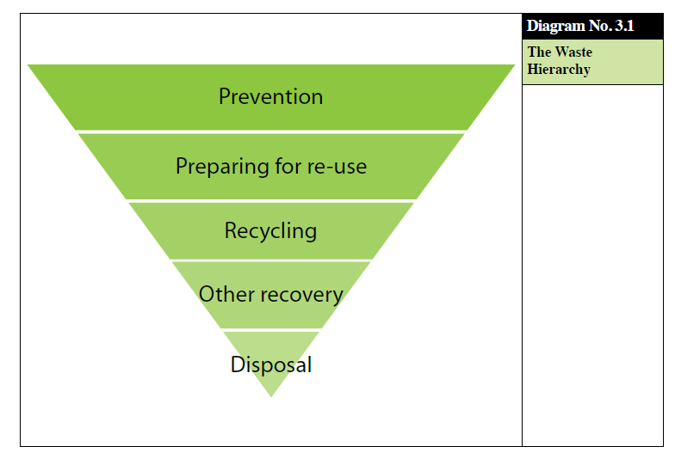

Strategic Planning Policy Statement (SPPS)

2.5 The SPPS was published by the former Department of the Environment in September 2015. The provisions of the SPPS must be taken into account in the preparation of Local Development Plans, and are also material to all decisions on individual planning applications and appeals.

2.6 The SPPS sets regional policy objectives for waste management development which are to:

- promote development of waste management and recycling facilities in appropriate locations;
- ensure that detrimental effects on people, the environment, and local amenity associated with waste management facilities (e.g. pollution) are avoided or minimised; and
- secure appropriate restoration of proposed waste management sites for agreed after-uses.
Role of the Local Development Plan

2.7 The SPPS states that in plan-making, councils should assess the likely extent of future waste management facilities for the plan area. Specific sites for the development of waste management facilities should be identified together with key site requirements including locational criteria. LDPs should also identify the need for appropriate waste management facilities within new development. Particular attention should be given to the potential impacts of existing and approved waste management facilities on neighbouring areas and the need to separate incompatible land uses.

2.8 A presumption in favour of waste collection and treatment facilities, and waste disposal (land filling and land raising) will apply where a need for such development is identified through the Waste Management Strategy and the relevant Waste Management Plan. In the case of Wastewater Treatment Works (WwTWs) need must be demonstrated to the satisfaction of the Department.

2.9 Councils, or where appropriate the Department, should fully consider the potential impacts of all waste management proposals. Important considerations will include: the types of waste to be deposited or treated and the proposed method of disposal; impacts on human health and the environment (including environmental pollution), roads/transport considerations (particularly where facilities depend on large transfer of materials, often generating a substantial volume of traffic), flood risk, practical restoration and aftercare arrangements, where appropriate.

2.10 Many waste management facilities by reason of their size, nature or location have the potential to cause significant damage to the environment in terms of visual intrusion, habitat or heritage destruction and pollution. In assessing all proposals for waste management facilities councils or where appropriate the Department will be guided by the precautionary principle that where there are significant risks of damage to the environment its protection will generally be paramount, unless there are imperative reasons of overriding public interest.
Planning Policy Statement 11 (PPS 11) Planning and Waste Management

2.11 PPS 11 Planning and Waste Management sets out the Department’s policies for waste management development.

2.12 PPS 11 has an important role in supporting the development of a range of waste management facilities consistent with the principles and objectives of the Waste Management Strategy and Waste Management Plans. PPS 11 supersedes Policies PSU 8 (in part) and PSU 14 of a Planning Strategy for Rural Northern Ireland (PSRNI).

2.13 The main objectives of this Planning Policy Statement are to:
- Promote the development, in appropriate locations, of waste management facilities that offer the Best Practical Environmental Option (BPEO) in meeting need as identified by the relevant Waste Management Plan (WMP), or as demonstrated to the Department’s satisfaction in the case of waste water treatment works (WWTWs);
- Ensure that detrimental effects on people, the environment, and local amenity associated with waste management facilities are avoided or minimised;
- Secure appropriate restoration of proposed waste management sites for agreed after-uses.

2.14 PPS 11 states that in relation to the role of the Development Plan the following should be taken into account:

- During the process of development plan preparation, District Councils may wish to discuss with the Department the likely extent of future waste management facilities for the particular plan area. As a result, particular sites for the development of waste management facilities may be identified together with the need for appropriate waste management facilities associated with new development.
- Development plans will also consider the potential impact of existing or approved waste management facilities when zoning adjoining lands for other forms of development and the need to separate incompatible land uses.
- There are specific requirements in respect of polluting and potentially polluting uses, and special or hazardous wastes. The Control of Major Accident Hazards (COMAH) Directive (EU Directive 96/82/EC) came into force on 3 February 1999 and requires development plans to consider the location of hazardous installations. Specifically, development plans must consider the need to maintain an appropriate distance between establishments where hazardous substances are present and residential areas, areas of public use or areas of nature conservation interest.

2.15 PPS 11 contains 5 policies concerned with different types of waste management facilities. The first policy WM 1 Environmental Impact of a Waste Management Facility sets out a series of the environmental tests that all applications must pass as a first step. Policy WM1 provides for a thorough examination of environmental effects and states that development will only be permitted where it can be demonstrated that all of the listed criteria can be met. The remaining policies are concerned with identifying the need for the waste management facilities and suitable locations for such proposals.

2.16 Policy WM2 Waste Collection and Treatment Facilities, Policy WM3 Waste Disposal, Policy WM4 Land Improvement, and Policy WM5 Development in the vicinity of Waste Management Facilities, all need to be taken into account in the determination of planning applications.

Transitional Period

2.17 A transitional period will operate until such times as a Plan Strategy for the Lisburn & Castlereagh City Council area has been adopted. During the transitional period planning authorities will apply existing policy contained within Planning Policy Statement 11 Planning and Waste Management together with the SPPS. Any conflict between the SPPS and any policy retained under the transitional arrangements must be resolved in the favour of the provisions of the SPPS.

3.0 EXISTING DEVELOPMENT PLAN

3.1 The Belfast Metropolitan Area Plan 2015 (BMAP) was prepared under the provisions of Part 3 of the Planning (Northern Ireland) Order 1991 by the former Department of the Environment (DOE). The Plan covers the City Council areas of Belfast and Lisburn and the Borough Council areas of Carrickfergus, Castlereagh, Newtownabbey and North Down. The Plan was adopted on 9th September 2014, however the Court of Appeal declared the adopted plan unlawfully adopted on 18th May 2017.

  - As a result, the existing Development Plans covering the Council area are as follows:
- Belfast Urban Area Plan (BUAP) 2001
- Lisburn Area Plan (LAP) 2001
- Carryduff Local Plan 1988-1993
- Ballymacoss Local Plan
- Lisburn Town Centre Plan
- Lagan Valley Regional Park Local Plan 2005

3.3 BMAP in its post-inquiry form was at an advanced stage and therefore remains a material consideration. Draft BMAP (November 2004) in its pre-inquiry form also remains a material consideration in conjunction with recommendations of the Planning Appeals Commission Public Local Inquiry Reports.

3.4 Volume 3 and Volume 5 of BMAP 2015 sets out policies on Lisburn and Castlereagh Districts respectively. These policies have been developed in the context of the Plan Strategy and Framework contained in Volume 1 of the Plan and are in general conformity with the RDS.

3.5 Volume 1 of BMAP 2015 sets out the strategy for waste management within the Plan Area. The Lisburn & Castlereagh City Council area is part of a larger group of 6 super Councils in the eastern part of Northern Ireland that have come together to form arc21, the Sub-Regional waste planning body. The arc21 Waste Management Plan was prepared under Article 23 of the Waste and Contaminated Land (NI) Order 1997, adopted by the Councils in 2003 and revised in 2006. The central focus of the Plan is an analysis of the waste streams arising in the arc21 region and associated potential for waste prevention, recycling, recovery and disposal.

3.6 In recent years, significant progress in waste management has occurred within the arc21 region, based on a strategy focussing on reducing, reusing and recycling. As recovery, reuse and recycling capacity grows, a decreasing amount of landfill will then be required to deal with residual material left by these processes. The Waste Management Plan also identifies ‘areas of search’ for the provision of necessary facilities and capacity. Proposals for waste management facilities will be considered against the prevailing regional planning policies.

4.0 EXISTING WASTE MANAGEMENT FACILITIES

Household Recycling Centres
4.1 There are three Council operated recycling centres within the Council
area. These are located at:
- The Cutts, Derriaghy, BT17 9HN
- Drumlough, Dromara Road, Hillsborough, BT26 6QA
- Comber Road, Carryduff, BT8 8AN

4.2 There may be a need for a further household recycling centre over the Plan period but no site has yet been identified. There are also a number of privately owned waste facilities throughout the Council district.

Landfill capacity
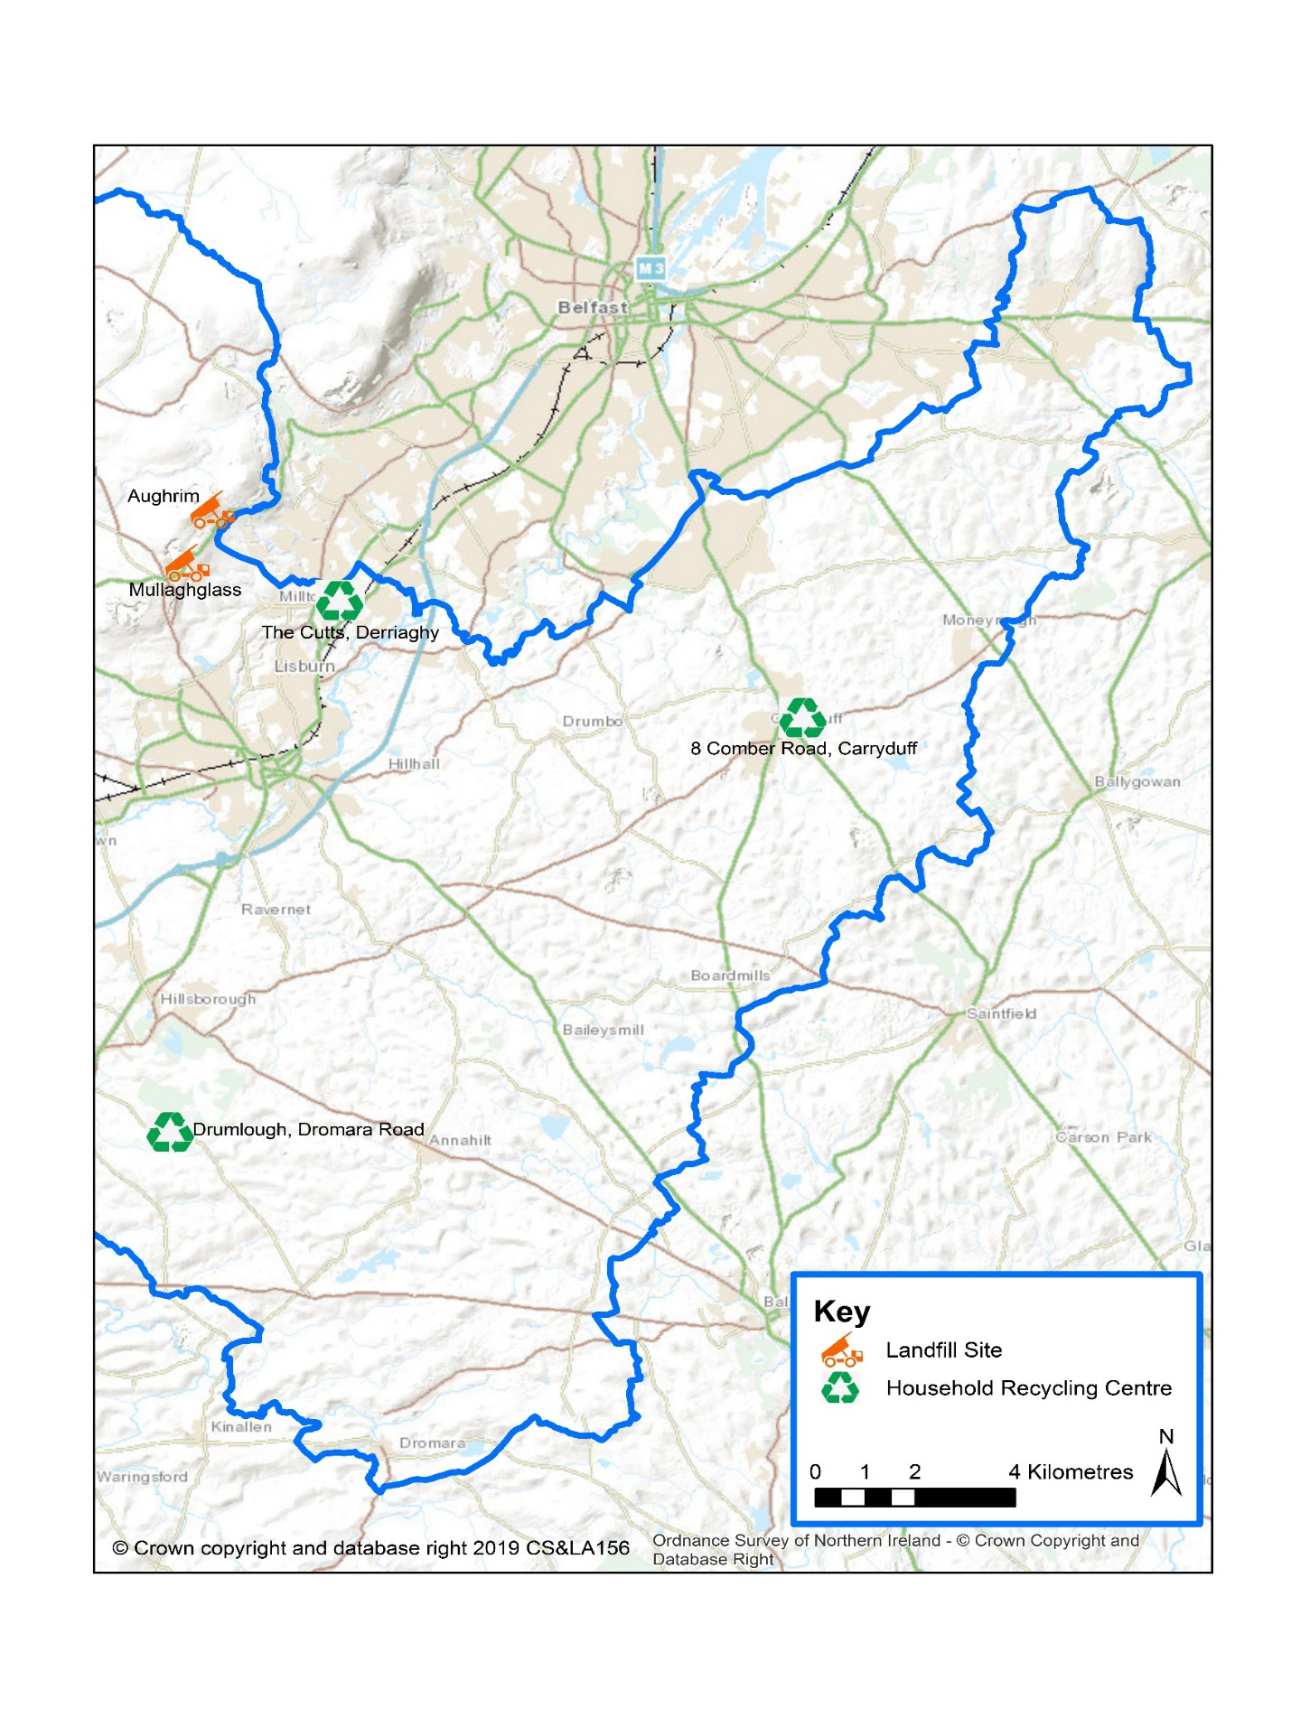
4.3 There are two active landfills for household waste in the Lisburn & Castlereagh City Council area. The remaining capacity of each landfill is shown below:

Map 1 Landfill and Household Recycling Centres in LCCC District

Table 1 Remaining Landfill Capacity in LCCC District (Source: NIEA)
Landfill | Approx remaining void space | Current fill rate | Estimated remaining years
Mullaghglass | 850,000 m3 | 140,000 tonnes/yr | 2015 – 2021  (5 – 6 years)
Aughrim | 2,900,000 m3 | 65,000 tonnes/yr | 2015 – 2055  (30 - 40 years)

4.4 Both these are regional landfills serving the arc21 waste management region. The issue of remaining landfill capacity is complex and will be influenced by factors wider than just the Lisburn & Castlereagh City Council area. There are 2 other regional landfills in the eastern region Cottonmount (Newtownabbey) and Crosshill (Crumlin) with significant remaining capacity. All these landfills sites provide capacity for users across the region. Trends and changes in waste arisings from both municipal sources and commercial/industrial sources will also have a significant impact. Furthermore, in recent years there has been a significant expansion in the export of waste for fuel to other countries in Europe as an alternative to landfill. This now accounts for approximately 15% disposal route for of all municipal waste in the last 2-3 years. This market is still growing and plans to build waste incinerators in the Belfast area have the potential to further reduce the amount of waste going to landfill.

4.5 Therefore, looking at the eastern region as a whole, it is estimated that there is likely sufficient landfill capacity until at least 2032, and if the landfill disposal rate declines as predicted this could be extended by 10-20 years more.

4.6 Full planning permission for a Residual Waste Treatment Facility at Hightown Quarry on the Boghill Road, Ballyutoag in Co. Antrim was initially granted planning approval in September 2017. This development is designed to deal with waste from five council areas, including Lisburn & Castlereagh City Council and includes a Mechanical and Biological Treatment facility, an Energy from Waste Thermal Treatment facility, an Incinerator Bottom Ash Treatment facility, a Refuse Derived Fuel Bale Storage building and an Administration/Visitor Centre. Following a legal challenge to the Department’s approval of planning permission the application was subsequently referred back to the Department for determination.
DfI are continuing to progress the application to the point where it is once again ready for a decision to be made.

5.0 KEY FINDINGS AND CONCLUSION

5.1 A summary of the key findings are as follows:-
- There may be a need for a further household recycling centre over the Plan period but no site has yet been identified. Work within and between neighbouring Councils in this respect should be explored through the relevant Waste Management Plan
- As recovery, reuse and recycling capacity grows, a decreasing amount of landfill will then be required to deal with residual material left by these processes.
- Looking at the eastern region as a whole, it is estimated that there is likely sufficient landfill capacity over the plan period until at least 2032.

CONCLUSION

5.2 Following on from the original Position Paper in December 2015, the purpose of this paper has been to update the baseline information regarding the waste management profile within the Lisburn & Castlereagh City Council area and examine the need for further waste facilities. This baseline will support the preparation of the Plan Strategy and Local Policies Plan, and as the process evolves will be updated/amended as necessary taking account of all relevant new information made available.

