Development Plan

Position Paper 12: Open Space, Sport & Outdoor Recreation
November 2019
Contents Page

Executive Summary 2
- Introduction 4
- Regional Policy Context 4
- Existing Development Plan 8
- Other Key Documents 12
- Open Space, Sport & Outdoor Recreation Profile 13
- Key Findings & Conclusion 23

Appendices
Appendix 1 Community Greenways within the LCCC area
Appendix 2 Pitches within the LCCC area
Appendix 3 Children’s Playgrounds
Appendix 4 Council-Owned Indoor Provision
Appendix 5 Main Outdoor Activities within LCCC
Appendix 6 Open Space Typologies

Executive Summary

This Position Paper aims to provide an overview of open space, sport and recreation provision in Lisburn & Castlereagh City Council to assist in the preparation of the Local Development Plan 2032.

Any future decision making will need to be made within the context of a Sustainability Appraisal under the provision of Planning (Northern Ireland) Act 2011. This paper is therefore intended to generate Member’s ideas on how planning can best accommodate the need for open space, sport and outdoor recreation facilities.

It is important to stress that in compiling the Position Paper the best information available has been used however it may need revised in light of the release of any new data

The paper provides an update on the Position Paper that was published in 2015 as part of the preparation of the Preferred Options Paper and has been informed through an independent audit of open space provision undertaken by professional consultants. This audit of open space provision was undertaken as part of the Council’s Open Space Strategy which will inform the Local Development Plan. In particular where the Open Space Strategy has identified spatial deficiencies in types of open space provision, it is expected that this will inform land use zonings, designations and key site requirements at Local Policies Plan stage

The aims of the paper are:

- To provide baseline information which will inform the Local Development Plan;

- To assess the land use needs of a growing population in Lisburn & Castlereagh City Council and to consider the adequacy of the existing provision for open space, sport and outdoor recreation provision; and

- To provide the spatial representation of the Council’s Community Plan and have regard to other plans and strategies being undertaken by the Council.
- INTRODUCTION

1.1 This paper examines the open space, sport and outdoor recreation provision within Lisburn & Castlereagh City Council.

1.2 Chapter 2 sets out the regional policy context on open space, sport and outdoor formulated within the context of the Regional Development Strategy and regional planning policies contained in Planning Policy Statements (PPS) and the Strategic Planning Policy for Northern Ireland (SPPS).

1.3 Chapter 3 outlines the current policy approach in the existing Development Plan Context.

1.4 Chapter 4 outlines other key documents (non-planning) that provide guidance on open space, sport and outdoor recreation provision.

1.5 Chapter 5 provides an overview of the open space and recreational provision within the Council area. Information has been derived from the Open Space Audit, carried out by external consultants as part of an overall Open Space Strategy for the Council.

1.6 The key findings and conclusion are provided in Chapter 6.

- REGIONAL POLICY CONTEXT

2.1 The Regional Policy Context is provided by the Regional Development Strategy (RDS) 2035, Strategic Planning Policy Statement for Northern Ireland (SPPS) and regional Planning Policy Statements (PPSs) where relevant. A summary of these documents as they relate to plan making and open space, sport and outdoor recreation is provided in the following sections.

Regional Development Strategy (RDS 2035)

The 2035 RDS provides an overarching strategic planning framework to facilitate and guide the public and private sectors in support of the Programme for Government. The RDS has a statutory basis prepared under the Strategic Planning (Northern Ireland) Order 1999. Local development plans must ‘take account’ of the RDS.

  - The RDS promotes the link between environment, health and wellbeing and places emphasis on supporting healthy lifestyles and the promotion of health in the community.

  - The RDS recognises the importance of accessible green infrastructure and the benefits it can offer not only to people but to urban and rural renaissance and to improving the overall environment. The guidance set out in RG 7 ‘Supporting urban and rural renaissance’ promotes recreational space within cities, towns and neighbourhoods, and advises that new developments or plans should make provision for adequate green and blue infrastructure (green infrastructure includes parks and green spaces; blue infrastructure includes ponds, streams and lakes). The RDS highlights the importance of community greenways and require these areas to be protected and enhanced as part of the network of open spaces in the Belfast Metropolitan Urban Area (BMUA) (SFG5: Protect and enhance the quality of the setting of the BMUA and its environmental assets). The green network provides opportunities to link walking and cycling routes to heritage and other areas of recreational interest. These recreation and amenity networks present an opportunity for people to get active, and promote the health and well-being of those living in urban areas.

Strategic Planning Policy Statement (SPPS)

  - The SPPS sets regional strategic objectives for open space, sport and outdoor recreation proposals which are to:-

- Safeguard existing open space and sites identified for future such provision;
- ensure that areas of open space are provided as an integral part of new residential development and that appropriate arrangements are made for their management and maintenance in perpetuity;
- facilitate appropriate outdoor recreational activities in the countryside that do not negatively impact on the amenity of existing residents;
- ensure that new open space areas and sporting facilities are convenient and accessible for all sections of society, particularly children, the elderly and those with disabilities;
- achieve high standards of siting, design and landscaping for all new open space areas and sporting facilities; and
- ensure that the provision of new open space areas and sporting facilities is in keeping with the principles of environmental conservation and helps sustain and enhance biodiversity.

Role of the Local Development Plan
  - The SPPS states that in plan making, Councils should bring forward an Open Space Strategy that must reflect the aim, objectives and policy approach of the SPPS, tailored to the specific circumstances of the plan area. The Local Development Plan (LDP) should make adequate provision for open space informed by an assessment of existing open space provision and future needs, and by liaising with other interested bodies.

  - There will be a policy presumption against the loss of open space to competing land uses in the LDP irrespective of its physical condition and appearance.

  - The LDP should contain a policy requiring new residential development of an appropriate scale to provide adequate and well-designed open space as an integral part of the development.

  - The LDP should also contain policy for the consideration of outdoor recreation in the countryside, taking account of visual and residential amenity, public safety, impact on nature conservation, landscape character, archaeology or built heritage and accessibility.

  - Zonings for future needs should take into account the following:-

- Accessibility to and from existing and proposed housing areas;
- The potential for any detrimental impact on biodiversity or on sensitive environmental areas and features;
- The contribution that open space can make to the quality of the environment, sense of place and community life;
- The importance of protecting linear open spaces such as pedestrian and cycle routes, community greenways, former railway lines and river and canal corridors many of which are valuable in linking larger areas of open space and providing important wildlife corridors / ecological networks;
- Promoting and protecting public access to and along the coast;
- Making adequate provision of green and blue infrastructure; and
- Identifying and designating areas of open space which perform a strategic function, such as landscape wedges in urban areas.

Planning Policy Statement 8 Open Space, Sport & Outdoor Recreation
  - PPS 8 Open Space, Sport & Outdoor Recreation sets out the Department’s policies for open space. It contains the following operational planning policies in relation to open space:
- Policy OS 1 Protection of Open Space
- Policy OS 2 Public Open Space in New Residential Development
- Policy OS 3 Outdoor Recreation in the Countryside
- Policy OS 4 Intensive Sports Facilities
- Policy OS 5 Noise Generating Sports and Outdoor Recreational Activities
- Policy OS 6 Development of Facilities ancillary to Water Sports
- Policy OS 7 The Floodlighting of Sports and Outdoor Recreational Facilities

  - Another relevant regional policy is PPS 7: Quality Residential Environments which requires adequate provision of public and private open space and landscaped areas as an integral part of any new residential development.

Transitional Period

2.13 A transitional period will operate until such times as a Plan Strategy for the Lisburn & Castlereagh City Council area has been adopted. During the transitional period planning authorities will apply existing policy contained within the above mentioned policy together with the SPPS. Any conflict between the SPPS and any policy retained under the transitional arrangements must be resolved in favour of the provisions of the SPPS.

- EXISTING DEVELOPMENT PLAN

Belfast Metropolitan Area Plan 2015 (BMAP)
  - The Belfast Metropolitan Area Plan 2015 is a development plan prepared under the provisions of Part 3 of the Planning (Northern Ireland) Order 1991 by the former Department of the Environment (DoE). The Plan covers the City Council areas of Belfast, Lisburn and the Borough Council areas of Carrickfergus, Castlereagh, Newtownabbey and North Down. The Plan was adopted on 9th September 2014, however the Court of Appeal declared the adopted plan unlawfully adopted on 18th May 2017.

  - As a result, the existing Development Plans covering the Council area are as follows:
- Belfast Urban Area Plan (BUAP) 2001
- Lisburn Area Plan (LAP) 2001
- Carryduff Local Plan 1988-1993
- Ballymacoss Local Plan
- Lisburn Town Centre Plan
- Lagan Valley Regional Park Local Plan 2005

3.3 BMAP in its post-inquiry form was at an advanced stage and therefore remains a material consideration. Draft BMAP (November 2004) in its pre-inquiry form also remains a material consideration in conjunction with recommendations of the Planning Appeals Commission Public Local Inquiry Reports.

  - Volume 3 and Volume 5 of Draft BMAP 2015 sets out policies on the former Lisburn and Castlereagh Districts respectively (“District Proposals”). These policies have been developed in the context of the Plan Strategy and Framework contained in Volume 1 of the Plan and are in general conformity with the RDS.

  - BMAP outlines the following with respect to Open Space, Sport and Outdoor Recreation:-

  - The Open Space, Sport and Outdoor Recreation Strategy promotes the concept of Community Greenways (Policy OS 1), which seek to re-establish corridor links between parks and natural areas to create a network of urban open space and provides policy guidance for new open space provision. In addition, Policy OS2 encourages the provision of new open space inside the Metropolitan Development Limit and Settlement Development Limits (subject to criteria).

  - The Plan acknowledges the large variety of open space, sport and outdoor recreational areas within Lisburn & Castlereagh City Council and identifies all areas of exiting open space above one hectare on Map No. 3 – Metropolitan Lisburn and Map No. 2/001 – Metropolitan Castlereagh. It takes account of privately owned playing fields, grassland areas, glens, parks, walkways and casual play areas located within housing areas.

  - In order to properly analyse open space provision within Lisburn & Castlereagh City Council, BMAP completed an open space audit which included an evaluation of all public and private open spaces and identified the different functions they serve. It assessed outdoor open space provision against the National Playing Fields Association (NPFA) which recommend a minimum standard of 2.4 hectares ‘outdoor playing space’ per 1000 population and studied their distribution and accessibility on a ward level.

  - Table 1 details the open space that was identified for both Lisburn & Castlereagh in BMAP.

Table 1: Open Space identified in BMAP

 | Outdoor Sports (ha) | Children’s Play Space (ha) | Amenity Open Space (ha) | Private Open Space (ha)
Lisburn City Council | 83.85 | 54.31 | 229.16 | 205.57
Castlereagh Borough Council | 79.39 | 25.72 | 174.83 | 172.72
TOTAL | 163.85 | 80.03 | 403.99 | 378.29

  - BMAP also identified several areas that were to be protected for future open space provision within Lisburn & Castlereagh (Table 2).

Table 2: BMAP Future Open Space Provision

Address | Area (hectares) | Proposals | Proposer
West Lisburn | 37.43 | Area to be protected for informal recreation / amenity purposes as part of the overall development of the West Lisburn employment / industrial zoning. | Lisburn City Council
Lands adj to Magheralave Road | 23.59 | Area to be developed as extension to Duncan’s Park & for new open space provision in association with proposed housing expansion. | Lisburn City Council
Hillsborough Road, Dromara | 1.4* | Council intend to develop this area as a riverside walkway / parkland area. | Lisburn City Council
*This area has been provided
Community Greenways
  - BMAP promotes the concept of Community Greenways which seek to re-establish corridor links between parks and natural areas to create a network or urban open space. Community Greenways provide places for both recreation and exercise alongside opportunities for pedestrian and cycle routes as well as wildlife habitats. Both publicly owned open space and private land are included – even where public access is not permitted, the green space can still provide important linkages and visual amenity within the urban area. Where public access is not available, BMAP detailed an alternative pedestrian route to provide a means of circumventing the private areas.

  - Following the changes to the Council boundaries in April 2015, 8 Community Greenways (as identified in BMAP) remain within Lisburn & Castlereagh City Council – see Table 3. Further details on each of the Community Greenways is provided in Appendix 1.

Table 3: Community Greenways identified in BMAP

BMAP Reference | Community Greenway
MCH 41/03* | Castlereagh Escarpment / Lagan Valley Regional Park (LVRP)
MCH 41/04* | Castlereagh Escarpment / Lagan Valley Regional Park (LVRP) at Belvoir
MCH 41/05 | Enler Greenway
MCH 41/06* | Comber Greenway
LC 39/01 | Friend’s School / Belfast Hills
LC 39/02 | Friend’s School / River Lagan
LC 39/03 | Friends School / Wallace Park / Millbrook / Lagan Valley Regional Park
LC 39/04 | Friends School / Lagan Valley Regional Park (LVRP)
ML 23/02* | Lagan Valley Regional Park (LVRP) / Colin Valley Golf Course
* Community Greenway continues into Belfast City Council
- OTHER KEY DOCUMENTS
Play and Leisure Policy Statement for Northern Ireland
  - This policy statement, produced by the Office of the First Minister and deputy First Minister in 2011, aims to improve current play and leisure provision for all children and young people aged 0-18 years. This strategy will help deliver on the aims of the ten-year strategy for children and young people in Northern Ireland 2006-2016 and aims to improve current play and leisure provision.

Sport Matters – The NI Strategy for Sport and Physical Recreation 2009-2019
  - Delivered by Sport NI working in partnership with the Department of Culture, Arts and Leisure, the Strategy sets out a new shared sporting vision of ‘a culture of lifelong enjoyment and success in sport’, as well as the key strategic priorities for sport and physical recreation to deliver a range of sporting outcomes and support the wider social agenda in areas such as education, health, the economy and the development of communities over the period 2009-2019. It explains how sport in Northern Ireland will be developed over the next ten years affirming the Government commitment to put in place effective structures and mechanisms in support of the vision.

Active Places Research Report 2009 & 2014 Update
  - This report completed by Sport NI identified unmet demand and shortfalls for sports facilities such as sports halls, swimming pools, tennis courts, athletic facilities and pitches in Northern Ireland. It presents opportunities for facility providers to strategically address key issues and unmet facility demands identified in their existing and proposed geographical areas. Unlike the 2009 Report, the 2014 update does not present tables for Athletics Tracks or Swimming Pools – in both instances the perceived shortfall has either been met, or is so minimal, that it cannot be attributed to one District Council area.

  - The facility shortfall tables presented in the 2009 Report excluded school sports facilities due to their limited availability for community use. However, in light of recent Community Use of Schools guidance published by Sport NI and the Department for Education, it is important to recognise the potential value of school sports facilities in addressing the facility shortfalls throughout Northern Ireland.

Community Use of Schools (January 2014)
  - This document was produced as the result of collaborative work between the Department of Culture, Arts and Leisure, Sport NI, Department of Education and other educational and non-educational stakeholders. This document provides practical guidance to achieving community use of schools sports facilities.

- OPEN SPACE, SPORT & OUTDOOR RECREATION PROFILE IN LISBURN & CASTLEREAGH CITY COUNCIL AREA

  - Open space can enhance the character of residential areas, civic buildings, conservation areas and archaeological sites. It can also help to attract business and tourism and thereby contribute to the process of urban regeneration. The use being made of the countryside for a range of sporting and outdoor recreational activities, particularly where these are associated with farm diversification, can contribute to the process of rural regeneration and help promote natural resource tourism.

  - Open space is not only used for exercise and relaxation purposes. It can also enhance the character of an area and improve the quality of urban life by providing important green lungs, health benefits, visual breaks from development, reducing flood risk and protecting wildlife habitats in built up areas.

5.3 Sport and outdoor recreation can make a significant contribution to our economy, our environment, our society and plays an important role in the life of the Northern Ireland population. Sport has an important role in:
- Tackling social exclusion
- Reducing anti-social behaviour
- Improving community cohesion
- Promoting healthy lifestyles
- Urban regeneration
- Child / personal development

Existing Outdoor Sport Provision
  - Throughout the Council area, there are a number of outdoor playing fields and sports pitches. Most of these are located within Lisburn City, the towns and villages and includes all council owned and privately owned facilities that are open to the public. A breakdown of pitch and outdoor sport provision provided within Lisburn & Castlereagh City Council are identified in Appendix 2. Lisburn & Castlereagh City Council owns and maintains a large variety of open space, sport and outdoor recreational areas throughout the Council area. This includes a number of playing fields such as those at Cairnshill (Castlereagh) and Limetree Avenue (Lisburn).

  - There are also privately-owned playing fields including those belonging to Lisnagarvey Hockey Club and Carryduff GAC and other areas of open space including private playing fields in the education sector and grassland areas, glens, parks, walkways and casual play areas located within housing areas

Existing Children’s Play Space Provision
5.6 Throughout the Council area, there are a number of children’s outdoor play areas. Most of these are located within Lisburn City, the towns and villages and includes all ‘useable’ casual or informal space for children’s play within housing areas along with local playgrounds and equipped playgrounds. The total number of children’s equipped play areas provided by Lisburn & Castlereagh City Council is set out in Appendix 3.
Existing Indoor Recreation and Leisure Provision
  - Outdoor recreation and leisure facilities are also complimented by indoor facilities (Details of existing indoor provision is provided in Appendix 4). Lagan Valley LeisurePlex in Lisburn has one of the biggest leisure pools in Ireland, competition and diving pools along with gym and outdoor football pitches. Lough Moss Leisure Centre in Carryduff has an all-weather synthetic pitch, outdoor pitches, multi-functional sports hall, gym, dance and boxing studio. These facilities are further complimented by three Activity Centres located within Lisburn City Centre (Glenmore, Kilmakee and Grove). These centres provide locally focussed recreation opportunities and promote a wide range of leisure activities to the public. Public provision of indoor recreation and leisure facilities in the villages and rural areas are mainly supplemented by various community and church halls and private clubs.
Community Greenways
  - As referred to previously, Community Greenways are green space networks, which enhance existing open space provision by linking areas together. Greenways can have recreational, ecological and aesthetic roles. In the urban area, they can ideally offer pedestrians the opportunity to walk from one area to another via pleasant green surroundings. Community Greenways may also act as a cycle network, allowing cyclists to have a safer journey with less noise & pollution. Whilst river corridors and disused railway lines can also provide a haven for wildlife, Community Greenways may also act as corridors linking areas of open space in urban areas with the countryside. Private open space can also be part of greenways – where public access is not allowed, the green space still provides some visual amenity within the built up area. Where public access is not available, BMAP detailed an alternative pedestrian route to provide a means of circumventing the private areas – these routes were intended to retain an appreciation of the greenway route.

  - BMAP considered that all Community Greenways should meet at least one of the following criteria:-
- Offer recreational linkage;
- Offer ecological / environmental linkage; or
- As a source of visual / recreational amenity

  - Details of the Community Greenways within the LCCC area are contained in Appendix 1.

Amenity Open Space Provision
  - In addition to the outdoor play space provided within LCCC, there are many parks, gardens and other outdoor areas that offer opportunities. Parks such as Castle Gardens, Hillsborough Forest, Wallace Park, Moat Park and Moira Demesne provide for dog walking, jogging, children’s play and other recreational activities.

  - The Lagan Valley Regional Park is a significant recreational resource and has variable urban and rural character, mature woodland, agricultural fields and much grassland diversity. While the majority of the Regional Park within the Council area is in agricultural use, there are areas within the Settlement Development Limit of Lisburn City which consist of amenity parklands and casual recreation areas focused on the riverside corridor. These recreation areas make a major contribution to the enjoyment of the Park, as well as playing a vital role in sustaining the well-established parkland character.

  - The Belfast Hills are a striking landscape feature which frame Lisburn City to the north and provide Lisburn with its unique natural setting. The Hills are important for their landscape, natural heritage and visual amenity, however, they also offer a resource for countryside recreation. Much of the land within the Belfast Hills is privately owned which limits formal access. BMAP designated a series of access points to address this problem and provide for countryside recreation and amenity development however the three access points within Lisburn & Castlereagh City Council transferred to Belfast City Council in April 2015.

  - Lisburn & Castlereagh City Council also offer many outdoor activities which appeal to tourists & residents alike. Further details of these activities can be found in Position Paper 11 Tourism and also at Appendix 5 of this paper.
Open Space Standards

5.15 Best practice guidance suggests that open space standards should contain three elements:
- Quantity – an amount of space per house unit or head of population. The Fields in Trust (formerly National Playing Fields Association) recommends a minimum standard for ‘outdoor playing space’ of 2.4 hectares per 1000 population. Outdoor playing space is made up of two main components. The first of these is land provided for outdoor sport, principally for youths and adults. The second is playing space for children.
- Quality – a benchmark against which quality can be measured. Open spaces need to be ‘fit for purpose’ and serve local communities by providing a level of service and functional provision to meet informal leisure and recreational needs.
- Accessibility – this is a key component of open space. Open spaces need to serve local communities and deliver locally accessible open space providing a local resource that addresses daily needs, supports access by walking, cycling, horse riding and public transport, supports unsupervised use with safe accessibility and promotes informal recreation and exercise e.g. dog walking, health walking or general passive use.

Open Space Audit Methodology

5.16 The Open Space Audit, carried out by consultants as part of the Council’s Open Space Strategy, involved the site visits and review of 351 no. open space sites, of over 0.5 hectares in site, throughout the Council area.

Each site was categorised (see Appendix 6 for Open Space Typologies) and information such as site facilities, planting , physical site features, context and built / natural features recorded, along with a recommendation for potential improvements.

Types of Open Space within LCCC
5.17 Eight open space typologies were used, each having a variety of uses and secondary uses / characteristics. The following chart illustrates that the largest category of open space is Amenity Greenspace (162 sites) followed by Playing Pitches (63 sites)

Figure 1: Numbers of Open Space Sites by Typology
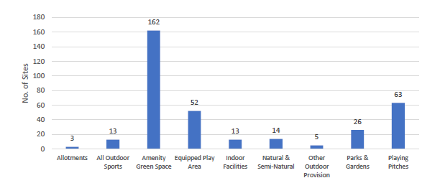

Quantity of Open Space
5.18 There is a total of 831.27 hectares of open space included in the Open Space Audit in the Lisburn & Castlereagh Council area. This area is limited to the areas of open space of 0.5 hectares in size which are publicly accessible and at least 0.5 hectares in size. Open space is distributed throughout the District Electoral Areas (DEA’s) as follows:-

Figure 2: Open Space Distribution (by DEA)
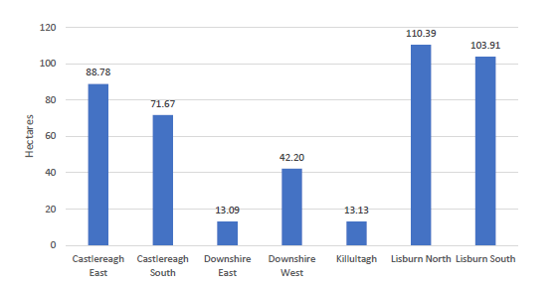

5.19 Settlements included in the audit vary considerably in their size, number of sites and quantity of open space. Table 4 and Figure 3 below illustrates the quantity of open space per settlement. The settlement with the largest area of open space is Lisburn, where much of the Council’s population live. There is a total of 175.35 hectares of open space in Lisburn City.

5.20 Carryduff, Castlereagh Greater Urban Area, Dundonald, Lisburn Greater Urban Area, Hillsborough and Moira also have significant quantities of open space. Hillsborough Forest Park provides an extensive area of open space in the countryside.

Table 4: Open Space Distribution by Settlement
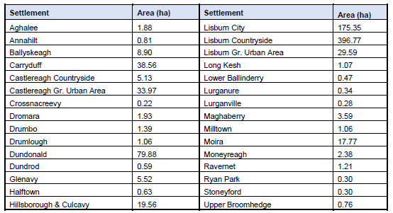

Figure 3: Open Space Distribution by Settlement
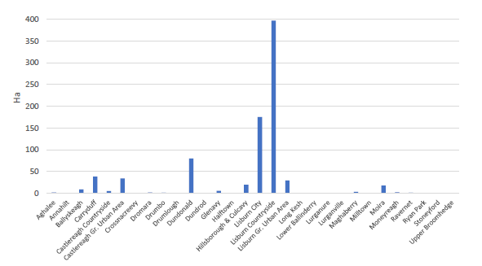

5.21 With regard to the area of the different types of open space, 57% of the total open space area is Parks & Gardens (475.99ha – this figure excludes the Lagan Valley Regional Park) with 22% in use as sports areas (179.60ha), 10% Natural & Semi-natural Greenspace (85.14ha) and 10% Amenity Greenspace (84.69ha). Only 3.30ha (1%) of the open space is equipped play areas, though much of this space is located in larger parks and open spaces. Allotments and community gardens comprise 2.55ha (less than 1%) of the open space.

Figure 4: Types of Open Space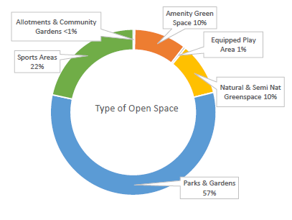
Table 5: Types of Open Space
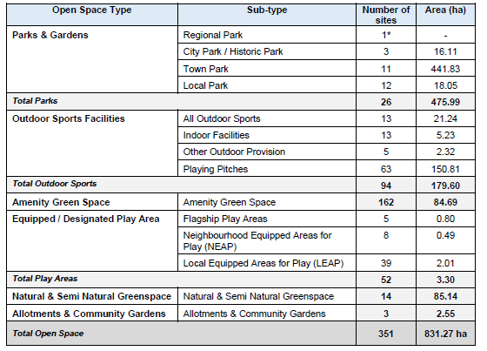

Quality of Open Space
5.22 The quality of each open space site was assessed and each site scored (Please refer to the following link: https://www.lisburncastlereagh.gov.uk/uploads/business/TECHNICAL_SUPPLEMENT_7_OPEN_SPACE_SPORT_AND_OUTDOOR_RECREATION.pdf
for a full breakdown on how the quality was assessed).

5.23 Lisburn City and Lisburn Greater Urban Area contains 9 out of 20 of the worst scoring open space sites. However, Lisburn City also includes 12 out of the 20 top scoring open spaces. Moira, Hillsborough and Dundonald contain high scoring sites.

5.24 Calculating an average quality score for each settlement can give an indication of overall quality of open space in a settlement. The average quality score is 65%. Figure X below indicates that Moira, Stoneyford, Moneyreagh, Ballyskeagh and Hillsborough have the highest average quality scores. Drumlough, Halftown, Upper Broomhedge, Lurganville and Ravernet are the settlements with the lowest average quality scores.

Figure 5: Settlement Average Quality Scores
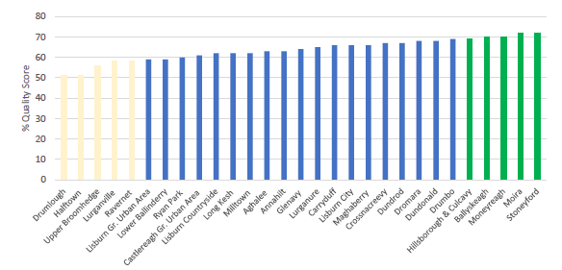

Accessibility of Open Space
5.25 The open space audit included an accessibility study, looking at the accessibility of the parks throughout the Council area. Please refer to https://www.lisburncastlereagh.gov.uk/uploads/business/TECHNICAL_SUPPLEMENT_7_OPEN_SPACE_SPORT_AND_OUTDOOR_RECREATION.pdf for further details on this.

- KEY FINDINGS & CONCLUSION

6.1 A summary of the key findings are as follows:-

- Explore opportunities along Lisburn’s Lagan Corridor for extending access and circulation to the towpath and the wider river and canal environs that have the potential to become an attraction for tourists and residents alike.
- Explore the potential for improving connectivity and linkages between areas of open space, with particular regard to further developing the Strategic Greenways as identified in the DfI Strategic Greenway Plan
- Recognise the importance of good quality open space, sport and outdoor recreation provision on the health & well-being of residents and explore opportunities for further enhancing this provision.

CONCLUSION
6.2 Following on from the original Position Paper in December 2015, the purpose of this paper has been to update the baseline information regarding the open space, sport and outdoor recreation profile within the Lisburn & Castlereagh City Council area and examine the need for further provision. This baseline will support the preparation of the Plan Strategy and Local Policies Plan, and as the process evolves will be updated/amended as necessary taking account of all relevant new information made available.

Appendix 1
Community Greenways within LCCC
LC 39/01 Friends’ School / Belfast Hills
Begin at Friends’ School on the Magheralave Road and travel along Clonevin Park, Antrim Road and Duncan’s Road to the entrance of Duncan’s Park on Beechdene Drive. This part of the greenway follows an established footway through this residential area. At the entrance to Duncan’s Park, follow the pathway north through the park and exit on Stockdam Road.
The following section in inaccessible to pedestrians:- Cross the Stockdam Road and continue along the reservoir,following the pathway and continuing parallel to the Magheralave Road and into the Belfast Hills where the greenway ends.
Alternative Pedestrian Linkage:- Exit on the Stockdam Road, and travel in a southerly direction until it joins the Duncan’s Road and then travel north west to join the Magheralave Road. Continue travelling north along the Magheralave Road to the Derriaghy Road and join the Greenway here.

Community Greenway LC 39/01
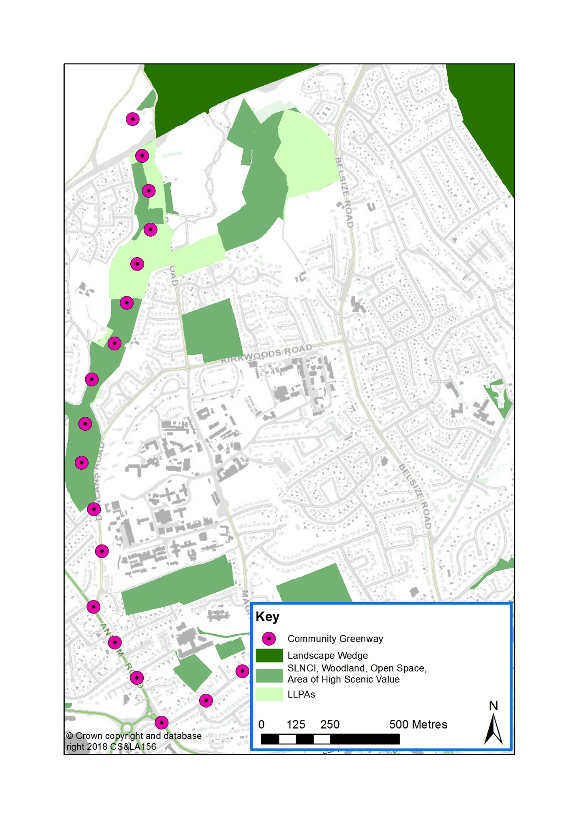
LC 39/02 Friends’ School / River Lagan
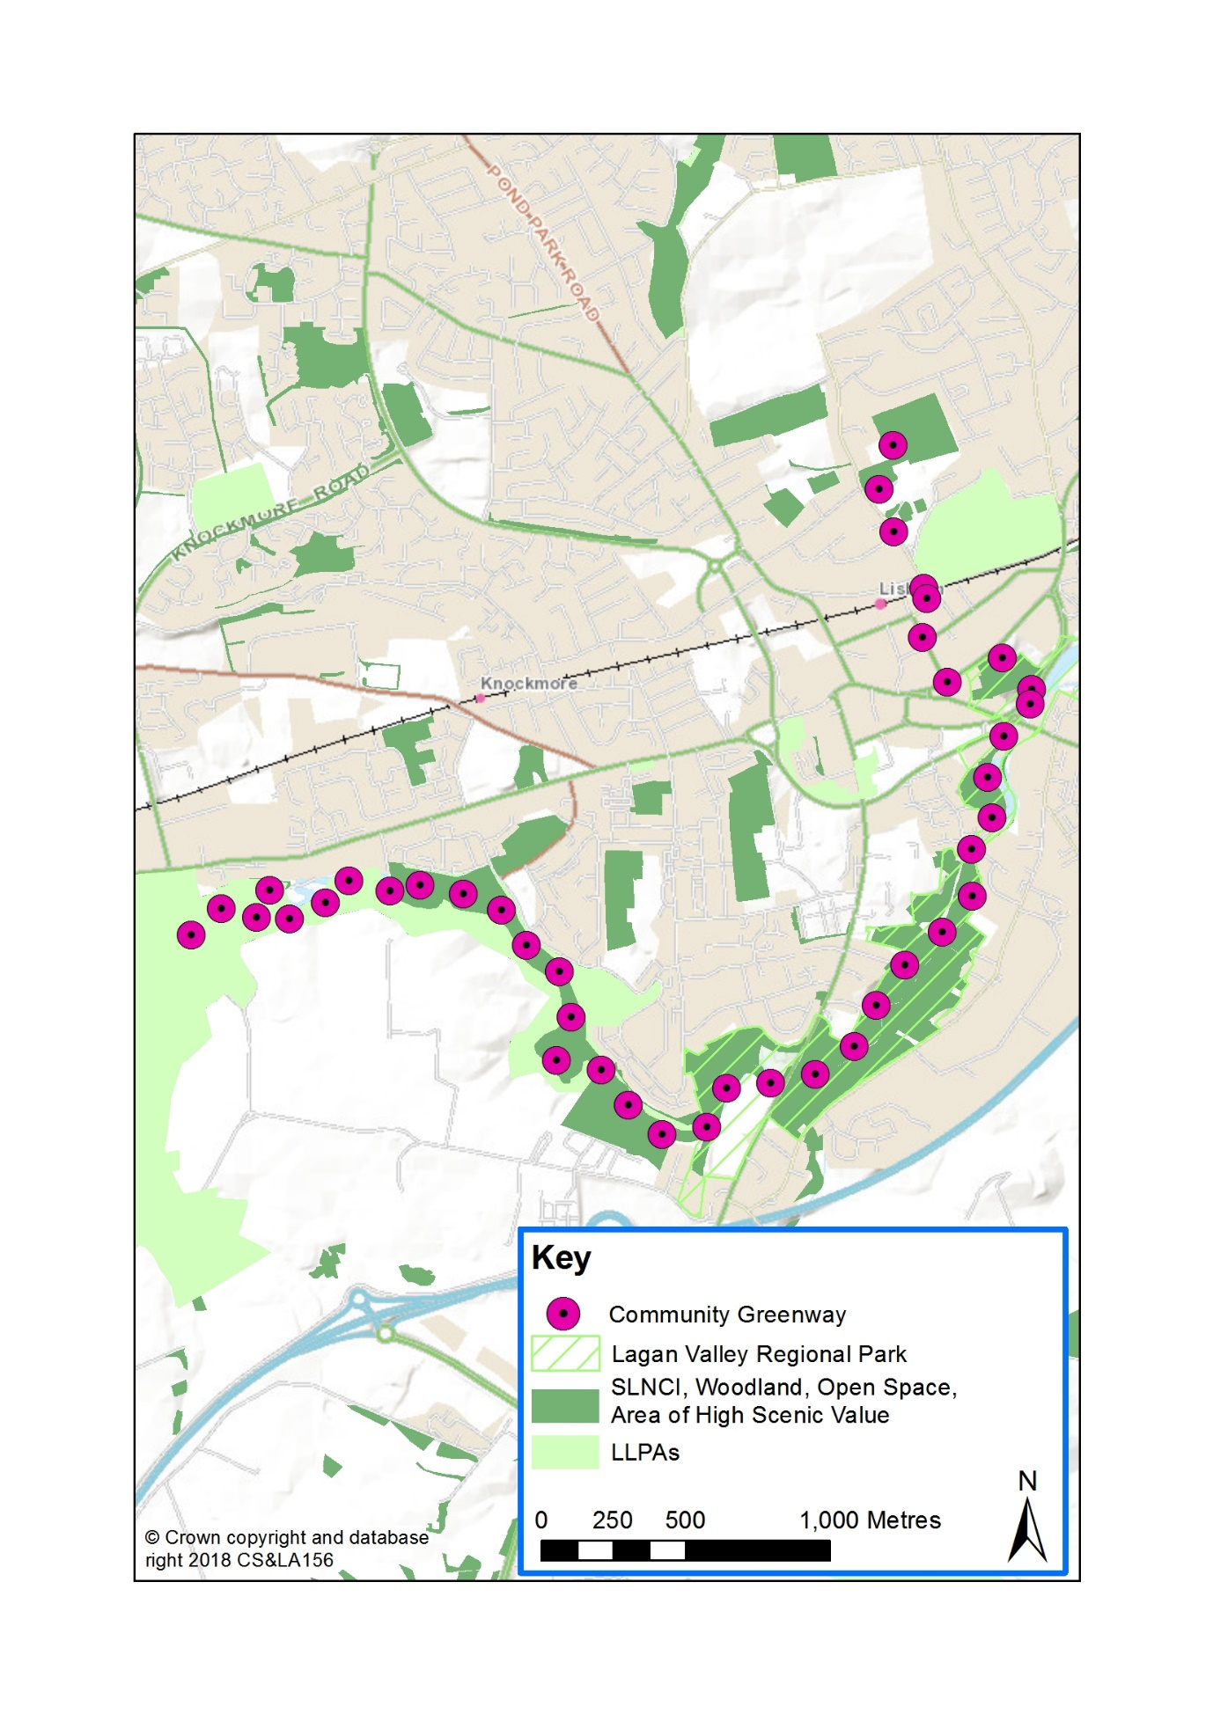
Begin at the Friends’ School playing fields ion the Magheralave Road. Continue to travel south down the Magheralave Road, past Wallace Park. At the end of the Magheralave Road, turn left onto Railway Street, and then at the end of the street, turn left again onto Castle Street and through Castle Gardens, exiting on Queen’s Road. Cross the Road and continue parallel to the Lagan in a south westerly direction, crossing the busy junction with Sloan Street to reach the Lagan Riverside path. Continue along the riverside path for approximately 2-3 km to west Lisburn where the greenway ends.

LC 39/03 Friends’ School / Wallace Park / Millbrook / Lagan Valley Regional Park (LVRP)
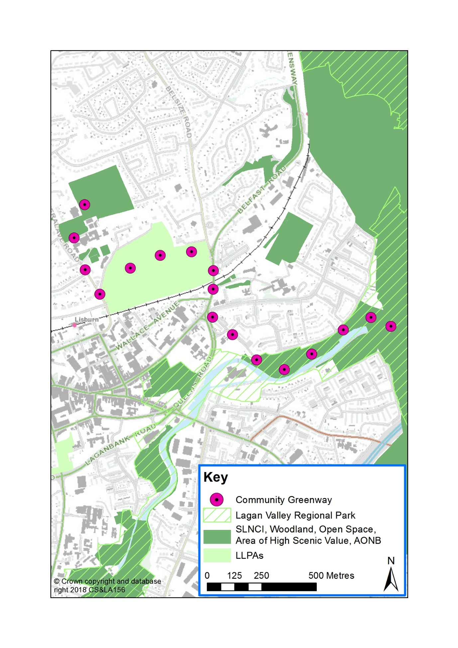
Begin at Friends’ School on the Magheralave Road. Travel down the Magheralave Road and turn left into Wallace Park. Travel through the park, exiting the park on the Belfast Road. Turn right and continue south for 300m to join Millbrook Road. At the end of Millbrook Road, travel across the redeveloped Millbrook / Huguenot Riverside Park to the Blue Bridge. Cross the bridge and join the towpath beside Ashmount Gardens, through to the LVRP, where the greenway ends.

LC 39/04 Friends’ School / Lagan Valley Regional Park (LVRP)
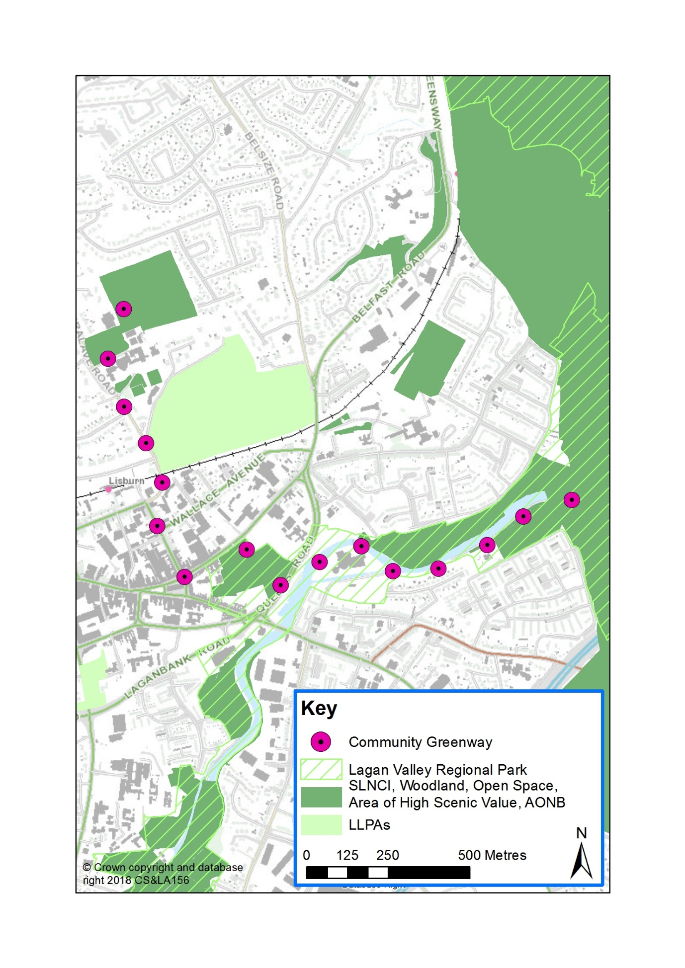
Begin at Friends’ School on the Magheralave Road. Travel down the Magheralave Road, past Wallace Park. At the end of the Magheralave Road, turn left onto Railway Street and then at the end of the street turn left again onto Castle Street and through Castle Gardens, exiting on Queen’s Road. Cross onto Lagan Valley Island, follow the pathway past the rear of the housing at Mandeville Avenue and through the open space at Ashmount Gardens, continuing into the LVRP, where the greenway ends.

MCH 41/03 Castlereagh Escarpment / Lagan Valley Regional Park (LVRP)
The following section is inaccessible to pedestrians:- Begin on the Saintfield Road, across from Saintfield Lodge Private Nursing Home. Cross the road and travel into the grounds of Knockbracken Healthcare Clinic, following the road past the buildings and along the boundary of the hospital grounds. Continue along the Purdysburn Road and then along Alderwood Hill and back out onto the Purdysburn Road continuing past the grassland and woodland on the left.
Alternative Pedestrian Linkage:- Begin on the Saintfield Road, across from Saintfield Lodge Private Nursing Home. Travel up the Saintfield Road in a northerly direction, past the hospital grounds, and left onto the Purdysburn Road. At the roundabout veer left and continue along the Purdysburn Road, past Alderwood Hill, Royal Oaks and the grassland and woodland on the left. Rejoin the greenway here.
The greenway continues on to the LVRP in Belfast City Council area

Community Greenway MCH 41/03
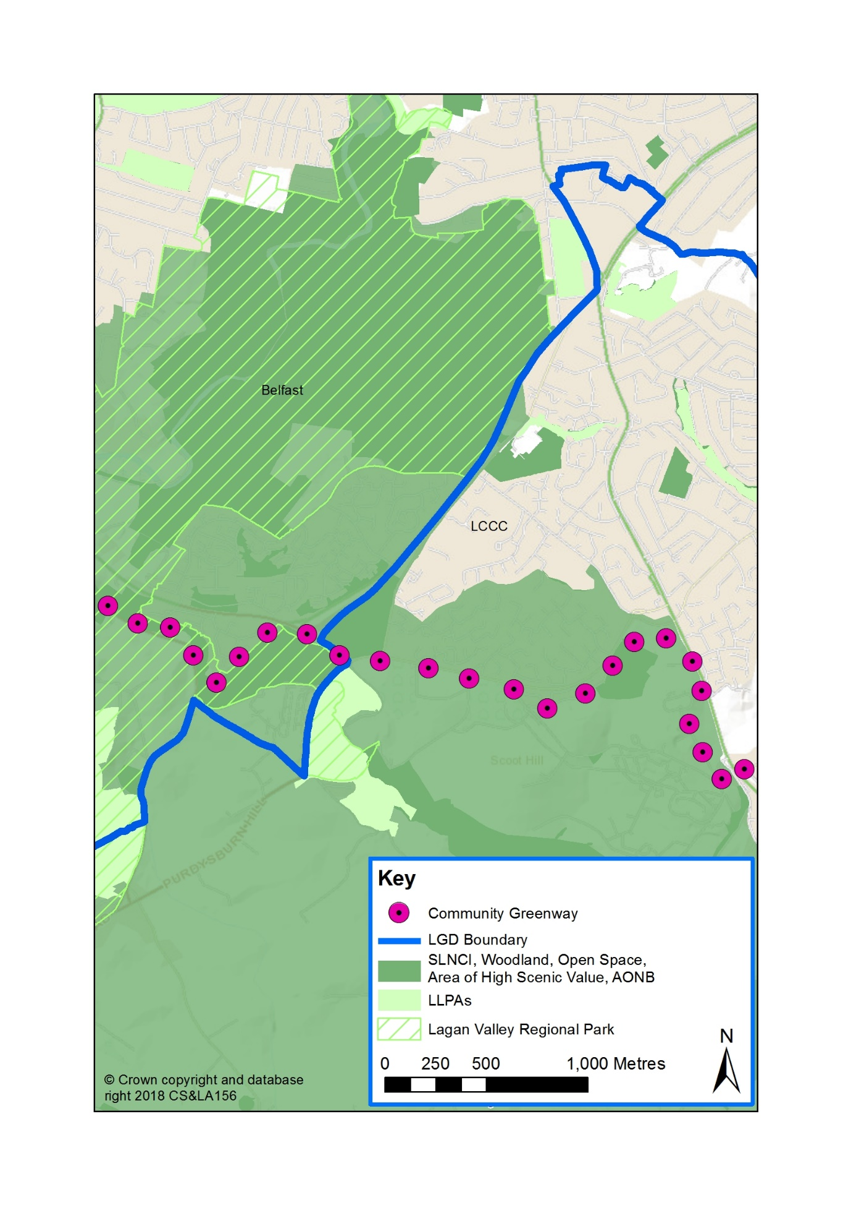

MCH 41/04 Castlereagh Escarpment / Lagan Valley Regional Park (LVRP) at Belvoir
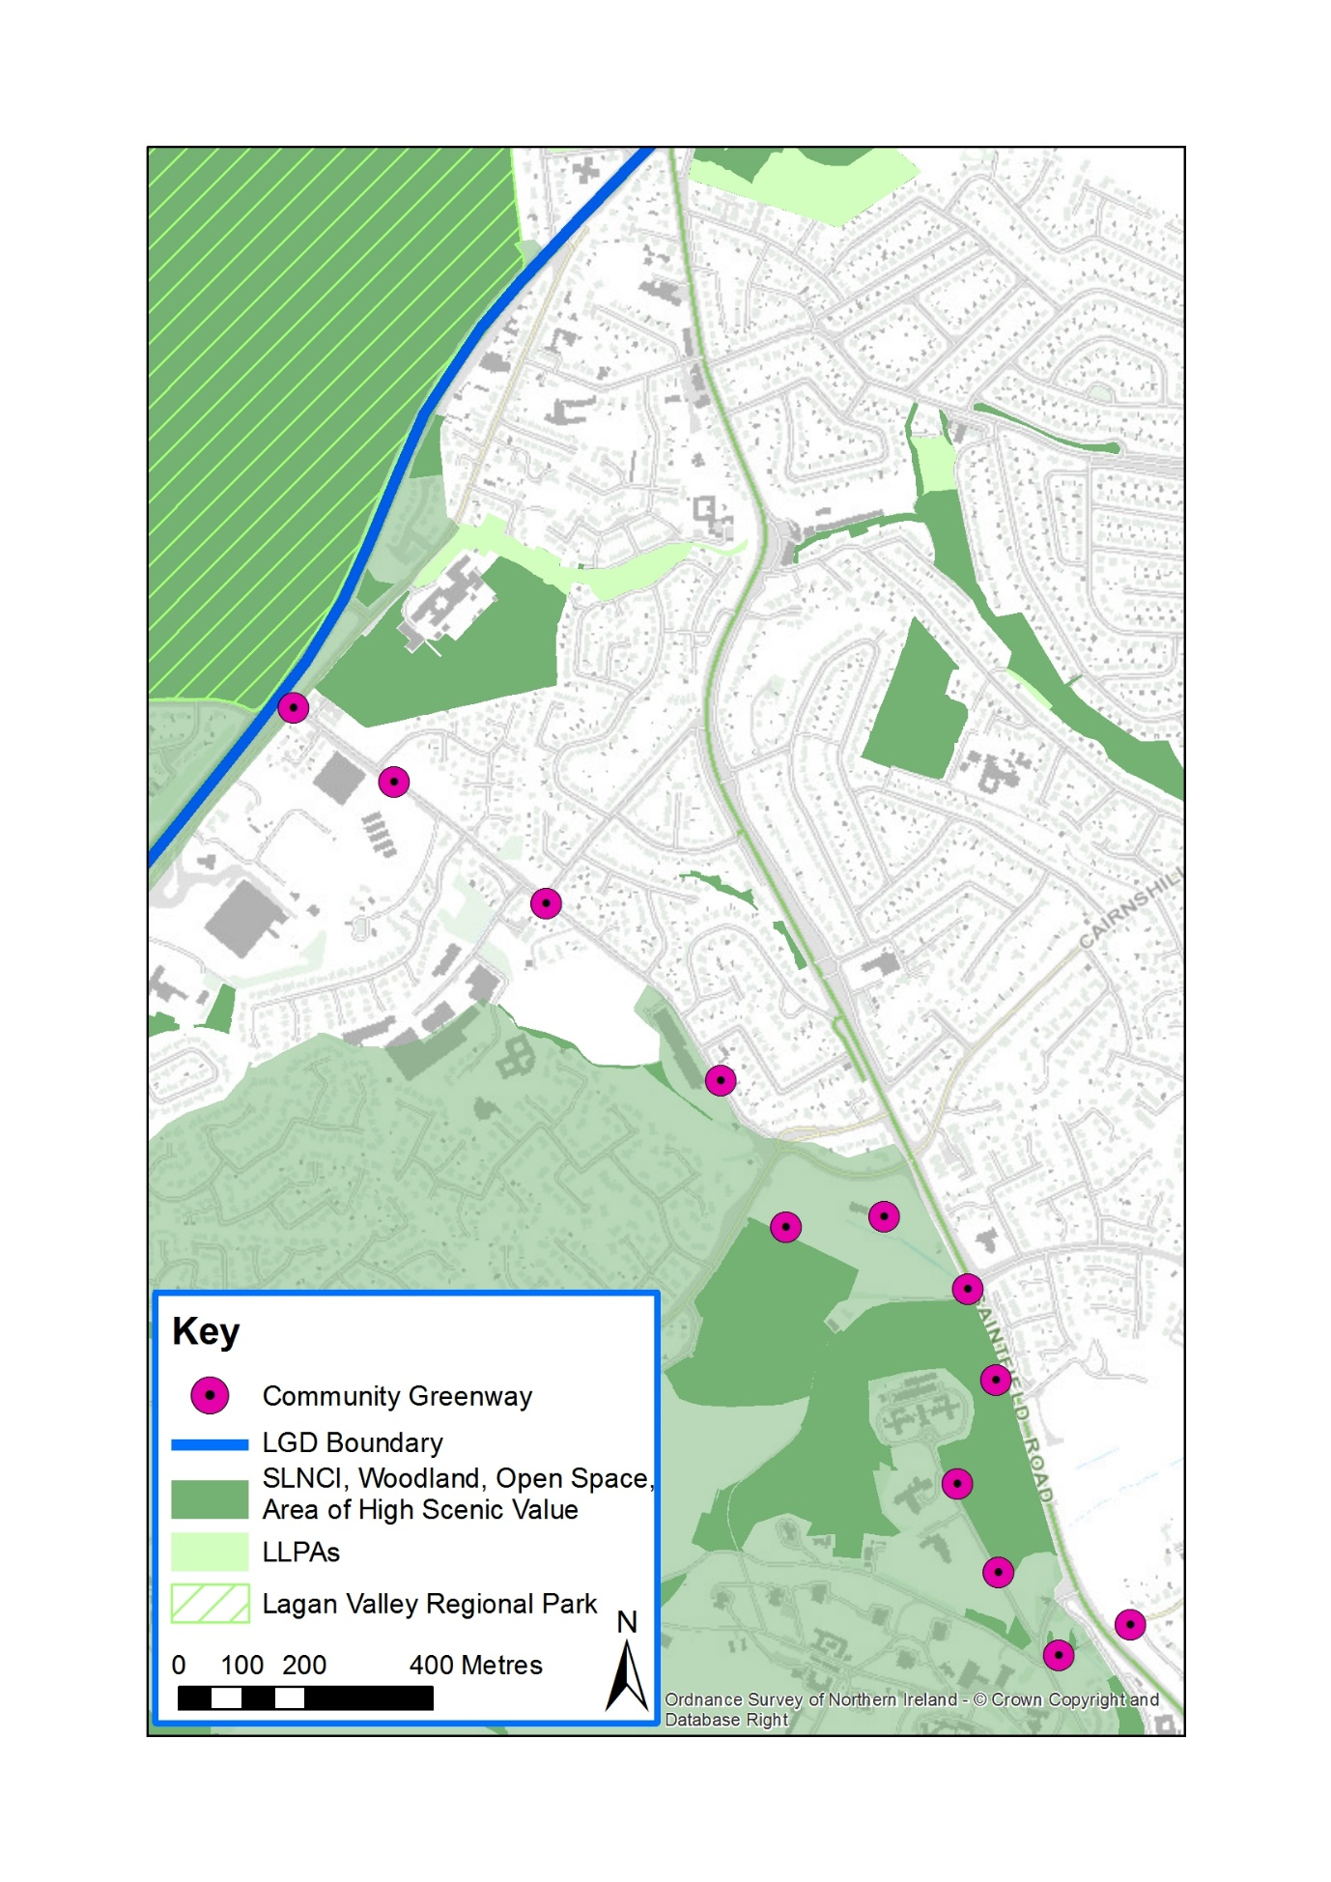
Begin at the edge of the Knockbracken Healthcare Clinic grounds and continue back onto the Saintfield Road, then turn left onto the Purdysburn Road. At the mini roundabout, continue straight onto the Beechill Road and past Beechill House on the left. Continue to the end of the Beechill Road and cross the Newtownbreda Road. Here, the greenway travels on to the LVRP within Belfast City Council area.

Enler Greenway MCH 41/05 Enler Greenway
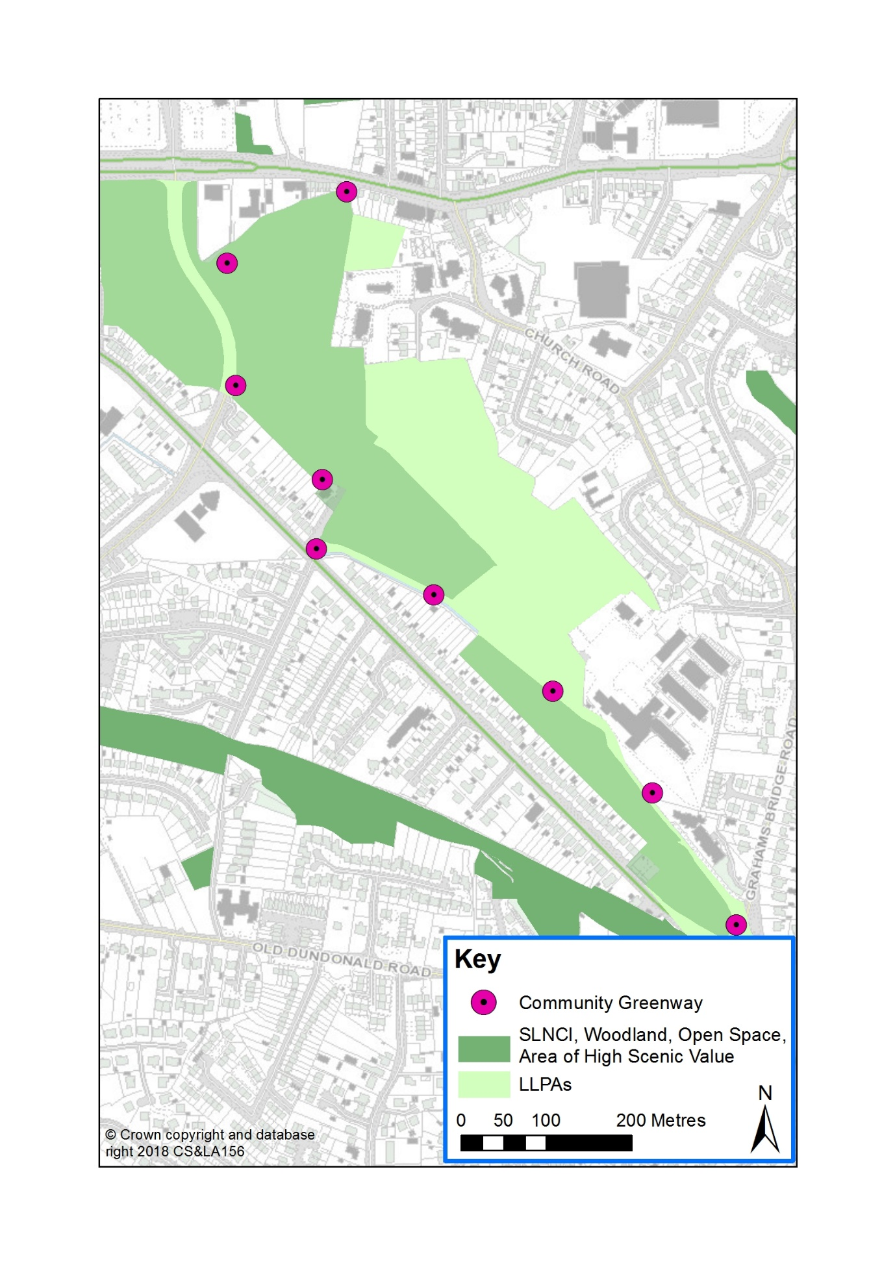
Begin at the entrance to Moat Park on the Upper Newtownards Road. Travel through the park in a southerly direction, exiting at the entrance to Dundonald Primary School. Travel along the path to the south of the playing field and follow the route through the open space at the rear of the houses on the Comber Road. Exit onto the Comber Road. The Comber Greenway can be accessed at this point at the junction with the Grahamsbridge Road where the greenway finishes.

MCH 41/06 Comber Greenway
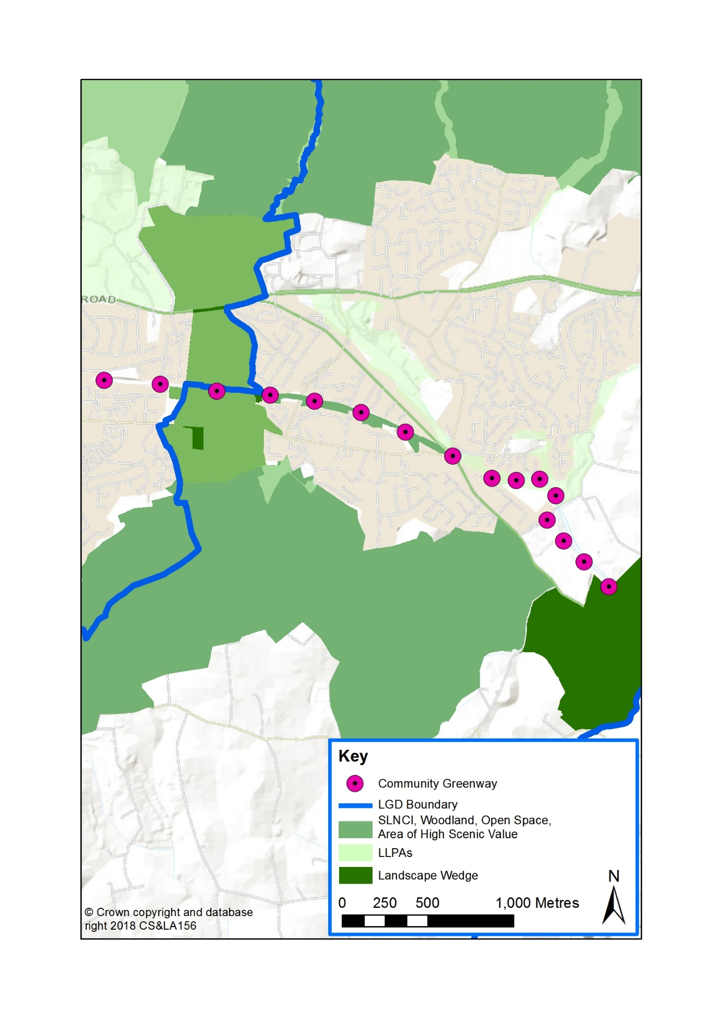
Following on from the Belfast section of the Comber Greenway (BT147/06), the LCCC section begins at Dundonald Cemetery, travelling east along the route of the old Belfast to Comber railway line past other residential accesses at North Sperrin, Upperlands Walk, East Link Road, Quarry Lane, Comber Road, Old Dundonald Road, Millmount Road to the Billy Neill Centre for Soccer Excellence on Comber Road where the greenway ends at the Plan boundary.

ML 23/02 Lagan Valley Regional Park (LVRP) / Colin Valley Golf Course
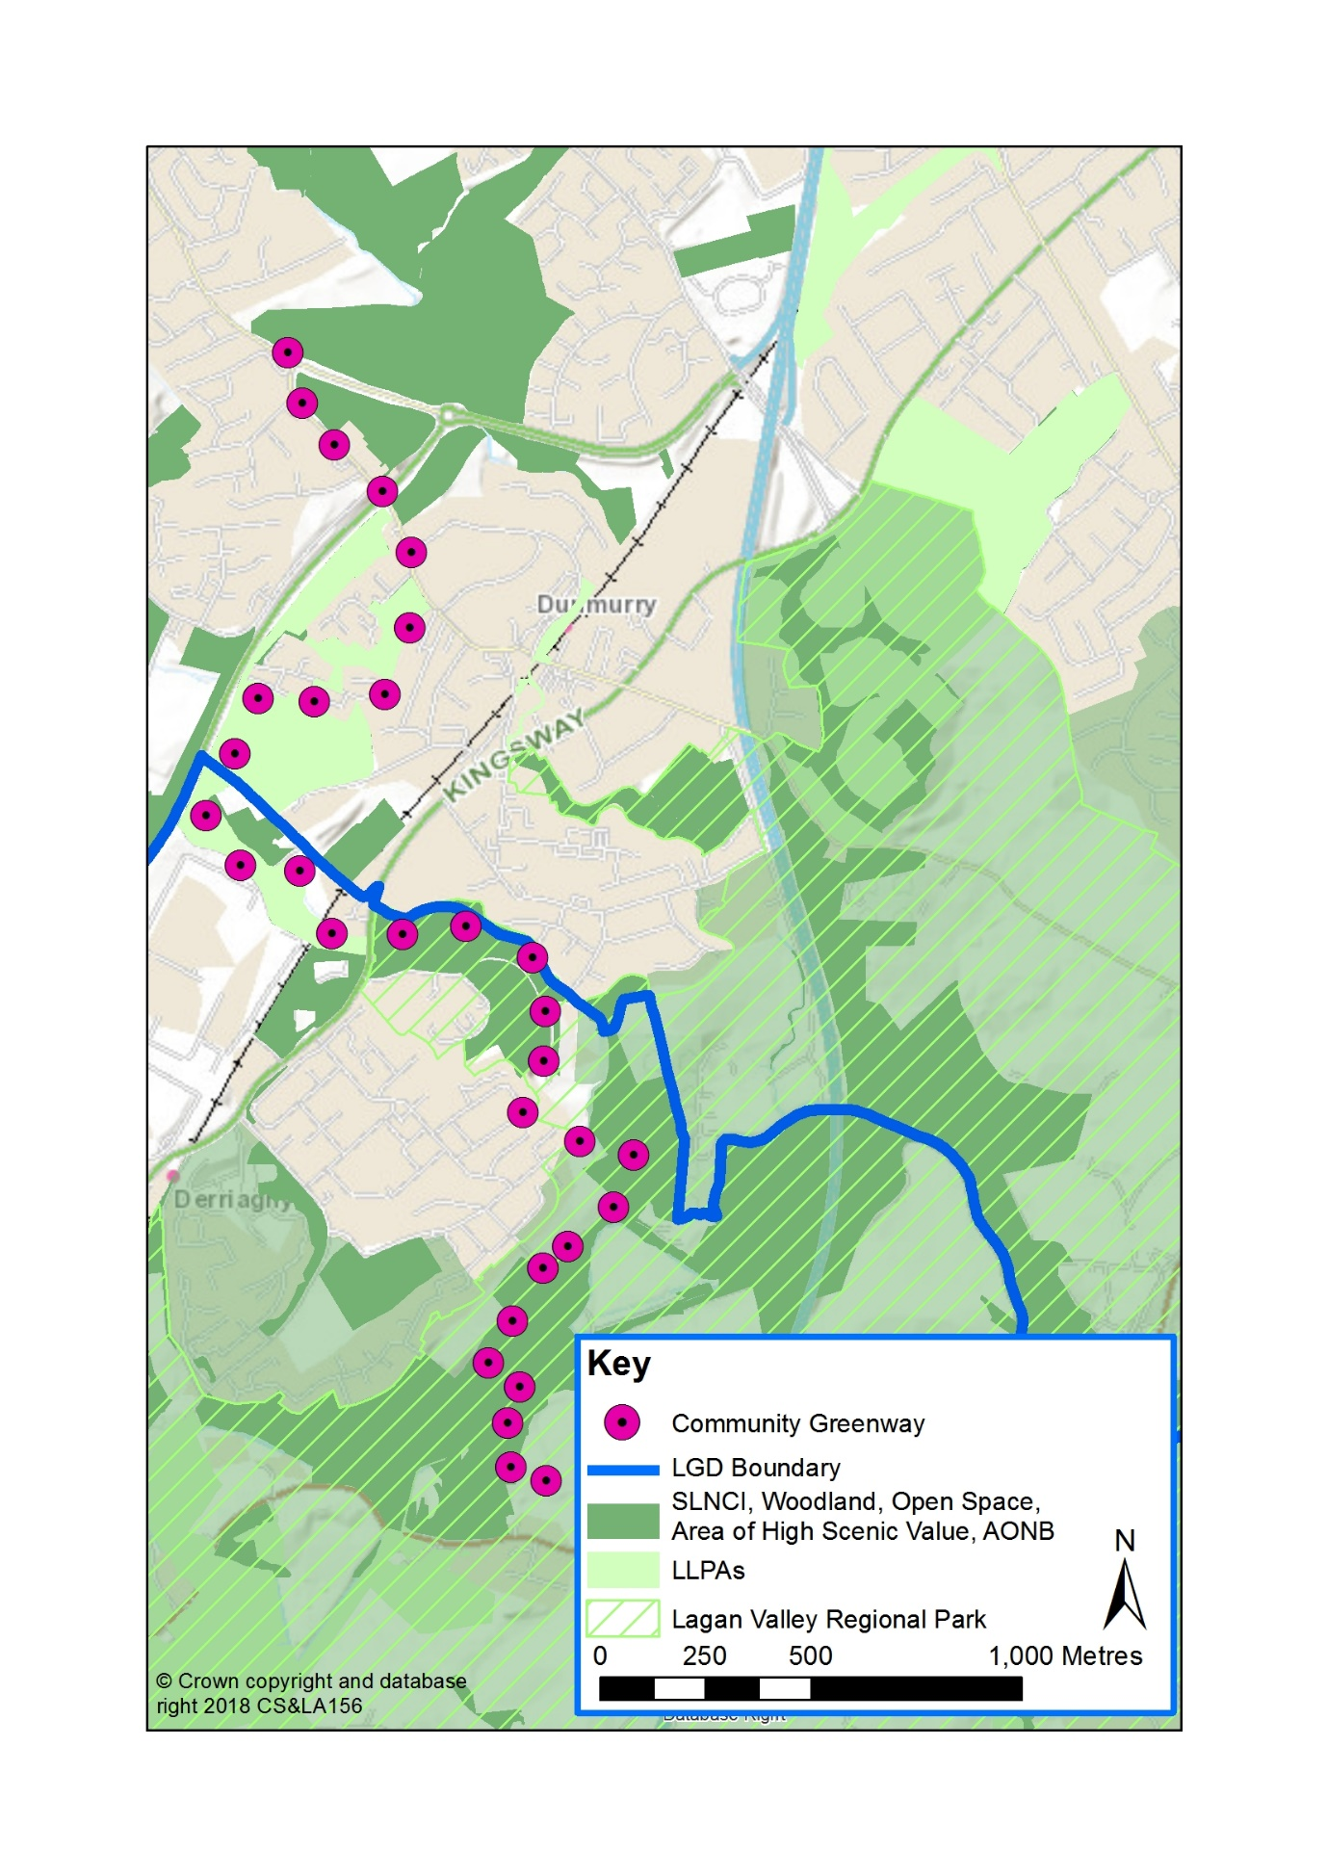
Begin at ‘Ballyskeagh Riverside Park’, then cross the Lagan Canal and the River Lagan via Ramblers Bridge into the Seymour Hill housing development, then turn right and follow Oak Tree Walk through Derriaghy Glen Linear Park and out onto Kingsway. Follow the remainder of this greenway through Belfast City Council area to connect with another greenway (ML 23/01) which continues on into the Belfast Hills.

Appendix 2
LCCC Playing Pitches

Lisburn City – Playing Pitches
Pitch | Address | DEA | Description
Barbour Memorial Playing Fields | Ballynahinch Road | Downshire West | 3 x Full Grass Pitches
Glenmore Activity Centre | Glenmore Park | Lisburn North | 1 x Full Grass Pitch  1 x Junior Grass Pitch
Grove Activity Centre | Ballinderry Park | Lisburn South | 2 x 5 a Side Pitches
Kirkwoods Playing Fields | Kirkwoods Road | Lisburn North | 1 x Full Grass GAA Pitch  1 x Training Grass Pitch
Lisburn Leisure Park | Governor’s Road | Lisburn South | 3 x Full Grass Pitches
Lisburn Leisure Park | Governor’s Road | Lisburn South | 6 x 5 a Side 3G Pitches  2 x 7 a Side 3G Pitches
Lisburn Rugby Club | Eglantine Road | Downshire East | 3 x Grass Rugby Pitches
Stanley Park,  Lisburn Leisure Park | Governor’s Road | Lisburn South | 1 x Full Grass Pitch
Queen Elizabeth II Playing Fields | Limetree Avenue | Lisburn South | 3 x Full Grass Pitches
Rathvarna Play Area | Windermere Lodge | Lisburn South | 1 x Junior Polymeric Pitch
Bluebell Stadium  Rushmore Playing Fields | Rushmore Drive | Lisburn South | 1 x Full Grass Pitch
Wallace Park | Belfast Road | Lisburn North | 3 x Full Grass Pitches
Laurelhill Sportzone | Laurelhill Road | Lisburn South | 1 x Full AstroTurf Pitch
Nettlehill Road | Nettlehill Road | Lisburn North | 1 x Full Grass Pitch

Greater Lisburn Urban Area – Playing Pitches
Pitch | Address | DEA | Description
Seycon Park | Hornbeam Road, Seymour Hill | Lisburn North | 1 x Full Grass Pitch

Greater Castlereagh Urban Area – Playing Pitches
Pitch | Address | DEA | Description
Billy Neill Soccer Centre | Comber Road | Castlereagh East | 7 x Full Grass Winter Pitches  2 x Full Grass Summer Pitches
Cairnshill Playing Field | 12 Beechill Park North | Castlereagh South | 1 x Full Grass Pitch  1 x Junior Grass Pitch
Brooklands Playing Fields | Dungoyne Park | Castlereagh East | 1 x Full Grass Pitch
Hydebank Playing Fields |  | Castlereagh South | 5 x Full Grass Pitches  1 x Junior Grass Pitch
Moat Park | Comber Road | Castlereagh East | 2 x Full Grass Pitches
Breda Park | Upper Braniel Road | Castlereagh South | 2 x Full Grass Pitches  1 x Full 3G Pitch
Ballyoran Centre | Rosneath Gardens | Castlereagh East | 1 x Junior 3G Pitch

Lisburn & Castlereagh City Council Towns – Playing Pitches
Settlement | Pitch | DEA | Address | Description
Carryduff | Lough Moss Leisure Centre | Castlereagh South | Hillsborough Road | 3 x Full Grass Pitches  1 X Junior GAA Grass Pitch
Carryduff | Lough Moss Leisure Centre | Castlereagh South | Hillsborough Road | 1 x Full AstroTurf
Carryduff | Carryduff Park | Castlereagh South | Edgar Road | 1 x Junior Grass Pitch
Carryduff | Carryduff GAC, | Castlereagh South | Knockbracken Drive | 2 x Full Grass GAA Pitches  1 x Training Grass GAA Pitch
Hillsborough | Hillsborough Village Centre | Downshire West | Ballynahinch Street | 1 x Full AstroTurf Pitch  1 x Full Grass Pitch
Hillsborough | Downshire YM FC | Downshire West | Old Coach Road | 1 x Full Grass Pitch
Hillsborough | Lisnagarvey Hockey Club, | Downshire West | Comber Road | 2 x Full AstroTurf Pitches
Moira | Moira Demesne | Downshire West | Main Street | 2 x Full Grass Pitches

Lisburn & Castlereagh City Council Rural Areas – Playing Pitches
Settlement | Pitch | DEA | Description
Aghalee | Aghalee Playing Fields  Lurgan Road | Killultagh | 1 x Full Grass
Ballyskeagh | New Grosvenor Stadium  Ballyskeagh Road | Downshire East | 1 x Full Grass Pitch
Drumbo | Drumbo Playing Fields  Front Road | Downshire East | 1x Full Grass Pitch
Dundrod | Dundrod Playing Field  Leathemstown Road | Killultagh | 1 x Full Grass Pitch
Glenavy | Crewe Park  Lisburn Road | Killultagh | 1 x Full Grass Pitch
Glenavy | St Joseph’s GAC,  Chapel Road | Killultagh | 1 x Full Grass GAA Pitch  1 x Training GAA Pitch
Maghaberry | Maghaberry Community Centre  Maghaberry Road | Killultagh | 1 x Junior AstroTurf Pitch
Milltown | Milltown Play Area  Milltown Crescent | Lisburn North | 1 x Junior Polymeric Pitch
Moneyreagh | Moneyreagh Community Centre  Church Road | Castlereagh East | 1 x Junior Grass Pitch
Upper Broomhedge | Anvil Park  Derrynahone Road | Downshire West | 1 x Full Grass Pitch
Maze | Lower Maze Social & Recreation Club  Bog Road | Downshire West | 1 x Full Grass Pitch  1 x Junior Grass Pitch

Appendix 3
LCCC Children’s Playgrounds
Lisburn City - Equipped Playgrounds
Playground | Address | DEA
Avonmore Play Area | Drumbeg Drive, Old Warren | Lisburn South
Ballymacoss Hill Play Park | Ballymacoss | Lisburn South
Barbour Memorial Playing Fields | Saintfield Road | Downshire West
Duncan’s Park | Duncan’s Road | Lisburn South
Duncan’s Glen Linear Park | Stockdam Road | Lisburn South
Glenmore Activity Centre | Glenmore Park | Lisburn North
Grove Activity Centre | Ballinderry Park | Lisburn South
Hilden | Grand Street | Lisburn North
Hillhall Playground | Hillhall Gardens | Downshire East
Hill Street | Old Warren | Lisburn North
Hugenot Play Area | Hugenot Drive | Lisburn North
Lambeg Park | Station Road | Lisburn North
Nettlehill Road Play Area | Nettlehill Road | Killultagh
Queen Elizabeth Playing Fields | Limetree Avenue | Lisburn South
Rathvarna Play Area | Windermere Lodge | Lisburn South
Wallace Park | Belfast Road | Lisburn North

Greater Lisburn Urban Area - Equipped Playgrounds
Playground | Address | DEA
Kilmakee Activity Centre | Rowan Drive, Seymour Hill | Lisburn North
River Road | Seymour Hill, Dunmurry | Lisburn North
Seymour Hill | Riverbank | Lisburn North

Greater Castlereagh Urban Area - Equipped Playgrounds
Playground | Address | DEA
Ballyoran Centre | Rosneath Gardens, Dundonald | Castlereagh East
Breda | Breda Terrace | Castlereagh South
Colby Park | Colby Park, Newton Park | Castlereagh South
Dungoyne | Dungoyne Park, Ballybeen | Castlereagh East
Moat Park | Comber Road | Castlereagh East

Lisburn & Castlereagh City Council Towns - Equipped Playgrounds
Settlement | Address | DEA
Carryduff | Carryduff Park, Edgar Avenue | Castlereagh South
Carryduff | Lough Moss | Castlereagh South
Carryduff | Green Oak Park, Killynure Green | Castlereagh South
Hillsborough | Main Street | Downshire West
Hillsborough | Ogles Terrace, Culcavy | Downshire West
Moira | Moira Demesne, Main Street, Moira | Downshire West

Lisburn & Castlereagh City Council Rural Area - Equipped Playgrounds
Settlement | Address | DEA
Aghalee | Aghalee Playing Fields, Lurgan Road | Killultagh
Annahilt | Glebe Road | Downshire West
Crossnacreevy | Houston Road / Ballygowan Road | Castlereagh East
Dromara | Rathfrisland Road | Downshire East
Drumbo | Front Road | Downshire East
Drumlough | R/o 1-14 Rockview Park | Downshire East
Halftown | Coronation Gardens | Downshire West
Glenavy | Johnston Park | Killultagh
Glenavy | Killultagh Grange | Killultagh
Glenavy | Lyngrove Hill | Killultagh
Lurganure | r/o Campbell’s Terrace | Downshire West
Lurganville | r/o Laganview Terrace | Downshire West
Maghaberry | Maghaberry Community Centre | Killultagh
Maghaberry | Maghaberry Village Green | Killultagh
Milltown | Milltown Crescent | Lisburn North
Moneyreagh | Church Road | Castlereagh East
Ravernet | Ravernet Gardens | Downshire East
Ryan Park | r/o 2-36 Ryan Park | Castlereagh East
Stoneyford | Stoneyford Road | Killultagh

Appendix 4
Council-Owned Indoor Sports Facilities

Facility | Address | Description
Dundonald Ice Bowl | Old Dundonald Road, Dundonald | Facilities include Ice rink, 10 pin bowling, soft play
Lough Moss Recreation Centre | Hillsborough Road, Carryduff | Facilities include sports hall, squash courts & gym
Lagan Valley LeisurePlex | Warren Park, Lisburn | Facilities include swimming pools, gym, sports halls, outdoor pitches
Grove Recreation Centre | Ballinderry Park, Knockmore | Facilities include multi-purpose sports hall & fitness suite
Kilmakee Recreation Centre | Seymour Hill | Facilities include multi-purpose sports hall & fitness suite
Glenmore Recreation Centre | Glenmore Park, Hilden | Facilities include sports hall, squash courts & a canoe club

Appendix 5
Main Outdoor Activities within LCCC
Activity | Facility
Angling | Angling is one of the most popular pastimes on water in the LCCC area and given its location close to Lough Neagh and along the River Lagan, it is strategically placed in a prime position to avail of the tourism opportunities angling can bring. Coarse and game angling can be enjoyed at many locations including Lough Neagh, Stoneyford Reservoir, Hillsborough Forest Lake, Lough Erne, Ballykeel and Brookhall Trout Fishery.
Athletics | City of Lisburn Athletics Club
Bowling | There are many bowling clubs within LCCC, offering indoor or outdoor bowling. Clubs include Drumlough Presbyterian BC, Hilden BC, IIBA Lisburn Zone, Lagan Valley Men’s BC, Lagan Valley Women’s BC, Lisnagarvey BC and Pond Park Indoor BC.
Canoeing | There are nine recognised Canoe Trails in Northern Ireland, one of which is directly accessible within the LCCC area – the ‘Lough Neagh Canoe Trail. This trail has many access points along the entire shoreline of Lough Neagh and can be accessed at Bartins Bay, Gawleys Gate and Rams Island.
Cricket | There are two Cricket Clubs within LCCC – Derriaghy Cricket Club and Lisburn Cricket Club
Cycling | There are ten, unsigned cycle routes between 20 and 40 miles in length, within the LCCC area, from the canal towpath sections to the more challenging Dromara Hills. These routes are detailed on www.cycleni.com
GAA | There are several Gaelic clubs within the LCCC area which include Carryduff GAC, St Joseph’s GAC and St Patrick’s GAC.
Golf | There are many golf courses within the LCCC area ranging from the Council owned courses of Aberdelghy and Castlereagh Hills Golf Course to the privately-owned courses at Down Royal and Rockmount to name but a few.
Hockey | Hockey Clubs that train within LCCC are Annadale, Lisnagarvey And South Antrim.
Horseriding | There are many equestrian centres in the LCCC area which provide experienced riders and novices with the opportunity of enjoying trekking. Local riding schools include Ballyknock Riding School, Drumaknockan House Stables, Mill Yard Equestrian Centre and Tullynewbank Stables.
Rugby | Lisburn Rugby Football Club also offers Mini and Youth Rugby
Running | Jog Lisburn Running Club
Soccer | There are several football clubs within LCCC, many of which offer youth and mini soccer. Clubs include Ballymacash Rangers, Dromara Village FC, Crewe United FC, Glenavy FC, Hillsborough Boys FC, Lisburn Colls, Lisburn Ladies FC, Lower Maze FC, Moira Albion FC, Lisburn Distillery and Spartak Lisburn.
Tennis | There are many clubs within LCCC including Downshire Tennis Club, Hilden Tennis Club and Wallace Park Indoor Tennis / Tennis Fundamentals.
Watersports | There are also many more opportunities for water based activities within LCCC area including Lough Aghery Waterski Club, Meteor Waterski Club and Lisburn City Paddlers based at Glenmore Activity Centre.

This list is not exhaustive but indicates the main activities available within Lisburn & Castlereagh City Council

Appendix 6
Open Space Typologies
