Development Plan
Position Paper 10: Development Constraints (Flood Risk, Drainage and Minerals)
November 2019
Contents Page

Executive Summary 3

1.0 Introduction 5

2.0 Regional Policy Context 5

3.0 Existing Development Plan 13

4.0 Strategic Flood Map and Flood Hazard Maps (DfI) 17

5.0 Flood Resilience 18

6.0 Reservoirs 20

7.0 Active Quarries 21

8.0 Key Findings and Conclusion 23

Appendix 1 – Planning Strategy for Rural Northern Ireland 24
Minerals Policies
Appendix 2 – Climate Change Map 28

Executive Summary

This Position Paper provides an overview in relation to flood risk, drainage and minerals in Lisburn & Castlereagh City Council area to assist in the preparation of the Local Development Plan 2032.

The Local Development Plan is made within the context of a Sustainability Appraisal under the provision of Planning (Northern Ireland) Act 2011. This paper is therefore intended to provide a baseline position on which policy and proposals for flood risk, drainage and mineral development in the Local Development Plan can be shaped over the plan period.

It is important to stress that in compiling the Position Paper the best information available has been used however further revisions may be required in light of the release of any new data or updated policy, advice or information.

This paper provides an update on the previous Position Paper which was produced as part of the preparation of the Preferred Options Paper and has been informed by consultations with the relevant statutory consultees including the Department for Infrastructure Rivers Agency and Department for Economy, Minerals and Petroleum Unit who have responsibility for promoting a more sustainable approach to dealing with flooding and mineral development in Northern Ireland by drafting relevant legislation, advice and policy.

The aims of the paper are:

- to provide baseline information which will inform the Local Development Plan;
- to assess the future land use needs of Lisburn & Castlereagh City Council to consider the adequacy of existing provision; and
- to provide the spatial representation of the Council’s Community Plan having regard to other plans and strategies being undertaken by the Council.

- INTRODUCTION

  - This paper sets out the policy context in relation to flood risk, drainage and minerals in the Lisburn & Castlereagh City Council area to assist in the preparation of the Local Development Plan 2032.

  - Chapter 2 sets out the regional and local policy context for planning in relation to old drainage, flood risk and minerals and includes relevant baseline information in relation to both all existing water impoundment reservoirs and quarries within the new Council area.

  - Chapter 3 outlines the current policy approach in the existing Plan context.

  - Chapters 4 to 6 provide an overview of how flood risk based on information supplied by Department for Infrastructure Rivers Agency strategic flood maps, and controlled reservoirs within the Council area.

  - Chapter 7 contains details regarding the active quarries which are operational within the Council area.

  - The key findings and conclusion are provided in Chapter 8.

- REGIONAL POLICY CONTEXT

2.1 The regional policy context is provided by the Regional Development Strategy (RDS) 2035, Strategic Planning Policy Statement for Northern Ireland (SPPS) and regional Planning Policy Statements (PPSs) where relevant. A summary of these documents in relation to plan making and flood risk/drainage and minerals development, is provided in the following paragraphs.

Regional Development Strategy 2035 (RDS)

Flood Risk & Drainage
2.2 Policy RG1 of RDS 2035 states that when allocating land for future employment uses, areas which are at risk of flooding should be avoided, where possible.

2.3 In relation to new development and flood risk, Policy RG8 of RDS 2035 states that residential development should not take place in areas which are known to be at risk of flooding. This policy also states that as part of the Housing Evaluation framework, an assessment of flood risk should be considered when allocating land for housing growth.

2.4 Policy RG12 of the RDS 2035 also advises that increased population, changes in household size, urban development and our lifestyles are putting pressure on our water resources and drainage systems.

2.5 Climate change will also have an impact on our water environment. Without action there are expected to be discrepancies between water demand and availability leading to the potential for water stress in some areas, more water quality problems in the natural environment and increased flood events from drainage systems, rivers and surface water run-off. Planning for the provision of water and drainage infrastructure and treatment facilities is both a practical and environmental necessity for regional development.

2.6 The key policy aims of RDS 2035 in relation to water, flood risk and drainage are:
- Integrate water and land-use planning. Land-use planning should be informed by current water and drainage infrastructure and future investment programmes. This will involve close cooperation between planning authorities and the water industry in the preparation of local development plans and long-term water strategies.
- Manage future water demand by reducing waste. To help manage future water demand in new developments, initiatives such as grey water recycling and rainwater harvesting should be promoted;
- Encourage sustainable surface water management. This will involve initiatives such as Sustainable Drainage Systems (SuDS) in significant development proposals. SuDS involve the use of natural systems with low environmental impact to dispose of dirty water and surface water in order to reduce the amount of water being released back into the watercourses.

Minerals
  - In relation to mineral development Policy RG11 is the key policy within RDS 2035. It states that Northern Ireland has a remarkably diverse range of rocks and geomorphological features. While selected sites require protection for their scientific, educational and research value, other topographical and geological features, if sensibly managed, can play an active role in economic development. The key aim of the policy in relation to minerals is to protect and manage important geological and geomorphological features.

2.8 Policy RG11 also states that designating special areas for protection is an effective way of ensuring our wildlife and natural landscapes retain their individual characteristics. Some areas are deemed of such importance that they are formally designated under various pieces of national and international legislation. One of the key aims of the policy is to protect designated areas of countryside from inappropriate development (either directly or indirectly) and continue to assess areas for designation.

Strategic Planning Policy Statement

2.9 The Strategic Planning Policy Statement for Northern Ireland (SPPS) was published by the former Department of the Environment in September 2015. The provisions of the SPPS must be taken into account in the preparation of Local Development Plans, and are also material to all decisions on individual planning applications and appeals.
Flood Risk & Drainage
2.10 The SPPS seeks to prevent future development that may be at risk from flooding or that may increase risk of flooding elsewhere. It promotes sustainable development through the retention and restoration of natural floodplains and natural watercourses as a form of flood alleviation and an important environmental and social resource. It also promotes sustainable development through encouraging the use of sustainable storm water management for the drainage of new development (SuDS). The Local Development Plans (LDPs) should also promote sustainable drainage systems (SuDS) within the plan area, for example, by requiring such solutions, where appropriate, for zoned land as a key site requirement.

2.11 The policy objectives within the SPPS in relation to flood risk and drainage are:
- Prevent inappropriate new development in areas known to be at risk of flooding, or that may increase the risk of flooding elsewhere;
- Ensure that most up to date information on flood risk is taken into account when determining planning applications and zoning / designating land for development in LDPs;
- Adopt a precautionary approach to the identification of land for development through the LDP process and the determination of development proposals, in those areas susceptible to flooding where there is a lack of precise information on present day flood risk or future uncertainties associated with flood estimation, climate change predictions and scientific evidence;
- Manage development in ways that are appropriate to the four main sources of flood risk in Northern Ireland i.e. fluvial, coastal, surface water and water impoundment (reservoir) breach or failure;
- Seek to protect development that is permitted within flood risk areas by ensuring that adequate and appropriate measures are employed to mitigate and manage the flood risks;
- Promote sustainable development through the retention and restoration of natural floodplains and natural watercourses as a form of flood alleviation and an important environmental and social resource;
- Promote sustainable development through encouraging the use of sustainable storm water management for the drainage of new development (SuDS).
- Promote public awareness of flood risk and the flood risk information that is available and of relevance to undertaking development.
- Promote an integrated and sustainable approach to the management of development and flood risk which contributes to:
- the safety and well-being of everyone,
- the prudent and efficient use of economic resources,
- the conservation and enhancement of biodiversity, and
- the conservation and archaeology and the built heritage

Role of Local Development Plan
2.12 The Local Development Plan must take account of the potential risks from flooding over the plan period and beyond. Flood risk may be a consideration in the definition of settlement limits and in decisions concerning the designation of new settlements. LDPs should also promote sustainable drainage within the plan area (for example through key site requirements).

2.13 LDPs must take account of the most up to date information on flood risk, in particular the Strategic Flood Maps prepared by Rivers Agency.

2.14 The LDP should apply a precautionary approach to development in areas that may be subject to flood risk now or in the future. LDPs should not bring forward sites or zone land that may be susceptible to flood unless in exceptional circumstances.

Minerals
2.15 The SPPS recognises that whilst minerals development can deliver significant economic benefits, there are also a number of challenges arising from this type of development which fall to be addressed through the planning system. The planning system has a key role to play in facilitating a sustainable approach to minerals development, and ensuring the appropriate restoration of sites after working has ceased. However, as the impact of mineral working on the environment can never be entirely reversed the broader role and responsibilities of government, the industry, customers and key stakeholders also need to be recognised.

2.16 The key policy objectives within the SPPS in relation to mineral development are:
- facilitate sustainable minerals development through balancing the need for specific minerals development proposals against the need to safeguard the environment;
- minimise the impacts of minerals development on local communities, landscape quality, built and natural heritage, and the water environment; and
- secure the sustainable and safe restoration, including the appropriate re-use of mineral sites, at the earliest opportunity.

Role of Local Development Plan
2.17 The SPPS advises that in plan preparation the Council should bring forward appropriate policies and proposals that reflect the SPPS but are tailored to the specific circumstances of the plan area. In particular, the LDP should:-
- ensure that sufficient local supplies of construction aggregates can be made available for use within the local, and where appropriate, the regional market area and beyond, to meet likely future needs over the plan period;
- safeguard mineral resources which are of economic or conservation value, and seek to ensure that workable mineral resources are not sterilised by other surface development which would prejudice future exploitation;
- identify areas (normally referred to in Development Plans as ‘Areas of Constraint) which should be protected from minerals development because of their intrinsic landscape, amenity, scientific or heritage value. There should be a general presumption against minerals development in such areas, however, where a designated area such as an Area of Outstanding Natural Beauty (AONB) covers expansive tracts of land, the LDP should carefully consider the scope for some minerals development that avoids key sites and would not unduly compromise the integrity of the area as a whole or threaten to undermine the rationale for the designation.

Planning Policy Statements

PPS 15 Planning and Flood Risk
2.18 The existing Planning Policy Statement for the assessment and determination of development within floodplains is Planning Policy Statement (PPS) 15 – Planning and Flood Risk which contains a general presumption against development within designated floodplains.

Role of the Development Plan
2.19 The preparation of a development plan provides a key opportunity for the planning authority to consider how best to plan for and facilitate sustainable patterns of development in the plan area in accordance with the broader sustainability objectives of the RDS and the Northern Ireland Sustainable Development Strategy. Flood risk management is one important aspect of sustainable development as flooding has far reaching and long term implications for society, the economy and the environment.

2.20 The role of development plans and flood risk management has assumed greater significance in recent years as a result of implementation of the European Union (EU) Floods Directive in Northern Ireland

2.21 When zoning land for development, the Council should adopt the precautionary approach and avoid land which has been identified as being at risk of flooding. Even if the proposal involves altering the levels of the land to mitigate against the potential for flooding, this will only serve to shift the flood risk to another location further along the watercourse.

2.22 When preparing policies for the Local Development Plan, the Council should ensure that, where possible, land which has been identified as being at risk of flooding is not zoned for certain types of development such as housing or industry. Such zoning would eradicate the natural function of such land to act as a flood relief pondage area.

2.23 Development plans have a role to play in furthering a more sustainable approach to flood management. This includes a number of measures such as:-
- the careful selection of housing and employment zonings;
- safeguarding flood plains them from development likely to impact upon their flood storage and conveyancing capacity;
- identifying and safeguarding from development areas of storm exceedance; and
- promoting sustainable drainage schemes (SuDS).

2.24 Development plans can reduce flood risk to vulnerable development (existing or proposed) through planning for storm exceedance. For example, within a site zoned for housing or economic development, the plan may, if appropriate, designate areas within or close to the site that could preferentially flood during extreme weather events, thereby reducing or avoiding flood risk to buildings whilst at the same time enhancing biodiversity.

Flood Risk and Climate Change
2.25 The most recent climate change predictions indicate an increased preponderance of hotter drier summers and warmer wetter winters, coupled with increased frequency of extreme weather occurrences such as heatwaves, dry spells, heavy rain and flooding.

2.26 Whilst flood risk is generally expected to increase in response to climate change, there is uncertainty surrounding the flood risks that particular areas of Northern Ireland face both today and in the future. This uncertainty applies both to the degree of climate change that will occur, and the implications this will have for rainfall patterns, and the permeability of the land. A precautionary approach is, however, recommended. The LDP should take account of the “Climate Change 2030” Strategic Flood Map (see Appendix 2) as well as Detailed Flood Hazard Maps (refer to https://www.infrastructure-ni.gov.uk/topics/rivers-and-flooding/flood-maps-ni). These identify risks of pluvial and fluvial flooding within the Plan area.

Planning Strategy for Rural Northern Ireland (PSRNI)

2.27 Regional planning policies for minerals development are currently set out in the Planning Strategy for Rural Northern Ireland (PSRNI). The relevant policies (See Appendix 1) are:
- MIN1: Environmental Protection
- MIN2: Visual Implications
- MIN4: Valuable Minerals
- MIN6: Safety and Amenity
- MIN7:Traffic
- MIN8: Restoration

2.28 These policies are reflected in the SPPS and form the basis for future mineral development in the LDP.

Transitional Period

2.29 A transitional period will operate until such times as a Plan Strategy for the Lisburn & Castlereagh City Council area has been adopted. During the transitional period planning authorities will apply existing policy contained within PPS 15 Planning and Flood Risk, and the minerals policies in the Planning Strategy for Rural Northern Ireland, together with the SPPS. Any conflict between the SPPS and any policy retained under the transitional arrangements must be resolved in the favour of the provisions of the SPPS.

3.0 EXISTING DEVELOPMENT PLAN

3.1 The Belfast Metropolitan Area Plan (BMAP) 2015 is a development plan prepared under the provisions of Part 3 of the Planning (Northern Ireland) Order 1991 by the former Department of the Environment (DOE). The Plan covers the City Council areas of Belfast and Lisburn and the Borough Council areas of Carrickfergus, Castlereagh, Newtownabbey and North Down. The Plan was adopted on 9th September 2014, however the Court of Appeal declared the adopted plan unlawfully adopted on 18th May 2017.

  - As a result, the existing Development Plans covering the Council area are as follows:
- Belfast Urban Area Plan (BUAP) 2001
- Lisburn Area Plan (LAP) 2001
- Carryduff Local Plan 1988-1993
- Ballymacoss Local Plan
- Lisburn Town Centre Plan
- Lagan Valley Regional Park Local Plan 2005

3.3 BMAP in its post-inquiry form was at an advanced stage and therefore remains a material consideration. Draft BMAP (November 2004) in its pre-inquiry form also remains a material consideration in conjunction with recommendations of the Planning Appeals Commission Public Local Inquiry Reports.

  - Volume 3 and Volume 5 of BMAP 2015 sets out policies on the former Lisburn and Castlereagh Districts respectively (“District Proposals”). These policies have been developed in the context of the Plan Strategy and Framework contained in Volume 1 of the Plan and are in general conformity with the RDS.

3.5 BMAP 2015 outlines the following with respect to flood risk & drainage and minerals within Lisburn and Castlereagh City Council area:

Flood Risk & Drainage
3.6 Volume 1 Plan Strategy and Framework, identifies a number of recorded flooded areas that significantly affect particular settlements within the Plan Area. One of these is the River lagan towards Lisburn, another is the Ravarnet River (page 97). Planning applications in these areas must be accompanied by an assessment of the flood risk in the form of a Flood Risk Assessment (FRA) with particular emphasis on flood resilience and resistance. In relation to flooding, BMAP 2015 also specifies through key site requirements where a flood risk assessment may be necessary.

3.7 Prospective developers are advised to liaise early in the formulation of their proposals with Northern Ireland Water and Rivers Agency to clarify flooding or flood plain issues that may affect particular sites.

3.8 Volume 3 and Volume 5 of BMAP 2015 sets out policies on the former Lisburn and Castlereagh Districts respectively. These policies have been developed in the context of the Plan Strategy and Plan Proposals contained in Volume 1 of the Plan and take account of the policy contained within the RDS.

3.9 BMAP 2015 Technical Supplement 9 – Public Services and Utilities includes the following information in relation to drainage:

NI Water, a Government owned company (GOCO) provides the water and sewerage services in Northern Ireland. It is responsible for drainage and disposal of surface water from the periphery of a development in accordance with the Water and Sewerage Service (NI) Order 1973 and the Amendment of 1993 (provided the drainage and disposal is within reasonable cost). It will adopt storm sewerage infrastructure within a development, provided it is constructed in accordance with NI Water under Article 17 of the Order and the developer is in possession of a “consent to discharge” from DFI Rivers Agency (if required).

Rivers Agency, a division of the Department for Infrastructure is the statutory drainage and flood defence authority for Northern Ireland. It regulates storm drainage discharge to natural watercourses and assumes responsibility for improvement schemes to alleviate flooding where such schemes meet the necessary cost/benefit criteria. Where required, Rivers Agency will be consulted in relation to applications for development, which may affect watercourses and floodplains.

Minerals
3.10 BMAP 2015, Volume 1 Planning Strategy & Framework seeks to sustain a living and working countryside while protecting areas which are visually or environmentally sensitive.

3.11 The diversity of landscapes in the BMAP Area provide a unique resource of significant environmental quality. The Metropolitan Urban Area enjoys a magnificent natural setting situated at the head of Belfast Lough, between the edge of the Antrim Plateau and the Castlereagh and Holywood Hills, with the River Lagan flowing through the Cities of Belfast and Lisburn. The Plan designates Areas of High Scenic Value (AOHSV) to protect the setting of the Metropolitan Urban Area and other areas of particular landscape merit. The following AOHSVs are located within the LCCC district: Portmore Lough, Magheraknock Loughs, Belfast Basalt Escarpment (majority within Belfast City Council Area), Castlereagh Slopes and Castlereagh Escarpment. Policy COU 6 of the Plan states that Planning permission will not be granted for development proposals that would be likely to have a significant adverse effect on the quality, character and features of interest in Areas of High Scenic Value.

3.12 In addition, a number of Local Landscape Policy Areas (LLPAs) and Landscape Wedges are designated throughout the Plan Area at locations which possess significant amenity value, landscape quality or local significance and must therefore be protected from undesirable or damaging development. Development likely to have a significant adverse effect on designated LLPAs or where visual separation between settlements is not maintained, will not be approved. There are also a number of Sites of Local Conservation Interest (SLNCIs) designated throughout the Plan Area. Policy for the control of development within or SLNCIs is contained within PPS 2: Natural Heritage.

3.13 Mineral exploration and development provides employment and necessary materials for construction in localised areas where useful deposits occur. However, extraction and processing can have a significant impact on the countryside. The Plan recognises the need for a sustainable approach that takes account of the need to protect and conserve environmental resources. Regional planning policies for mineral developments are currently set out in A Planning Strategy for Rural Northern Ireland (See Annex 1). This contains a range of policies for the control of mineral developments, taking into account environmental protection, visual amenity, public safety and traffic considerations. Mineral developments also need to respect the environmental policies contained in PPS 2: Natural Heritage and PPS 6: Planning, Archaeology and the Built Heritage.

4.0 STRATEGIC FLOOD MAP AND FLOOD HAZARD MAPS

4.1 The EU “Floods Directive” (2007/060/EC) came into force on 26th November 2007 and aims to establish a framework that will contribute to reducing the impact of flooding on communities and the environment.

4.2 Compliance with this Directive is the responsibility of DFI Rivers Agency who have recently begun implementing the Directive by presenting flood risk and hazard maps which were published in 2013.

4.3 With reference to flooding in each specific river basin, Rivers Agency published Flood Risk Management Plans (FRMPs) for the three main river basins in Northern Ireland (Lough Neagh – Neagh Bann, North Western and North Eastern) in December 2015. The Council should ensure that the new LDP is compatible with these FRMPs.

4.4 Rivers Agency, Planning Advisory Unit advises on the flooding potential for individual sites which are the subject of planning applications and where flooding is likely to occur. Rivers Agency currently operate a presumption against development within the floodplain in accordance with Planning Policy Statement 15 (PPS 15). Rivers Agency recommends that any flooding policy prepared as part of LDP should be closely aligned with the current policy (i.e. PPS 15).

4.5 The Rivers Agency Flood Maps (Indicative Flood Maps and Flood Hazard Maps) identify land in existing settlements within the Lisburn & Castlereagh City Council District which have at least a 1% chance of flooding in any given calendar year and can be found at https://www.infrastructure-ni.gov.uk/topics/rivers-and-flooding/flood-maps-ni. The Flood Hazard Maps concentrate on an overall total of 69 Areas of Significant Flood Risk (ASFR) within settlements in Northern Ireland (49 of these locations are subject to further study), and a total of 5 of the ASFRs fall within the LCCC area.

5.0 FLOOD RESILIENCE

5.1 The former Department for Regional Development (now DFI) published “Sustainable Water – A Long Term Water Strategy for Northern Ireland” in March 2016. The paper presents the best way forward for managing the water supply in Northern Ireland.

5.2 Part 3 of the document entitled “Flood Risk Management and Drainage” makes a range of recommendations which may be considered when preparing the Local development Plan. It calls for the construction of “resilient development” which can withstand extreme rainfall events with minimal or no flood damage. The document also stresses that the Council should prevent development in areas of high flood risk and ensure that future development does not increase flood risk. Furthermore, another document published by NIEA entitled “Managing Water” states that the concept of Sustainable Drainage Systems (SuDS) should be promoted through future regional planning policy and via local development plans. The aims of both these documents can be encouraged through the following measures:
- When zoning land for development, large surface water schemes such as lakes, wetlands and wet woodlands could be created to meet the future drainage needs of proposed development in the area. A typical example is the Craigavon balancing lakes, created in the 1970s to take rainwater from the built up area of Craigavon and which also provide a recreational facility for the local community.
- Planning policy should require that drainage proposals are considered at the design stage so that the final scheme minimises surface water run-off. It is likely that a range of SuDS will be required to ensure this. Typical examples include green roofs, permeable paving, soakaways, ponds and wetlands.
- Planning policy should incorporate the requirement for “design for exceedance proposals in all new development. In other words, developers must indicate how the proposed drainage system will cope in the event of surface water run-off flows exceeding normal or expected levels.
- Planning policy should require that SuDS are the preferred option for all new development. Figure 1 shows an example of how Sustainable Drainage Systems (SuDS) can be provided.

Figure 1 Example of a Sustainable Drainage System (SuDS)
Source: https://www.ofwat.gov.uk/future/sustainable/drainage/current
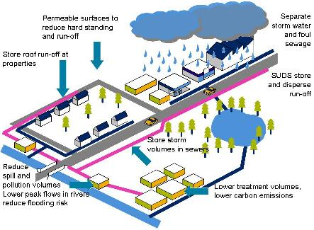

6.0 RESERVOIRS

6.1 The first stage of Reservoirs (Northern Ireland) 2015 has been enacted, the second stage which will deal with maintenance and management of reservoirs has still to be enacted. The Reservoir’s Bill (Northern Ireland) is intended to ensure that the existing ‘controlled reservoirs’ in Northern Ireland are managed in a more efficient and safety conscious manner.

6.2 When preparing an LDP the SPPS states that new development within the flood inundation area of a controlled reservoir can only be justified where the condition, management and maintenance regime of the reservoir are appropriate to provide assurance regarding reservoir safety. Development will be precluded where the FRA indicates a likelihood of fast flowing and/or deep inundation.

6.3 In the Lisburn and Castlereagh City Council District there are 10 controlled reservoirs, detailed in the following list. Most of these reservoirs are in, or close to existing settlements.
- Boomers, Leathemstown & Stoneyford reservoirs, managed by NI Water;
- Broadwater, managed by the Department for Infrastructure;
- Hillsborough Castle Pond, managed by a 3rd Sector organisation;
- Culcavy, Knockbracken & Monlough, privately owned reservoirs;
- Duncan’s Dam, managed by Lisburn & Castlereagh City Council; and
- Begny Lake at Dromara, manged by DfI Rivers.

6.4 Two further service reservoirs (Poleglass & Ballyhanwood, located in neighbouring Council areas) also inundate into the Lisburn & Castlereagh City Council area.

6.5 In addition, the following NI Water Service reservoirs will be regarded as controlled reservoirs:
- Breda
- Danescroft
- Lisnabreeny (1)
- Lisnabreeny (2)
- Magheraliskmisk
- Purdysburn

7.0 ACTIVE QUARRIES

7.1 In the LCCC district there are a total of 7 active quarries as detailed in Map 1 and Table 1 below:
Map 1: Location of Active Quarries within LCCC District and surrounding area
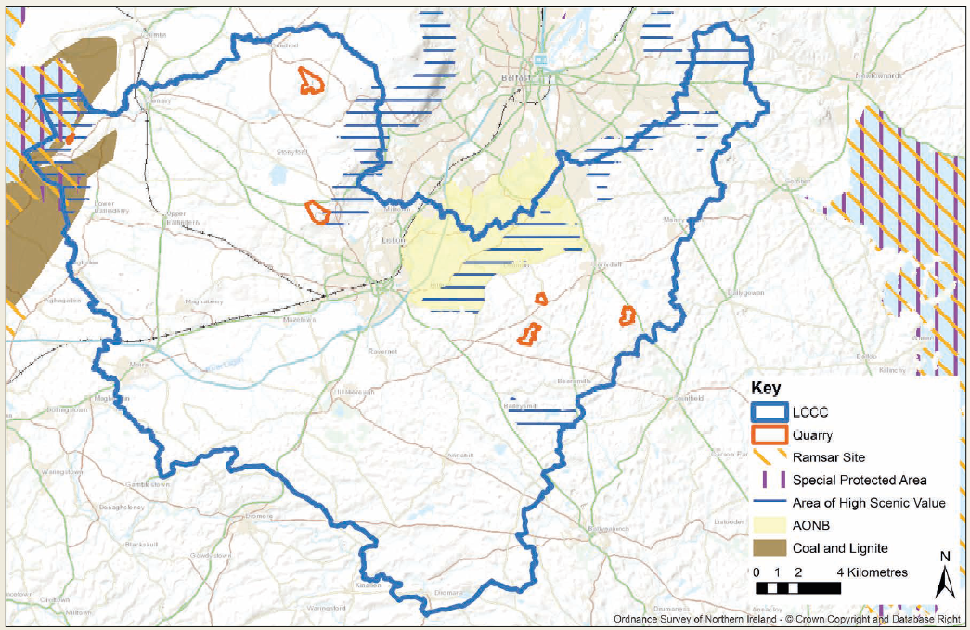
Table 1: Active Quarries in LCCC District
 | Location | Owner/Operator | Type
1 | Ballymagarrick Quarry, Ballynagarrick | M W Johnston & Sons | Basalt & Igneous Rock excl. granite
2 | Budore Quarry, Dundrod | McQuillan Group | Sandstone/Gritstone
3 | Sandy Bay No.1 Sand Wharf Mulholland's Wharf | Mulholland Bros Brick & Sand | Sand & Gravel
4 | Sandy Bay No. 2 Sand Wharf |  | Northstone Materials
5 | Whitemountain Quarry, | White Mountain | Whitemountain Quarries Ltd
6 | Temple Quarry, Ballycarngannon | Whitemountain Quarries Ltd | Basalt & Igneous Rock excl. granite
7 | Lisdoonan Quarry, Saintfield Road | ConexpoNI | Sandstone/Gritstone
Source: Quarry Products Association 2017

7.2 When preparing an LDP the Council is advised to safeguard mineral resources which are of economic or conservation value, and seek to ensure that workable mineral resources are not sterilised by other surface development which would prejudice future exploitation.

8.0 KEY FINDINGS AND CONCLUSION

8.1 A summary of the key findings are as follows:-

Flood Risk and Drainage
- Local Development Plans should be compatible with and compliment the Flood Risk Management Plans published by Rivers Agency in December 2015;
- Consideration should be given to avoiding zoning land for residential development which has been identified as being at risk of flooding, either on the Strategic Climate Change or the Hazard Flood maps or land close to existing reservoirs;
- Consider opportunities for formulating planning policy which makes drainage a key element of design and which promotes the use of SuDS.

Minerals
- Consider how the new Local Development Plan should safeguard mineral resources which are of economic or conservation value, and seek to ensure that workable mineral resources are not sterilised by other surface development which would prejudice future exploitation;
- Consider how the Local Development Plan should identify areas which, because of their intrinsic amenity value such as designated AONBs including area of scientific value or archaeological or historic interest should be protected from minerals development.

CONCLUSION

8.2 Following on from the original Position Paper in November 2015, the purpose of this paper has been to update the baseline information regarding the flood risk & drainage, and mineral development profile within the Lisburn & Castlereagh City Council area and examine the need for further provision. This baseline will support the preparation of the Plan Strategy and Local Policies Plan, and as the process evolves will be updated/amended as necessary taking account of all relevant new information made available.

Appendix 1 – A Planning Strategy for Rural Northern Ireland Minerals Policy
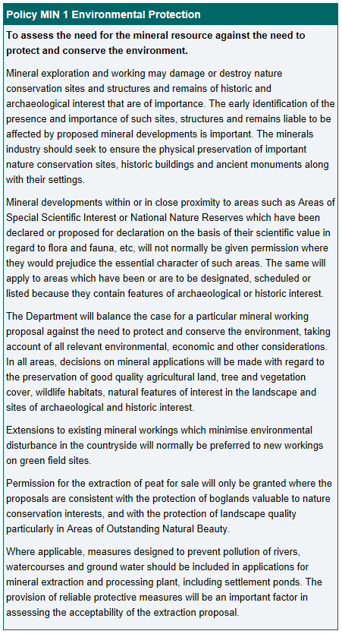

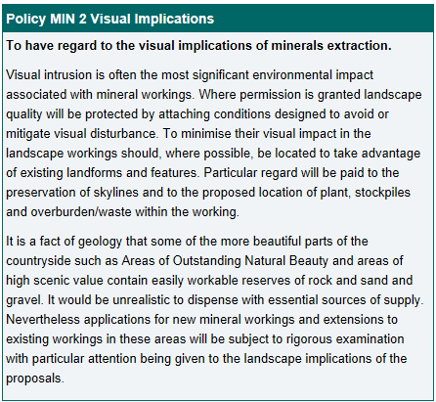

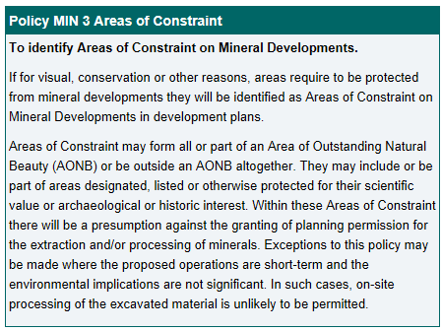
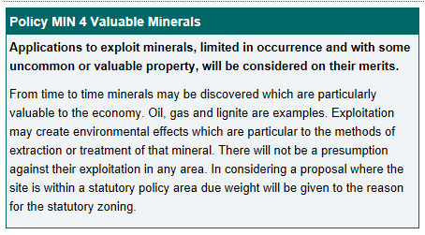
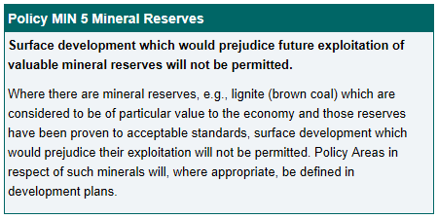
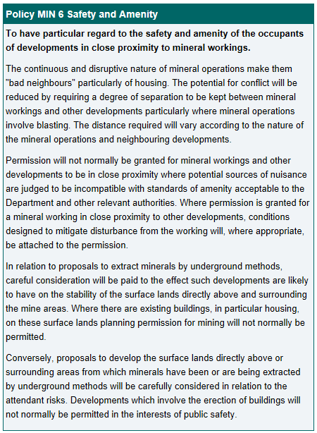
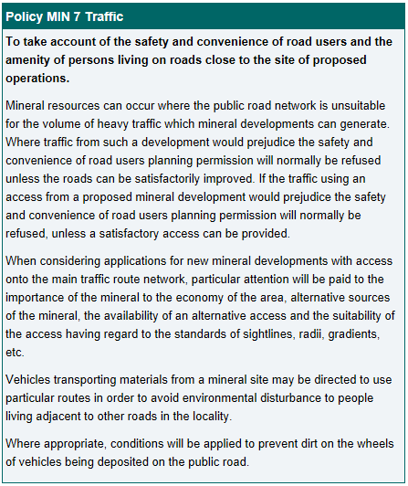

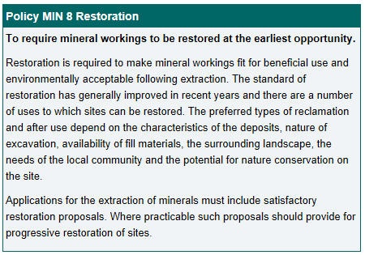

Appendix 2 Climate Change Flood Risk Map
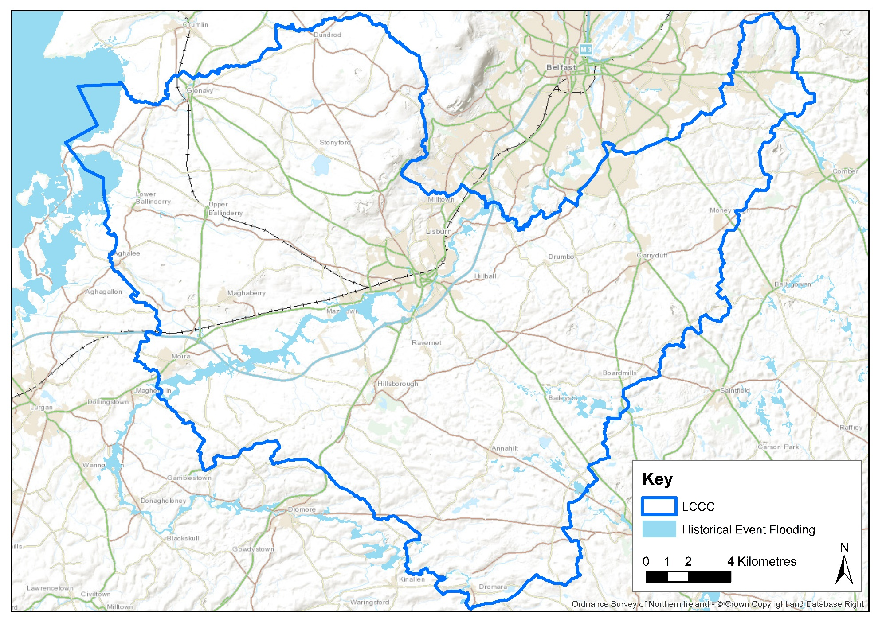
Source: DfI Rivers FloodData

CIRIA C688 Flood resilience and resistance for critical infrastructure.
Sustainable Water – A Long Term Strategy for Northern Ireland 2015-2040, DRDNI March 2016
Managing Stormwater – A Strategy for Promoting the Use of Sustainable Drainage Systems, NIEA, September 2011

